Condensing Furnace Standard
Department of Energy Residential Furnace Standards Rulemaking Summary

Scope
- Residential non-weatherized gas-fired furnaces and mobile home gas-fired furnaces
History
Year | Minimum Standard | Key Activity
1987 | Non-Condensing Furnace – 35 years | March 1987: Current minimum standard of 78% Annual Fuel Utilization Efficiency (AFUE) adopted by US Congress in National Appliance Energy Conservation Act.
1988 - 2009 |  | No changes to DOE standard
2009 |  | October 2009: Manufacturers and efficiency advocates negotiated an agreement that included an update to the standard by setting three different levels by climate regions: the North, South, and Southwest.
2010
2011 |  | December 2009: The American Public Gas Association filed a lawsuit objecting to the process used to adopt the standards.
2012 |  | No changes to DOE standard while court case is pending
2013
2014 |  | April 2014: U.S. Court of Appeals for the D.C. Circuit approved a settlement between DOE and the APGA - new DOE rulemaking to be completed by March 2016
2015 |  | March 2015: DOE released for public review analysis of the costs and benefits of condensing furnace standard  November 2015: Minimum become 80% AFUE noncondensing
2016 |  | March 2016: Anticipated DOE Final Rule for updated standards.
2017 - 2020 |  | Mandatory five year period between final rule and effective date
2021 | Condensing Furnace | March 2021: Anticipated effective date for updated standards. This would be the first effective update to the standard level in 34 years.
2021-2051 |  | Projected total accumulated energy savings over 30 years in U.S.:  2.78 Quads or 28 Billion Therms.

Supporters and Opponents
PG&E Position | Key Supporters of Position | Counter Position | Key Supporters of Counter Position
Support DOE proposed condensing furnace standard as cost effective the nation and California. Analysis is correct. | NEEP  ACEEE  CEC  NRDC  EEI  Earthjustice  The Consumer Federation of America  National Consumers Law Center  Massachusetts Union Of Public Housing Tenants  Texas Ratepayers' Organization to Save Energy | DOE should withdraw rulemaking since it is not cost effective because the analysis is flawed | SCG  AGA  APGA  AHRI  HARDI  ACCA  NAHB

Southern California Gas Analysis
After several initial meeting with SCG they decided to leave the statewide team and do their own analysis. Their consultant

2012 CALIFORNIA GAS REPORT – PREPARED BY THE CALIFORNIA GAS AND ELECTRIC UTILITIES
The California Gas Report (CGR) includes in its projections the impact of gas energy efficiency standards which, while important, are minor compared to electricity production savings.

“Residential
Households in the PG&E service area are forecast to grow 0.8 percent annually from
2012 to 2030. However, gas use per household has been dropping in recent years due to improvements in appliance and building-shell efficiencies. … Due to expected continuing upgrades in appliance and building efficiencies, as well as warming temperatures,
PG&E forecasts total residential demand to decline on average by 0.1 percent per year from
2012 to 2030, implying an average decrease in gas use per household of 1.0 percent per year.” (p. 37)

Electricity Savings (shown in bright blue) dominate the reduction in gas sales volume as shown by this chart. (p. 40)
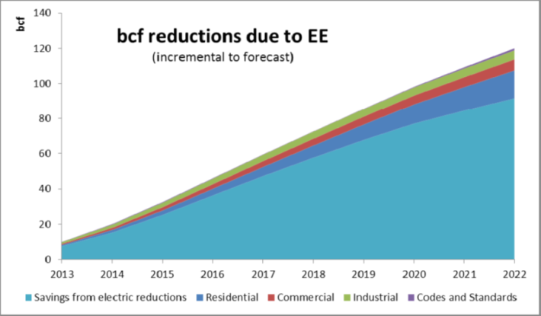
“GREENHOUSE GAS LEGISLATION / AB32
During the forecast horizon covered by this CGR, there are many uncertainties that may significantly impact the future trajectory of natural gas demand. … On the one hand, more aggressive energy efficiency programs and/or increased targets for renewable electricity supplies could significantly reduce the use of natural gas by residential and commercial customers and power plants. On the other hand, increased penetration of electric and natural gas vehicles could reduce gasoline use and overall greenhouse gas (GHG) emissions, but increase consumption of natural gas.
PG&E will continue to minimize GHG emissions by aggressively pursuing both demand-side reductions and acquisition of preferred resources, which produce little or no carbon emissions.”
(p. 39)

Extreme Impact Case: All Furnaces Condensing
- Data from 2013 Monthly by County
- 1 Billion Therms used for heating
- All furnaces are condensing (will not occur till 2050)
- 13% heating savings
- 5% residential natural gas reduction
- 1 % reduction in PG&E Gas Volume

Condensing Furnaces more Competitive
Condensing Standard makes Furnaces more competitive with Heat pumps for which standards have been steadily increasing. When a high efficiency alliance becomes the standard then costs are reduced. With condensing as the minimum furnace efficiency the high efficiency furnace will cost less than the competing high efficiency heat pump.

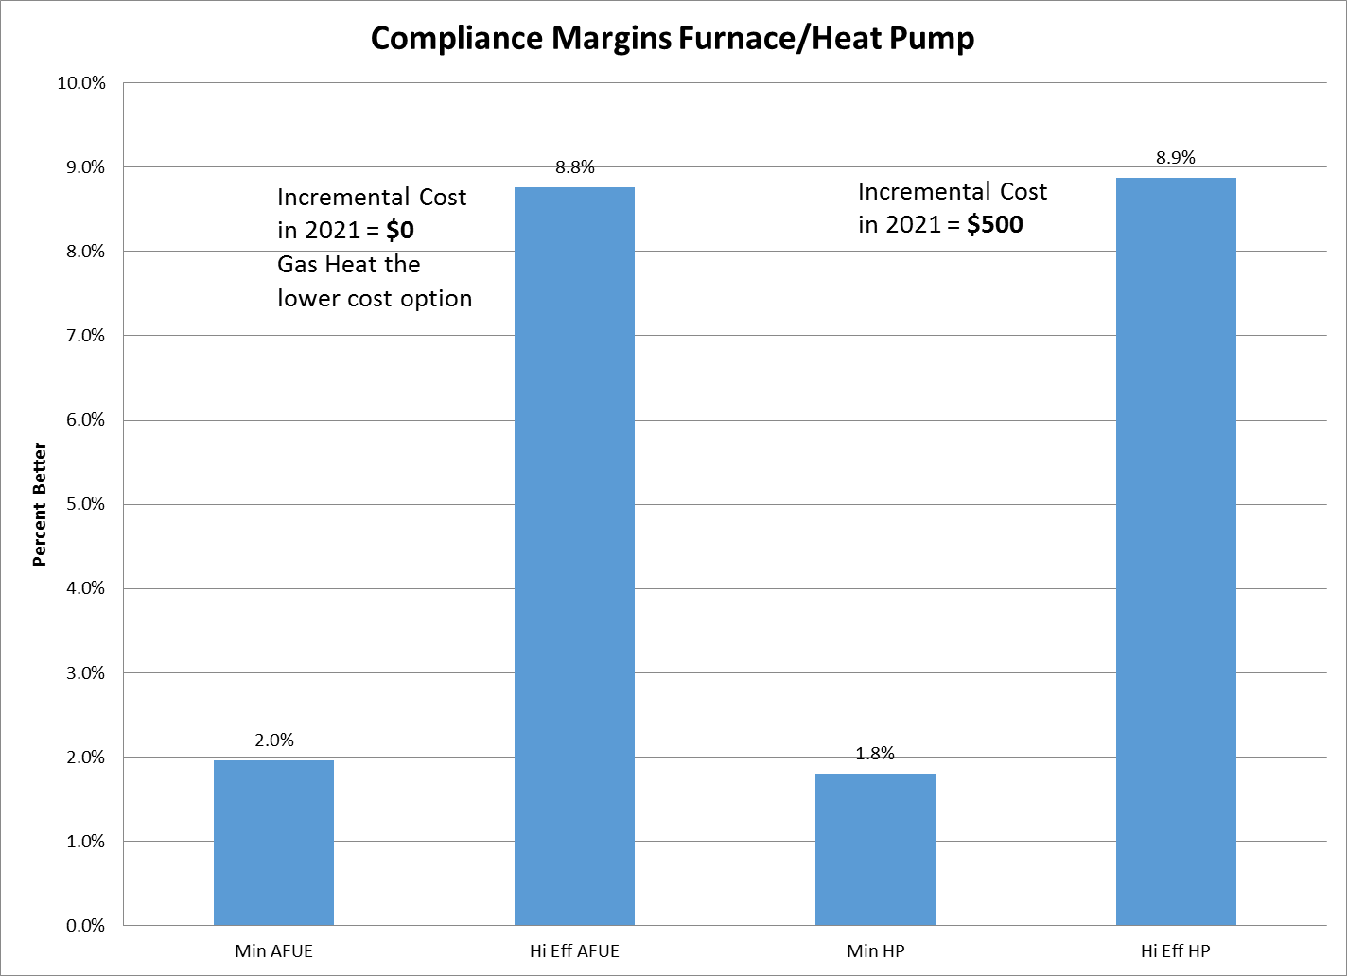

We Stand with our Customer by Supporting Condensing Furnaces
- Half of households are tenants
- More than half of new households (2010 to 2030) will be tenants
- DOE analysis did not consider tenant costs and benefits
- Rents are location driven - not driven by repair and replacement costs
- Landlords have no incentive to install anything but minimum efficiency units
- NOx limits, set based on health impacts, are met using condensing furnaces
- Condensing furnaces are cost effective for most California ratepayers
PG&E Takes a Leadership Position by Supporting DOE and CEC
As a national leader in energy efficiency and customer care PG&E benefits from a reputation for having the vision and commitment needed to be the utility of the future. Integration of Electric Vehicles, Natural Gas Vehicles, and renewables into a low carbon grid will take the support of regulators, legislatures, investors, and customers. Support is more likely to given to a utility found to be a partner in achieving Local, State, and National energy efficiency goals. Electric Vehicles powered by the low carbon PG&E grid will increase sales while supporting societal goals. Natural Gas vehicles and power plants will provide a reduced carbon impact, increased sales and benefit society. It is with this long term perspective and a commitment to our customers that PG&E supports the DOE condensing furnace standard.

