DOE Furnace Standards Status
September 9, 2016

History
March 2015
DOE released its proposed standard of 92 AFUE for all of the United States. In support of the proposal DOE revised the analysis done in support of the previous standard that had 80 AFUE in mild regions and 92 AFUE in the cold northern regions. A successful lawsuit by AGA and others forced the revised analysis. The PG&E C&S team worked with the Statewide IOU Team conducting several conference call workshops explaining the DOE LCC methodology. SCG decided to withdraw from the SW effort and hire their own consultant to support their efforts to oppose DOE.

September 2015
A revised analysis by DOE was released in response to comments opposing the 92 AFUE. Stakeholders requested that the concept of a 2-tier standard based on furnace capacity be considered. The DOE analysis considered the 2-tier standard with capacity cutoffs of 45, 55, and 65 kBtu/h with various combinations of AFUE for furnaces above the cutoffs was presented.

October 2015
Comments from Stakeholders were due October 14, 2015 which was extended to November 6th. The PG&E team prepared a draft comment letter for internal review. The draft supported a 50 kBtu/h cutoff with 95 AFUE for furnaces above the cutoff. Given the importance of the issue the C&S team worked with leadership to develop a briefing memo for Nick Stavropoulos. After several meetings it was decided that PG&E would not submit a comment letter. Negotiations were started between Energy Efficiency Advocates, AHRI, and AGA. PG&E did not participate.

Now
September 2016
DOE has issued a pre-publication Federal Register supplemental notice of proposed rulemaking (SNOPR) pertaining to residential furnaces. (September 2, 2016).

DOE will hold a public meeting Monday, October 17, 2016 from 9:00 a.m. - 5:00 p.m. at DOE's Forrestal Building, Room 6E-069, 1000 Independence Ave., S.W., Washington, D.C. Comments are due after the meeting which will probably be in early November.

DOE estimates that the proposed standard will reduce US energy use by 2.9 quadrillion Btu’s (quads) over 30 years of sales, which is enough to meet all of New England’s gas and propane heating needs for 16 years. The savings from this standard rank it as the biggest end-use natural gas saver of any standard ever issued.

The proposed standard requirements are in Table I.1
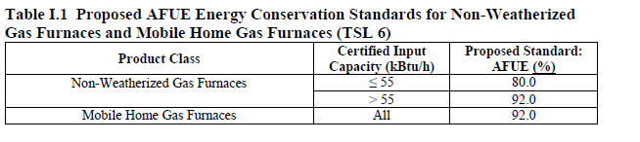

The DOE proposal is close to what the C&S team October 2015 draft comment letter supported.

The negotiations between the EE advocates, manufacturers, and AGA apparently did not result in a joint submission to DOE. PG&E did not participate but we understand that input capacities substantially above 55 kBtu/h were being considered.

As noted by DOE, the 55kBtu/h capacity dividing point serves to address the concerns stakeholders have for apartments and low income occupants.

We are reaching out to AGA and SCG to understand their positions.

It is in PG&E’s EE interest to support DOE because the gas savings are large and we take a leadership position in the eyes of CPUC and CEC.

It is in PG&E Gas business interest to support DOE because the standard will make condensing gas furnaces lower in cost while increasing the competitive gap energy efficiency gap with electric heat pumps.

