DOE Furnace Standards Status
September 8, 2016 update to October 2015 Memo

DOE has issued a pre-publication Federal Register supplemental notice of proposed rulemaking (SNOPR) pertaining to residential furnaces. (September 2, 2016). DOE will hold a public meeting October 17, 2017.

DOE will hold a public meeting Monday, October 17, 2016 from 9:00 a.m. - 5:00 p.m. at DOE's Forrestal Building, Room 6E-069, 1000 Independence Ave., S.W., Washington, D.C. Comments are due after the meeting and will probably be in early November.

DOE estimates that the standard proposed today will reduce US energy use by 2.9 quadrillion Btu’s (quads) over 30 years of sales, which is enough to meet all of New England’s gas and propane heating needs for 16 years. The savings from this standard rank it as the biggest end-use natural gas saver of any standard ever issued.

The proposed standard requirements are in Table I.1
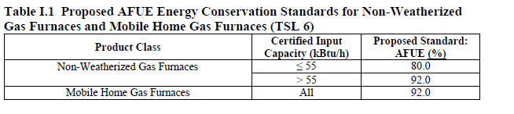

The proposal is close to what the C&S team was proposing to recommend.

The negotiations between the EE advocates, manufacturers, and AGA apparently did not result in a joint submission to DOE. PG&E did not participate but we understand that input capacities substantially above 55 kBtu/h were being considered.

As noted by DOE, the 55kBtu/h capacity dividing point serves to address the concerns stakeholders have for apartments and low income occupants.

We are reaching out to AGA and SCG to understand their positions.

It is in PG&E’s EE interest to support DOE because the gas savings are large and we take a leadership position in the eyes of CPUC and CEC.

It is in PG&E Gas business interest to support DOE because the standard will make condensing gas furnaces lower in cost while increasing the competitive gap energy efficiency gap with electric heat pumps.

