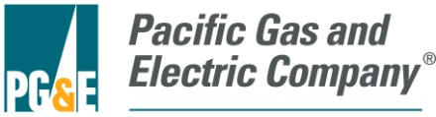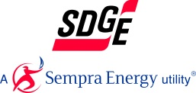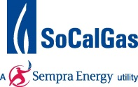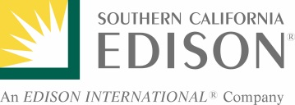

July 12, 2017
Mr. Daniel Cohen
U.S. Department of Energy
Office of the General Counsel
1000 Independence Avenue, SW.
Washington, DC 20585

ID Number: DOE_FRDOC_0001-3375

Dear Mr. Cohen:

This letter comprises the comments of list participating utilities in response to the Department of Energy’s (DOE’s) Request for Information (RFI) as part of its implementation of Executive Order 13771 (The Office of the White House 2017). These comments focus specifically on DOE’s Appliance and Equipment Standards Program as well as the energy efficiency standard and test procedure regulations developed and implemented by this program.

The signatories of this letter, collectively referred to herein as the California Investor-Owned Utilities (CA IOUs), represent some of the largest utility companies in the Western United States, serving over 35 million customers combined. As energy companies, we understand the potential of DOE’s regulations, developed and updated by the Appliance and Equipment Standards Program, to cut costs and reduce energy consumption for our customers while maintaining or increasing the value of covered products and appliances. We have witnessed the implementation of existing appliance standards developed by DOE over the past two decades and seen their effectiveness through significant energy savings from covered products. These standards have been an effective and critical tool in reducing energy use in homes and businesses nationwide, freeing up economic resources for alternate uses.

The CA IOUs have been involved with DOE’s Appliance and Equipment Standards Program as stakeholders in DOE’s public rulemaking process since 2001. SoCalGas has formal representation on the Appliance Standard and Rulemaking Federal Advisory Committee (ASRAC) since 2016 when Ms. Michelle Sim was invited by the then Secretary Moniz to join. Ms. Sim represents the interests of the California IOU’s through her position on the committee. We appreciate DOE’s efforts to solicit input from stakeholders on how best to implement Executive Order 13771 to achieve meaningful burden reduction. The CA IOUs ask DOE to carefully consider the following comments in response to this RFI.

As directed by Executive Order 13777 (The Office of the White House 2017), the regulatory reform task force will identify regulations that, among other things, are “ineffective”. Overall, the CA IOUs believe DOE’s appliance and test procedure regulations are in fact effective policy tools that help reduce energy consumption and drive technology innovation. We outline some of the positive aspects and impacts in the following sections. With that said, we are of the opinion there is room for improvement. It is in this spirit that the CA IOUs have in the past submitted constructive comments in the scope of numerous rulemakings, and it is also in this spirit that we provide further recommendations as responses to select DOE RFI questions below in this document.

Energy Efficiency Regulation Impacts: States and Utilities
Many states have compelling needs for advanced appliance efficiency standards, either due to energy costs, state policy goals, regional differences, or other factors. Federal appliance standards can be a strong policy tools for reducing energy use in existing buildings. For example, in California, the California Public Utility Commission (CPUC) established an energy goal for zero net energy (ZNE) performance in new residential construction by 2020 and in new commercial construction by 2030 (California Public Utility Commission 2008). Advanced appliance efficiency standards play a significant part in making the achievement of these goals realistic

Utility rebate and other voluntary programs that incentivize efficient products, such as the Environmental Protection Agency (EPA) ENERGY STAR® program, are critical to achieving economies of scale that drive costs down for advanced efficiency technologies. DOE rulemakings inform the creation of ENERGY STAR programs, and the outcomes of these programs can inform future DOE rulemakings in a cycle of continuous improvement.

These programs, as well as DOE’s energy conservation standards (ECS) rely on energy consumption metrics based on DOE test procedure regulations. By developing and regularly revising test procedure regulations to incorporate market developments, technological changes, and lessons learned, DOE provides a stable foundation for quantifying and comparing appliance performance. This is critical for meaningful standards and programs, and we support DOE in these efforts.

Energy Efficiency Regulation Impacts: Driving Innovation
DOE energy efficiency regulations advance technological innovation. Voluntary programs support commercialization of emerging technologies by incentivizing the adoption of promising technologies in the early phase of market introduction and accelerate future market adoption. Adoption into regulation stimulates manufacturers to develop new, differentiated products in response to their high-margin, high-efficiency products becoming the new baseline when new DOE standards take effect. This promulgates energy efficiency, societal progress in general, and domestic and international competitiveness – in fact, innovation is a cornerstone of the world’s most successful economies.

Responses to Select DOE Questions
Below are the CA IOU responses to some of the specific questions listed in the RFI.

Question 1: How can DOE best promote meaningful regulatory cost reduction while achieving its regulatory objectives, and how can it best identify those rules that might be modified, streamlined, or repealed?
- Regarding streamlining regulations, the CA IOUs strongly support the efforts of the Appliance Standards and Rulemaking Federal Advisory Committee (ASRAC) established by DOE to improve the process of establishing and updating certain energy efficiency regulations by facilitating stakeholder engagement, data collection, and consensus-building among impacted stakeholders. SoCalGas is currently a member of ASRAC, representing Investor Owned Utilities interests.

The ASRAC working group process streamlines certain efficiency regulations – reducing the overall time a rulemaking takes to finalize as compared to a typical “notice and comment” rulemaking. For example, the commercial package air conditioners final rule, which was negotiated through an ASRAC working group, was finalized in eight months from the establishment of the ASRAC working group to a DOE direct final rule. The process would have taken significantly more time, likely several years, had it gone through a non-negotiated rulemaking. This process implemented by DOE should continue to be used for other products, where it makes sense, as a way to shorten rulemaking timelines, thereby reducing overall regulatory costs for both stakeholders and DOE.

In addition to the reduced costs associated with the regulatory process, another major advantage of the ASRAC process is the possibility to establish multi-tier standards. This approach provides manufacturers with regulatory certainty over a longer period of time, enabling them to invest and plan for multiple rounds of standards. Multi-tier (or multi-phase) standards can enhance the efficiency and cost-effectiveness of rulemaking activities by having one analysis that leads to two standard updates at future dates. The first tier would follow DOE’s statutory requirements in establishing the level that is technically feasible, economically justified, and results in the most energy savings. The second tier could be more an aspirational level that may only become cost effective in the future.

DOE accepted this multi-tier approach from the outcome of ASRAC working group for the commercial package air conditioners final rule, which updated standard levels with a compliance date of January 1, 2018 for the first tier and January 1, 2023 for the second tier (Energy Efficiency and Renewable Energy Office, Department of Energy 2016). This multi-tier approach was strongly supported by industry, efficiency advocates, consumer groups, and utilities for this product category.

Question 2: What factors should DOE consider in selecting and prioritizing rules and reporting requirements for reform?
- DOE should prioritize promulgating efficiency regulations that account for different regional impacts. For example, in 2011, DOE finalized regional regulations for residential central air conditioners and heat pumps. Based on levels agreed to by a coalition of stakeholders, the standards set efficiency levels for three regions based on the number of heating degree days and climate zone, a significant improvement compared to the previous version of this regulation. DOE should seek such legislative changes for all products where typical uses, performance, savings opportunity and cost/benefit, and consumer impact vary with location.

In promulgating new or updated efficiency regulations, DOE should leverage existing voluntary standards, such as the ENERGY STAR Program or AHRAE standards, and leverage relevant information associated with the voluntary standards (e.g., shipment data, technology adoption, etc.) to help form the basis of new or updated mandatory standards. Leveraging existing data could potentially reduce the costs of undergoing certain efficiency regulations.

Question 3: How can DOE best obtain and consider accurate, objective information and data about the costs, burdens, and benefits of existing regulations? Are there existing sources of data DOE can use to evaluate the post-promulgation effects of regulations over time? We invite interested parties to provide data that may be in their possession that documents the costs, burdens, and benefits of existing requirements?
- There are a number of retrospective studies by environmental advocates that have reviewed the impacts of DOE efficiency regulations, which are cited below. They found that energy efficiency regulations have provided significant economic benefits for consumers through saving energy and freeing up funds for other use, which culminates in broader macroeconomic benefits to both the local and national economy.

One study examined the impacts of energy efficiency standards on ten residential and commercial electric-powered products. The study concluded that for the ten products studied, as efficiency regulations take effect, performance of the products improves and products become more feature-rich (Mauer, et al. 2013). Figure 1 provides a graphical representation of price declines for residential clothes washers paired with capacity increases and increased energy efficiency as each new standards update takes effect.

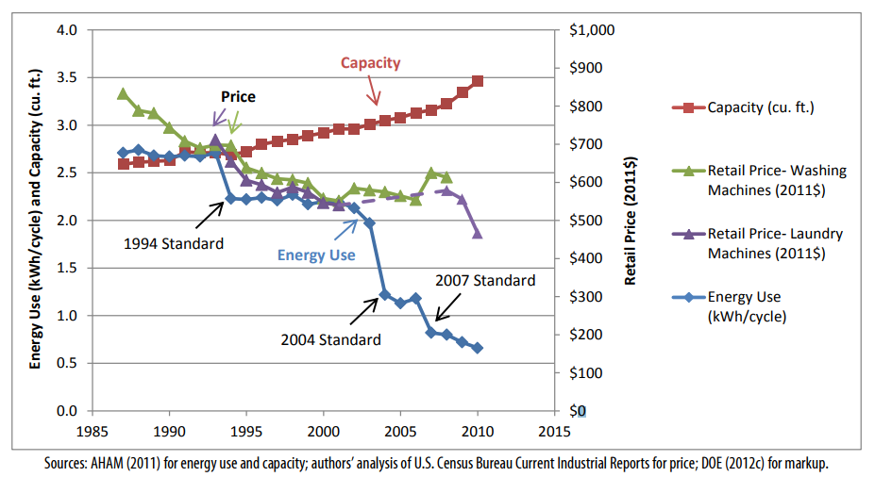
Figure 1: Clothes washer energy use, volume, and retail price from 1987-2010.
Source: Mauer, deLaski, Nadel, Fryer, & Young, 2013.

Another report examines the job increases through 2030 due to utility bill savings associated with current and prospective energy efficiency standards. Based on the report’s analysis, an average of 318,000 jobs are created annually for historic standards with an expected additional 47,000 jobs created annually for prospective standards (Gold, et al. 2011). A paper published in the Energy Policy Journal estimates 0.38 job-years are created for every GWh of electricity saved due to energy efficiency measures (Wei, Patadia and Kammen 2010). Another report further supported this concept by citing that “the positive economic impacts of MEPS [Minimum Efficiency Performance Standards] on consumers may have been underestimated” (Taylor, Spurlock and Yang 2015). One of the goals of DOE’s regulatory reform task force is to identify regulations that “eliminate jobs, or inhibit job gains”. This research shows that impacts of energy efficiency regulations on jobs and consumers may have been underestimated, consequently, they should not be repealed.

Question 4: Are there regulations that simply make no sense or have become unnecessary, ineffective, or ill-advised and if so what are they? Are there rules that can simply be repealed without impairing DOE’s statutory obligations and, if so, what are they?
- In regards to regulations considered for repealing, the CA IOUs highlight the following anti-backsliding provision in EPCA. We understand that it prevents DOE from updating existing finalized regulations in such a way that it would result in either increases in the maximum allowable energy use or decreases the minimum required energy efficiency of a covered product (Energy Conservation Standards n.d.):

The secretary may not prescribe any amended standard which increases the maximum allowable energy use, or, in the case of showerheads, faucets, water closets, or urinals, water use, or decreases the minimum required energy efficiency, of a covered product.

Conversely, DOE can modify non-finalized regulations, such as the furnace rulemaking. SoCalGas and other parties docketed comments in that rulemaking, strongly questioning whether economic benefit had been appropriately demonstrated. Critical comments included, but were not limited to:
- Many input data points were intransparent, not available for review, or outdated,
- Many assumptions were not properly justified,
- Fuel switching considerations were not aligned with market experience
- The no-new-standards-case consumer choice model was inaccurate
- The accuracy of the methodology using probability distributions was extremely difficult to confirm due to the complexity of the models and the software in use
- Incomplete consideration of regional differences, e.g. for California

Question 5: Are there rules or reporting requirements that have become outdated and, if so, how can they be modernized to better accomplish their objective?
- No comment.

Question 6: Are there rules that are still necessary, but have not operated as well as expected such that a modified, or slightly different approach at lower cost is justified?
- Associated with our comments on Question 1 regarding ASRAC, the CA IOUs believe that the stakeholder negotiation approach should be considered for other rulemakings where appropriate. The streamlined process of ASRAC reduces the regulatory costs for both stakeholders and DOE in the long-term. Additionally, ASRAC could be used to help address test procedures and standards that may need to be updated based on technological innovations outside of the scheduled review cycle to ensure the regulations are still relevant. Having a nimbler process to update regulations would be helpful for utility incentive programs, which are based on the test procedures and standard regulations developed by DOE.

Question 7: Are there rules of the Department that unnecessarily obstruct, delay, curtail, or otherwise impose significant costs on the siting, permitting, production, utilization, transmission, or delivery of energy resources?
- No comment.

Question 8: Does DOE currently collect information that it does not need or use effectively?
- The CA IOUs strongly support DOE’s efforts to collect information and work with stakeholders, such as trade organizations and others, in support of establishing and updating efficiency regulations. We support an increase in collection of fair and accurate data . In particular, it will be helpful to expand public knowledge of appliance shipment information due to the gaps in the data provided by manufacturers and their associations. DOE’s efforts to collect, effectively use, and share the information ensure rulemakings are data-driven processes. In terms of compliance and enforcement, the information DOE collects ensures the proper implementation of the efficiency regulations promulgated by DOE.

In order to make this collection process more seamless and robust, DOE should provide more advance notice about its own planned data collection activities in support of future standards and test procedures rulemakings. If DOE’s stakeholders, both manufacturers and non-manufacturers, had a better understanding of DOE’s future plans for data collection for rulemakings, they would be better able to effectively contribute to the process, while simultaneously strengthening DOE’s analyses and reducing DOE’s regulatory costs. Examples of product data that could be provided to DOE by stakeholders include: energy performance data; market shipment data; testing data on product prototypes; data on retail, installation, and maintenance costs; and energy consumption data of installed equipment.

Question 9: Are there regulations, reporting requirements, or regulatory processes that are unnecessarily complicated or could be streamlined to achieve statutory obligations in more efficient ways?
- DOE should consider staging test procedure and standard rulemaking updates for a given product category so that the test procedure regulations are completed before the standards rulemaking. Staging the rulemakings in this way would be sensible to ensure standards regulations are based on updated metrics and data from a new or modified test procedure.

- DOE should improve the life cycle cost (LCC) methodology and its inputs and models to alleviate the shortcomings identified by SoCalGas and others per the response here to Question 4. This applies to all rulemakings that employ these techniques, not just the cited example of furnaces.

- DOE should work closely with other agencies, such as the EPA, the California Energy Commission (CEC), and the European Commission, to share, where feasible, reported product data. Agency collaboration could reduce duplicative reporting burden for manufacturers. Each of the agencies noted manages public-facing product databases displaying information on product efficiency, among other attributes. Given the overlap of reported data required by these agencies, a standardized test template and single product submission to one entity, such as the CEC’s Modernized Appliance Efficiency Database System (MAEDBS), that would be shared with other applicable databases could reduce costs for manufacturers.

- DOE should also consider updating its current compliance certification database to allow stakeholders to more easily search for information on complying products and access test reports. Since utility incentive programs, aimed at increasing adoption of efficient products, establish program requirements based on certified product data, having better access to DOE’s database could potentially reduce additional manufacturer reporting burden for products eligible for incentive programs.

Question 10: Are there rules or reporting requirements that have been overtaken by technological developments? Can new technologies be leveraged to modify, streamline, or do away with existing regulatory or reporting requirements?
- As mentioned previously in comments to Question 9, DOE should work closely with other agencies that manage product databases to reduce duplicative reporting burden for manufacturers by sharing product data when applicable. This could reduce costs for manufacturers and could potentially reduce administration costs for DOE. In addition, the reported product data would be clearer and more consistent for consumers and other stakeholders, such as utilities, that use the product databases.

Question 11: Does the methodology and data used in analyses supporting DOE’s regulations meet the requirements of the Information Quality Act?
- No comment.

The CA IOUs thank DOE for the opportunity to be involved in this process and encourage DOE to carefully consider the recommendations outlined in this letter.

Sincerely,

References
California Public Utility Commission. 2008. "California Long Term Energy Efficiency Strategic Plan ."
Eilert, Pat, Doug Naaf, Joanthan McHugh, Alex Chase, and Yanda Zhang. 2012. "Code Driven Portfolios." ACEEE Summer Study on Energy Efficiency in Buildings .
Energy Conservation Standards. n.d. "42 U.S.C. § 6295."
Energy Efficiency and Renewable Energy Office, Department of Energy. 2016. "Energy Conservation Program for Certain Industrial Equipment: Energy Conservation Standards for Small, Large, and Very Large Air-Cooled Commercial Package Air Conditioning and Heating Equipment and Commercial Warm Air Furnaces; Direct final rule." EERE-2013-BT-STD-0007-0113.
Gold, Rachel, Steven Nadel, John A Laitner, and Andrew deLaski. 2011. Appliance and Equipment Efficiency Standards: A Money Maker and Job Creator. ACEEE & ASAP.
Griffin, Abbie. 2002. "Product development cycle time for business-to-business products." Industrial Marketing Management 291-304.
J.D. Power. 2014. Company Impact Report: Energy Efficiency Programs and Awareness. J.D. Power and Associates, McGraw Hill Financial.
Mauer, Joanna, Andrew deLaski, Steven Nadel, Anthony Fryer, and Rachel Young. 2013. Better Appliances: An Analysis of Performance, Features, and Price as Efficiency Has Improved. ACEEE & ASAP.
Nadel, Steven, and Andrew deLaski. 2013. Appliance Standards: Comparing Predicted and Observed Prices. ACEEE & ASAP.
Pacific Gas & Electric. 2017. "PG&E's Energy Efficiency Business plan 2018-2025."
Taylor, Margarat, C. Anna Spurlock, and Hung-Chia Yang. 2015. Confronting Regulatory Cost and Quality Expectations: An Exploration of Technical Change in Minimum Efficiency Performance Standards. Berkeley: Lawrence Berkeley National Laboratory.
The Office of the White House. 2017. "Executive Order 13771." Reducing Regulation and Controlling Regulatory Costs. January 30.
—. 2017. "Presidential Executive Order 13777: Enforcing the Regulatory Reform Agenda." February 24.
U.S. Department of Energy. 2016. "Building Technologies Office Multi-year Program Plan." February.
—. 2017. "Saving Energy and Money with Appliance and Equipment Standards in the United States." January.
US Department of Energy. 2017. "Reducing Regulation and Controlling Regulatory Costs: Request for Information (RFI)." Federal Register, May 20: 24582-24583.
VanBuskirk, R D, C LS Kantner, B F Gerke, and S Chu. 2014. "A retrospective investigation of energy efficiency standards: policies may have accelerated long term declines in appliance costs." Environmental Research Letters 9 (11).
Wei, Max, Shana Patadia, and Daniel M Kammen. 2010. "Putting renewables and energy efficiency to work: How many jobs can the clean energy industry generate in the US?" Energy Policy.

DOE published the intent to establish the working group was published in April 2015, the working group finalized a term sheet in June 2015, and DOE published a direct final rule in December 2015.
The product types were refrigerators, clothes washers, dishwashers, residential central air conditioners and heat pumps, toilets, general service light bulbs, incandescent reflector lamps, fluorescent lamp ballasts, commercial rooftop air conditioners and heat pumps, and refrigerated beverage vending machines.
“Price data were available from 1987-2008 for washing machines and from 1993-2001 and 2008-2010 for laundry machines (washers & dryers)” (Mauer, et al. 2013).

