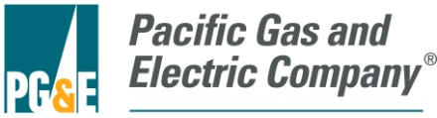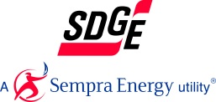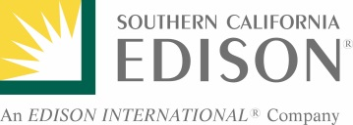

July 14, 2017
Mr. Daniel Cohen
U.S. Department of Energy
Office of the General Counsel
1000 Independence Avenue, SW.
Washington, DC 20585

ID Number: DOE_FRDOC_0001-3375

Dear Mr. Cohen:

This letter comprises the comments of the Pacific Gas and Electric Company (PG&E), San Diego Gas and Electric (SDG&E), and Southern California Edison (SCE) in in response to the Department of Energy’s (DOE’s) Request for Information (RFI) as part of its implementation of Executive Order 13771 (The Office of the White House 2017). These comments focus specifically on DOE’s Appliance and Equipment Standards Program as well as the energy efficiency standards and test procedure regulations developed and implemented by this program.

The signatories of this letter, collectively referred to herein as the California Investor-Owned Utilities (CA IOUs), represent some of the largest utility companies in the Western United States, serving over 32 million customers combined. As energy companies, we understand the potential of DOE’s regulations, developed and updated by the Appliance and Equipment Standards Program, to cut costs and reduce energy consumption for our customers while maintaining or increasing the value of covered products and appliances. We have witnessed the implementation of existing appliance standards developed by DOE over the past two decades and seen their effectiveness through significant energy savings from covered products. These standards have been an effective and critical tool in reducing energy use in homes and businesses nationwide, freeing up economic resources for alternate uses.

The CA IOUs have been involved with DOE’s Appliance and Equipment Standards Program since 2001 as stakeholders in DOE’s public rulemaking process and participants in Appliance Standard and Rulemaking Federal Advisory Committee (ASRAC) working groups. We appreciate DOE’s efforts to solicit input from stakeholders on how best to implement Executive Order 13771 to achieve meaningful burden reduction while continuing to meet DOE’s statutory responsibilities in accordance with the Energy Policy and Conservation Act of 1975 (EPCA), as amended (Energy Conservation Standards n.d.). The CA IOUs ask DOE to carefully consider the following comments in response to this RFI.

Energy Efficiency Regulation Impacts: Nationwide
As directed by Executive Order 13777 (The Office of the White House 2017), the regulatory reform task force will identify regulations that, among other things, are “ineffective.” The CA IOUs believe DOE’s appliance and test procedure regulations are among the most impactful and effective policy tools in reducing energy consumption and driving technology innovation. DOE currently develops, updates, and implements energy efficiency regulations and test procedures for more than 60 appliances. These products represent about 90 percent of home energy use, 60 percent of commercial building energy use, and 30 percent of industrial energy use. Nationally, the cumulative positive impacts of these regulations are massive: by 2020 an estimated $1 trillion will have been saved on consumers’ utility bills and 71 quadrillion British thermal units (quads) of energy will have been avoided (U.S. Department of Energy 2017). DOE efficiency standards have significantly impacted energy demand since the mid-1990s. Figure 1 depicts the cumulative annual energy savings, in quads, from DOE energy efficiency regulations since the first standards took effect.

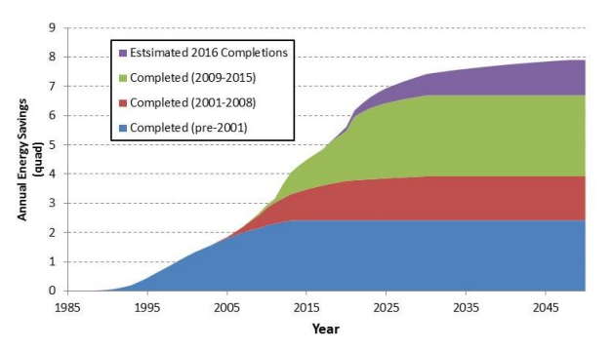
Figure 1: Energy savings as a result of DOE appliance efficiency regulations.
Source: U.S. Department of Energy, 2016.

Energy Efficiency Regulation Impacts: States and Utilities
Many states have compelling needs for advanced appliance efficiency standards, either due to energy costs, state policy goals, regional differences, or other factors. Federal appliance standards can be one of the strongest policy tools for reducing energy use in existing buildings. For example, in California, the California Public Utility Commission (CPUC) established an energy goal for zero net energy (ZNE) performance in new residential construction by 2020 and in new commercial construction by 2030 (California Public Utility Commission 2008). Advanced appliance efficiency standards will play a significant part in achieving these goals.

Utility rebate and other voluntary programs that incentivize efficient products, such as the Environmental Protection Agency (EPA) ENERGY STAR® program, are critical to achieving economies of scale that drive costs down for advanced efficiency technologies. These programs rely on energy consumption metrics based on DOE test procedure regulations. Thus, it is critical to periodically review and update test procedures, as prescribed in EPCA, to ensure the energy metrics are representative of new features, technologies, and actual performance.

Energy Efficiency Regulation Impacts: Driving Innovation
DOE energy efficiency regulations advance innovation in energy efficiency technology. Voluntary programs support commercialization of emerging technologies by incentivizing the adoption of promising technologies in the early phase of market introduction and rapid increase of market adoption. Adoption into regulation stimulates the appliance manufacturers to develop new, differentiated products in response to their high-margin, high-efficiency products becoming the new baseline when new DOE standards take effect. For example, lighting efficiency regulations adopted in 2007 signaled a shift away from traditional incandescent light bulbs. At the time, compact fluorescent light bulbs (CFLs) were considered the prime candidate to fill the void; but over the next ten years, a significant amount of investment and innovation in this industry resulted in the introduction of several new product types that provided improved efficiency without the apparent quality or performance issues plaguing CFLs. These innovations included halogen light bulbs, and later LED light bulbs that are dimmable, have very good color quality, and are virtually indistinguishable from traditional products. This process continues cyclically, as efficiency regulations are adopted and updated periodically, driving products toward more cost-effective energy efficiency innovations with each cycle (Eilert, et al. 2012).

In a retrospective study looking at the effect of DOE efficiency regulations, the study authors found that for each of the ten different products examined, manufacturers introduced and expanded the availability of new features as efficiency regulations took effect (Mauer, et al. 2013).

Figure 2 depicts a DOE summary of the above and other benefits of the Appliance Standards regulations.

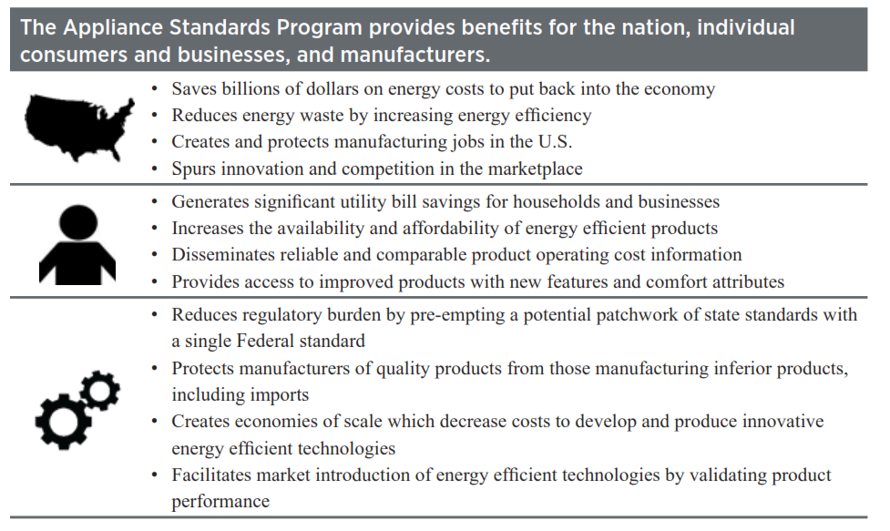Figure 2: Summary of benefits from appliance standards.
Source: U.S. Department of Energy, 2017.

EPCA Requirements
DOE’s regulatory reform task force is also tasked with identifying regulations that impose costs that exceed benefits. EPCA has safeguards in place to ensure efficiency regulations do not violate this requirement as detailed in the following provisions (Energy Conservation Standards n.d.):

(B)(i) In determining whether a standard is economically justified, the Secretary shall, after receiving views and comments furnished with respect to the proposed standard, determine whether the benefits of the standard exceed its burdens by, to the greatest extent practicable, considering—
(I) the economic impact of the standard on the manufacturers and on the consumers of the products subject to such standard;
(II) the savings in operating costs throughout the estimated average life of the covered product in the type (or class) compared to any increase in the price of, or in the initial charges for, or maintenance expenses of, the covered products which are likely to result from the imposition of the standard;
(III) the total projected amount of energy, or as applicable, water, savings likely to result directly from the imposition of the standard.

Specifically, EPCA requires every energy efficiency standards regulation promulgated by DOE to be “economically justified,” specifically requiring that the cumulative benefits of the regulation exceed the cumulative costs. As discussed below, energy efficiency advocates and Lawrence Berkeley National Laboratory found that DOE overestimated numerous appliance product prices and life cycle costs post-regulation, and thereby underestimated economic benefits.

As directed by Executive Order 13777, the regulatory reform task force shall also identify regulations that are “outdated” (The Office of the White House 2017). EPCA again provides statutory requirements to ensure that efficiency standards and test procedures are reviewed on a periodic basis. Since DOE has expanded the Appliance and Equipment Standards Program to cover a larger share of home, commercial, and industrial energy use, it is increasingly important for DOE to retain its ability to update current energy efficiency standards and test procedure regulations on a periodic basis to ensure standards remain relevant.

Responses to Specific DOE Questions
Below are the CA IOU responses to some of the specific questions listed in the RFI.

Question 1: How can DOE best promote meaningful regulatory cost reduction while achieving its regulatory objectives, and how can it best identify those rules that might be modified, streamlined, or repealed?
- Regarding streamlining regulations, the CA IOUs strongly support the efforts of the ASRAC established by DOE to improve the process of establishing and updating certain energy efficiency regulations by facilitating stakeholder engagement, collecting data, and building consensus among impacted stakeholders. The CA IOUs are currently members of ASRAC’s working groups.

The ASRAC working group process implemented by DOE should continue to be used for other products, where it makes sense, as a way to shorten rulemaking timelines, thereby reducing overall regulatory costs for both stakeholders and DOE. This process streamlines certain efficiency regulations – reducing the overall time to finalize a rulemaking as compared to a typical “notice and comment” rulemaking. For example, the commercial package air conditioners final rule, which was negotiated through an ASRAC working group, was finalized in eight months from the establishment of the ASRAC working group to a DOE direct final rule. The process would have taken significantly more time, likely several years, had it gone through a non-negotiated rulemaking.

In addition to the reduced costs associated with the regulatory process, another major advantage of the ASRAC process is the possibility to establish multi-tier standards. This approach provides manufacturers with regulatory certainty over a longer period of time, enabling them to invest and plan for multiple rounds of standards. Multi-tier (or multi-phase) standards can enhance the efficiency and cost-effectiveness of rulemaking activities by having one analysis that leads to two future standards updates. The first tier would follow DOE’s statutory requirements in establishing the level that is technically feasible, economically justified, and results in the most energy savings. The second tier could be an aspirational level, such as the maximum technologically feasible level.

DOE accepted this multi-tier approach from the outcome of the ASRAC working group for the commercial package air conditioners final rule, which updated standard levels with a compliance date of January 1, 2018 for the first tier and January 1, 2023 for the second tier (Energy Efficiency and Renewable Energy Office, Department of Energy 2016). This multi-tier approach was strongly supported by industry, efficiency advocates, consumer groups, and utilities for this product category.

Question 2: What factors should DOE consider in selecting and prioritizing rules and reporting requirements for reform?
- DOE should prioritize promulgating efficiency regulations that account for different regional impacts. In 2011, DOE finalized regional regulations for residential central air conditioners and heat pumps, the first standards promulgated by DOE that differed due to varying efficiency needs for this equipment in different regions of the United States. Based on levels agreed to by a coalition of stakeholders, the standards set efficiency levels for three regions based on the number of heating degree days and the climate zone. DOE should seek legislative changes that prioritize the promulgation of regional energy and water efficiency regulations for products where there is an opportunity to address the unique needs of a location, such as severe drought conditions or increasingly severe winter storms.

- In promulgating new or updated efficiency regulations, DOE should leverage existing voluntary standards, such as the ENERGY STAR Program, and relevant information associated with the voluntary standards (e.g., shipment data, technology adoption, etc.) to help form the basis of new or updated mandatory standards. Leveraging existing data could potentially reduce the costs of undergoing certain efficiency regulations.

- DOE should prioritize rules based on the specific development cycles of each unique appliance industry. EPCA prescribes a five-year gap between the publication of the final rule and the compliance date for standards of newly-covered products. In prioritizing the establishment of new energy efficiency regulations for currently uncovered products, the CA IOUs believe DOE should seek legislative changes that provide it more flexibility in setting earlier effective dates for products where the market is rapidly changing, such as lighting products and electronics equipment.

One study suggests that consumer product development cycles typically take just under 2.5 years for new-to-the-world products (i.e., highly innovated products). Figure 3 is a graphical representation of the study results. For products and product lines with major revisions, (i.e., those potentially affected by a DOE standard), the average product development cycle is approximately 15 months. According to this study, on average, industrial firms have been taking 2.25 years to develop their more innovative projects.

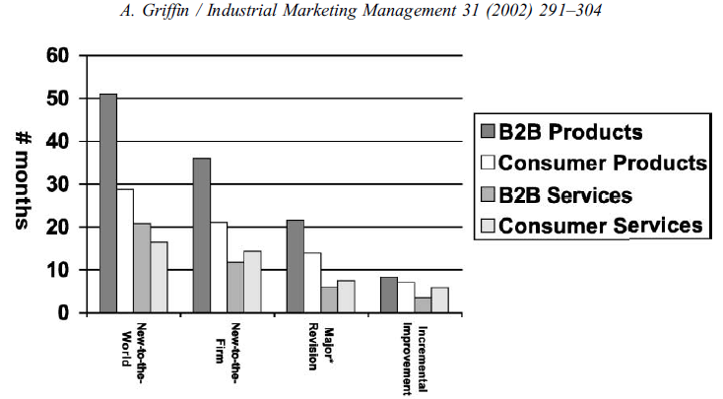
Figure 3: Average product development cycles by product type.
Source: Griffin, 2002.

With this compelling evidence that product development cycles are significantly shorter than five years, we urge DOE, with stakeholder input, to consider a shorter period between the final rule and compliance dates on a case-by-case basis for each rulemaking. Additionally, this would ensure that standards are applicable to products on the market at the time of compliance.

Question 3: How can DOE best obtain and consider accurate, objective information and data about the costs, burdens, and benefits of existing regulations? Are there existing sources of data DOE can use to evaluate the post-promulgation effects of regulations over time? We invite interested parties to provide data that may be in their possession that documents the costs, burdens, and benefits of existing requirements?
- There are a number of retrospective studies that have reviewed the impacts of DOE efficiency regulations, which are cited below. Energy efficiency regulations have provided significant economic benefits for consumers through saving energy and freeing up funds for other use, which culminates in broader macroeconomic benefits to both local and national economies.

One study examined the impacts of energy efficiency standards on ten residential and commercial lighting products. The study concluded that as efficiency regulations take effect performance of the products improves and products become more feature-rich (Mauer, et al. 2013). Figure 4 provides a graphical representation of price declines for residential clothes washers paired with capacity increases and increased energy efficiency as each new standards update takes effect.

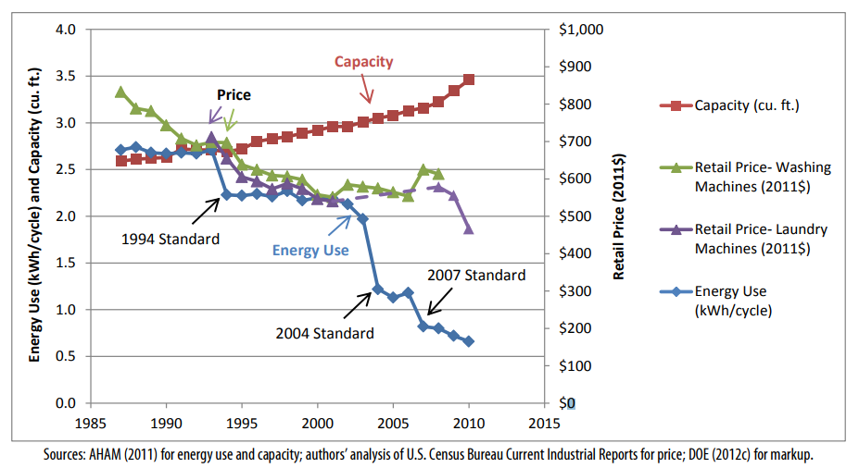
Figure 4: Clothes washer energy use, volume, and retail price from 1987-2010.
Source: Mauer, deLaski, Nadel, Fryer, & Young, 2013.

Another report examines the job increases through 2030 due to utility bill savings associated with current and prospective energy efficiency standards. Based on the report’s analysis, an average of 318,000 jobs are created annually for historic standards with an expected additional 47,000 jobs created annually for prospective standards (Gold, et al. 2011). A paper published in the Energy Policy Journal estimates 0.38 job-years are created for every GWh of electricity saved due to energy efficiency measures (Wei, Patadia and Kammen 2010). One of the goals of DOE’s regulatory reform task force is to identify regulations that “eliminate jobs, or inhibit job gains”, and this research shows that impacts of energy efficiency regulations on jobs may have been underestimated. Based on multiple studies, efficiency regulations have a positive impact on jobs.

These impacts will likely be greater than predicted in the future as there is evidence that DOE has overestimated price increases for appliances after standards implementations. Based on one study, looking at ten products the median price increase of an appliance after regulation was $10, significantly less than the median DOE estimate of $108 (Nadel and deLaski 2013). Another report further supported this concept citing that “the positive economic impacts of MEPS [Minimum Efficiency Performance Standards] on consumers may have been underestimated” (Taylor, Spurlock and Yang 2015). These results show that job creation and consumer savings may likely be greater than predicted by DOE in the future, making future efficiency regulations even more critical for the macroeconomic health of the nation.

Question 4: Are there regulations that simply make no sense or have become unnecessary, ineffective, or ill-advised and if so what are they? Are there rules that can simply be repealed without impairing DOE’s statutory obligations and, if so, what are they?
- In regards to regulations that can be repealed, the CA IOUs highlight the following anti-backsliding provision in EPCA, which prevents DOE from updating existing regulations that result in either an increase in the maximum allowable energy use or a decrease in the minimum required energy efficiency of a covered product (Energy Conservation Standards n.d.):

The secretary may not prescribe any amended standard which increases the maximum allowable energy use, or, in the case of showerheads, faucets, water closets, or urinals, water use, or decreases the minimum required energy efficiency, of a covered product.

Therefore, statutory requirements explicitly prohibit any existing efficiency standards or test procedures from being repealed by DOE.

Question 5: Are there rules or reporting requirements that have become outdated and, if so, how can they be modernized to better accomplish their objective?
- No comment.

Question 6: Are there rules that are still necessary, but have not operated as well as expected such that a modified, or slightly different approach at lower cost is justified?
- Associated with our comments on Question 1 regarding ASRAC, the CA IOUs believe that the stakeholder negotiation approach should be considered for other rulemakings where appropriate. The streamlined process of ASRAC reduces the regulatory costs for both stakeholders and DOE in the long-term. Additionally, ASRAC could be used to help address test procedures and standards that may need to be updated based on technological innovations outside of the scheduled review cycle to ensure the regulations are still relevant. Having a nimbler process to update regulations would be helpful for utility incentive programs, which are based on the test procedures and standard regulations developed by DOE.

Question 7: Are there rules of the Department that unnecessarily obstruct, delay, curtail, or otherwise impose significant costs on the siting, permitting, production, utilization, transmission, or delivery of energy resources?
- No comment.

Question 8: Does DOE currently collect information that it does not need or use effectively?
- The CA IOUs strongly support DOE’s extensive efforts to collect information and work with stakeholders, such as trade organizations and others, in support of establishing and updating efficiency regulations. We support an increase in data collection efforts to expand public knowledge of appliance shipment information due to the gaps in the data provided by manufacturers and their associations. DOE’s efforts to collect and effectively use the information ensure rulemakings are data-driven. In terms of compliance and enforcement, the information DOE collects ensures the proper implementation of the efficiency regulations promulgated by DOE and the realization of the massive associated consumer benefits previous cited in response to Question 3.

In order to make this collection process more seamless and robust, DOE should provide more advance notice about its own planned data collection activities in support of future standards and test procedures rulemakings. If DOE’s stakeholders, both manufacturers and non-manufacturers, had a better understanding of DOE’s future plans for data collection for rulemakings, they would be better able to effectively contribute to the process, while simultaneously strengthening DOE’s analyses and reducing DOE’s regulatory costs. Examples of product data that could be provided to DOE by stakeholders include: energy performance data; market shipment data; testing data on product prototypes; data on retail, installation, and maintenance costs; and energy consumption data of installed equipment.

Question 9: Are there regulations, reporting requirements, or regulatory processes that are unnecessarily complicated or could be streamlined to achieve statutory obligations in more efficient ways?
- DOE should consider staging test procedure and standard rulemaking updates for a given product category so that the test procedure regulations are completed before the standards rulemaking. Staging the rulemakings in this way would be sensible to ensure standards regulations are based on updated metrics and data from a new or modified test procedure.

- DOE should work closely with other agencies, such as the EPA, the California Energy Commission (CEC), and the European Commission, to share, where feasible, reported product data. Agency collaboration could reduce duplicative reporting burden for manufacturers. Each of the agencies noted manages public-facing product databases displaying information on product efficiency, among other attributes. Given the overlap of reported data required by these agencies, a standardized test template and single product submission to one entity, such as the CEC’s Modernized Appliance Efficiency Database System (MAEDBS), that would be shared with other applicable databases could reduce costs for manufacturers.

- DOE should also consider updating its current compliance certification database to allow stakeholders to more easily search for information on complying products and access test reports. Since utility incentive programs, aimed at increasing adoption of efficient products, establish program requirements based on certified product data, having better access to DOE’s database could potentially reduce additional manufacturer reporting burden for products eligible for incentive programs.

Question 10: Are there rules or reporting requirements that have been overtaken by technological developments? Can new technologies be leveraged to modify, streamline, or do away with existing regulatory or reporting requirements?
- As mentioned previously in comments to Question 9, DOE should work closely with other agencies that manage product databases to reduce duplicative reporting burden for manufacturers by sharing product data when applicable. This could reduce costs for manufacturers and could potentially reduce administration costs for DOE. In addition, the reported product data would be clearer and more consistent for consumers and other stakeholders, such as utilities, that use the product databases.

Question 11: Does the methodology and data used in analyses supporting DOE’s regulations meet the requirements of the Information Quality Act?
- No comment.

The CA IOUs thank DOE for the opportunity to be involved in this process and encourage DOE to carefully consider the recommendations outlined in this letter.

Sincerely,

References
California Public Utility Commission. 2008. "California Long Term Energy Efficiency Strategic Plan ."
Eilert, Pat, Doug Naaf, Joanthan McHugh, Alex Chase, and Yanda Zhang. 2012. "Code Driven Portfolios." ACEEE Summer Study on Energy Efficiency in Buildings .
Energy Conservation Standards. n.d. "42 U.S.C. § 6295."
Energy Efficiency and Renewable Energy Office, Department of Energy. 2016. "Energy Conservation Program for Certain Industrial Equipment: Energy Conservation Standards for Small, Large, and Very Large Air-Cooled Commercial Package Air Conditioning and Heating Equipment and Commercial Warm Air Furnaces; Direct final rule." EERE-2013-BT-STD-0007-0113.
Gold, Rachel, Steven Nadel, John A Laitner, and Andrew deLaski. 2011. Appliance and Equipment Efficiency Standards: A Money Maker and Job Creator. ACEEE & ASAP.
Griffin, Abbie. 2002. "Product development cycle time for business-to-business products." Industrial Marketing Management 291-304.
J.D. Power. 2014. Company Impact Report: Energy Efficiency Programs and Awareness. J.D. Power and Associates, McGraw Hill Financial.
Mauer, Joanna, Andrew deLaski, Steven Nadel, Anthony Fryer, and Rachel Young. 2013. Better Appliances: An Analysis of Performance, Features, and Price as Efficiency Has Improved. ACEEE & ASAP.
Nadel, Steven, and Andrew deLaski. 2013. Appliance Standards: Comparing Predicted and Observed Prices. ACEEE & ASAP.
Pacific Gas & Electric. 2017. "PG&E's Energy Efficiency Business plan 2018-2025."
Taylor, Margarat, C. Anna Spurlock, and Hung-Chia Yang. 2015. Confronting Regulatory Cost and Quality Expectations: An Exploration of Technical Change in Minimum Efficiency Performance Standards. Berkeley: Lawrence Berkeley National Lanoratory.
The Office of the White House. 2017. "Executive Order 13771." Reducing Regulation and Controlling Regulatory Costs. January 30.
—. 2017. "Presidential Executive Order 13777: Enforcing the Regulatory Reform Agenda." February 24.
U.S. Department of Energy. 2016. "Building Technologies Office Multi-year Program Plan." February.
—. 2017. "Saving Energy and Money with Appliance and Equipment Standards in the United States." January.
US Department of Energy. 2017. "Reducing Regulation and Controlling Regulatory Costs: Request for Information (RFI)." Federal Register, May 20: 24582-24583.
VanBuskirk, R D, C LS Kantner, B F Gerke, and S Chu. 2014. "A retrospective investigation of energy efficiency standards: policies may have accelerated long term declines in appliance costs." Environmental Research Letters 9 (11).
Wei, Max, Shana Patadia, and Daniel M Kammen. 2010. "Putting renewables and energy efficiency to work: How many jobs can the clean energy industry generate in the US?" Energy Policy.

Typo in legend is from original report. Legend label for purple wedge should read “Estimated 2016 Completions”.
DOE published the intent to establish the working group in April 2015, the working group finalized a term sheet in June 2015, and DOE published a direct final rule in December 2015.
B2B (Business to Business)
“Price data were available from 1987-2008 for washing machines and from 1993-2001 and 2008-2010 for laundry machines (washers & dryers)” (Mauer, et al. 2013).

