**PG&E Review: Installation Cost for Replacement Condensing Furnaces**

Supporters of DOE’s proposed condensing furnace standard view the standard as cost effective based on DOE’s analysis, which supporters believe to be accurate. Supporters include:

|  |  |
| --- | --- |
| * PG&E | * The Consumer Federation of America |
| * NEEP | * National Consumers Law Center |
| * ACEEE | * Massachusetts Union of Public Housing Tenants |
| * California Energy Commission (CEC) | * Texas Ratepayers’ Organization to Save Energy |
| * Natural Resource Defense Council (NRDC) | * Earth Justice |
| * EEI |  |

Opponents of the Furnace standard believe DOE should withdraw the rulemaking as they believe it is not cost effective and the DOE analysis is flawed. Opponents of the standard include:

|  |  |
| --- | --- |
| * SoCal Gas | * HARDI |
| * AGA | * ACCA |
| * APGA | * NAHB |
| * AHRI |  |

A key issue in contention is the estimated cost to replace noncondensing with condensing furnaces, which depends upon the complexity of the replacement and the distribution of “easy” to “complex” replacements. PG&E conducted an independent review of DOE’s analysis of installation cost for replacement condensing furnaces, using consulting firm TRC, and concluded DOE’s analysis is accurate. Replacement costs cover a fairly wide range, but, on average, replacement condensing furnaces are cost-effective.

**Inclusion of Installation Cost Scenarios in LCC Analysis**

DOE’s analysis shows the condensing furnace standard to be Life Cycle Cost (LCC) cost effective for the Nation and California. Opponents of the standard have questioned whether the impact of difficult and high installation cost furnace replacements has been adequately accounted for in the LCC.

The table below shows the data resulting from DOE’s methodology used in the LCC analysis. Depending on the complexity of the replacement, the increased installation cost for a condensing versus noncondensing furnace ranges from a low of $371 to a high of $1527. The “Percent of Annual Shipments” serves to put the results in perspective. High cost scenarios represent only 5.8% of shipments.



**Distribution of Installation Costs**

The DOE LCC analysis generates 10,000 results which are organized into “bins” for plotting. The graph shows the distribution of occurrences is concentrated around the $627 average and that there is long “tail” of high cost installations. It is these few high cost cases that are memorable even though they represent a small fraction of cases. As discussed by DOE, these high incremental costs were driven by what is called “orphaned water heaters”, which represents 14.4% of the annual furnaces shipped and installed. In more than half of these cases (8.3 %) the water heater vent does not have to be sized but does need to be upgraded to a dual wall vent pipe.

The results of the LCC analysis are best understood by viewing the distribution in the chart below. 80% of cases have an incremental cost less than $1250.

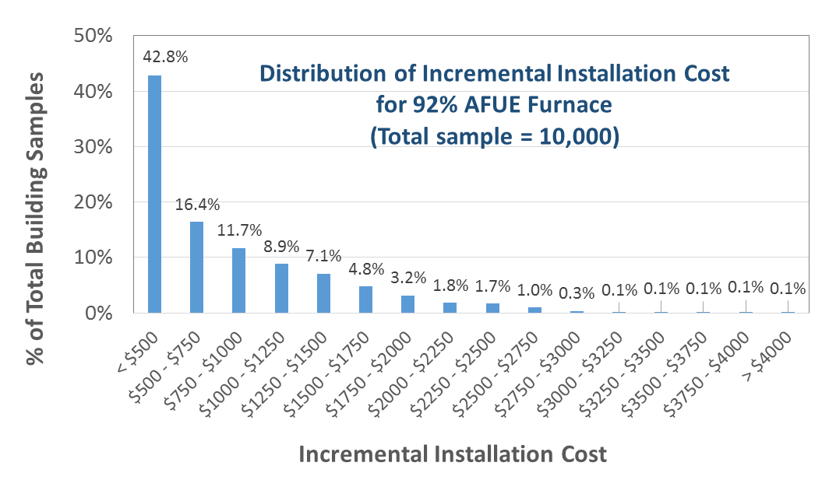

**Technology Solution for High Cost Installations**

An example of the creative and innovative response to condensing furnace standards comes from a major supplier of materials for heating contractors. One type of high cost case is an attached dwelling (e.g. row house) in the Northeast with a masonry chimney into which the furnace and water heater are venting flue gases. The DuraVent technology provides for the condensing furnace to be vented in a flexible stainless steel pipe that is located inside the atmospheric venting water heater flue.



As shown in the second illustration, the dual flue vent provides a less expensive solution to the need to line the existing masonry chimney. In discussions with Philadelphia Gas staff, it was determined that they were visualizing that condensing furnaces required horizontal venting. However, they have now verified that the existing furnace and water heater vented through a masonry chimney that is straight and goes from the basement to the roof can be addressed with the DuraVent solution.





The DuraVent solution reduces installation costs for this scenario from $1206 to $753. Running the lower cost through the LCC analysis results in negative LCCs becoming positive, as shown in the table below. The first column is the AFUE level where 92% is the DOE proposed level. The second is the LCC with DuraVent showing that all but the 90% levels are positive. The third column lists the LCC without DuraVent.



In the 5 years until condensing furnaces become mandatory it can be predicted that other companies will develop and market solutions to compete with DuraVent and solve other high cost installation problems.