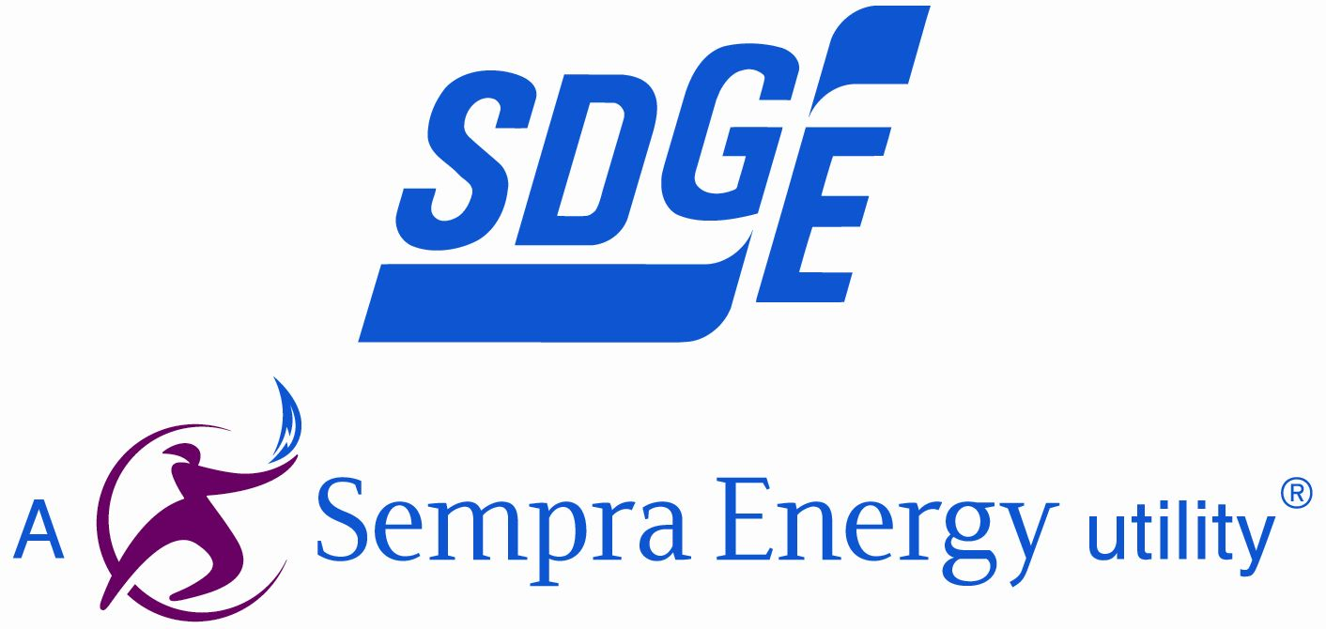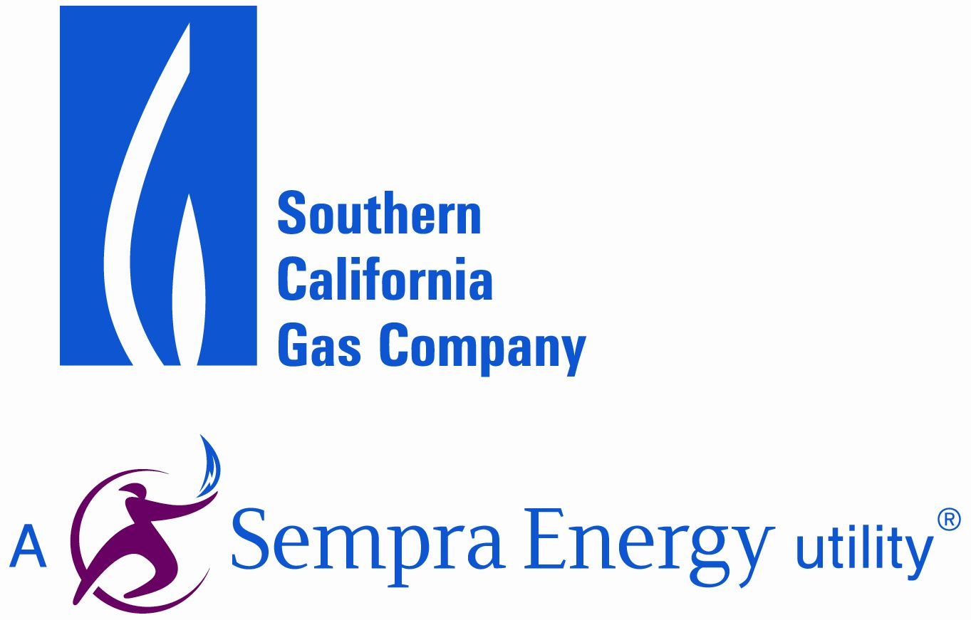

Ms. Brenda Edwards, EE–41
Office of Energy Efficiency and Renewable Energy
Energy Conservation Program for Consumer Products
U.S. Department of Energy
1000 Independence Avenue, SW.
Washington, DC 20585–0121

Docket Number: EERE–2010–BT–TP–0010
RIN: 1904–AC21

Dear Ms. Edwards:

This letter comprises the comments of the Pacific Gas and Electric Company (PG&E), Southern California Gas Company (SCGC), San Diego Gas and Electric (SDG&E), and Southern California Edison (SCE) in response to the Department of Energy (DOE) Test Procedure Notice of Proposed Rule (NOPR) for Residential Furnace Fans.

The signatories of this letter, collectively referred to herein as the California Investor Owned Utilities (CA IOUs), represent some of the largest utility companies in the Western United States, serving over 35 million customers. As energy companies, we understand the potential of appliance efficiency standards to cut costs and reduce consumption while maintaining or increasing consumer utility of the products. We have a responsibility to our customers to advocate for standards that accurately reflect the climate and conditions of our respective service areas, so as to maximize these positive effects.

We commend DOE in its efforts to establish an accurate test procedure for residential furnace fans, and for their inclusion of stakeholder involvement in refining the proposal set forth in this NOPR. We are in agreement with many components of the proposal, however, we have a number of recommended revisions to the test procedure, which we believe will greatly improve its accuracy.

- We advise developing a hybrid test procedure that draws from AMCA 210, ASHRAE 37, and AHRI 210-240.

Based on our own review of DOE’s proposal and other industry test standards, we believe that DOE should develop its own test procedure that incorporates aspects from ASHRAE 37 (American Society of Heating, Refrigerating, and Air-Conditioning), AMCA 210 (Air Movement and Control Association), and AHRI 210-240 (Air-Conditioning, Heating, and Refrigeration Institute). We believe that adopting the test apparatus procedure from ASHRAE 37, which is appliance specific, will yield considerably more accurate results than strictly using AMCA 210, which was not expressly designed to test HVAC systems. However, we do not advocate simply adopting ASHRAE 37 in lieu of AMCA 210. Portions of AMCA 210 are needed for measuring fan power at different flow rates. It also provides the necessary test specifications for the fan and its evaluation of its efficiency. In addition to AMCA 210 and ASHRAE 37, AHRI 210-240 should be incorporated into the test procedure. AHRI 210-240 specifies a test method for performance rating of unitary air-conditioning and heat pump equipment; since heat pumps with furnace fans are within the scope of this rulemaking, aspects of this standard will be necessary to adequately measure FER and IFER for heat pump products.

Regardless of DOE’s interpretation of a hybrid test procedure taking into account these three industry standards, we strongly urge DOE to maintain the requirement that all furnace fans be tested as factory-installed in the HVAC product in which they are integrated.

- We recommend the incorporation of ASHRAE 193-2010 for measuring air leakage, which should also be incorporated into the Fan Efficiency Ratio (FER) and Integrated Fan Efficiency Ratio (IFER).

Concerning airflow restriction, results from a study by PG&E and Lawrence Berkeley National Laboratory indicate that the dominant air handler used in today’s residential market has a permanent split capacity (PSC) motor and forward inclined blade blower wheels. The housing has one opening on each side with the direct drive motor located inside the blower wheel and a rectangular discharge. This side entry means that the air flow inside the air handler cabinet is pulled through the narrow gap between the intake to the blower and the cabinet, followed by a 90 ̊turn to enter the blower wheel. Given this well documented effect, we recommend that DOE account for air leakage in the test procedure.

Air leakage is covered by the ASHRAE Standard 193-2010. DOE should use this standard to test cabinet leakage and develop a metric that captures the energy penalty incurred by leakage.

- We recommend that DOE require electrical power monitoring equipment capable of measuring up to the 30th harmonic with a sampling rate of 4 kilohertz to accurately measure active and reactive power..

The most prevalent furnace fan/motor combinations have power factor less than one. PSC motors range between 0.70 – 0.91 power factor, and ECM motors average around 0.65 power factor. This increases generation and transmission costs and reduces power quality for customers. Moreover, given the energy draw from these products, monitoring power factor and total harmonic distortion are particularly important, and if regulated in the standards rulemaking, could increase energy savings and reduce societal cost.
To accurately measure power factor and total harmonic distortion we recommend DOE require use of power meters capable of measuring up to the 30th harmonic with a 4-kilohertz sampling rate, which is what the CA IOUs use in its laboratories for testing.

- In order to increase transparency of a chosen methodology, DOE should provide analytical support in a supplemental notice of proposed rulemaking by using three-dimensional graphs for depicting power, pressure, and airflow.

We believe that an evaluation of power measurements, represented as a function of outlet static pressure and airflow will enhance DOE and stakeholder understanding of the relationship between these metrics. The problem with a surface plot is that it implies that the fan can operate anywhere on the surface, when in fact it is typically along specific curves fixed by the distinct fan set points. For standard PSC motors, this is a speed setting; for ECMs it’s a torque or airflow set point. Figures 1 and 2 below show the curves for these two types of motors on the same fan and furnace. Ultimately, we believe an analysis like this will help DOE and stakeholders to determine the adequate number of test points needed to accurately evaluate FER and IFER.

Figure 1. A Carrier 58CTA090 Furnace with Standard Fan and PSC Motor Tested at Constant Speed
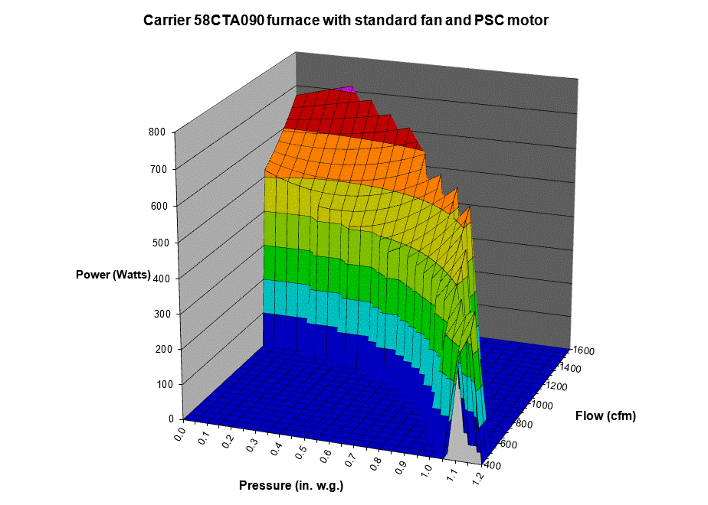
Figure 2. A Carrier 58CVA090 Furnace with Standard Fan and ECM 2 Motor Tested at Constant Torque
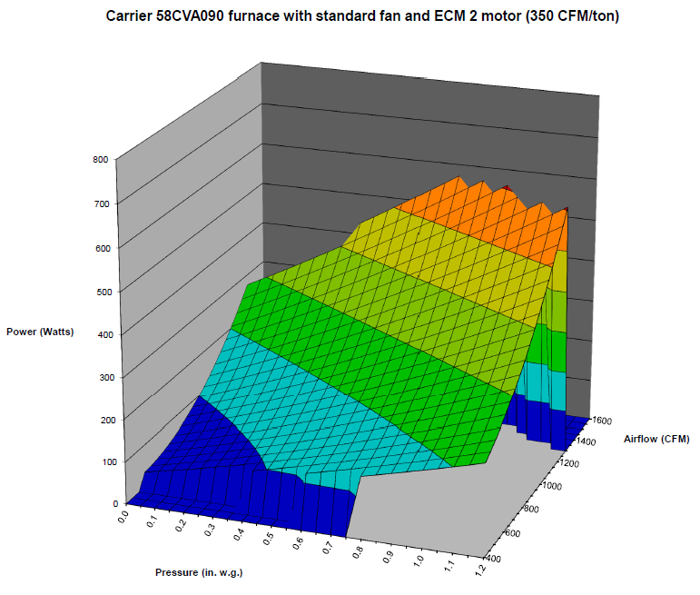

- DOE should evaluate the test airflow control settings to ensure that the growing market of variable speed fans is adequately addressed.

Test airflow control settings should reflect typical variable speed operation given that numerous variable capacity burners and compressors are making their way into the market. To increase transparency and stakeholder understanding, we advise that DOE publish this analysis in a Supplemental Notice of Proposed Rulemaking (SNOPR).

- We recommend that DOE increase the proposed test ESP.

In a recent study for the California Energy Commission, “Efficiency Characteristics and Opportunities for New California Homes,” results showed that California furnace fans in the cooling mode are working against much higher static pressures than listed in the NOPR. The average is about 0.85 IWC, as depicted in Figure 3 below.

Figure 3. Cooling Airflow Average External Static Pressure
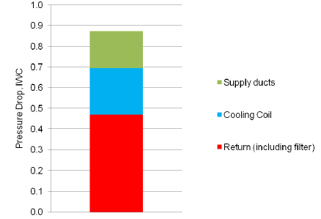

Figure 4 below, also taken from the CEC report, shows the pressure drops in the return, evaporator coil, and supply duct system arranged from least to most restrictive system. Approximately 2/3 of the systems had external static pressures above 0.80.

Figure 4. Cooling Airflow External Static Pressure by Component
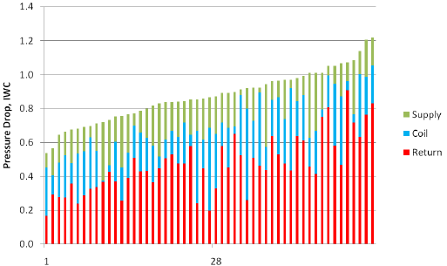

Based on this recent study, we believe the proposed values in the NOPR for units designed to be paired with an evaporatoir coil (0.65 ESP) is much lower than it ought to be. We recommend that DOE revise this proposed ESP value upward from 0.65 to at least 0.80 to reflect this study and the study referenced in Table III.3 of the NOPR, which states 0.73 as the average with coil ESP for single-family homes.

In conclusion, we would like to reiterate our support to DOE for establishing test procedures for residential furnace fans. We thank DOE for the opportunity to be involved in this process and encourage DOE to carefully consider the recommendations outlined in this letter.

Sincerely,
Rajiv Dabir  Manager, Customer Energy Solutions  Pacific Gas and Electric Company | Lance DeLaura  Southern California Gas Company
Michael Williams  Manager, Design & Engineering Services  Southern California Edison | Chip Fox  Residential Programs and Codes & Standards Manager  San Diego Gas and Electric Company

Walker, Iain and James Lutz. 2007. "Comparing Residential Furnace Blowers for Rating and Installed Performance." Lawrence Berkeley Laboratory Report, LBNL 62344. http://epb.lbl.gov/publications/pdf/lbnl-62344.pdf
Ibid.
California Energy Commission (2011). “Efficiency Characteristics and Opportunities for New California Homes (ECO).” Public Interest Energy Research Project (PIER) Program (CEC-500-2012-062). http://www.energy.ca.gov/2012publications/CEC-500-2012-062/CEC-500-2012-062.pdf
Ibid.
Ibid.
Test Procedure Notice of Proposed Rulemaking on Residential Furnace Fans. 5/15/2012. http://www.gpo.gov/fdsys/pkg/FR-2012-05-15/pdf/2012-10993.pdf

