**Condensing Furnace Standard**

**Department of Energy Residential Furnace Standards Rulemaking**

Supporters and Opponents

|  |  |  |  |
| --- | --- | --- | --- |
| PG&E Position | Key Supporters of Position | Counter Position | Key Supporters of Counter Position |
| Support DOE proposed condensing furnace standard as cost effective the nation and California. Analysis is correct. | * NEEP * ACEEE * CEC * NRDC * EEI * Earthjustice * The Consumer Federation of America * National Consumers Law Center * Massachusetts Union Of Public Housing Tenants * Texas Ratepayers' Organization to Save Energy | **DOE should withdraw rulemaking since it is not cost effective because the analysis is flawed** | * SCG * AGA * APGA * AHRI * HARDI * ACCA * NAHB |

**We Stand with our Customer by Supporting Condensing Furnace Standard**

* Tenant household protection
  + Half of households are tenants
  + More than half of new households (2010 to 2030) will be tenants
  + Landlords have no incentive to install anything but minimum efficiency units
* NOx limits, set based on health impacts, are met using condensing furnaces
* Condensing furnaces are cost effective for California ratepayers providing a competitive option to Heat Pumps into the future
* CPUC funds the Codes & Standards Program
  + Standards supported when they are cost effective
  + Cost of high efficiency appliances drop when they become the minimum allowed
  + State environmental policy implemented

**Key Issues Addressed**

* Reduced natural gas sales
  + Less than 1% of PG&E gas sales
  + Included in 2014 California Gas Report
  + CPUC decoupling police protect earnings
* Switching to electric heating
  + Like for like replacement the norm
  + Gas heat is preferred
  + Difficult under CEC and CPUC regulations
  + Costly new electrical circuit needed
* Impact on lower income households
  + Predominately rent dwelling at location determined rates
  + Heating costs reduced
  + DOE analysis did not consider tenant costs and benefits – if it had LCC would be even more positive
  + Rents are location driven - not driven by repair and replacement costs
* Difficult and expensive installations
  + Included in the LCC analysis
  + With innovation, technology, and experience installation costs drop
* Climate Zones with mild winters
  + California has 16 Climate Zones from mild to cold
  + Inefficient older homes have high gas usage
* Complex and Opaque Life Cycle Cost analysis
  + Best business decision making methodology used
  + Analytic tools publically available

**PG&E Takes a Leadership Position by Supporting DOE and CEC**

As a national leader in energy efficiency and customer care PG&E benefits from a reputation for having the vision and commitment needed to be the utility of the future. Integration of Electric Vehicles, Natural Gas Vehicles, and renewables into a low carbon grid will take the support of regulators, legislatures, investors, and customers. Support is more likely to given to a utility found to be a partner in achieving Local, State, and National energy efficiency goals. Electric Vehicles powered by the low carbon PG&E grid will increase sales while supporting societal goals. Natural Gas vehicles and power plants will provide a reduced carbon impact, increased sales and benefit society. It is with this long term perspective and a commitment to our customers that PG&E supports the DOE condensing furnace standard.

**\*\*\*\*\*\*\*\*\*\*\*\*\*\*\*\*\*\*\*\*\*\*\*\*\*\*\*\*\*\*\*\*\*\*\*\*\*\*\*\*\*\*\*\*\*\*\*\*\*\*\*\*\*\*\*\*\*\*\***

**Appendix:**

**Additional Materials**

**2014 CALIFORNIA GAS REPORT – PREPARED BY THE CALIFORNIA GAS AND ELECTRIC UTILITIES**

The California Gas Report (CGR) includes in its projections the impact of gas energy efficiency standards which, while important, are minor compared to electricity production savings. Thus the proposed furnace standard is included in the projections.

**“Residential**

Households in the PG&E service area are forecast to grow 0.8 percent annually from 2015 to 2035. However, gas use per household has been dropping in recent years due to improvements in appliance and building-shell efficiencies. … Total residential demand is expected to remain flat despite household growth due to continuing upgrades in appliance and building efficiencies, as well as warming temperatures.” (p. 38-39)

“Forecast of cumulative natural gas savings due to energy efficiency is provided in the figures below.” (p. 39)



**“GREENHOUSE GAS LEGISLATION / AB32**

During the forecast horizon covered by this CGR, there are many uncertainties that may significantly impact the future trajectory of natural gas demand. … On the one hand, more aggressive energy efficiency programs and/or increased targets for renewable electricity supplies could significantly reduce the use of natural gas by residential and commercial customers and power plants. On the other hand, increased penetration of electric and natural gas vehicles could reduce gasoline use and overall greenhouse gas (GHG) emissions, but increase consumption of natural gas.

PG&E will continue to minimize GHG emissions by aggressively pursuing both demand-side reductions and acquisition of preferred resources, which produce little or no carbon emissions.”

(p. 39)

**Extreme Impact Case: All Furnaces Condensing**

* Data from 2013 Monthly by County
* 1 Billion Therms used for heating
* All furnaces are condensing (will not occur till 2050)
* 13% heating savings
* 5% residential natural gas reduction
* 1 % reduction in PG&E Gas Volume

**History**

|  |  |  |
| --- | --- | --- |
| **Year** | **Minimum Standard** | **Key Activity** |
| 1987 | **Non-Condensing Furnace – 34 years** | March 1987: Current minimum standard of 78% Annual Fuel Utilization Efficiency (AFUE) adopted by US Congress in National Appliance Energy Conservation Act. |
| *1988 - 2009* | *No changes to DOE standard* |
| 2009 | October 2009: Manufacturers and efficiency advocates negotiated an agreement that included an update to the standard by setting three different levels by climate regions: the North, South, and Southwest. |
| 2010 |  |
| 2011 | December 2009: The American Public Gas Association filed a lawsuit objecting to the process used to adopt the standards. |
| 2012 | *No changes to DOE standard while court case is pending* |
| 2013 |
| 2014 | April 2014: U.S. Court of Appeals for the D.C. Circuit approved a settlement between DOE and the APGA - new DOE rulemaking to be completed by March 2016 |
| 2015 | March 2015: DOE released for public review analysis of the costs and benefits of condensing furnace standard  November 2015: Minimum become 80% AFUE noncondensing |
| 2016 | March 2016: Anticipated DOE Final Rule for updated standards. |
| 2017 - 2020 | *Mandatory five year period between final rule and effective date* |
| 2021 | **Condensing Furnace** | March 2021: Anticipated effective date for updated standards. This would be the first effective update to the standard level in 34 years. |
| *2021-2051* | Projected total accumulated energy savings over 30 years in U.S.:  **2.78 Quads or 28 Billion Therms**. |

**Condensing Furnaces more Competitive**

Condensing Standard makes Furnaces more competitive with Heat pumps for which standards have been steadily increasing. When a high efficiency alliance becomes the standard then costs are reduced. With condensing as the minimum furnace efficiency the high efficiency furnace will cost less than the competing high efficiency heat pump.

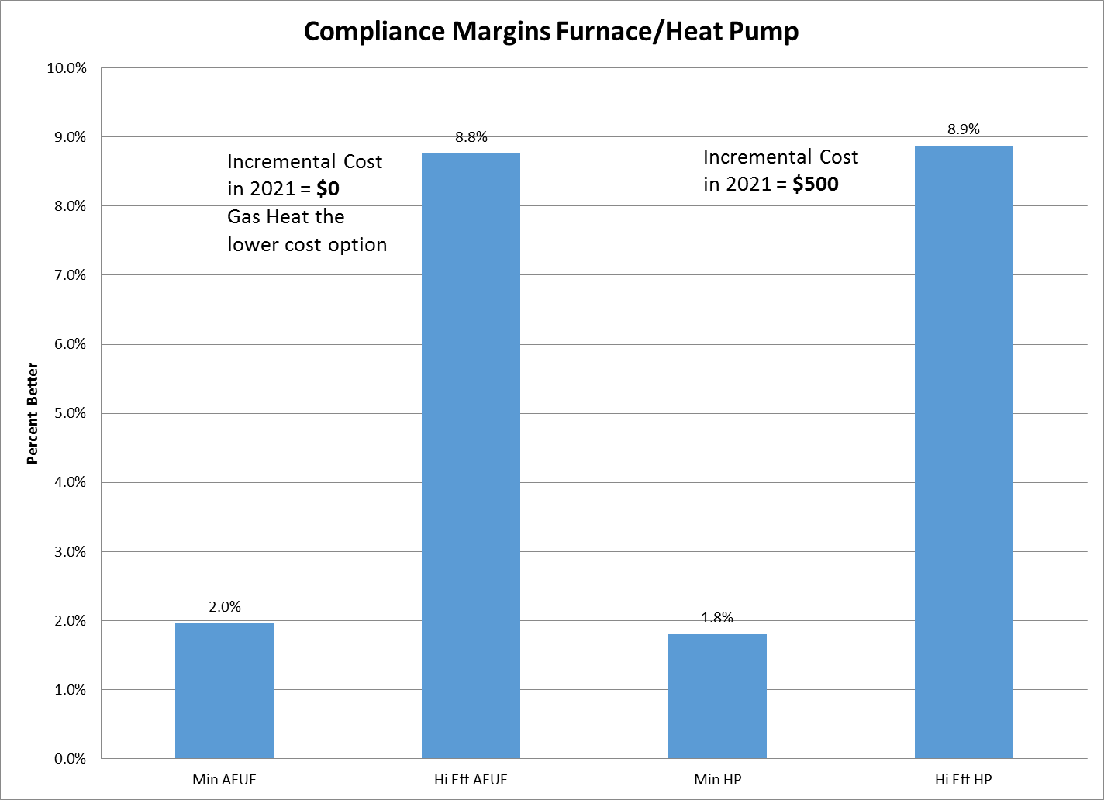

**Southern California Gas Analysis**

After several initial meeting with SCG, they decided to leave the statewide team and do their own analysis. Their consultant only considered replacement and left out new construction which DOE estimates to be 25% of the market. In new construction condensing furnaces can cost less since they use plastic air intake and flue gas exhaust piping. The SCG analysis used the Los Angeles Airport and San Diego weather stations where very little heating is needed. This choice ensured that condensing furnaces would be found to not be cost effective as would be expected. PG&E’s analysis shows that when the DOE analysis is modified, to correct a few overly conservative assumptions, the California positive LCC value increases.

It is a principle of national standards that societal impacts be assessed. Any minimum efficiency level that is selected will result in there being be winners (positive Life Cycle Cost – LCC) and losers (negative LCC). The minimum efficiency level is set to benefit the vast majority of consumers, achieve savings for the nation, while having an acceptable impact on the net present value of manufacturers. According to the DOE analysis:

The cumulative net present value (NPV) of total consumer costs and savings for the proposed NWGF and MHGF AFUE standards ranges from $3.1 billion to $16.1 billion at 7- percent and 3-percent discount rates, respectively.

SCG consultant makes an assertion that has been proven incorrect making it necessary to have minimum appliance standards stating:

"These data can support the position that the standard is not needed, because where the higher efficiencies make economic sense, they are already being adopted by consumers. Government intervention would therefore appear unnecessary."

In the DOE analysis this issue was addressed with the finding that without condensing furnaces being required their market share would remain constant into the future. In the case of every appliance standard opponents make this argument yet experience over 40 years of standards shows that consumers have benefited. Today a refrigerator uses 30% of the energy it used in the 1980s without being priced out reach of buyers. Air conditioners are twice as efficient yet are considered to be standard equipment for all new houses built anywhere but on the coast. Manufacturers have consistently responded to new standards with innovation and creativity to keep or increase their market share.