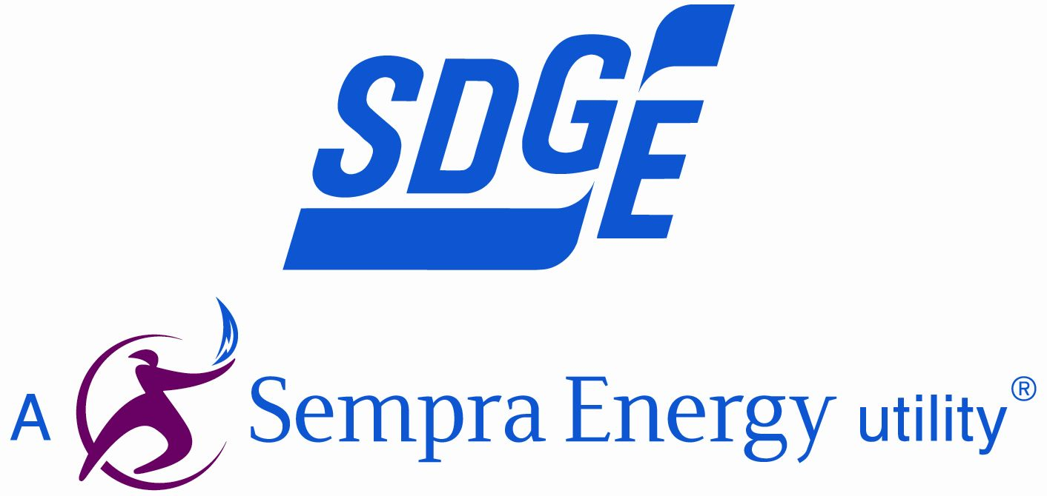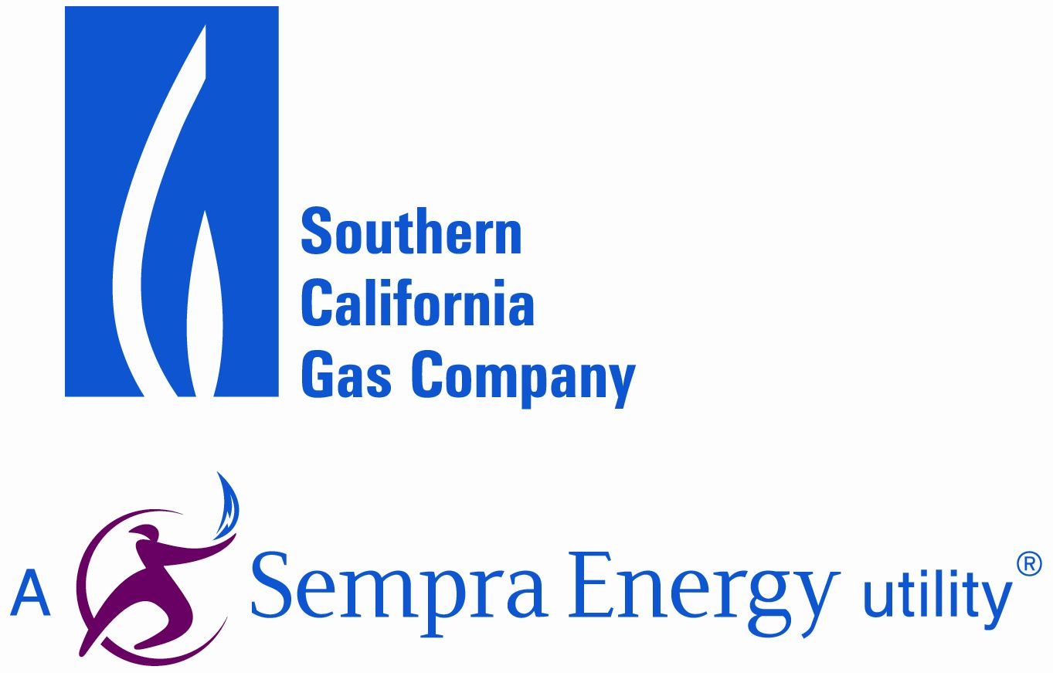

Ms. Brenda Edwards, EE–41
Office of Energy Efficiency and Renewable Energy
Energy Conservation Program for Consumer Products
U.S. Department of Energy
1000 Independence Avenue, SW.
Washington, DC 20585–0121

Docket Number: EERE–2010–BT–STD–0011
RIN: 1904–AC22

Dear Ms. Edwards:

This letter comprises the comments of the Pacific Gas and Electric Company (PG&E), Southern California Gas Company (SCGC), San Diego Gas and Electric (SDG&E), and Southern California Edison (SCE) in response to the Department of Energy (DOE) standards rulemaking Preliminary Technical Support Document (PTSD) for Residential Furnace Fans.

The signatories of this letter, collectively referred to herein as the California Investor Owned Utilities (CA IOUs), represent some of the largest utility companies in the Western United States, serving over 35 million customers. As energy companies, we understand the potential of appliance efficiency standards to cut costs and reduce consumption while maintaining or increasing consumer utility of the products. We have a responsibility to our customers to advocate for standards that accurately reflect the climate and conditions of our respective service areas, so as to maximize these positive effects.

We commend DOE in its efforts to establish performance standards for residential furnace fans, and for their inclusion of stakeholder involvement in refining the assumptions and information presented in the technical support document. We agree with many of its components; however, we have a number of recommended revisions to the PTSD, which we believe will greatly enhance realization of energy savings from the rulemaking.

- We advise DOE to consider the entire cabinet and its contents within the regulation furnace fan energy consumption; this should include the fan, motor, heat exchanger, housing on the fan, and cabinet.

In the PTSD, DOE defined a furnace fan as “consisting of a fan motor and its controls, an impeller, and a housing, all of which are components of an HVAC product that includes additional components, including the cabinet”. In order to reduce ambiguity, we think a typical furnace fan ought to be defined as, “a unit consisting of a fan motor, its controls, an impeller, shroud, and cabinet that houses all of the heat exchange material for the furnace”. The circled items in the schematic below (Figure 1) depict components of the furnace fan that affect its energy consumption and are not already regulated; these parts should be included within the scope of this rulemaking.

Figure 1. Schematic of a Furnace Fan and its Components
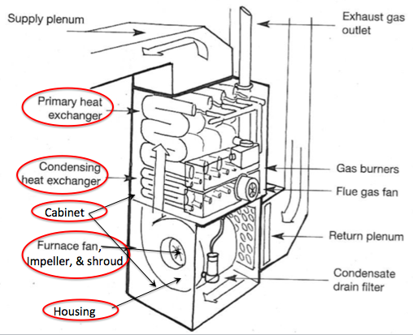

- DOE should consider including central air conditioning (CAC) and heat pumps (HP) within the scope of the rulemaking since the current test procedure under the CAC/HP rulemaking does not sufficiently capture the fan energy associated with these units. If this is not possible, DOE should include the indoor unit of split system CAC/HP products within the scope since default values are prescribed for fan energy in the test procedure for these units.

While the seasonal energy efficiency ratio (SEER) and heating seasonal performance factor (HSPF) are intended to measure energy consumption associated with CAC and HP units, respectively, we believe that the test procedure conditions for which these measurements are conducted do not adequately capture fan energy. More specifically, these units are being tested at external static pressure (ESP) 0.1 - 0.2 in w.c., which is extremely low for measuring furnace fan energy consumption. Field studies presented in the PTSD found that weighted-average ESP found that that units paired with an evaporator coil was 0.73 in w.c., which is several times higher than the values used in the SEER and HSPF test procedures.

We ask DOE to reconsider including all CAC/HP products within the scope of this rulemaking. At the very least, we strongly urge DOE to include split-system CAC/HP units for which a default value for furnace fan energy is prescribed in calculating SEER and HSPF values, which creates a potential loophole for manufacturers. To this end, the indoor units of heat pumps could also be sold as air handlers. We recommend that DOE consider “Non-Weatherized Heat Pump Air Handlers” as a 10th product class for this rulemaking.

- DOE should consider combining CAC/HP, furnaces, and furnace fan rulemakings to ensure that these standards are more complementary for these interrelated products.

We recognize that DOE must issue a final rule for furnace fans in 2013, and that standards for CAC/HP and furnaces were recently finalized in rulemakings completed in 2011. While we realize that DOE cannot combine the three products into one rulemaking during this rulemaking cycle, we strongly recommend that DOE include all three products in the next iteration of standards for these products, which should be finalized by 2019 (for furnaces and CAC/HP). Given that these products are interrelated in terms of their performance and energy consumption, we believe that the development of adequate standards and test procedures is best served by combining these three separate rulemakings (CAC/HP, furnaces, and furnace fans) into one. We believe that this will have the effect of strengthening collaboration between DOE and stakeholders, and fostering innovative thinking around the creation of standards for these units.

- Airflow path design should be considered as an efficient technology option since manufacturers have shown that this design can impact system efficiency.

We concur with manufacturers that the size of the cabinet and the geometry of the heat exchanger(s) would be the primary targets for improvements in airflow path design, which would have an effect on both thermal and electrical efficiency. While we realize that optimizing thermal and electrical efficiency simultaneously is more difficult than optimizing just one or the other, we believe that consideration of the whole unit’s performance is necessary to maximize energy savings. As such we recommend that DOE develop a methodology to account for energy differences associated with these components.

- Constant circulation mode should be included in this rulemaking since we anticipate an increase in time spent in this mode due to stricter building codes calling for more airtight building envelopes.

Constant circulation mode on the air handler is a primary means for mechanical ventilation of homes. As states increasingly adopt building codes calling for more airtight building envelopes, the need for mechanical ventilation increases as natural ventilation decreases. For instance, the 2008 California T-24 Building Energy Efficiency Standards requires all low-rise residential buildings to have a whole-building ventilation system and satisfy other requirements to achieve acceptable indoor air quality (IAQ). California adopted the requirements of ASHRAE Standards 62.2-2007, except that opening and closing windows, although permitted by ASHRAE, is not an acceptable option for providing whole-building ventilation in CA. The continuous whole-building ventilation rate is determined by the table below.

Table 1. Minimum Ventilation Rates Specified in Title 24 for residential buildings
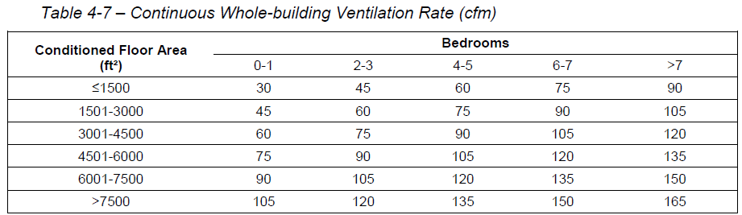

If a furnace fan is being used to provide the required mechanical ventilation, it must not consumer more than 0.58 W/CFM, which is about 60% higher than the default value used in AHRI 210/240 for rating CAC/HP (0.365 W/CFM). As such, we believe that 400 hours per year in constant circulation mode is a conservative estimate, and recommend that DOE account for this mode in the measurement of the furnace fan’s energy consumption.

- Backward-inclined impellers should not be considered as a technology option since their efficient performance only occurs over a narrow operating range, and they greatly under-perform outside this range.

While backward-inclined impellers may be more energy efficient over a narrow operating range, based on IOU testing, these energy efficiency gains are not necessarily robust since these units underperform outside this range. Additionally, their performance is highly sensitive to external static pressure, unlike forward inclined impellers. For these reasons, we recommend that backward inclined impellers not be treated as an energy efficient design option.

- To ensure that hydronic air handlers can be realistically evaluated against other furnace fan units, we recommend that DOE consider using a default value for standby mode so that these units can be evaluated using the fan efficiency rating (FER) instead of the integrated fan efficiency rating (IFER).

While we are highly supportive of accounting for standby and off-mode power consumption of hydronic air-handlers, we are concerned that the IFER rating inhibits consumers’ ability to make an apples-to-apples comparison with other furnace fans. We are concerned that consumers may mistakenly assume that furnace fans have lower overall energy consumption than hydronic air-handlers by incorrectly comparing FER and IFER values. In order to reduce confusion associated with having two values, help consumers make meaningful comparisons of these units, and to adequately address standby and off-mode power of hydronic air-handlers, we recommend that DOE (1) establish a separate maximum energy consumption levels for the off-mode and standby modes, applicable to hydronic air-handlers, and (2) then use FER for hydronic air handlers.

In conclusion, we would like to reiterate our support to DOE for establishing performance standards for residential furnace fans. We thank DOE for the opportunity to be involved in this process and encourage DOE to carefully consider the recommendations outlined in this letter.

Sincerely,
Rajiv Dabir  Manager, Customer Energy Solutions  Pacific Gas and Electric Company | Lance DeLaura  Southern California Gas Company
Michael Williams  Manager, Design & Engineering Services  Southern California Edison | Chip Fox  Residential Programs and Codes & Standards Manager  San Diego Gas and Electric Company

Preliminary TSD, page 1-1. http://www1.eere.energy.gov/buildings/appliance_standards/pdfs/ff_prelim_ch_01_introduction_2012_06_27.pdf
ACEEE Consumer Guide
Code of Federal Regulations, Chapter 10, Part 430, Subpart B, Appendix M
Preliminary TSD, page 7-5.
Section 4.6.0 from CEC-400-2008-016-CMF
Section 4.6.3 from CEC-400-2008-016-CMF

