DOE PUBLIC MEETING MEMO: Residential Furnace Fans Energy Conservation Standards (NOPR)
  - Department of Energy Public Meeting – December 3, 2013, 9:00 a.m. to 4 p.m.
  - U.S. Department of Energy, Forrestal Building Room 8E-089
  - 1000 Independence Avenue, SW., Washington, DC 20585
  - Prepared for Marshall Hunt, by Energy Solutions
Milestone | Date
NOPR | 10/15/2013
Public Meeting | 12/3/2013
Comment Deadline | 12/24/2013
Final Rule | End of 2013
Effective Date | 1/1/2019

KEY LINKS:
- NOPR: http://www.regulations.gov/#!documentDetail;D=EERE-2010-BT-STD-0011-0067
- TSD: http://www.regulations.gov/#!documentDetail;D=EERE-2010-BT-STD-0011-0068
- Test Procedure: http://www.regulations.gov/#!documentDetail;D=EERE-2010-BT-TP-0010-0029

CONTENTS IN THIS MEMO:
- Key Talking Points for CA IOUs
- Detailed Evidence to support key talking points
- Overview of Rulemaking (notable DOE decisions to date)
  - Product Classes in Scope
  - Review of Fan Energy Rating metric & calculation (FER)

- KEY TALKING POINTS FOR CA IOUs
  - We are supportive of DOE’s proposed Standard level of TSL 4 (constant torque BPM + multi-staging) on the grounds that:
    - Net benefits to the consumer outweigh net costs under the Life Cycle Analysis that DOE conducted (in reference to Table 8.4.9 – also provided later in this document). TSL 4 has the lowest Life Cycle Costs of all of the TSL levels (Table 8.4.9)
    - The payback period for consumers associated with TSL 4 is 3.5 years, which is only just slightly longer than TSLs (1-3) (Table 8.4.9). We recognize that the payback period for TSL 5, 12.8 years is unreasonably long.
    - Cumulative quad savings under TSL 4 is almost twice as high as savings under TSL 2 or 3 (Table V.19 – also provided in this document).
    - BPM motors are fairly common and manufacturers should not have trouble increasing the market share of these products with the new standards 5 years from the publication of the final rule
  - We urge DOE to include measurement of and standards for True Power Factor because:
    - Low power factor has a direct effect on both the quality of power and the efficiency of transmission and distribution, which adds operating cost to maintaining a reliable system. Added up, these costs can be significant, and therefore should be accounted for.
    - Power factor also becomes more an issue in Brushless Permanent Magnet motors
  - We previously commented on the following issues, and DOE did not take our recommendation. We may wish to comment on these again:
    - Inclusion of Hydronic Air Handlers and establish separate metric for their standby mode so that they may be evaluated against other furnace fans using the FER (low market share, so not a huge loss if they don’t include it)
    - In the Test Procedure SNOPR stage in May 2013, we recommended that DOE require manufacturers to report Fan Energy Rating values for heating, cooling, and constant circulation modes to avoid incentivizing manufacturers to design products that over perform or under perform in certain modes
      - In addition, requiring report of FER in all operating modes will increase the transparency of product performance to allow consumers to make informed purchasing decisions based expected performance on their climate zone.
      - We would like some clarification on the Q_{Max} and FER calculations.

- SUPPORTING EVIDENCE FOR POINTS A & B
  - We are supportive of DOE’s proposed Standard level of TSL 4 (constant torque BPM + multi-staging).
TSL 4 is based on the use of constant torque BPM + multi-stage
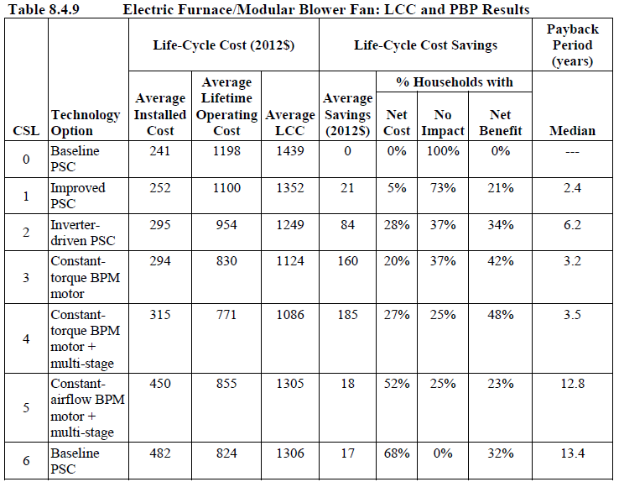
Smallest Life Cycle Cost
Benefits outweigh cost
Reasonable simple payback

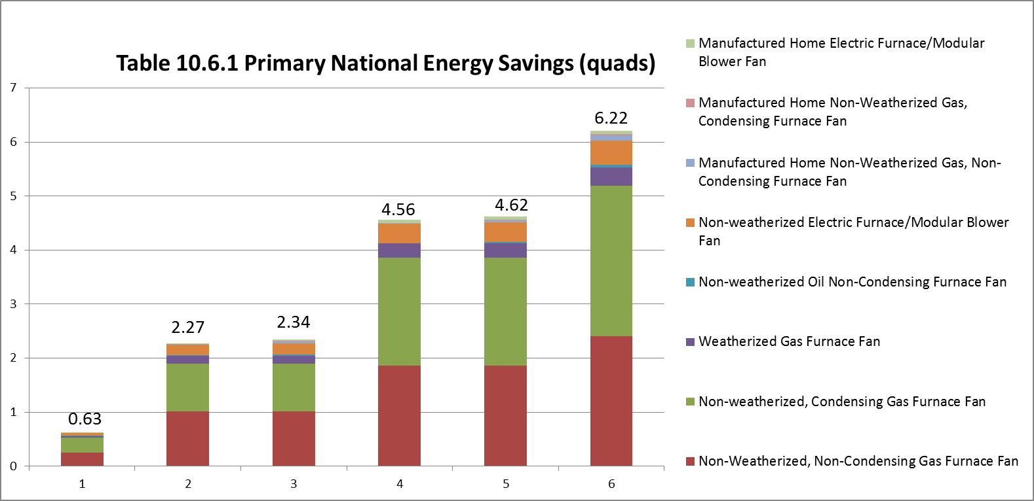
Quad savings almost double between TSL 2/3 to TSL 4

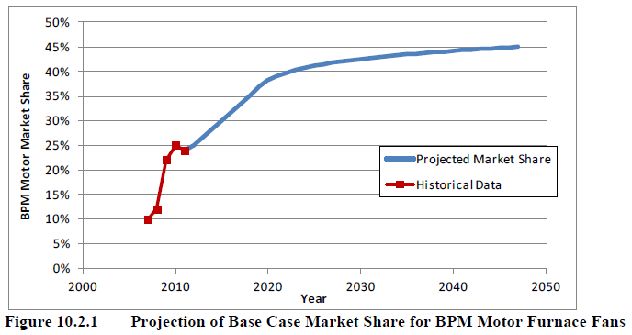
Supply is less likely to be a constraint given that upwards of 35% of the market will likely be using BPMs in the base case

  - We urge DOE to include measurement of and standards for True Power Factor because:
    - Marshall, we don’t have good stats on Power Factor for BPMs. I’m happy to help track down. Would any of the PG&E labs have this?

- OVERVIEW OF RULEMAKING (NOTABLE DOE DECISIONS TO DATE)
- DOE is only proposing to address those circulation fans that are used in furnaces and modular blowers
- DOE determined that hydronic air handlers are not in the scope of this rulemaking (we advocated that DOE include hydronic air handlers previously)
  - Product Classes included:
    - Non-weatherized, non-condensing gas furnace fan (NWG-NC)
    - Non-weatherized, condensing gas furnace fan (NWG-C)
    - Weatherized non-condensing gas furnace fan (WG-NC)
    - Non-weatherized, non-condensing oil furnace fan (NWO-NC)
    - Non-weatherized electric furnace / modular blower fan (NWEF/NWMB)
    - Manufactured home non-weatherized, non-condensing gas furnace fan (MH-NWG-NC)
    - Manufactured home non-weatherized, condensing gas furnace fan (MH-NWG-C)
    - Manufactured home electric furnace / modular blower fan (MH-EF/MB)
    - Manufactured home weatherized gas furnace fan (MH-WG)
    - Manufactured home non-weatherized oil furnace fan (MH-NWO)
- Screened-out technologies: housing design modifications and airflow path design (we advocated that airflow path design be included previously)
  - DOE claims these are captured in the FER metric and thus did not consider them as explicit design options
  - DOE claims to have little quantitative data correlating specific housing design modifications with efficiency improvements
  - Design Considerations Considered:
    - 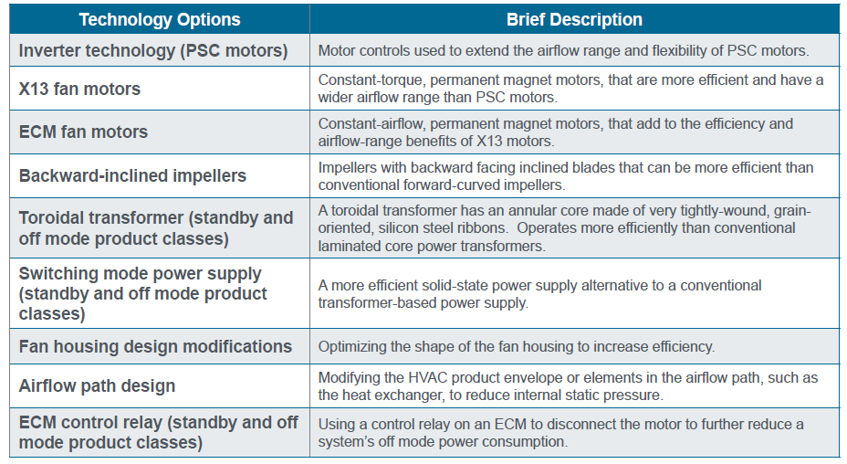
- FER (Fan Energy Rating) incorporates operation mode and hours assumptions to represent national furnace fan motor use at a maximum airflow setting (calculated as Q_{Max}, associated with the heating mode, using the equation in f. below). Estimated annual electrical energy consumption is a weighted average of the furnace fan electrical input power measured separately for multiple airflow-control settings at different external static pressures
Installation Type | Weighted average ESP (in. w.c.)
Units with an internal evaporator coil | 0.5
Units designed to be paired with an evaporator coil | 0.65
Units installed in manufactured homes | 0.3

  - DOE proposes to weight measurements using designated annual operating hours for each function that are intended to represent average operation:
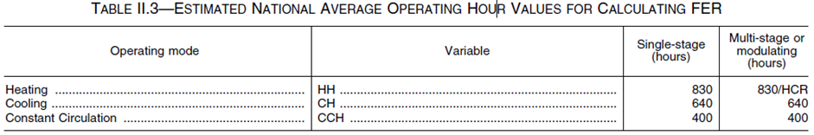
  - The test procedure specifies the Q_{Max} calculation; manufacturers cannot select an airflow-control setting of their choice when testing their products
  - FER and Q_{max} are calculated using the following equations:

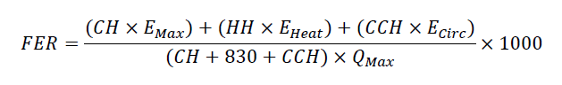
    - CH = annual furnace fan cooling operating hours
    - E_{max} = furnace fan electrical consumption at maximum airflow-control (cooling) setting operating point
    - HH = annual furnace fan heating operating hours
    - E_{heat} = furnace fan electrical consumption at default heating airflow-control setting (single stage) and low-heating airflow control setting (multi-stage heating)
    - CHH = annual furnace fan constant circulation hours
    - E_{circ} = furnace fan electrical consumption at default constant-circulation airflow-control setting
    - Q_{max} = airflow at maximum airflow-control setting operating point
    - 1000 = constant to put metric in terms of watts/1000cfm (consistent with industry standard)

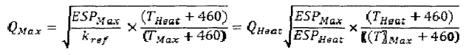
    - ESP_{Max} = external static pressure measured at operating point in maximum airflow-control setting
    - ESP_{Heat} = external static pressure measured at the operating point in the heating airflow-control setting
    - T_{Heat} = Outlet air temperature in the heating airflow-control setting
    - T_{Max} = Outlet air temperature in the maximum airflow-control setting

- With regard to the rebound effect for high efficiency motors, DOE does not adjust operating costs in the NIA because they assume the value gained by the incremental increase in operating hours is equivalent to the economic value (i.e. enhanced comfort associated with use of constant circulation) gained by consumers who choose increase the operating hours.
  - While rebound effect does not affect the economic evaluation of the standards, it does have an impact on savings. The factors in table 10.3.3. are applied as reductions to savings.
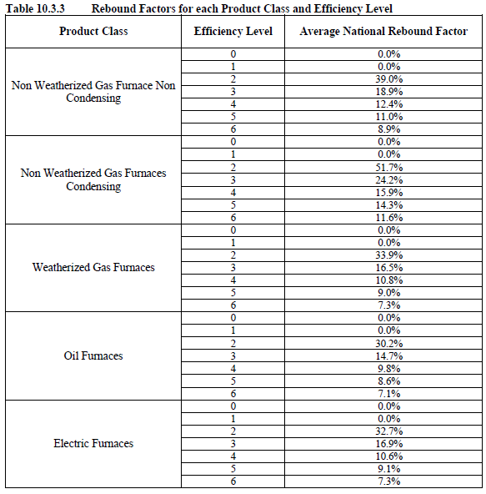
Rebound Effect for TSL 4 is much lower than TSLs 1-3. We could push for lower, but don’t have data/grounds to stand on that point.

