**DOE Test Procedure NOPR**

**Test Procedures for Residential Furnace Fans**

**NOPR:** <http://www.gpo.gov/fdsys/pkg/FR-2012-05-15/pdf/2012-10993.pdf>

**Comments to improve Test Procedure:**

1. **Cabinet effects such as airflow restriction and air leakage should be accounted for in the energy consumption of residential forced air system blower fans. DOE should consider employing the following test methodology to generate a energy efficiency coefficient(s) that is applied to the Furnace Fan Efficiency metric to appropriately deduce its value.**

For the purposes of this procedure the word furnace is broadly defined as:

These include products that use electricity for the purposes of circulating air through duct work, hereinafter referred to as ‘‘residential furnace fans’’ or simply ‘‘furnace fans,’’ the subject of today’s notice. (42 U.S.C.6295(f)(4)(D)).

With this in mind DOE should make sure that the test procedure comprehensive. Concern airflow restriction the results from a study by PG&E and Lawrence Berkeley National Laboratory findsthat the dominant air handler used in today’s residential market is a permanent split capacity (PSC) motor with forward inclined blade blower wheels (Lutz & Walker 2005). The housing has one opening on each side with the direct drive motor located inside the blower wheel and a rectangular discharge. This side entry means that the air flow pattern inside the air handler cabinet is pulled through the narrow gap between the intake to the blower and the cabinet followed by a 90 turn to enter the blower wheel. Given this well documented effect, we believe this should be accounted for in the test procedure (Lutz & Walker 2005).

Air leakage is covered by the ASHRAE Standard 193-P, November 6, 2009. DOE should use this standard to test cabinet leakage and develop a metric that captures the energy penalty incurred by leakage. Of concern must be the location of the furnace/heat pump cabinet which can vary from being a basement, interior, garage, or attic.

1. **We recommend that true power factor and harmonic distortion be measured and evaluated in the test procedure and that DOE set a minimum standard for each.**

The most prevalent furnace fan/motor combinations have power factor less than one. PSC motors range between 0.7 – 0.91 for power factor, and ECM motors average around 0.65 for power factor. This increases generation and transmission costs and reduces power quality for customers. Moreover, given the energy draw from these products, monitoring power factor and total harmonic distortion are particularly important, and if regulated in the standards rulemaking, could increase energy savings and reduce societal cost.

1. **In order to increase the transparency of a chosen methodology, we urge DOE to provide analytical support to show whatever methodology is chosen reflects laboratory measurements within 5 %.**

**We recommend that DOE use three-dimensionsal (3D) graphs to more accurately inform the test procedure methodology and to enhance stakeholder understanding. Examples are shown below**

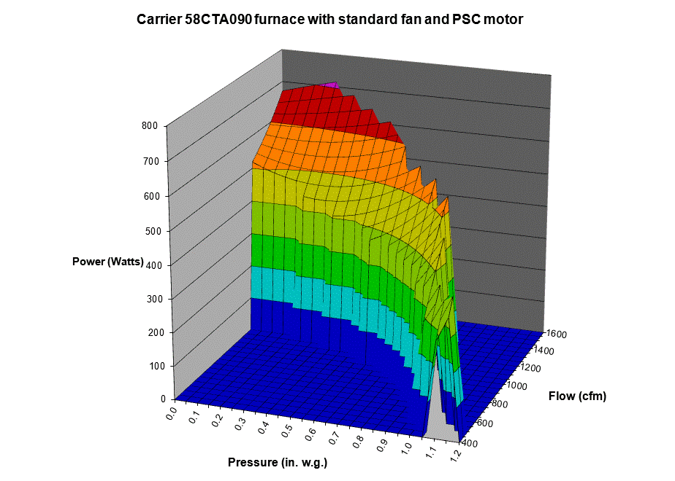

1. **DOE should evaluate whether the airflow control settings adequately address a growing market for variable speed fans that work with the numberous variable capacity burners and compressors appearing in the marketplace.**

1. **We recommend that DOE increase the proposed external static pressure (ESP) values so that consumers’ expectations of a product’s performance are more aligned with how these products perform in the field.**

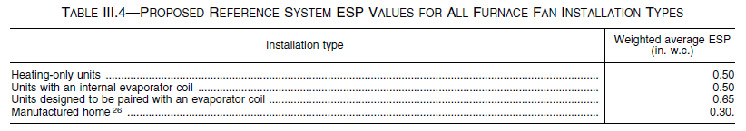

In a recent study for the California Energy Commission (Proctor Engineering Group Ltd., 2011) produced the results shown in the “Figure 13” inserted below. The details of the tests that are used to produce the averages are displayed in “Figure 14”.





From this work it is clear that in California furnace fans in the cooling mode are working against much higher pressures that listed in the NOPR. The average is about 0.85 IWC.