California Energy Efficiency Coordinating Committee-Hosted Meeting for
Composition, Diversity, Equity & Inclusion Working Group (CDEI WG)
Summary of 3rd Meeting
February 23, 2022 1:00-4:00
See Supporting Documents on Meeting Page
Facilitator: Katie Abrams, SESC

On February 23, 2022, the CAEECC hosted its third meeting for the Composition, Diversity, Equity & Inclusion Working Group (CDEI WG). The meeting was held via Zoom. 21 representatives attended from 14 WG Member organizations (including Leads, Alternates and Ex Officio). A full list of meeting attendees is provided in Appendix A.

The meeting summary focuses on high-level agreements, issues/areas of divergence, and next steps. In discussion bullets, indented and italicized text represents responses to questions/comments.

The presentation used throughout the meeting is available on the CAEECC meeting page (see link above to Meeting Materials, CDEI WG 3rd Mtg Slides (2.21.2022), under “Meeting Materials”).

Housekeeping & Homework Summary
Facilitator Katie Abrams welcomed new Working Group (WG) Member Genaro Bugarin, replacing Melanie Peck as the lead representative for The Energy Coalition.

Abrams provided general reminders, zoom etiquette, and meeting norms. WG Members confirmed they’re on board with the meeting norms and groundrules.

She noted that based on the homework survey, the fifth and final WG meeting will be held Friday 3/18 from 10-12pm. There won’t be time between the four and fifth meetings (only 3 days apart) to do work between meetings, but rather, the 5th meeting will provide spaciousness to ensure the WG covers all remaining topics before finalizing its priority recommendations and signing off on the final report. Katie walked through a timeline and strategy moving forward to generate a report out of recommendations made today (see slides for details).

WG Member Discussion (verbal and chat)
- Assuming "best intentions" do not equate to centering Justice and Equity in reality.
- Request for clarity on the expectation for recommendations, the quantity, and the report framework.
- Katie clarified that the reports can vary in length based on recommendation quantity and consensus.
- Request for a brief example from an alternative opinion(s) where there was no consensus
  - Example here: https://www.caeecc.org/equity-metrics-working-group-meeting and then click on "EMWG Final Report (10.20.21)" - it'll download the doc and you can look on p.12-13 for the example. In this example, NRDC and PAO wrote option 2 together as they didn't agree with the main proposal.

She presented key take-aways from the homework and walked through the process for evaluating and categorizing the homework, available at the slides linked above.

Competency Building
Mabell Garcia Paine (Viridis Consulting) and Dany Kahumoku (ICF) presented the draft recommendations they developed as volunteers leading the mini team on Competency Building, and noted Alison LaBonte (CPUC) has served in a volunteer advisory capacity. The slides are available on the meeting page.
- Dany clarified that the mini group members volunteered to do this work
- Three areas of impact: application phase, orientation, and during CAEECC membership
- Mini grouped asked for feedback on prioritization of recommendations and language of recommendations.

Summary of WG Member questions and feedback:
- Consider the distinction of commitment and DEI training vs Racial Justice training
- Consider leveraging existing courses (including those from the Workforce Education & Training programs)
- Suggestion to think wholistically about EE policy handouts, training, and courses
- Possible recommendation to identify the need and employ a team to figure out the how
- Dialogue on whether there still needs to be a concurrent requirement, subsequent to the crash course, to demonstrate some level of EE competency? Will there be some sort of grounding for EE competency? Suggestion to elevate environmental Justice expertise and those experts from frontline communities and CBOs to have power and decision-making shared with them.
- New possible rec: Primer on the power/influence and agenda/historic positions of various stakeholder/entity types represented in CAEECC

Katie summarized proposed next steps as follows: prioritization survey due in a few days; mini team develops proposals and submit by Monday 3/7; Katie to circulate mini team proposals a week in advance of next meeting; mini team to present proposal at 4th meeting. No one objected to these proposed next steps.

Elizabeth Lowe, Kelsey Jones, and Alice Sung volunteered to join the mini team.

Restructuring Caeecc
Breakout Summaries:
Participants self-assigned themselves to one of three breakout groups: 1) Accountability & Reporting, 2) Composition, 3) Application Process. Each breakout group prioritized/reranked the ideas in the Recommendations Ideas google doc available here. They then discussed and refined recommendations for their priority ideas.

In full plenary, each of the 3 breakout facilitators (Suhaila Sikand, Lara Ettenson, and Katie Abrams) summarized key take aways from breakout discussion as follows:
- Accountability & Reporting
  - Discussed how to develop a framework for DEI as well as using DEI vs DEIJ/JEDI
- Composition
  - Discussed internal processes, assigned seats and definition parameters
- Application Process
  - Discussed new priority #1

The top priority recommendations can be found on the google docs linked here: https://docs.google.com/document/d/1nl0h5JOecfvJZ735ll6k409HHhUlvCTQBkzV7dzH5Kk/edit?usp=sharing

Alice Sung, Bernie Kotlier, Yeshi Lemma, Lara Ettenson volunteered to refine and draft recommendations.

Katie summarized next steps as parallel to the Competency Building mini team (although instead of a prioritization survey, the mini team would use the google docs feedback). WG Members have until 3/7 to add additional comments on Restructuring CAEECC recommendations to the google docs linked above.

Compensation
Fabi Lao (CSE) and Jim Dodenhoff (Silent Running) presented the status report they developed as volunteers leading the mini team on Compensation, and noted Nicole Cropper (CPUC) has served in a volunteer advisory capacity. Their presentation (Word doc titled “Compensation – Draft Recommendations Status Report” is available on the meeting page. Attribution has been included where it seems important for followup (for example, in possible non-consensus topics).

Summary of WG Member questions and feedback:
- Could the energy efficiency budget allow funding of the CAEECC in any new composition? For example, pay for the compensation of community-based organizations and energy justice & Equity consultants and subject matter expertise that met new eligibility in a contract?
  - One recommendation could be to expand the budget for this purpose (not sure on feasibility or legality)
- As background, this is the main CAEECC decision, although task and responsibilities are often added to CAEECC with new decisions.
- Belief that compensation is a prerequisite for most recommendations.
- Discussion of funding from legislation vs ratepayer dollars vs foundation funding
  - Bernie suggested legislation to fund diversity in an organization that’s advising a state agency; didn’t feel private funding was appropriate
    - Legislation brings uncertainty and is largely outside of CAEECC’s control; could also bring up legal questions (e.g., CAEECC may not be able to lobby for such legislation since it may not be appropriate to use ratepayer funds to lobby staff)
  - Annette suggested considering ratepayer funding (ie through the upcoming EE Proceeding). Illinois uses ratepayer funds to support CBOs in a similar advisory group.
    - Nicole: CPUC is receiving complaints of increased bills, which is a consideration for requesting additional ratepayer funds. Most of the increased rates are due to infrastructure upgrades and wildfire mitigation, so it's important to highlight that reallocating funds could come from other buckets that are not safety related.
- Mini team requested examples of organizations wanting to join CAEECC but for which compensation is a hurdle
  - CEJA, TURN, and Rising Sun both said multiple times it's a capacity issue
  - foundation funding in Illinois wasn’t as stable as proceeding/ratepayer funds
- If compensation is provided, it’s essential to ensure diverse representation and inclusion of members. If not, will exacerbate inequities amongst organizations
- Suggestion to leverage funding from Justice40 campaign
- Shift funds from what harms EJ communities to directly resourcing them to provide their expertise in the solutions.

Katie noted there appears to be a non-consensus issue on whether or not foundation funding and/or pursuing funding through legislation is appropriate.

Katie summarized next steps are parallel to Competency Building.

Recruitment & Retention
Nicole Cropper (CPUC) was the only participant to volunteer for this mini group, and she noted the importance of WG Member representation. After the meeting, Annette Beital volunteered to join this mini team.

Mini team next steps are parallel to Competency Building.

Facilitation:
Nils Strindberg (CPUC) was the only participant to volunteer for this mini group; he and Alison LaBonte noted the importance of WG Member representation.

Katie summarized that the CPUC, as a recipient/decision maker of this WG’s recommendations, cannot be the primary and only volunteer to prioritize and flesh out Facilitation recommendations. Thus, unless anyone volunteers for this mini team, its section in the final report will be limited to the list based on the WG’s brainstorming thus far, prioritized by the forthcoming survey.

Review Draft of Final Report Outline
Katie presented the draft outline for the final report, which was posted to the meeting page 5 days before the meeting for Members to review; Members can redline additional suggested changes by COB Friday 2/25.

Wrap-Up and Next Steps
Katie presented proposal that outreach plan to engage additional voices pivot to being included in the Final Report as a recommendation to engage these dozen or so types of organizations in the course of implementing DEI recommendations. Members agreed with this suggestion.

Katie reminded WG Members of the meeting goals.

Katie requested feedback on the meeting, noting they can email her, Lara, or Fabi; or fill out the anonymous feedback survey.

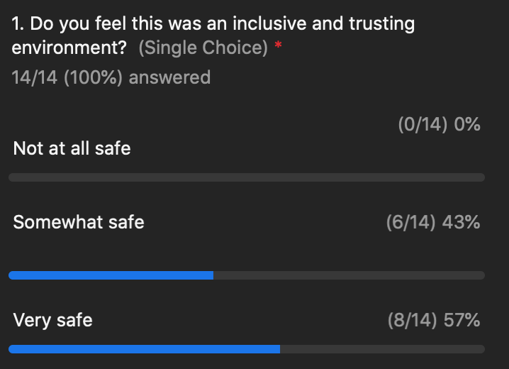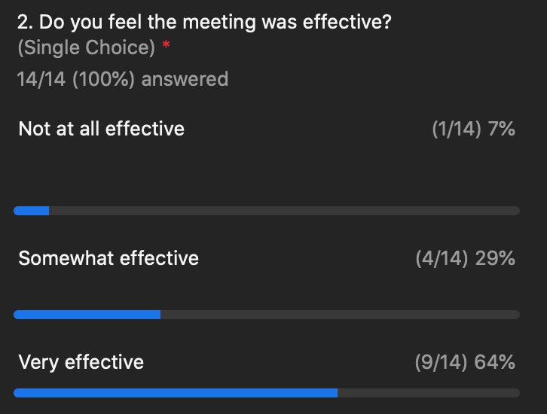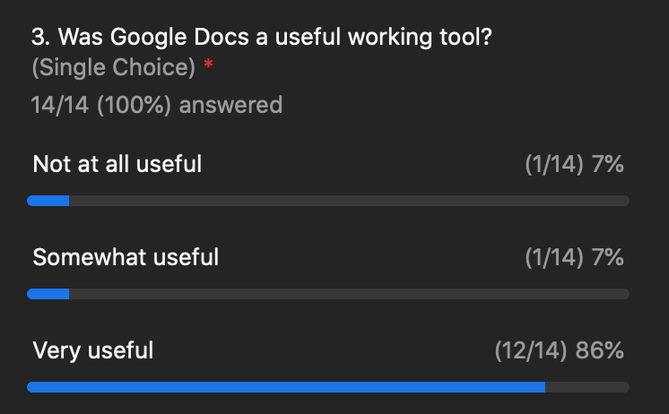

Facilitation Team
- Meeting Summary: draft, post, notice by 3/2 COB
- Report: circulate draft final report and mini team proposals by COB Wednesday 3/9

Meeting Participants
- Meeting Summary: Review draft meeting summary, and provide redlines edits - by 3/14 COB
- Recommendation prioritization survey: due COB Fri 2/25
- Consider volunteering for a mini team (especially for Facilitation)
- Report outline: send Katie proposed changes (in redline) by COB Fri 2/25
- Restructuring CAEECC: optionally, add comments to google docs by COB Tue 3/1

Appendix A: Attendance

Attendance for Feb 23, 2022 CDEI Working Group Meeting #3
Working Group Member Representatives & Alternates
Organization | First | Last
CEE | Bernie | Kotlier
CSE | Fabi | Lao
Don Arambula Consulting | Don | Arambula
Don Arambula Consulting (alternate) | Elizabeth | Lowe
Energy Efficiency Council | Allan | Rago
Energy Efficiency Council (alternate) | Ron | Garcia
Future Energy Enterprises (alternate) | Annette | Beitel
Greenbank Associates | Alice | Sung
ICF | Dany | Kahumoku
NRDC | Lara | Ettenson
SCE | Patty | Neri
SEI (Strategic Energy Innovations) | Stephanie | Doi
Silent Running LLC | James | Dodenhoff
SJVCEO | Kelsey | Jones
The Energy Coalition | Genaro | Bugarin
Viridis Consulting, LLC | Mabell | Garcia Paine
Ex-Officio
CPUC | Nicole | Cropper
CPUC | Peter | Franzese
CPUC | Alison | LaBonte
CPUC | Yeshi | Lemma
CPUC | Nils | Strindberg
Public
Tre’laine Associates | Pepper | Hunziker

