Central Coast Leaders in Energy Action Program (CC-LEAP)

Implementation Plan
Revised Draft
August 6, 2020

Table of Contents

Table of Contents 1
Program Budget and Savings 2
Program and/or Sub-Program Name 2
Program / Sub-Program ID number 2
Program / Sub-Program Budget Table 2
Program / Sub-Program Gross Impacts Table 2
Program / Sub-Program Cost Effectiveness (TRC) 2
Program / Sub-Program Cost Effectiveness (PAC) 2
Type of Program / Sub-Program Implementer 2
Market Sector(s) 2
Program / Sub-Program Type 3
Market Channel(s) and Intervention Strategies 3
Implementation Plan Narrative 3
Program Description 3
Program Delivery and Customer Services 4
Program Design and Best Practices 6
Innovation 8
Metrics 9
For Programs Claiming To‐Code Savings 9
Pilots 10
Workforce Education and Training 10
Workforce Standards 10
Disadvantaged Worker Plan 10
Additional Information 11
Supporting Documents 11
Program Manuals and Program Rules 11
Program Theory and Logic Model 11
Process Flow Chart 11
Diagram of Program 12
Quantitative Program Targets 13
Incentive Tables, Workpapers, Software Tools 13
Evaluation, Measurement & Verification 13
Normalized Metered Energy Consumption (NMEC) 14

Program Budget and Savings

Program and/or Sub-Program Name
Central Coast Leaders in Energy Action Program (CC-LEAP)

Program / Sub-Program ID number

Program / Sub-Program Budget Table

Central Coast Leaders in Energy Action Program (CC-LEAP) | Program Cycle: 2020-2023
Administration | $32,000
Marketing & Outreach | $25,000
Direct Implementation | $691,000
Total Budget | $748,000

Program / Sub-Program Gross Impacts Table
Not applicable for this program

Program / Sub-Program Cost Effectiveness (TRC)
Not applicable for this program

Program / Sub-Program Cost Effectiveness (PAC)
Not applicable for this program

Type of Program / Sub-Program Implementer
Third Party Government Partnership

Market Sector(s)
Market/Sector Served: Public Sector

Customer Segments Served: Public agencies including city governments & townships, tribes, county governments (including unincorporated areas under county jurisdiction), K-12 school districts, water/wastewater agencies/districts, and other public agencies (not served by statewide programs)

Program / Sub-Program Type
Non-Resource

Market Channel(s) and Intervention Strategies
Downstream; Technical Assistance

Implementation Plan Narrative

Program Description
The Central Coast Leaders in Energy Action Program (CC-LEAP or Program) is a public sector non-resource Local Government Partnership (LGP) program which offers integrated energy efficiency project delivery services within the County of San Luis Obispo and parts of the County of Santa Barbara serviced by PG&E. At no cost to agencies, CC-LEAP will provide customized and objective project management, engineering, and financing support services as a “one-stop shop” enabling agencies to achieve energy upgrades at public facilities expeditiously and cost-effectively.
CC-LEAP will demonstrate how actions by a broad group of public agencies can drive more cost-effective energy solutions in the public sector. The Program aims to inspire action achieving the following three objectives:
- Expand the implementation of cost-effective energy efficiency projects.
- Make energy efficiency expertise accessible and available.
- Integrate energy efficiency as a standard business practice for public agencies.
CC-LEAP’s project delivery process will move agencies and projects from planning and identification to execution and completion in five phases (Figure 1).

Project Identification
Energy Audit
Design & Procurement
Construction
Hand-off
Figure 1. The five phases of CC-LEAP’s project delivery process
Each phase includes several steps that ensure industry best practices, agency alignment, PG&E/third party (3P) coordination, and cost-effective solutions. The Program will provide a dedicated project manager for each agency as a single point of contact for streamlined delivery of services and to ensure high customer service. As a non-resource program, CC-LEAP will work closely with all PG&E resource acquisition programs to maximize savings claimed towards PG&E’s public sector portfolio.

Program Delivery and Customer Services
CC-LEAP will target public agencies within the County of San Luis Obispo and County of Santa Barbara serviced by PG&E. The Program will channel resources through a highly coordinated model to deliver customized and comprehensive energy efficiency projects to a geographically isolated region that would otherwise be underserved.
Public agencies eligible for services include:
• City governments and townships
• Tribes
• County governments, including unincorporated areas under county jurisdiction
• K-12 school districts
• Water/wastewater agencies/districts
• Other public agencies (not served by statewide programs)
Leveraging the support of the Counties, CC-LEAP will work with existing networks and trusted local partners to ensure agencies receive program services. Following is a summary of the tasks and deliverables in each phase of the CC-LEAP integrated project delivery process. The approach is designed to be customized to meet individual agency needs and remain cost-effective while serving the objectives of the Program. The approach will also be tailored to avoid duplication of services provided by other third-party implementers.
Enrollment and Project Identification
An initial meeting to introduce CC-LEAP services will take place with the agency and any other appropriate stakeholders such as PG&E or 3P. The agency will sign a customer participation agreement form to acknowledge their enrollment in the program and confirm the agency point of contact that CC-LEAP will coordinate with to deliver services. Once enrolled, a project team made up of a CC-LEAP project manager (PM) and engineering subcontractor (engineer) is introduced to provide ongoing support to the agency with energy efficiency projects from identification to completion.
Energy analysis services will be offered to new agencies to compare agency-owned assets and identify energy-intensive infrastructure with opportunities for cost-saving energy efficiency projects. Services will include benchmarking through ENERGY STAR Portfolio Manager® (ESPM). Through ESPM, agencies will also be supported with AB 802 compliance, where applicable. To develop internal capacity and commitment to long-range planning, the Program will lead agencies through a process that helps them to understand opportunities and chart a multi-year path to implementation.
The PM will work with the agency to develop an energy services roadmap that includes a project-focused action plan. The agency can then evaluate progress to know if it has achieved its goals and create a pathway to establish energy efficiency as a standard business practice. Once potential projects are identified, the project team will determine potential energy savings, share project funding options, and ensure agency buy-in before proceeding with additional CC-LEAP resources.
Energy Audit
Once a project is identified, the agency will be asked to sign a project commitment form that communicates program services and records the agency’s commitment to pursue a viable project prior to the investment of program resources. The project scope will be confirmed during an audit kickoff meeting and CC-LEAP will coordinate with all potential stakeholders, including PG&E and 3Ps, to avoid customer confusion, program duplication, and to identify opportunities for collaboration.
The project team will then complete a detailed site visit of the agency’s facility/asset and identify a preliminary list of energy efficiency measures (EEMs) or operational and maintenance improvements. The preliminary list will include high-level energy savings, cost estimates, and estimated resource program incentive amounts. Once the agency selects measures for implementation, the engineer will complete the detailed audit calculations and will work with the PM to develop a project proposal for the agency. Findings from the audit will be input into a financial calculator. Outputs from the audit and financial calculator will then be summarized in a project proposal that outlines the EEMs, estimated energy savings, annual and lifetime cost savings, and incentive amounts. The proposal will also provide financial metrics, financing opportunities, a cash flow analysis with various funding and financing options, and a project implementation timeline.
Following project proposal review and alignment with the agency, the PM will coordinate with PG&E or other 3P stakeholders to confirm roles and responsibilities for the incentive application development and submission or 3P project installation. If applicable, the project team can develop and submit a project feasibility study (for PG&E custom incentive measures), pre-screening form, incentive application, or any on-bill financing or other funding and financing paperwork.
Design & Procurement
If applicable, the engineer will develop technical performance specifications for the final package of measures. CC-LEAP will provide customized procurement assistance to agencies depending on whether they perform the work themselves, manage their own competitive bid solicitation, or choose a simplified cooperative procurement approach (indefinite quantity construction contract). If the agency releases a bid for project construction services, CC-LEAP can provide procurement support in the form of supplementary bid package materials and sample language. If an agency chooses a cooperative purchasing approach, they will select a contractor. Then, an on-site joint scope walk will be scheduled with the contractor, engineer, agency representative, and the PM to review and agree upon the project scope. If required, the PM may also provide support to agency staff for internal project approval, such as drafting a staff report and draft resolution.
Construction
Once the agency authorizes the contractor to proceed, a construction kickoff meeting will be scheduled. The PM will review the CC-LEAP roles and responsibilities during construction, emphasize the need for communication of scope changes, and ensure proper project documentation for PG&E and 3P program requirements. The agency is the “project owner of record” and will be responsible for all construction contracts and costs and designating a construction manager. The project team can provide project management support and review contractor submissions to verify work is performed according to design specifications and PG&E/3P program requirements.
Hand-off
After project completion, the PM will work with the agency and contractor to collect the relevant documentation required to submit the appropriate Installation Report (IR) package so the agency can receive incentives and/or secure project financing. Once the IR package is approved, the PM will send a project closeout survey to the agency to provide feedback on CC-LEAP services.

Program Design and Best Practices
CC-LEAP is designed to plan, identify, and support the delivery of comprehensive energy efficiency projects in existing buildings throughout the supported region. Types of facilities and assets supported will include but are not limited to: schools, administrative buildings, community centers, pools, police stations, park lighting, water and wastewater treatment plants, and city halls. A primary measure of success will be energy savings funneled to public sector resource acquisition programs. CC-LEAP will align with PG&E downstream intervention strategies and programs and actively work to ensure other PG&E offerings such as the upstream, midstream, direct install, and PG&E third party programs are leveraged when feasible. CC-LEAP will also coordinate with key partners across the state to share best practices and continuously improve operational efficiency.
CC-LEAP offers extensive project delivery services that enable public agencies to overcome barriers to identify and seamlessly implement cost-effective energy retrofits. The following table highlights market barriers and CC-LEAP strategies to overcome them.

Public Agency Barriers | CC-LEAP Intervention Strategies
Limited staffing resources to devote to energy efficiency | CC-LEAP will provide a dedicated project manager to work with the agency from project start to finish. The project manager facilitates the coordination of various program services and navigates a breadth of resources that would otherwise require significant staff time investment.
Limited technical expertise and knowledge of energy projects and issues | CC-LEAP offers technical expertise and knowledge for public agencies through a dedicated engineering subcontractor. The subcontractors will complete audits, analyze and recommend energy efficiency measures, and support project procurement through the development of technical performance specifications.
Limited access to actionable data for informed decision making | CC-LEAP will provide pertinent energy efficiency project data and metrics tailored to enable an agency to make informed decisions throughout a project’s lifecycle.
Short term budget horizons | CC-LEAP will work with agencies to identify long range energy efficiency needs through the energy services roadmap process and will help agencies integrate upgrades into capital improvement plan (CIP) budgets. Project managers will also work with agency staff on phased project implementation strategies to work within the confines of budget cycles.
Limited access or resources to secure funding for energy efficiency projects | CC-LEAP will provide comprehensive financial analysis and access to various forms of funding. The Program will also support the preparation of financing application packages and the fulfillment of documentation requirements related to the energy efficiency measures.
Lack of resources for auditing | CC-LEAP will provide targeted no-cost audits based on agency need.
Lack of resources and limited knowledge of procurement for energy efficiency | CC-LEAP brings extensive energy efficiency expertise, procurement knowledge, and customized strategies to meet agency needs. The Program will help agencies identify appropriate procurement pathways and provide resources for agencies to pursue their preferred procurement method.
Inability to evaluate the merits of energy efficiency opportunities due to lack of resources and expertise | CC-LEAP will provide third party impartial advisory services and expertise to help agencies choose a course of action to meet their needs.
Risk aversion and hesitation to try unproven methods | CC-LEAP brings experience and will share case studies on the implementation of proven services and products. Other agencies can share their lessons learned through peer to peer learning, which helps drive agencies to take energy efficiency actions.
Lengthy decision-making timelines and requirements for transparency and stakeholder engagement | CC-LEAP will work side by side with agencies to expedite implementation, participate in and support public meetings, and make presentations, as requested, to elected officials and decision-makers at key points throughout the process.

Innovation
CC-LEAP aims to maximize savings opportunities while reducing implementation costs. Innovative program elements include start-to-finish integrated service delivery, streamlined data analytics, partnerships with private companies, and continuous improvement procedures.
Start-to-finish Integrated Service Delivery: Public agencies face unique barriers across all stages of an energy efficiency project’s lifecycle. CC-LEAP offers comprehensive, start-to-finish project support to overcome common barriers at every project phase. Additionally, CC-LEAP will seamlessly integrate and coordinate all available and applicable energy efficiency programs and services to avoid duplication and customer confusion. This integrated and cost-effective approach reduces customer touch points and enables public agencies to complete deeper and more comprehensive energy efficiency projects than would otherwise be feasible.
Streamlined Data Analytics: CC-LEAP will leverage various energy analysis tools to compare agency-owned assets, such as buildings and streetlights, to identify energy intensive infrastructure with opportunities for cost-saving energy efficiency projects. Additionally, ENERGY STAR Portfolio Manager® (ESPM) will be used for benchmarking, streamlining comprehensive data analysis, and project opportunity identification. ESPM will also be used for AB802 benchmarking compliance.
Partner with Private Companies: CC-leap will partner with engineering firms, financial partners, and energy service companies (ESCOs) to drive market share, provide the highest level of technical services, and provide a greater number of options to meet the unique requirements of individual agencies. Strategic partnerships will multiply CC-LEAP's impact and offer opportunities for innovative solutions.
Continuous Improvement Procedures: CC-LEAP will employ a continuous improvement approach to all aspects of program implementation. This approach will include evaluation and development of program strategies to control costs and ensure that the most efficient methods are deployed for implementing projects. The regular evaluation of feedback and lessons learned from program staff, subconsultants, agency participants, and stakeholders will also ensure that CC-LEAP is operating as cost effectively as possible.

Metrics
CC-LEAP will track the following key performance indicators (KPIs) and will report on these metrics to PG&E on a quarterly frequency throughout the program cycle.
Metric | Method
Supported Savings (kWh, kW, therms) | Gross first-year kWh/kW/therm savings achieved through PG&E/3P resource public sector programs that were supported by the Program.
Project Pipeline Savings (kWh, kW, therms) | Gross first-year kWh/kW/therm savings estimated during project identification and refined/updated throughout the project lifecycle.
Enrolled Agencies | Number of eligible public agencies that have submitted a signed enrollment form.
Project Proposals Presented | Number of project proposals delivered presenting audit findings including EEMs, estimated energy savings, measure costs, eligible incentives, and bill savings.
Public Sector Buildings with Current Year Benchmark | Number of public sector facilities with a current year benchmark within ENERGY STAR Portfolio Manager® (ESPM) supported by the Program.
Projects Managed | Number of energy retrofit projects supported by the Program measured by the total number of projects developed and managed by program.
Educational Opportunities | Number of educational opportunities presented to a public agency audience within the Santa Barbara and San Luis Obispo County program territory.

For Programs Claiming To‐Code Savings
This section is not applicable.

Pilots
This section is not applicable.

Workforce Education and Training
CC-LEAP will leverage and build upon PG&E’s existing Workforce, Education, and Training (WE&T) opportunities by informing public sector staff of relevant energy management strategies and standards. These may include Title 24 standards, advanced lighting controls, and Building Operator Certification. CC-LEAP will partner with 3P WE&T program implementers to expand WE&T activities and offerings in the CC-LEAP service territory.

Workforce Standards
CC-LEAP will not directly provide the installation of energy efficiency equipment. Nonetheless, the program will provide due diligence to ensure that energy efficiency projects supported by the program adhere to the Workforce Standards for Heating, Ventilation, and Air Conditioning (HVAC) and Advanced Lighting Control Programs as applicable. The program will integrate messaging and direction to public agencies during the project lifecycle to ensure projects installed comply with CPUC Workforce Standards as stipulated in D.18-10-008. These standards will be referenced and reiterated during the delivery of various program services including the following touchpoints:

- Project Proposal will highlight the importance and purpose of the standards.
- Technical specifications will include language that program participants will reference prior to project installation.
- Procurement Kickoff meeting will include an agenda item to highlight the significance of the standards and requirements for agencies to submit applicable documentation and confirm adherence to the guidelines at project closeout.

To demonstrate due diligence, CC-LEAP may request program participants share applicable documentation to demonstrate adherence to the Workforce Standards which may include any certifications, apprenticeship programs, accredited degrees, or other workforce training programs.

Disadvantaged Worker Plan
CC-LEAP will not directly support access to career opportunities in the energy efficiency industry. In order to provide disadvantaged workers with improved access to career opportunities, CC-LEAP will leverage other programs that support disadvantaged workers and promote those resources to participating public agencies.

Additional Information
No additional information is required.

Supporting Documents

Program Manuals and Program Rules
Please see attachment: Central Coast Leaders in Energy Action Program (CC-LEAP) Program Policies and Procedures Manual.

Program Theory and Logic Model
The Program Theory and Logic Model below provides a visual depiction of the underlying CC-LEAP theory and approach.

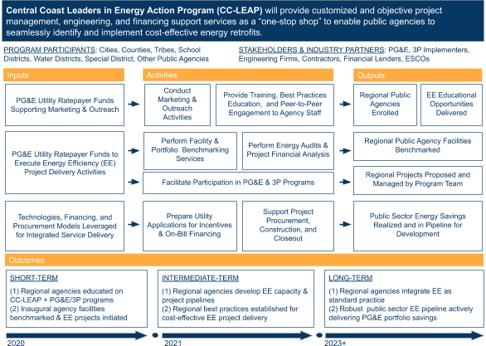

Process Flow Chart
The process flow chart below visualizes the components of program participant entry through project closeout, where energy efficiency savings will be realized.

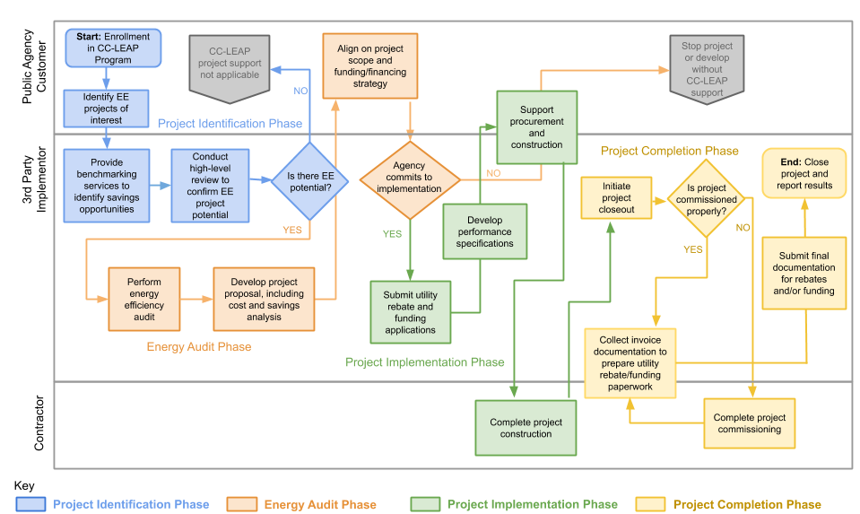

Diagram of Program
The diagram below demonstrates the CC-LEAP implementation structure, integration of third party resource program coordination, and influences by strategic partners on participant and program outcomes.

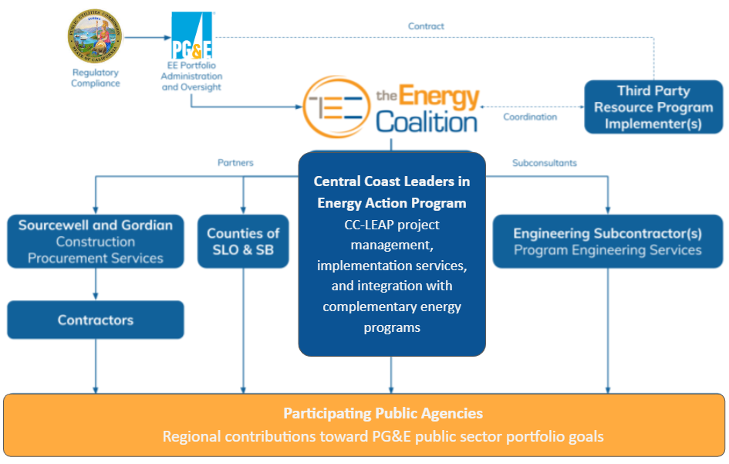

Quantitative Program Targets
The following table provides a high-level overview of quantitative annual targets over the three year program cycle.

Metric | Year 1  July 2020 –  June 2021 | Year 2  July 2021 –  June 2022 | Year 3  July 2022 –  June 2023 | Cumulative  Targets
Supported Savings | 50,000 kWh  3 kW  0 therms | 2,000,000 kWh  150 kW  7,500 therms | 3,000,000 kWh  230 kW  10,000 therms | 5,050,000 kWh  383 kW  17,500 therms
Project Pipeline Savings | 3,000,000 kWh  230 kW  9,000 therms | 5,000,000 kWh  380 kW  15,000 therms | 7,000,000 kWh  500 kW  18,000 therms | N/A (pipeline develops into Supported Savings reported)
Enrolled Agencies | 10 | 10 | 5 | 25
Project Proposals Presented | 10 | 15 | 25 | 50
Public Sector Buildings with Current Year Benchmark | 10 | 30 | 30 | 70
Projects Managed | 10 | 15 | 25 | 50
Educational Opportunities | 4 | 4 | 2 | 10

Incentive Tables, Workpapers, Software Tools
CC-LEAP will funnel energy efficiency projects through resource programs with varying incentive values. The program will leverage approved software tools, as applicable to the various resource programs, to deliver projects.

Evaluation, Measurement & Verification
CC-LEAP will comply with all CPUC and PG&E directives, activities, and requests regarding the Program and project evaluation, measurement, and verification (EM&V). The following describes the approaches and data that will be collected for ongoing program evaluation. Project information will be gathered through a series of discussions and verification checks with each public agency customer. A database within the CC-LEAP Implementer’s Customer Relationship Management (CRM) system will be used to track information about the customer, project, energy savings claimed, and other details that will help show the impact of this program. Data will be shared on a quarterly basis or more frequently as needed. Once information is gathered, it will be entered in the database and then used to generate reports. Savings will support overall CC-LEAP public sector goals.

Normalized Metered Energy Consumption (NMEC)
Not applicable for this program.

