MSMWG Documents Redlined during 9/9 Meeting

Objectives/sub-Objectives
Note: The sub-Objectives were all agreed to by WG, but need to fix grammar on #3. Also a question about whether motivation or desire in #2 fits best for sub-Objective and related metrics which use the term “interest in”. Also agreed to work on definition of “energy efficiency market” for final report.

Sub-objective #1
Demand: Build, enable, and maintain demand for energy efficient projects, products, and services in all sectors and industries to ensure interest in, knowledge of benefits of, or awareness of how to obtain energy efficiency products and/or services. [Activity e.g., educating customers, building demand]

Sub-objective #2
Supply: Build, enable, and maintain supply chains to increase the capability and desire of market actors to supply energy efficient projects, products, and/or services and to increase the ability, capability, and desire of market actors to perform/ensure quality installations that optimizes energy efficiency savings. [Activity e.g., training contractors]

Note: Consider whether “motivation: is a better term than “desire”?

Sub-objective #3
Partnerships: Build, enable, and maintain partnerships between with consumers, governments, advocates, contractors, suppliers, manufacturers, community-based organizations and/or other entities to obtain delivery and/or funding efficiencies for energy efficiency projects, products, and/or services and added value for partners. [Activity e.g., building partnerships]

Note: Get right grammar…

Sub-objective #4
Innovation and Accessibility: Build, enable, and maintain innovation and accessibility in technology, approaches, and services development to increase cost-effectiveness value of, decrease costs of, increase energy efficiency of, and/or increase scale of and/or access to emerging or existing energy efficient projects, products, and/or services. [Activity e.g., moving beneficial technologies towards greater cost-effectiveness]

Sub-objective #5
Access to Capital: Build, enable, and maintain greater, broader, and/or more equitable access to capital and program coordination to increase affordability of and investment in energy efficient projects, products, or services. [Activity e.g., access to capital]

Primary Objective
“Supporting the long-term success of the energy efficiency market”
- Should we define energy efficiency market—e.g., “Individuals and organizations participating in transactions with one another for energy efficiency products and services including customers and market actors.”
- Work on this for report ahead of next meeting.

Principles for Metric-Setting/Application

- Segment vs. Program
  - Market Support (MS) metrics proposed by the working group (WG) should focus on measuring performance of the overall segment, not of individual programs.
  - When developing metrics, the WG should take a top-down approach meant to assess whether the MS segment is performing against the five sub-objectives.
- Guidelines to setting metrics
  - The recommendations of the WG should not prevent program and portfolio design flexibilities as this is important in the MS segment.
  - Sub-objectives, metrics, and indicators can be revisited in the future to adjust as needed, in a TBD stakeholder process.
- When to use them—CHANGE QUESTION LANGUAGE?
  - MS programs should serve at least one MS sub-objective.
- Program Portfolios
  - PAs (especially the IOU-PAs) are encouraged, but not required, to offer a portfolio of MS programs that support all 5 of the MS segment sub-objectives.
  - PAs and Program Implementers can develop their own MS metrics to track the performance of their programs.
  - Although MS segment programs can contribute to Resource Acquisition program participation in the short and long term, MS segment programs are not required to do so.
  - Non-Resource Codes and Standards (C&S) activities should be segmented within C&S and not MS.
  - The Market Support Segment should build and enable the foundation for future long-term energy savings that align with Commission and California climate policy.
- Reporting
  - PAs should begin tracking and reporting on all applicable MS metrics during program years 2022-2023.

- Target setting
  - Option 1: PAs should not set targets for MS segment metrics until data has been collected during the first 2 program years (or a baseline has been set)—e.g., in 2023 advice letter for 2024-2027. PAs could present targets for MSMWG proposed metrics during the 2023 true-ups for the 2024-2027 cycle.
  - Option 2: PAs should include targets with their MS segment metrics with the Business Plan/4 Year Application filings.
  - Note to MSWG:
  - The MSWG may want to recommend certain metrics be changed to indicators without targets, rather than metrics with targets. [Delete in final report.]

Metrics
Key Associated Metric for Sub-objective #1
Demand: Build, enable, and maintain demand for energy efficient projects, products, and services in all sectors and industries to ensure interest in, knowledge of benefits of, or awareness of how to obtain energy efficiency products and/or services. [Activity e.g., educating customers, building demand]

- Total Market – AKAB Survey to IOU Customers
  - % of customer sample aware of EE product/service (awareness)
  - % of customer sample that is knowledgeable of EE product/service's benefits (knowledge)
  - % of customer sample that is interested in obtaining the product/service (attitude)
  - % of customer sample that has taken action towards obtaining product/service (behavior a)
  - % of customers that have obtained products/services (behavior b)
  - Notes:
    - Should this be sample of IOU Customers; just program participants; or participant and non-participant sample?

    - What’s scale---by PA territory, IOU territory, and/or statewide
    - Is obtain and product/service right terms?
    - WG was leaning toward making sure the data collection allowed for fidelity at the PA level, and probably collecting information for both program participants and non-participants

Key Associated Metric for Sub-objective #2
Supply: Build, enable, and maintain supply chains to increase the capability and desire of market actors to supply energy efficient projects, products, and/or services and to increase the ability, capability, and desire of market actors to perform/ensure quality installation that optimizes energy efficiency savings. [Activity e.g., training contractors]

- Total Market – AKAB Survey to California Market Actors
  - Capability and desire to supply
    - % of market actors aware of energy efficient products and/or services that can be supplied to customers (awareness)
    - % of market actors knowledgeable of energy efficient products and/or services that can be supplied to customers (knowledge)
    - % of market actors that are interested in supplying energy efficient products and/or services to customers (attitude)
    - % of market actors that have supplied energy efficient products and/or services to customers (behavior)

  - Increase ability, capability and desire to realize quality installations
    - % of market actors aware of what is required to perform/ensure quality installation of energy efficient products and/or services that optimizes energy efficiency savings (awareness)
    - % of market actors knowledgeable of how to perform to perform/ensure quality installation of energy efficient products and/or services that optimizes energy efficiency savings (knowledge)
    - % of market actors that are interested in performing/ensuring quality installation of energy efficient products and/or services that optimizes energy efficiency savings (attitude)
    - % of market actors that have performed/ensured quality installation of energy efficient products and/or services that optimizes energy efficiency savings (behavior)

Key Associated Metric for Sub-objective #3
Partnerships: Build, enable, and maintain partnerships between with consumers, governments, advocates, contractors, suppliers, manufacturers, community-based organizations and/or other entities to obtain delivery and/or funding efficiencies for energy efficiency projects, products, and/or services and added value for partners. [Activity e.g., building partnerships]

- Survey to Program Partners identified by PAs
  - Number of partners
  - Assessed value of the partnership by partners
  - % of partners that have taken action supporting energy efficiency or
  - Total activity of all partners together

- We may need to define partnerships
  - Option A: A relationship resembling a legal partnership and usually involving close cooperation between parties having specified and joint rights and responsibilities
  - Option B: Agreement between organizations, people, etc to work together
- Can we address data exchange gap? (in a metric or indicator)
  - Consider data relationships—shared data systems in place; and working smoothly—indicators
- Which of these are true metrics (that can quantify and have targets) vs. indicators?

Key Associated Metric for Sub-objective #4
Innovation and accessibility: Build, enable, and maintain innovation and accessibility in technology, approaches, and services development to increase cost-effectiveness value of, decrease costs of, increase energy efficiency of, and/or increase scale of and/or access to emerging or existing energy efficient projects, products, and/or services. [Activity e.g., moving beneficial technologies towards greater cost-effectiveness]

- Performance verification
  - Aggregated confidence level in performance verification by product, project, and service
  - Types, precision and accuracy required by payors for verification of benefits
  - No., types, and purposes of payors for performance verification
- % Increase in (in market penetration and awareness of) new products:
  - Percent increase in market penetration of new EE products or services
  - Percent increase in awareness of new EE products or services
- Validation and cost-effectiveness
  - number of new, validated technologies recommended to CalTF
  - number of projects that validate the technical performance, market and market barrier knowledge, and/or effective program interventions of a new technology
  - cost effectiveness of a technology prior to market support program relative to cost effectiveness of a technology after intervention by the market support program (% change in cost effectiveness)
Key Definitions: "new" refers to technology that has not previously been assigned a measure code by any CA ratepayer funded PA. "Validated" refers to assessment of technology/market/program characteristics by a PA or entity that is financially independent of the manufacturer.
Methodology: a) Count number of submissions to CalTF; b) Count number of projects completed per program tracking database; c) estimated cost effectiveness utilizing CPUC approved process (TBD).
These prioritized metrics were not discussed in the sub-group.

Key Associated Metric for Sub-objective #5
Access to capital: Build, enable, and maintain greater, broader, and/or more equitable access to capital and program coordination to increase affordability of and investment in energy efficient projects, products, or services. [Activity e.g., access to capital]

- Total Market – AKAB Survey
  - % of market participants aware of capital access opportunities for investments in energy efficient projects, products, and/or services (awareness)
  - % of market participants knowledgeable about capital access opportunities for investments in energy efficient projects, products, and/or services (knowledge)
  - % of market participants interested in leveraging capital access opportunities for investments in energy efficient projects, products, and/or services (attitude)
  - % of market participants that were unable to take action due to access to capital or affordability of energy efficient projects, products, or services (behavior)
  - Add one or more additional output based metric (e.g., # of customer projects leveraged program dollars; capital investment program dollars leveraged)
Notes:
- Consider adding one or more output based metrics that could serve as proxies for changes in access and affordability—e.g., # of customer projects that leveraged financing programs dollars; amount of capital investment program dollars leveraged; median percent of upfront cost defrayed from customers
- Consider changing “market actors” to “market participants” (including both individuals and organizations)
- Distinction between financing offerings and general access to capital
- Consistent on who to survey as in other sub-Objectives—e.g., program participants and non-participants/broader population

CSE Proposed Market Support/Market Transformation Language for Inclusion in Report
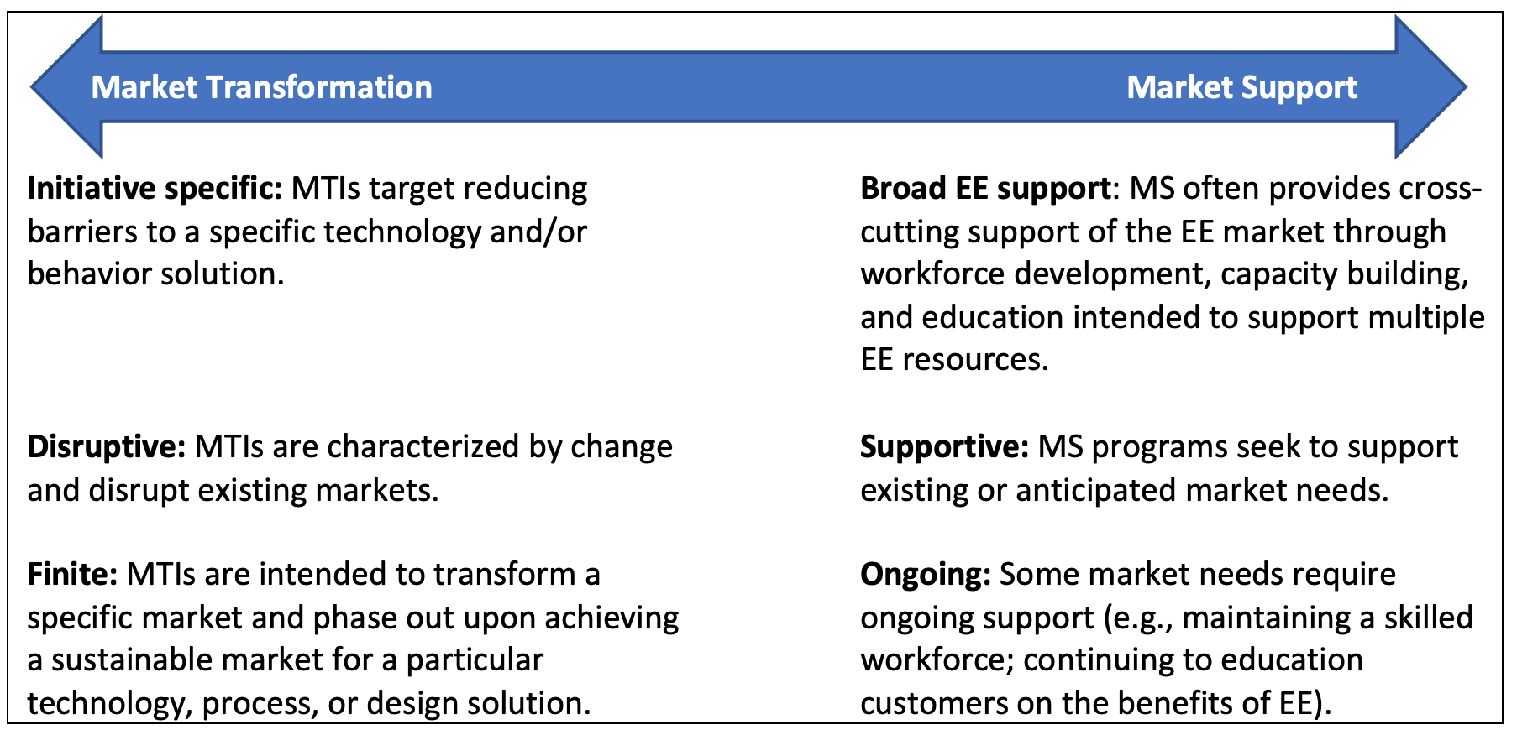

(new from 8/9/2021 proposal)
- The California energy efficiency (EE) market will benefit most from a collaborative approach between the Market Transformation Administrator (MTA) and EE Rolling Portfolio Program Administrators. The CAEECC Working Group understands MT and the Market Support (MS) segment to be distinct efforts and offers the following guidance:
- MT and MS efforts will require ongoing and significant collaboration among administrators and stakeholders to be successful.
- MTIs and MS programs will not operate in silos and activities within each effort are anticipated to influence the other; including providing additional support or changing the needs of the EE market.
- Administrators should not be inhibited by rigid distinctions but should consider conceptual differences when designing MS programs and identifying MTIs.

