Central California Energy Watch (CCEW)
Implementation Plan
San Joaquin Valley Clean Energy Organization

IMPLEMENTATION PLAN

San Joaquin Valley Clean Energy Organization
4747 N. First Street, Suite 140
Fresno, CA 93726
Courtney B. Kalashian, Executive Director
ckalashian@pesc.com

August 14, 2020
Table of Contents
Program Overview 2
Program Budget and Savings 2
Implementation Plan Narrative 2
1. Program Description 2
2. Program Delivery and Customer Services 3
3. Program Design and Best Practices 6
4. Innovation 9
5. Metrics 9
6. For programs claiming to-code savings 10
7. Pilots 10
8. Workforce Education and Training 10
9. Workforce Standards 10
10. Disadvantaged Worker Plan 10
11. Additional information 10
Supporting Documents 10
Program Theory and Program Logic Model 11
Process Flow Chart 12
Quantitative Program Targets 13
Diagram of Program 16
Program Manuals 17

Central California Energy Watch (CCEW) Implementation Plan

Program Overview
The Central California Energy Watch is a non-resource program offering under the PG&E Public Sector portfolio. The CCEW is designed to develop energy savings opportunities in Public Sector infrastructure, develop and deliver project leads to PG&E’s Resource Acquisition Programs (RAP), and develop short, mid and long-term energy efficiency project pipelines. The program runs from July 1, 2020 - June 30, 2023. The San Joaquin Valley Clean Energy Organization (SJVCEO) implements the program.

Program Budget and Savings
- Program Name: Central California Energy Watch (CCEW).
- Program ID Number: EEGA_CODE_#14
- Budget Table:
 | Y1 | Y2 | Y3 | Total
ADMIN | $66,500.00 | $66,500.00 | $66,500.00 | $199,500.00
MARKETING | $40,915.00 | $41,337.00 | $32,775.00 | $115,027.00
IMPLEMENTATION | $534,000.00 | $566,250.00 | $550,250.00 | $1,650,500.00
TOTAL | $641,415.00 | $674,087.00 | $649,525.00 | $1,965,027.00

- Gross Impacts Table: Not applicable, CCEW is a non-resource program.
- Cost Effectiveness (TRC): Not applicable, CCEW is a non-resource program.
- Cost Effectiveness (PAC): Not applicable, CCEW is a non-resource program.
- Type of Program: Partnership.
- Market Sector: Public.
- Program Type: Non-resource.
- Market channel(s) and Intervention Strategies, campaign goals, and timeline:
- Market channel(s): Downstream.
- Intervention strategies: Technical assistance, capacity building.
- Campaign goals:
  - GHG Emission Reduction
  - Lower Public Agency Energy Costs
  - Support Local Control
  - ZNE Local Governments by 2033
- Timeline: July 1, 2020 through June 30, 2023.

Implementation Plan Narrative
- Program Description: The CCEW is a public agency focused program to help hard-to-reach (HTR) and Disadvantaged Communities (DAC) access, understand, and participate in energy efficiency through Investor Owned Utility (IOU) administered, third-party programs. The program builds on existing relationships, data, and experience to align to the PG&E portfolio vision for Local Government Partnerships (LGP).
Access and time are the primary barriers of HTR public agencies, as described throughout this document. Equity in access to resources will yield scaled energy savings in geographically HTR public agencies, resulting in lower RAP costs and more cost-effective EE portfolio for PG&E. By creating a common approach to support efficient systems, while maintaining the ability to respond to local concerns, we will move HTR and DAC public agencies towards increased capacity, working together to improve the quality of life throughout Central California.

The CCEW territory is largely geographically rural (by the CPUC’s HTR definition Stanislaus, San Joaquin and Merced counties are part of the Bay Area Metropolitan Statistical Area and not considered rural; Monterey, Madera, Fresno, Tulare, Kings and Kern counties are all considered rural). Accessing our communities is cost intensive for RAPs. Labor and travel costs increase dramatically the further from an urban center a provider goes. By being based in Central California, we can reach the customer in a more cost-effective manner. Our program expends the effort to queue up a project pipeline, eliminating the need for RAPs to travel repeatedly to our communities without the certainty of opportunity conversion.

Our goals are broad but designed to support public agencies on their path toward Zero Net Energy (ZNE). Each agency is on their own path toward their own energy goals, and the CCEW is designed to support them.
GOAL 1: GHG emission reductions
GOAL 2: Lower agency energy costs
GOAL 3: Support local control
GOAL 4: ZNE local governments by 2033

The program objectives support CCEW partners on their energy journey and help prepare them for participating in the PG&E RAPs.
OBJECTIVE 1: Support knowledge transfer among public agencies,
OBJECTIVE 2: Facilitate public agency EE projects with deeper savings and more comprehensive EE tactics, leading to integrated energy solutions,
OBJECTIVE 3: Leverage Strategic Energy Plans (or other strategy documents, i.e. Energy Action Plans, Climate Action Plans, GHG inventories, etc.)
OBJECTIVE 4: Create a common platform, all in largely HTR and DAC areas.

- Program Delivery and Customer Services:
How will the EE program deliver offerings (including program strategies/tactics, market channel, and targeted customer group)?
The CCEW will provide interpersonal customer attention and blend it with opportunity aggregation to ensure our partners are queued up for RAPs; support knowledge transfer among public agencies; facilitate Energy Efficiency (EE) projects with deeper savings and more comprehensive EE tactics; leverage Strategic Energy Plans (or other strategy/policy documents), and create a common platform through data and approach. All in largely HTR and Disadvantaged Communities (DAC).
We will utilize a largely downstream delivery channel, connecting direct to the end use customer.

Our key market actors include past “Energy Champions”, local elected officials, and public agency staff. “LGP’s would appear to be the essence of local programs…” and as such, require a localized approach to program delivery. From our experience, what works in San Joaquin County does not work in Tulare County, and what has worked with the City of Avenal does not work with the City of McFarland (both small cities in Kern County). There are programmatic similarities that they all want and participate in, but the way the program is delivered--and more importantly accepted by the end user--is unique.

How will it reach customers, including those in CPUC defined HTR/DAC?
CCEW targeted customers include any public agency in one of the nine counties identified as eligible (Fresno, Kern, Kings, Madera, Merced, Monterey, San Joaquin, Stanislaus, and Tulare) that is served by PG&E as the electric provider of record. For agencies with split utility service only those accounts belonging to PG&E will be considered eligible. Cities and counties are our primary target audience, special districts being second, and school districts being third.

CCEW efforts should align, at minimum, with the percentage of population that qualifies as HTR (66% of counties in CCEW are considered geographically HTR) and DAC (County-Level: 77%; City-Level: 62%). Six of the nine counties in the CCEW qualify as rural and 33 of the 55 cities are in DACs. While public agencies are not yet categorized as HTR, we consider a combination of geography, DAC, AB1550 and annualized costs to create a broad definition, based on the work conducted by the Rural Hard to Reach Working Group (RHTR). Our program is designed to function specifically for public sector customers located in rural areas and/or DACs. For program purposes, the CCEW considers geography as the primary measure of HTR.

New enrollment for a CCEW partner will consist of an intake process (intake interview and signed form by agency representative) identifying the needs and past EE efforts of the agency. Intake forms will be used to identify or triage the readiness and level of expected participation by the agency.

We reach our partners and potential partners through low, medium, and high touch communication strategies that support our goal to meet the customer where they are on their energy journey. Broadly, we utilize email campaigns, newsletters, social media, and new media to promote the successes of program participants and highlight RAPs offerings, as well as updates related to code changes, state policy implications, regulatory decisions, and funding opportunities. More directly, we communicate with individual partners via email and phone on a schedule determined by the end user. We do focus our directed communication on those actively engaged, or on the verge of active engagement to maximize our own staff resources. We meet with participants sub-regionally on every-other-month basis, and individually as needed.

MARKETING APPROACH 1: In-person (one-on-one and groups) meetings and presentations.
MARKETING APPROACH 2: Digital engagement (one-on-one and groups) email correspondence, email campaigns, email newsletters, new media (BLOGEE, PODEE, Fast Chats)
MARKETING APPROACH 3: Activity (group, may be delivered in person or digitally), includes informational sessions and “plug and play” offerings from ENERGY STAR, including Energy Treasure Hunt, Battle of the Buildings and ‘Kill-a-Watt Krackdown’.

Services:
Our CCEW partners will be able to better understand their project needs by first understanding their energy use—where and when they’re using energy, and what it is costing them to use it. Our program activities exist to create a common platform to work from, as well as a common language to communicate among each other and to the RAPs.

Once a public agency is actively participating in program activities one through three, they are providing data that allows us to refer them into RAPs.

Program Activities (PA):
PA 1- Energy Benchmarking and Maintenance:
Utilizing ESPM, Green Button, and PG&E’s Share My Data and Energy Insight, we identify use patterns, changes, and opportunities for energy savings. By viewing this information across multiple agencies, we will develop scaled savings opportunities, aggregate customers for RAPs, create economies of scale for public dollars, inform future community wide plans, and develop policies in support of EE procurement and leadership.

PA 2: Infrastructure Inventory (II):
The SJVCEO developed a public-facing, web-based platform to work collaboratively with local governments to create infrastructure inventories that the customer can access, while simultaneously allowing us to see where opportunities exist for energy equipment improvements. The inventories are ‘crowd sourced’ allowing the customer to update their information through a secured log-in and SJVCEO staff to augment information utilizing data gathered from our ESPM access, PG&E Energy Insight, agency insurance filings and Risk Management Reports. We also pull from previous inventories conducted by other third parties.

PA 3: Energy Readiness Reports (ERR):
Our ERRs remove barriers from implementing public sector energy projects. ERRs are our primary tool for communicating with agency staff and local elected officials, because they are easy to comprehend. We realized audit reports were overwhelming for our small cities and counties and found the person who received the audit often did not know how to read it. With the ERR, we use data analysis collected from Energy Benchmarking to determine the most pragmatic opportunities for energy savings. We sit down with the agency and determine what is realistic to accomplish. The list is narrowed, and we work together to move forward on opportunities most likely to result in energy savings projects.

The ERR addresses many components outside of the energy data. It identifies opportunities for funding and financing paths/programs and includes council ready documents that support agency staff in moving projects from conception to completion, as well as applicable EE policies.

PA 4: Exchange Dashboard:
Our internal project tracking database (ED) (built on the Teamwork project management platform) allows us to log project concepts from their earliest inception. It is here that we record progress, meeting notes, audit reports, etc. to support the agency, the RAP, and the Program Administrator with documented points of intervention. The ED also serves as a singular source for tracking KPI metrics, and other points of data allowing us to track the program’s efficacy over time.

PA 5: ENERGY STAR Portfolio Manager GRITS:
GRITS is a project-management platform offered at no cost thorough the US EPA. GRITS allows public agencies to calculate, track, and share the energy, financial, and carbon savings data from energy savings projects. The GRITS tool allows us to develop a strong business case analysis for project that need extra development.

Each program activity allows for points of education for the customer through varied educational opportunities.

PA 6: Marketing, Education and Outreach (MEO):
See Marketing Approach in previous section.

- Program Design and Best Practices:

Describe the program strategies/tactics that will be used to reduce the identified market barriers for the targeted customer group and/or market actor(s):
Our two primary barriers that we aim to overcome are access and time. In a 2019 survey of local governments (cities and counties) in the San Joaquin Valley, San Luis Obispo County, and the High Desert region of eastern San Bernardino County, we asked, “Thinking about your time, would you rather develop your own personal skills and capacity in EE and project management or rely on a no-cost expert to support EE planning and project management?” 100% of respondents said they’d rather rely on the outside source. When we asked them why they complete EE projects, 100% of respondents listed “cost savings for my agency” as the top reason.

From this same survey, 60% of respondents prefer either in person one-on-one meetings and/or check in calls or group meetings. And 80% have participated in and feel positive towards our monthly webinar series, “Fund-it Fast Chats”. We’ve been experimenting with meeting the customer more where they are, and we’re seeing that they prefer it--public sector customers are high touch!

Data will drive the direction of CCEW agency referral into RAPs. The CCEW will view resource program direction at an agency level, a sub-regional level, and at a regional level. For example, utilizing our data platforms, we can identify—specifically through Energy Benchmarking, II and ED--all our public agencies using above 20% above average on pumping, with pumps lacking VFDs or past EE intervention, and direct them toward the appropriate RAP. Additionally, we could fulfill a request from a RAP looking to meet a reduction goal on a constrained circuit by utilizing data from our Energy Benchmarking, II, ED and GRITS, to make referrals to appropriate agency staff.

How we coordinate with RAPs will vary based on how the RAPs are structured to work with non-resource programs and the utility program administrator. However, we have a strong working relationship with third parties in an open market and are confident in our ability to develop our future relationships that work towards the portfolio level goals.

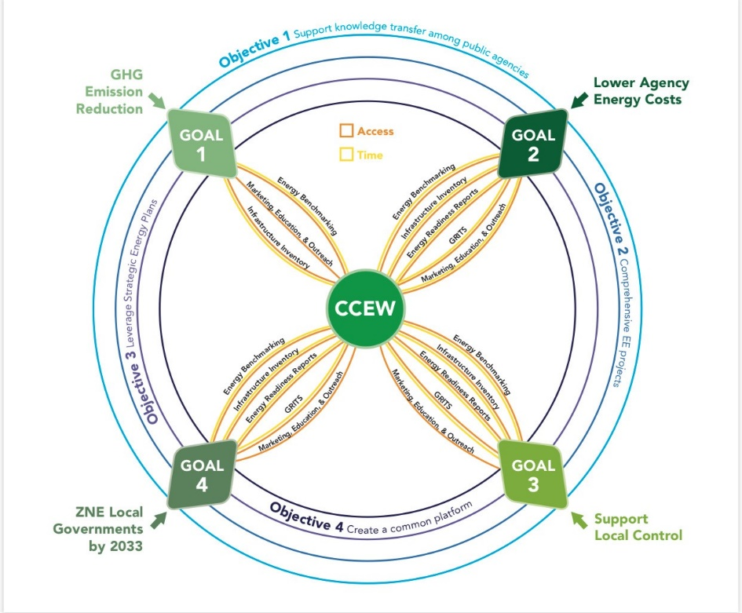

Describe how why the program approach constitutes “best practices” and/or “lessons learned:”
Public agencies are exponentially impacted by economic downturns and hampered in their ability to collect tax revenue to fill their General Funds. Local governments do not have the opportunity to raise income as a commercial business might, and therefor are reliant upon the economic health of their communities. Geographically hard to reach communities were hit harder and were slower to recover than more metro/urban areas. The SJVCEO, with our public agencies, weathered the Great Recession by aggregating cities and counties to pursue group funding opportunities at Federal and State levels, as well as foundation funding to build energy policies that would lay the foundation for more robust energy work in positive economic years. By aggregating CCEW participants, the pool of opportunity increases a RAP fit, and reduces costs for program participants.

The work in support of more comprehensive projects can only come about by having a complete view of an agency’s energy portfolio. As a learned best practice, we utilize the data on hand to help public agencies understand their energy portfolio in a holistic view. For those we have not previously worked with, we are adept at the energy benchmarking process and can quickly bring them up to speed.

One of the issues that we have seen is that opportunities for public agency staff to learn about energy has been at too high a level, and not structured to meet local concerns. The CCEW will leverage existing trainings offered by PG&E, as well as those that may be offered by non- utility program administrators throughout the region. Our CCEW program marketing is built around taking a common approach that can be tailored by subregion or at the agency level. We rely on previously created content from the program administrators, as well at the US EPA and DOE, to leverage resources in a more cost-effective manner, while delivering quality educational offerings through a singular point of access—the CCEW.

In the past decade, many public agencies have completed some form of a strategic energy plan in support of the CALEESP. The SJVCEO, through our LGP work, has assisted agencies in creating energy action plans and climate action plans. Other LGPs have put time into creating GHG inventories, so instead of recreating wheels, we will mobilize the public agencies to put the polices in these plans into action. The ideas have been vetted and approved by governing boards, the CCEW will help guide our public agency partners through implementing policies internally as well as community wide.

The CCEW vision for HTR and DAC public agencies is simple: EE is a culture, where rural agencies are participating and delivering through RAPs on par with their urban counterparts (if not better!). The common approach of the PG&E LGP program aligns ability of the SJVCEO, through the CCEW, to respond to local needs and concerns. We will expand on our successes and improve customer understanding of their energy use and how that data should inform their investment decisions. By doing so, we will meet the designed outcomes of the PG&E program, as well as the guiding principles of our own agency.

Include descriptions of key software tools that are significant to program strategy and implementation, including audit tools.
The SJVCEO utilizes free and low-cost tools to support CCEW Program Activities. Key software by Program Activity:

PA1/Energy Benchmarking: Energy Star Portfolio Manager, Green Button, PG&E Energy Insight, PG&E Share My Data.
PA2/Infrastructure Inventory: II is already built on Drupal, a free and open-source web content management framework. II pulls data sets from the Energy Benchmarking platforms.
PA3/Energy Readiness Reports: prepared in Microsoft Word and Excel.
PA4/Exchange Dashboard: ED is built on the Teamwork Project Management Software platform.
PA5/GRITS: Offered to ESPM users, at no cost through the Sustainable Endowments Institute, GRITS is a project level platform that calculates, tracks, and shares the energy, financial, and carbon savings data form sustainability projects.
PA6/MEO: The SJVCEO uses SquareSpace for website, Blog-EE and digital marketing campaigns. We host meetings and record our Fast Chats webisodes on the Zoom and Microsoft Teams platforms. Our POD-EE is recorded and edited using Audacity software and housed on Spotify.

- Innovation: The CCEW is a program that moves customers towards accessing innovative RAP programs. The CCEW focuses on building actionable pipelines from data that will empower public agencies to make informed choices. RAPs are the leaders of innovation, and CCEW is a supportive service to ensure the RAPs innovation is accessed by eligible communities.

The CCEW approaches innovation through “market strategy” and “delivery approach,” both resulting from lessons learned implementing prescribed LGP programs from 2009-2020.

Our II, while simple in design, promotes agency staff participation in their energy resource management.

Our delivery approach of serving primarily HTR and DAC communities is innovative because we aggregate at the project and/or opportunity level which encourages new customer engagement from a persistently stubborn market group.

- Metrics: The CCEW will be tracked using a combination of foundational(f) and supporting(s) Key Performance Indicators (KPIs). Those include:
- Contacts (f): Number of Contacts: by sector and by type.
- Pipeline (f): kW/kWh/Therms savings: pipeline tracking by status, "potential", "committed", "completed”.
- Audit/Reports (f): Number of audits or reports prepared or presented.
- Projects Managed (s): Number of projects managed and/or using GRITS, those where financing is facilitated or through OBF.
- Education (s): Number of Educational Opportunities offered.
- Benchmarking (s): Number or percentage of Buildings Benchmarked.

- For programs claiming to-code savings: Not applicable.
- Pilots: Not applicable.
- Workforce Education and Training: Not applicable.
- Workforce Standards: CCEW does not offer services that include the installation of HVAC equipment or advanced lighting controls. The General Workforce Standards set forth by the CPUC shall apply.
  - A quality workforce supports the program outcomes by ensuring HTR and DAC communities have access to locally based energy efficiency professionals with the ability to guide work forward in the unique confines that distinguish the public sector.
  - While CCEW is a non-resource program without installation services, the program will strive to maintain workers with applicable certifications and degrees based on the job skill level, i.e. the Energy Manager should be certified by IOU WE&T programs to conduct Level I audits.
  - Compliance with Workforce Standards will be included on monthly reports and reviewed quarterly with the PG&E Program Manager.

- Disadvantaged Worker Plan: 391/1015 zip codes in the top 25% of the CalEnviro Screen tool are in the areas that the SJVCEO actively recruits for employment. Narrowing in more, 20 of the 25 zip codes in Fresno County, where SJVCEO offices are headquartered, are in the top 25% of high unemployment zip codes. At present, 50% of SJVCEO staff (60% normally, but one employee is furloughed due to COVID impacts) meet the minimum requirement for "Disadvantaged Worker". We will continue to recruit workers in the communities we serve, ensuring our local capacity grows.

- Additional information: Not applicable.

Supporting Documents
Attached documents in PDF format:
- Program Manuals and Program Rules: to be included
- Program Theory and Program Logic Model: included
- Process Flow Chart: included
- Incentive Tables, Workpapers, Software Tools: not applicable
- Quantitative Program Targets: included
- Diagram of Program: included
- Evaluation, Measurement & Verification (EM&V): not applicable
- Normalized Metered Energy Consumption (NMEC): not applicable

Program Theory and Program Logic Model
Equity in access to resources will yield scaled energy savings in geographically HTR public agencies, resulting in lower RAP costs and more cost-effective EE portfolio for PG&E. By creating a common approach to support efficient systems, while maintaining the ability to respond to local concerns, we will move HTR and DAC public agencies towards increased capacity, working together to improve the quality of life throughout Central California.
An aware and educated customer base will lead to scaled energy savings at reduced energy costs. We believe in meeting the customer where they are in their energy journey and providing the support they require at that point in time. We will leverage our existing access to local government data and build upon that library to give public agencies a quantified plan for action.
OBJECTIVE 1: Support knowledge transfer among public agencies
Problem Statement | HTR/DAC public agencies lack opportunities to collaborate on EE and encourage regionally significant actions.
Interventions | PA1/Energy Benchmarking, PA2/Infrastructure Inventory, PA/3 Energy Readiness Reports, PA6/Marketing, Education, Outreach
Desired Outcomes | Agencies collaborate and compete to develop meaningful EE projects and policies amongst other HTR/DAC communities.
OBJECTIVE 2: Facilitate public agency EE projects with deeper savings and more comprehensive EE tactics, leading to integrated energy solutions
Problem Statement | HTR/DAC public agencies have approached EE from a lens of deferred maintenance and low hanging fruit.
Interventions | PA1/Energy Benchmarking, PA2/Infrastructure Inventory, PA/3 Energy Readiness Reports, PA5/GRITS, PA6/Marketing, Education, Outreach
Desired Outcomes | HTR/DAC public agencies initiate comprehensive EE tactics to produces scaled savings and impactful policies.

OBJECTIVE 3: Leverage Strategic Energy Plans (or other strategy documents, i.e. Energy Action Plans, Climate Action Plans, GHG inventories, etc.)
Problem Statement | HTR/DAC public agencies have plans addressing EE but lack capacity to act on those plans.
Interventions | PA2/Infrastructure Inventory, PA/3 Energy Readiness Reports, PA5/GRITS, PA6/Marketing, Education, Outreach
Desired Outcomes | HTR/DAC public agencies actively implement strategic energy investment within their infrastructure.
OBJECTIVE 4: Create a common platform, all in largely HTR and DAC areas.
Problem Statement | HTR/DAC public agencies are often small, not cost effective to reach, and often (wrongly) considered less sophisticated than their urban counterparts, and as a result, overlooked in program delivery.
Interventions | PA1/Energy Benchmarking, PA2/Infrastructure Inventory, PA/3 Energy Readiness Reports, PA5/GRITS, PA6/Marketing, Education, Outreach
Desired Outcomes | HTR/DAC public agencies work from the same EE language and data format to work seamlessly with RAPs.

Process Flow Chart

Quantitative Program Targets
Key Performance Indicators (KPI)
- ID: Contacts
Category: Foundational
Definition: Number of contacts by sector and type
Measurement: Reported monthly, reviewed quarterly. By customer type (city, county, special district, k-12), DAC or HTR, active or passive.
Target/Milestone:
Passive contact to include at minimum:
- Newsletter (monthly)
- Social media posting (daily, platform dependent)
Active contacts to include, at minimum:
- Annual meetings (3)
- Sub-regional meetings (7)
- In-person meetings (as needed)
- 1:1 Energy Coaching sessions (weekly)
Data Source: Exchange Dashboard (digital channels will be measured within their respective channel tracking, i.e. newsletters through SquareSpace service) and reported into Exchange Dashboard.

- ID: Pipeline
Category: Foundational
Definition: kW/kWh/Therms savings: pipeline tracking by status, "potential", "committed", "completed'.
Measurement: Reported monthly, reviewed quarterly. By customer type (city, county, special district, k-12), DAC or HTR, pipeline status (potential, committed, completed)
Target/Milestone: Pipeline to be reflective of the HTR and DAC characteristics, meaning, at any given time:
- 75% of pipeline should come from HTR and
- 65% should come from DACs,
As well as supportive of larger PG&E and State goals. Overarching program goals include:
- pipeline potential opportunities that meet or exceed doubling of EE from 2015 baseline by agency and
- 40% reduction of GHG emissions over 1990 levels;
- committed energy savings of 20% over baseline 2015 use;
- completed energy savings of 8% over 2015 baseline.
Data Source: Exchange Dashboard (data pushed from ESPM, GRITS, II and EI for reporting purposes)

- ID: Audits/reports
Category: Foundational
Definition: Number of audits or reports prepared or presented.
Measurement: monthly, reviewed quarterly. By customer type (city, county, special district, k-12), DAC or HTR, number and type of audit conducted (in-person or virtual), number of reports completed, number of reports presented. Number of leads delivered to RAPs. Percentage of recommendations acted on.
Target/Milestone: Activity to be reflective of the HTR and DAC characteristics, meaning, at any given time:
- 75% of audit/report activity should come from HTR and
- 65% should come from DACs.
Data Source: Exchange Dashboard updated by assigned staff.

- ID: Projects Managed
Category: Supporting
Definition: Number of projects managed and/or using GRITS, those where financing is facilitated or through OBF.
Measurement: Reported monthly, reviewed quarterly. By customer type (city, county, special district, k-12), DAC or HTR, GRITS project dashboards created and presented. Number of project leads delivered to RAPs.
Target/Milestone: Activity to be reflective of the HTR and DAC characteristics, meaning, at any given time:
- 75% of project managed should come from HTR and
- 65% should come from DACs.
Data Source: Exchange Dashboard (data pushed from GRITS)

- ID: Education
Category: Supporting
Definition: Number of educational opportunities offered.
Measurement: Reported monthly, reviewed quarterly. Attendee by customer type (city, county, special district, k-12), DAC or HTR, delivery type (digital or in-person)
Target/Milestone: educational opportunities to include at minimum:
- Blog articles (2 per week)
- Fast Chat (monthly)
- Education Bundles (monthly)
- Energy saving activities/competitions (6 over three years)
- Other educational opportunities (may include industry events, PGE or 3P options as well) (5 over three years)
Data Source: Exchange Dashboard updated by assigned staff.

- ID: Benchmarking
Category: Supporting
Definition: Number or percentage of Buildings Benchmarked
Measurement: Reported monthly, reviewed quarterly. By customer type (city, county, special district, k-12), DAC or HTR, service type (new entry or maintenance), gross square footage, AB 802 compliance.
Target/Milestone:
- 100% of enrolled agencies benchmarked at minimum of 90% total agency energy portfolio.
- 100% of enrolled agencies kept in compliance with AB802
Data Source: Exchange Dashboard (data housed in ESPM, but monthly aggregated reporting delivered in Exchange Dashboard)

Diagram of Program
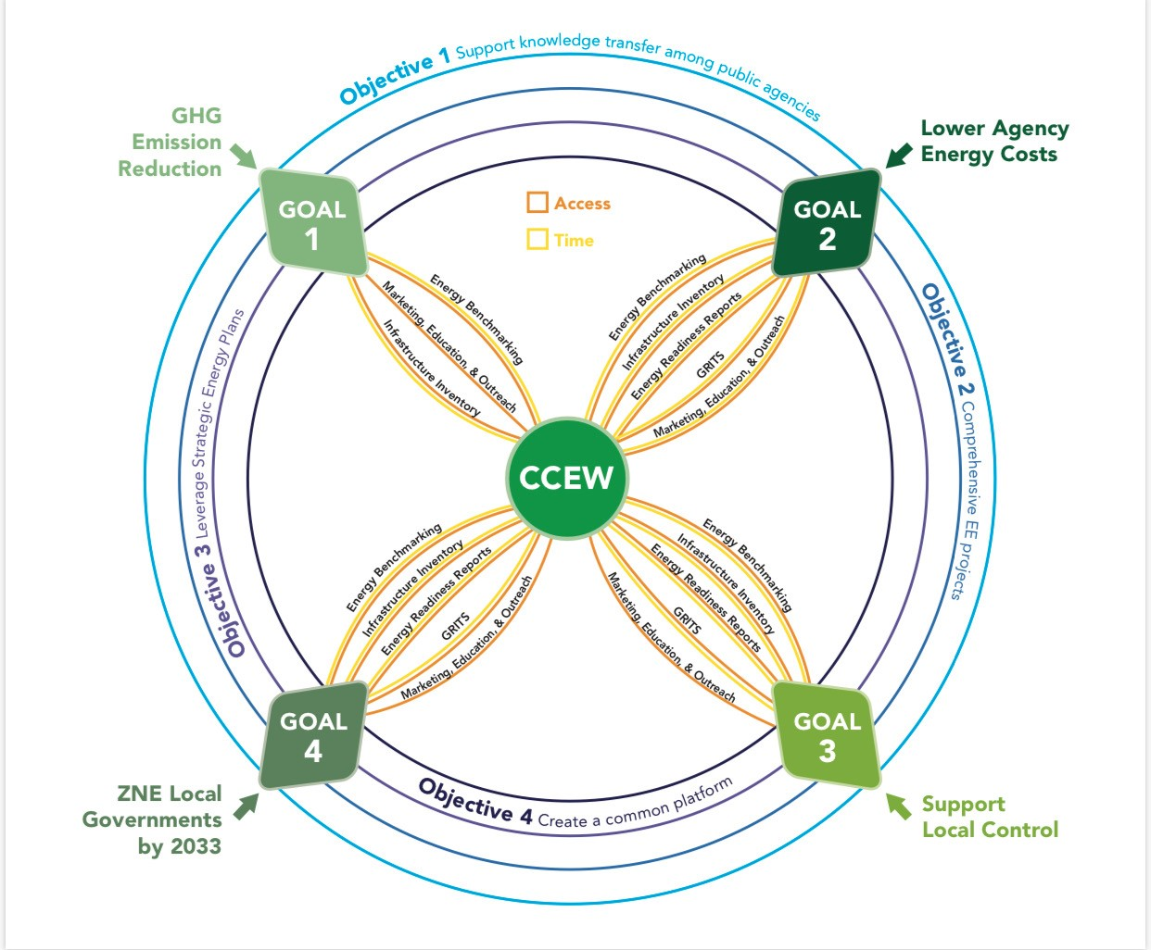

Program Manuals
- Eligible Measures or measure eligibility, if applicable
- Customer Eligibility Requirements
- Contractor Eligibility Requirements
- Participating Contractors, Manufacturers, Retailers, Distributers, and Partners
- Additional Services
- Audits
- Sub-Program Quality Assurance Provisions
- Other Program Metrics

For nonresidential customers, Hard-to-reach (HTR) are those customers who meet each of the following criteria: primary language other than English, <20 kW and/or 10,000 therms, and leased/rented facility. If the nonresidential customer resides in a defined Disadvantaged Community, then only two of these criteria must be met to be considered HTR.
Administrative Law Judge’s Proposed Decision Providing Guidance for Initial Energy Efficiency Rolling Portfolio Business Plan Filings “Proposed Decision”, July 19, 2016.

