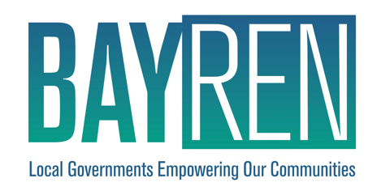

Bay Area Regional Energy Network (BayREN)

Public Sector Integrated Energy Services

Implementation Plan

PY2024 - 2027

October 2024

THIS PAGE INTENTIONALLY LEFT BLANK

Table of Contents

Program Overview 3

Program Budget and Savings Information 3

Program Implementation Plan Narrative 4

1. Program Description 4

2. Program Delivery and Customer Service 5

3. Program Design and Best Practices 7

4. Innovation 9

5. Metrics 9

6. For Programs Claiming To-Code Savings 9

7. Pilots 9

8. Workforce Education and Training 10

9. Workforce Standards 10

10. Disadvantaged Worker Plan 10

11. Additional information 10

Supporting Documents 11

1. Program Manuals and Program Rules 11

2. Program Theory and Program Logic Model 11

3. Process Flow Chart 12

4. Incentive Tables, Workpapers, Software Tools 12

5. Quantitative Program Targets 12

6. Diagram of Program 13

7. EM&V 13

8. Normalized Metered Energy Consumption (NMEC) 13

**Program Overview**

The Bay Area Regional Energy Network (BayREN) Integrated Energy Services (IES) Program coordinates existing and emerging energy programs and provides supplemental services to local governments and special districts to help transform their public facilities. The program fills gaps in existing program offerings to facilitate building energy improvements. The program includes two services: 1) an Energy Concierge service that will serve as a point of contact to help local governments in the Bay Area identify and apply for energy programs, and 2) an Energy Roadmapping service that provides technical support and assistance to help local governments develop comprehensive and actionable plans for improving their facilities and meeting their energy goals.

Program Budget and Savings Information

1. Program and/or Sub-Program Name: **Integrated Energy Services**

2. Program ID number: **BAYREN11**

3. Program Budget Table:

|  |  |  |  |  |
| --- | --- | --- | --- | --- |
|  | 2024 | 2025 | 2026 | 2027 |
| Administration | $78,094.00 | $80,348.00 | $103,058.00 | $105,078.00 |
| Implementation | $668,927.00 | $650,253.00 | $679,676.00 | $688,292.00 |
| Marketing/Outreach | $94,047.00 | $103,392.00 | $95,942.00 | $99,070.00 |
| Incentives | $- | $- | $- | $- |
| Total | $841,068.00 | $833,993.00 | $878,676.00 | $892,440.00 |

4. Program Gross Impacts Table: N/A

|  |  |  |  |  |  |  |  |  |  |  |  |  |
| --- | --- | --- | --- | --- | --- | --- | --- | --- | --- | --- | --- | --- |
| **PY** | **Total System Benefit** | **TRC** | **PAC** | **TRC (no admin)** | **PAC (no admin)** | **RIM** | **Gross kWh** | **Gross kW** | **Gross Therm** | **Net kWh** | **Net kW** | **Net Therm** |
| 2024 | $ - | - | - | - | - | - | - | - | - | - | - | - |
| 2025 | $ - | - | - | - | - | - | - | - | - | - | - | - |
| 2026 | $ - | - | - | - | - | - | - | - | - | - | - | - |
| 2027 | $ - | - | - | - | - | - | - | - | - | - | - | - |

5. Program Cost Effectiveness (TRC): N/A

6. Program Cost Effectiveness (PAC): N/A

7. Type of Sub-Program Implementer (Core, third party or Partnership): **PA-Delivered**

8. Market Sector(s) (i.e., residential, commercial, industrial, agricultural, public): **Public Sector**

9. Program / Sub-program Type (i.e., Non-resource, Resource): **Non-resource**

10. Market Channel (i.e., downstream, midstream, and/or upstream): **Downstream**; and Intervention Strategies (e.g., direct install, incentive, finance, audit, technical assistance, etc.): **Technical Assistance**

Program Implementation Plan Narrative

1. Program Description

The objective of the Integrated Energy Services (IES) program is to build, enable, and maintain demand for integrated building energy upgrades and operations. The program proposes to satisfy the unique energy and resilience goals of each participating local government by coordinating participation in existing and emerging programs addressing energy efficiency, demand response, distributed energy resources, grid integration, etc., and by providing supplemental technical services to fill gaps. These activities will serve to enhance the cost-effectiveness of other ratepayer funded programs by increasing uptake and close rates.

Local governments are necessary partners for achieving the State’s energy goals. Many Bay Area local governments have aggressive climate action goals and typically have several other energy-related goals and intentions for their portfolios, such as energy efficiency, resilience, fleet electrification, and operational savings. However, achieving these multiple goals is complex and involves integrating various strategies and value streams that often exceed the capacity of local government staff.

The proposed program addresses several barriers to Public Sector engagement. Notably, local government staff have limited time, resources, and budgets to analyze, design, and construct projects outside of routine capital improvements - let alone navigate complicated technology assessments and incentive processes. Although there are programs available in the Bay Area, local government staff find it difficult to identify those which can best assist them with desired projects. In addition, most programs are limited in scope, while local governments have a wide variety of goals that could all affect the energy systems of their facilities.

The IES program consists of two subprograms: Energy Concierge and Energy Roadmapping.

#### Energy Concierge

The Energy Concierge subprogram will provide an objective central single point of contact to help local governments find and access the best program options for their specific needs. The service will also assist local governments to determine their eligibility for particular programs and assist them with the enrollment process. A collateral benefit of this strategy is that it will increase the uptake of existing programs and reduce program administration costs.

#### Energy Roadmapping

The Energy Roadmapping subprogram[1] will work with local governments and provide technical and engineering assistance to develop “roadmaps” for improving their buildings to meet their unique energy goals. In addition, the Roadmapping service will offer energy assessments of designated and potential Community Resilience Centers and technical assistance for energy system improvements. These activities will include working with staff to understand their project plans and goals, analyze and assess their facilities and equipment, and provide recommended phased energy measures to improve their facilities.

Services will be available for projects ranging from single facilities to building portfolios, and could address new construction, retrofits and recommissioning, end-of-life replacement, and operations and maintenance.

1. Program Delivery and Customer Service

Customers

The program will primarily target local governments, with a particular focus on staff responsible for sustainability, resilience, and capital projects. Secondary targets will include local government special districts, such as regional parks agencies or agencies created by local governments, as well as designated community resilience centers. There are 109 local governments (cities and counties) and 419 special districts[2] in the Bay Area, covering 20% of California’s total population.

Marketing and Outreach

BayREN marketing and outreach includes both local and regional activities. BayREN member counties serve as trusted messengers and are responsible for creating localized marketing plans that address the characteristics and needs of their communities. County representatives will be responsible for marketing directly to their local cities. County outreach strategies may include direct contacts with city and county staff, announcements and presentations at relevant meetings, social media posts, and other approaches as appropriate.

BayREN will also carry out complementary regional marketing for the program. This will include social media posts, regional email outreach, and announcements and presentations at regional meetings including BayREN’s Codes & Standards Program’s quarterly Forums.

The Energy Roadmapping service will prioritize facilities that serve equity priority communities, based on either facility type or geographic location. The criteria for identifying these facilities will be based on the Metropolitan Transportation Commission’s (MTC) [Equity Priority Communities Framework](https://mtc.ca.gov/planning/transportation/access-equity-mobility/equity-priority-communities).

Energy Concierge Services

The Energy Concierge subprogram will include the following activities and services:

* **Regional and County Specific Marketing and Outreach:**BayREN marketing and outreach includes both local and regional activities, as described above.
* **Collect and maintain information about relevant programs.** A key part of this effort will be developing a comprehensive database of programs and resources relative to the full suite of building energy solutions. This database will be routinely updated and will serve as a resource when responding to queries. The data collected will be used to maintain and update BayREN’s[Resource Guide for Reducing Energy Use and Carbon Emissions from Municipal Buildings](https://www.bayren.org/sites/default/files/2021-11/resource-guide-reducing-energy-use-and-carbon-emissions-from-municipal-buildings_june-2021.pdf) which is available on the BayREN website.
* **Coordination.** BayREN will coordinate with other Program Administrators, local governments, and organizations serving the public sector to determine referral criteria and ways to work together and leverage each other’s efforts.
* **Respond to queries and assist with applications.** When requests are received, this service will determine what programs and resources are available and could be good fits for a particular project. This work will involve conversations with local governmentstaff to determine opportunities for upgrade measures and program referrals. As appropriate, BayREN can offer high-level assistance with program applications, providing guidance on navigating application requirements and ensuring enrollment is not denied due to overlapping benefits.
* **Track and report.** The Energy Concierge subprogram will track and report on metrics as listed below, as well as challenges and barriers encountered. In addition, the subprogram will communicate as appropriate with other PAs and agencies about feedback from applicants and barriers related to their programs.

Energy Roadmapping Services

The Energy Roadmapping subprogram will include the following activities and services:

* **Regional and County Specific Marketing and Outreach:** BayREN marketing and outreach includes both local and regional activities, as described above.
* **Goal Planning:** BayREN will engage with local governmentsto articulate high-level goals relative to local energy objectives, including energy efficiency, climate action, decarbonization, resilience, grid-integration, and how those goals relate to each other as well as to the specifics of the facility or portfolio. Emphasis will be placed on minimizing lost opportunities and leveraging all appropriate resources. BayREN will work with local government staff to understand their objectives and constraints, characterize the project, and review project plans and capital improvement plans in order to produce a roadmap to achieve their aims.
* **Support services:** BayREN will offer a host of services to support the energy roadmap process. These will include:
  + Detailed site assessments, technical assistance and recommendations, including project phasing options;
  + Calculation of facility baseline energy usage, energy costs, and greenhouse gas (GHG) emissions;
  + Analysis of facility climate and energy vulnerabilities;
  + Electric readiness assessments to identify opportunities to replace equipment upon failure with carbon-neutral alternatives and whether electrical service upgrades will be required;
  + Provision of financial, energy, and GHG emissions savings estimates for all recommended measures to support objective decision making;
  + Identification of relevant financing strategies and assistance programs;[3] and
  + Analysis of potential locations and sizing for solar PV and battery energy storage systems (if applicable to the project)
* **Track and report:** The Energy Roadmapping service will report on metrics as listed below, as well as challenges and barriers encountered.

1. Program Design and Best Practices

The IES program is intended to overcome several barriers local governments face to deploying integrated building energy upgrades to address their energy goals. In doing so, the program will increase public sector participation in energy efficiency programs and also enhance the cost-effectiveness of other ratepayer funded programs by increasing uptake and close rates.

The barriers to be addressed include the following:

* Local governments need assistance comprehending and accessing existing and emerging programs, which are often fragmented by technology or geography. While there are many incentive and financing options available to local governments, these are rapidly changing and confusing to local government staff trying to sift through offerings and eligibility requirements. As a result, local government staff often don’t know what programs are available or how to tell what program or set of programs would be the best fit for a particular project.
* Local government goals and objectives often require approaches that span siloed program offerings.[4]
* Public sector staff often lack the expertise and time needed to take on integrated energy projects. Unlike many of their private-sector counterparts, local governments manage diverse portfolios, with applications, scales and reliability requirements that often demand custom-engineered solutions.

The Energy Concierge subprogram will address these barriers by helping local government staff to assess their desired projects in order to understand and connect with appropriate programs. These referrals will cover all program administrators and local goverments offering programs in the Bay Area, providing objective information about program options, requirements, and best fit. In addition, the referrals will cover all components of energy systems, including efficiency, fuel-substitution, demand flexibility, thermal and electric storage, grid-integration, microgrids/back-up generation, low-GHG refrigerants, fleet charging and other climate action and resiliency related measures.

The Energy Roadmapping subprogram will also take a holistic approach to improving energy systems in public buildings, addressing the siloed nature of most current programs. This subprogram will provide additional expertise to local governments, helping them to develop roadmaps for meeting all of their local energy goals in a rational and actionable way.

The program as a whole addresses the need that local governments have for solutions that transcend traditional program offerings and are tailored to their specific needs. This is consistent with recommendations from a recent ACEEE paper[5] on integration of energy efficiency and demand response, and these recommendations could apply to integration of other technologies as well:

* *Enact organizational changes within utilities and other program administrators that support implementation of integrated EE/DR.*
* *Develop industry guidelines, metrics, and practices for assessing integrated EE/DR program impacts, value, and cost effectiveness. Document and share results from integrated EE/DR programs.*
* *Pursue integrated programs when the net benefits (e.g., fully capturing the resources’ value streams, more efficient administration, a streamlined customer experience) outweigh the costs of integration.*

1. Innovation

The IES program will support innovation by leveraging value streams through the integration of energy efficiency and other customer energy-related improvements. Through careful planning, local governments will be able to deploy projects that satisfy a range of needs and allow them to more actively participate in a range of energy programs, services and markets.

1. Metrics

The program will track the metrics and indicators below:

* Number and % increase/decrease of calls in which the Energy Concierge provides referrals or other assistance for municipal building projects (MS_02_BVM (2a))
* Count of projects where the Energy Concierge assisted a LG staff (or LGs consultants) to submit an application for a program (MS_BVM_02)
* Number and % increase/decrease of customers receiving Energy Roadmaps (MS_02_BVM (2b))
* Percent of customers receiving an Energy Roadmap who have taken action toward implementation within one year (MS_06_BVM)
* Estimated electricity energy savings (RA_BVM_01)
* Estimated electricity demand savings (RA_BVM_02)
* Estimated natural gas savings (RA_BVM_03)
* Estimated GHG reductions (RA_BVM_04)

Additional metrics may also be tracked as possible and appropriate.

6. For Programs Claiming To-Code Savings

Not applicable.

7. Pilots

Not applicable.

8. Workforce Education and Training

Not applicable.

9. Workforce Standards

There are no new workforce standards as part of this program. Projects referred to other programs will comply with the standards of that PA.

10. Disadvantaged Worker Plan

There is no direct implementation proposed as part of this program. Projects will comply with the disadvantaged worker plans of the referral PAs.

11. Additional information

Not applicable.

Supporting Documents

1. Program Manuals and Program Rules

The Program Manual will be developed and incorporated into this Implementation Plan as part of the program launch activities. Since this program supports and complements other programs, this timing will allow the Program Manual to be based on the most current information about those programs. Developing the Program Manual at that time will also allow the program staff and consultants who will be managing and involved with the program to develop the Manual.

2. Program Theory and Program Logic Model

The logic model for this program is provided below.

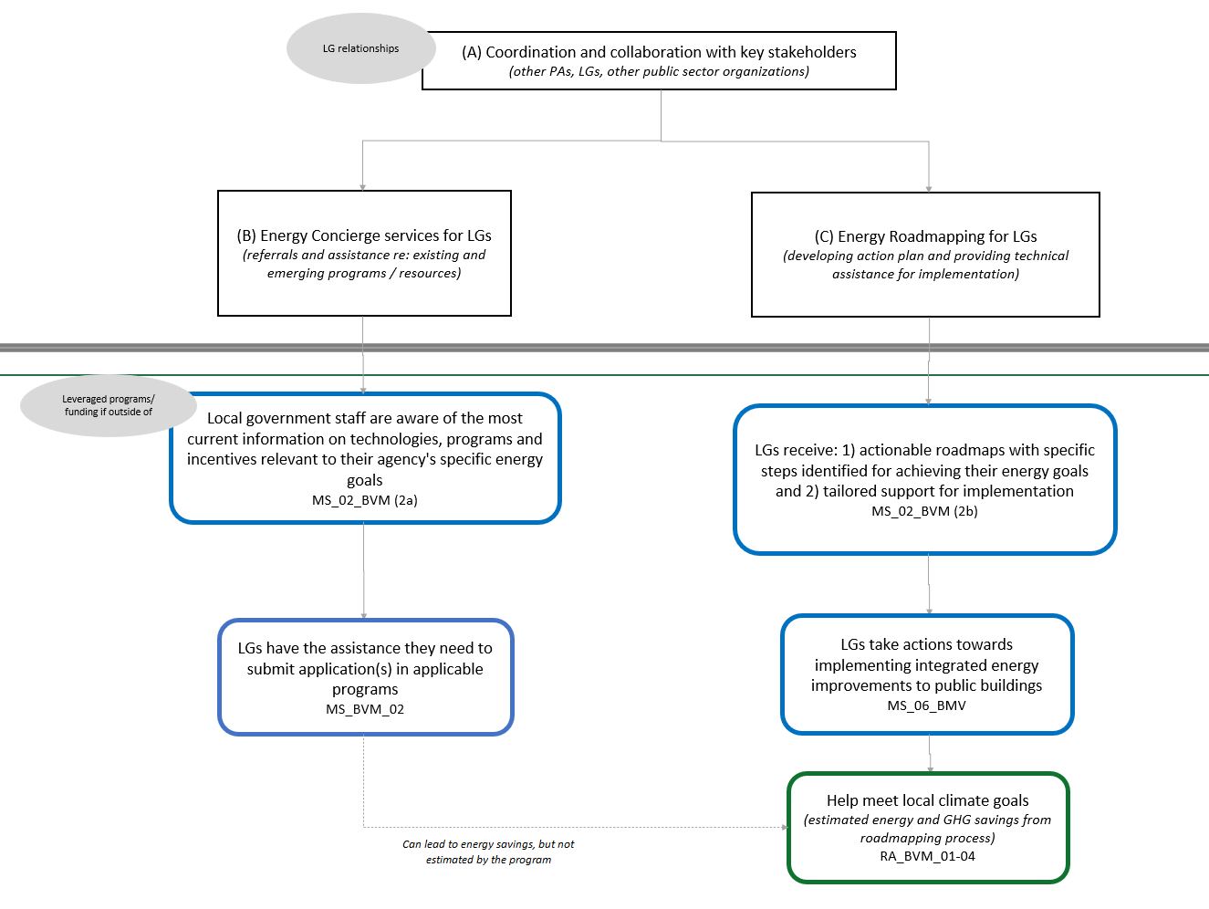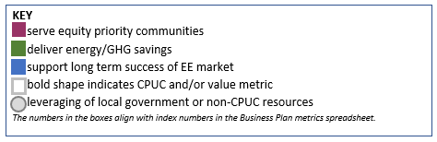

3. Process Flow Chart

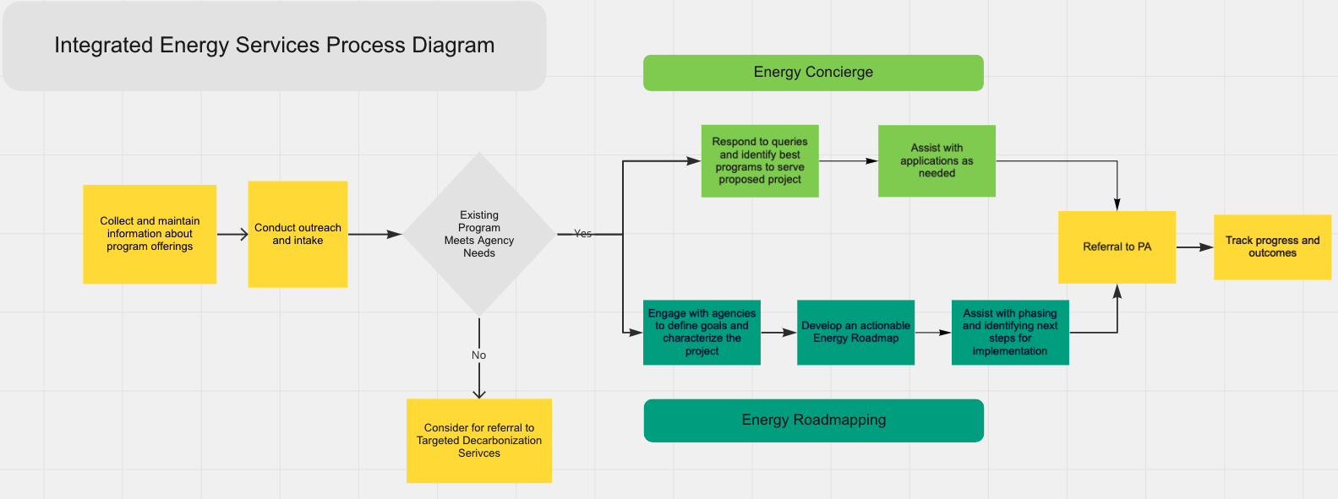

4. Incentive Tables, Workpapers, Software Tools

Not applicable. The program does not provide incentives for measures and does not claim any savings.

5. Quantitative Program Targets

|  |  |  |  |  |  |  |  |  |  |  |  |
| --- | --- | --- | --- | --- | --- | --- | --- | --- | --- | --- | --- |
| Metric | Method | | | Targets | | | | | | | |
|  | |  | | **2024** | | | **2025** | | | **2026** | **2027** |
| Energy Concierge Referrals | | | Count of calls in which the Energy Concierge provides referrals or other assistance for municipal building projects. | | 50 | | | 50 | | 50 | 50 |
| Energy Roadmaps Completed | Count of Energy Roadmaps provided to a local government. | | | 4 | | 8 | | | 10 | | 10 |

6. Diagram of Program

The diagram below shows linkages among BayREN’s portfolio of programs. Additional linkages to other programs will be explored through BayREN’s existing Joint Cooperation Memorandum and other ongoing coordination processes among the energy efficiency PAs.

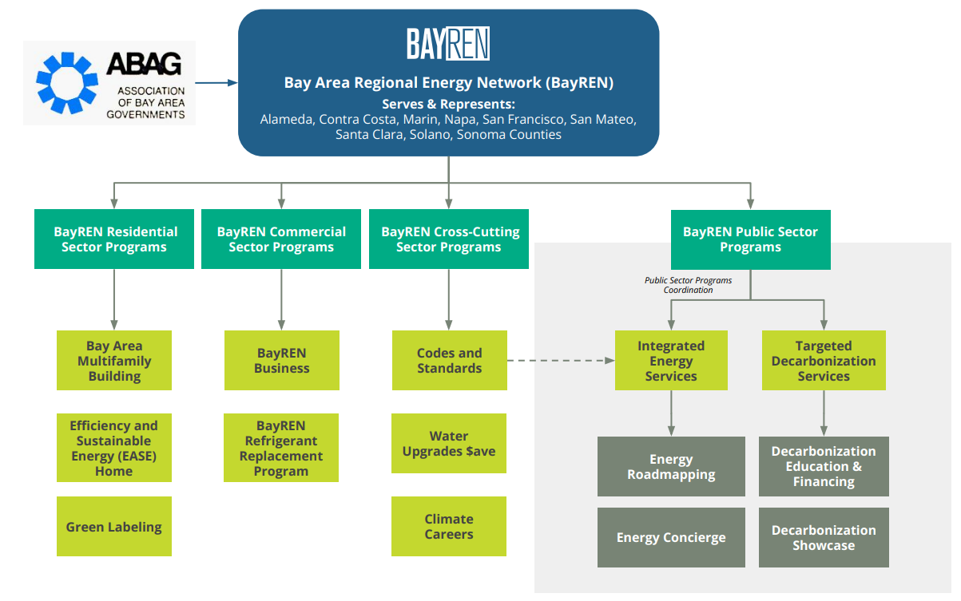

7. EM&V

BayREN will ensure that data collection activities are embedded in the IES program design to capture the information necessary to meet evaluation requirements and to expand the understanding of local government needs and best practices related to integrated energy projects. A database will be used to track information about the local governments, roadmaps, projects and goals, referrals, and other details that will help show the impact of the IES program. Although specific energy savings metrics are not directly tied to this program, the estimated energy savings reported as indicator values will be based on standard engineering calculations of energy savings. All data collected will be available for evaluation upon request by the CPUC.

8. Normalized Metered Energy Consumption (NMEC)

Not applicable

1. The Energy Roadmapping subprogram will build off BayREN’s [Municipal Zero Net Energy/Zero Net Carbon Assistance Program](https://www.bayren.org/local-government-resources/zero-net-energyzero-net-carbon-assistance-municipal-buildings), which provided free engineering technical assistance to help local governments retrofit or construct buildings to meet zero net energy (ZNE) or zero net carbon (ZNC) goals.
2. [California State Controller](https://publicpay.ca.gov/Reports/SpecialDistricts/SpecialDistricts.aspx?year=2020)
3. This would utilize the Energy Concierge Service’s database and experience.
4. Local governments typically have several energy-related goals and intentions for their buildings, such as energy efficiency, climate action and resilience, yet achieving these goals will all involve considering how equipment, renewables, storage and grid-integration are configured. For example, implementing energy efficiency improvements to a building can allow for a smaller HVAC system. Similarly, while the objective of automated demand response (ADR) and storage programs may be to manage peak demand, a local government may also want to use these systems for more prolonged periods as back-up generation or to participate in wholesale power markets. These considerations affect not only the sizing and types of storage but the capacity of the heating equipment, the building circuitry, and the control schemes.
5. [Integrated Energy Efficiency and Demand Response Programs](https://www.aceee.org/sites/default/files/publications/researchreports/u1906.pdf). Dan York, Grace Relf, and Corri Waters. September 2019 U1906 © American Council for an Energy-Efficient Economy.