➕

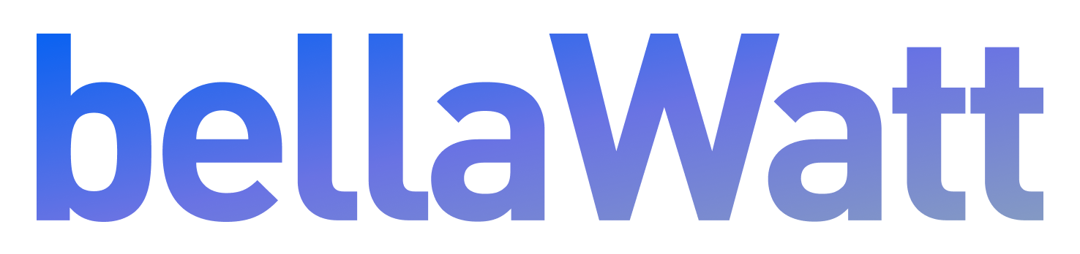

PG&E Marketplace Refresh

Implementation Plan [Draft]
March 14, 2022

Table of Contents
Table of Contents 2
Program Overview 4
Program Budget and Savings 4
1. Program and/or Sub-Program Name 4
2. Program / Sub-Program ID number 4
3. Program / Sub-Program Budget Table 4
4. Program / Sub-Program Gross Impacts Table 5
5. Program / Sub-Program Cost Effectiveness (TRC) 5
6. Program / Sub-Program Cost Effectiveness (PAC) 5
7. Type of Program / Sub-Program Implementer 5
8. Market Sector(s) 5
9. Program / Sub-Program Type 5
10. Market channel and Intervention Strategies 5
Implementation Plan Narrative 6
1. Program Description 6
Program Objectives 6
2. Program Delivery and Customer Services 7
3. Program Design and Best Practices 7
4. Innovation 9
5. Metrics 12
User Metrics 12
Performance Metrics 12
Customer Satisfaction (CSAT) 13
6. For Programs claiming to-code savings 13
7. Pilots 13
8. Workforce Education and Training 13
9. Workforce Standards 13
10. Disadvantaged Worker Plan 13
11. Additional information 14
Supporting Documents 14
1. Program Manuals and Program Rules 14
2. Program Theory and Program Logic Model 15
3. Process Flow Chart 17
4. Incentive Tables, Workpapers, Software Tools 18
5. Quantitative Program Targets 18
6. Diagram of Program 18
7. Evaluation, Measurement & Verification (EM&V) 19
8. Normalized Metered Energy Consumption (NMEC) 20
9. Population-level NMEC Programs 20

The following information is provided to the CPUC to house on the California Energy Data and Reporting System (CEDARS), in accordance with CPUC decisions and Staff guidance.

Program Overview
Marketplaces are a place of information exchange, value found, and delight. ZappyRide and Bellawatt's Marketplace Refresh implementation aims to create a more centralized location for customers to find added value from their utility, leading to better customer satisfaction and more realized benefits.
ZappyRide and Bellawatt's solution evolves the current marketplace model beyond residential products—incorporating a full suite of customer-facing products, programs, and tools offered by PG&E.
This array of offerings will be presented in a simple, easy-to-use way that educates customers about energy saving opportunities to suit their needs and assist them in taking action.

Program Budget and Savings

1. Program and/or Sub-Program Name
PG&E Marketplace

2. Program / Sub-Program ID number
PGE_Res_002E

3. Program / Sub-Program Budget Table
 | 2022 | 2023 | Total
Implementation | $588,400 | $227,200 | $815,600
Maintenance | $0 | $77,400 | $77,400
Total | $588,400 | $304,600 | $893,000

4. Program / Sub-Program Gross Impacts Table
Not applicable for this program

5. Program / Sub-Program Cost Effectiveness (TRC)
Not applicable for this program

6. Program / Sub-Program Cost Effectiveness (PAC)
Not applicable for this program

7. Type of Program / Sub-Program Implementer
Third Party Delivered

8. Market Sector(s)
Cross-cutting: residential, commercial, industrial, agricultural

9. Program / Sub-Program Type
Non-Resource

10. Market channel and Intervention Strategies
Downstream for PG&E customers
Marketplace will attract customers to use the website by offering tailored solutions which may include products, programs, incentives, services, and/or rates specific to the customer’s needs.

Implementation Plan Narrative

1. Program Description
The online energy marketplace is a unique opportunity to provide a one-stop solution that guides PG&E customers with relevant, timely, and contextual personalization to help them make the best possible decision—all while playing a vital role in PG&E's carbon reduction strategies.
The key challenge in this space is to create an equitable resource that accommodates the vast range of motivations that make up a customer's goals. Each customer comes with unique needs and constraints that include intent, level of knowledge, and timeline.
In order to effectively educate and assist customers with adopting energy management technologies, ZappyRide and Bellawatt will create, operate, and manage a geo-targeted, marketplace website for PG&E that accommodates these diverse customer profiles with the following strategies:
- Champion customer satisfaction and customer benefits as the driving design principle
- Create a top-of-the-funnel journey point to help guide and direct customers
- Incorporate relevant, contextual, and timely personalization to help increase ease-of-use, understanding, and desired customer actions
- Introduce relevant user journeys for non-residential customers
- Build scalability into the information architecture—enabling extensibility to any combination of new product, program, or service types without impacting the smoothness of the user experience

Program Objectives
- Support goals of Assembly Bill (AB) 793
  - Raise awareness of and increase engagement with energy management technology (EMT)
  - Incentives for adopting EMT
  - Educating residential and small-medium business customers about EMT programs
  - Include lower income customer programs
- Simplify customer experience where they are presented with relevant, actionable recommendations for whatever energy-related issues they are looking to resolve

2. Program Delivery and Customer Services
The Marketplace will serve as a key top-of-the-funnel gateway for customers to learn about Energy Efficiency (EE), Electric Vehicle (EV) , Demand Response (DR), Distributed Generation (DG), Resiliency, and Income Qualified (IQ) products and programs. This web-based Marketplace will be available to all residential and non-residential PG&E customers.
Features will be made available via a three phased approach as follows:
Phase 1 – Marketplace Refresh
Phase 1 will be the initial release of ZappyRide and Bellawatt's marketplace solution and include residential products and programs for EE and Resiliency. Products and programs will be accessible in a searchable and filterable manner that allows for expansion to add additional offerings in subsequent Phases 2 and 3.
Phase 2 – Comprehensive Product
Phase 2 will incorporate additional residential product and program offerings to also include EV, DR, DG, and IQ customers. Phase 2 will also introduce support for non-residential products, programs, and tools.
All new products, programs, and tools will be added to the searchable and filterable interface designed in Phase 1 and contain a new multi-step wizard to help users who are unsure where to start. The wizard will be designed in Phase 1 and developed and launched during Phase 2.
Phase 3 – Future State Features
Phase 3 will integrate with PG&E’s recommendation engine that analyzes actual customer energy usage and profile data to develop personalized, actionable recommendations. In addition, ZappyRide and Bellawatt will integrate with PG&E’s rate energy services to provide best rate recommendations, as well as inform customers how Marketplace offerings may impact their rate options and annual energy costs.

Table: Website Requirements by Phase
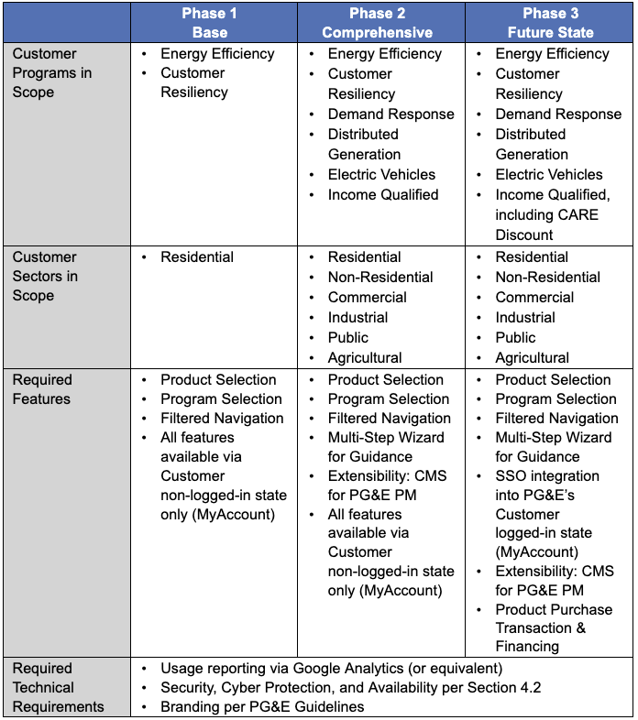

3. Program Design and Best Practices
For many years, ZappyRide and Bellawatt’s tagline has been “user-friendly software for energy companies.” ZappyRide and Bellawatt believe that many of our industry’s products go astray by the large number of stakeholders required to launch each project. The stakeholders are a necessity—a utility cannot launch a product without at least the program staff, legal, marketing, and digital strategy’s review. ZappyRide and Bellawatt minimize this by endlessly advocating for the user first.
ZappyRide and Bellawatt believe in this so much that user-testing is ongoing throughout the project, and schedules are designed around a process called 3Phase Delivery where ZappyRide and Bellawatt lean heavily on user-testing both up-front during Design, and at the end during Delivery. As a result, significant progress is made in improving the products that are built.
New product or product refresh efforts include Ideation and Design methods such as in-depth interviews and surveying. Optimization efforts to de-risk or improve existing usability include card sorting and prototyping. Evaluation methods measure product performance against targets, where ZappyRide and Bellawatt prefer to rely on usability testing and benchmarking, along with A/B testing.
To deeply understand users, ZappyRide and Bellawatt establish Personas informed by user research that identifies common patterns in needs, motivations, goals, and pain points. These Personas are then used to inform product designs and feature prioritization.
ZappyRide and Bellawatt establish Personas through a mix of qualitative and quantitative research, including novel proprietary methods. Qualitative research includes exploratory in-depth interviews, participant observation, market research, and surveying. Quantitative research includes data mining and surveying.
User research determines:
- What are the primary problems and/or pain points that customers are facing?
  - What barriers prevent them from having a successful interaction with a product?
- How are they currently attempting to solve the above problems?
- What are the optimal ways to help achieve their goals?
- In-scope and out-of-scope personas
ZappyRide and Bellawatt translate these insights into feature requirements, user flows, information architecture, and ultimately full featured designs & prototypes.
To develop unique solutions, ZappyRide and Bellawatt prefer to lead structured ideation sessions with relevant stakeholders to understand and map problem and opportunity areas. In the process, ZappyRide and Bellawatt apply design thinking methods with market-research-informed contextualization to initiate outside of the box ideation.

Design Thinking Method
- Empathize — Conduct research and develop an understanding of users
- Define — What are their needs?
- Ideate — How can they be solved?
- Prototype — Building a tangible wireframe
- Test — Share prototype with users for feedback
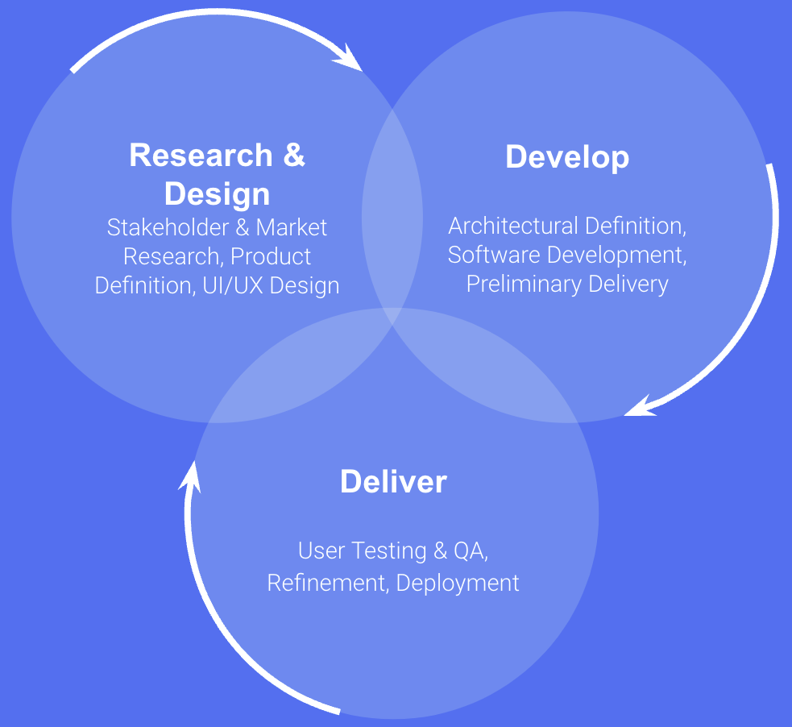
- Repeat as necessary

4. Innovation
The current industry standard for online energy marketplaces relies on a certain level of upfront consumer knowledge which can stymie the discoverability of relevant EE and DSM opportunities. The modern online consumer's expectations have evolved to prioritize easy access to detailed product and program information, reviews, and recommendations—all in a streamlined, easy to navigate online experience.
Given this increasingly common need, the primary innovation of this program introduces personalization and intelligent guidance to recommend relevant products, programs, and services based on individual customer profiles.
Customers will be provided actionable recommendations, starting points, and access to real forecasted benefits by leveraging available customer information such as:
- Demographic
- Enrolled rate
- Location
A second component of this program's personalization innovation will incorporate an optional wizard questionnaire prompt. This feature will provide customers with tailored search results based on inputs including but not limited to the following:
- Customers can enter address, zip code, type of building, and household income range to identify available programs and incentives for which they are eligible.
- Customers can enter their objective (e.g., energy savings, EV purchase, solar options, resiliency) and their project budget. The Marketplace will then be able to provide program or incentive recommendations to meet their needs.
- In addition to these inputs, flexibility will be built into the wizard to provide the option to customize and add more parameters such as average monthly utility bill to further improve personalized recommendations.
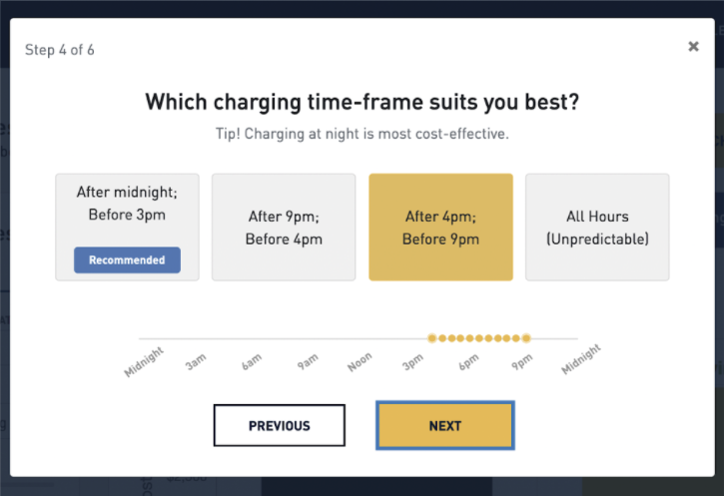
Example of a wizard flow
For the final phase of this program, personalized "Action Plans" will be created for customers—intelligently guiding customers to optimal solutions for their needs based on available data. For example, if data indicates that a customer is enrolled in CARE or known to be income qualified, the Marketplace may highlight which products are available for ESA-qualified customers.)
The end result is a frictionless, holistic experience for PG&E customers that intelligently navigates them to the products and programs that will help them achieve their respective goals.

5. Metrics
ZappyRide and Bellawatt utilize an online data analytics platform for reporting the progress of the program real-time or near real-time.
At a minimum, the dashboard will track the following activity both by each customer sector (residential, commercial, etc.) as well as the total across all sectors:

User Metrics
- # of Visits and # of Unique Visitors
- Time on Site
- Returning Visitors
- # of Page Views
  - Page Views per Visit
- Bounce Rate
- Geolocation (both website traffic and purchases)
- Device
- Visits by product or program category
- Top Pages Viewed
- Top Brands
- Top Products
- Top Programs

Performance Metrics
- Number of users and sessions, average session duration, sessions per user
- Bounce rate
- Abandonment rate
- Referral sites (where did the user come from)
- Questionnaire completion rates
- Returning visitors
- Number of shares and comments on social media
- How many users followed through on Marketplace's recommendation
  - Click-through rate
  - Click to submit
- Page Load Response time
- Workload statistics by day by hour (peak times)

Customer Satisfaction (CSAT)
Customer surveys will be performed and reported on a quarterly basis. Surveys will focus on the customer’s satisfaction with the PG&E Marketplace functionality (visual appeal and ease of understanding), ability to drive awareness of PG&E products and programs and the influence the site had on the customer’s next steps.
Survey results will include customer complaints and resolution times—along with feedback from customers on how the PG&E Marketplace user experience can be improved.

6. For Programs claiming to-code savings
This section is not applicable to the PG&E Marketplace program.

7. Pilots
This section is not applicable to the PG&E Marketplace program.

8. Workforce Education and Training
Marketplace will direct individuals looking for courses on specific residential or non-residential topics to PG&E’s suite of free classes, ranging from Induction Cooking to Energy Audit Skills to Heat Pump HVAC Installation.

9. Workforce Standards
This section is not applicable to the PG&E Marketplace program.

10. Disadvantaged Worker Plan
This section is not applicable to the PG&E Marketplace program.

11. Additional information

Supporting Documents
Attach the following documents (in PDF format):

1. Program Manuals and Program Rules
There are no eligibility requirements for a customer to use Marketplace as it is a publicly-available online platform with no restricted access.

2. Program Theory and Program Logic Model
Goals / Objective:
Evolve the traditional marketplace archetype into a personalized guide that seamlessly connects utility customers to a number of different energy-related products, programs, and tools — simplifying a historically confusing user experience.
Inputs / Barriers:
- No single starting point to facilitate product and program discovery
- Customers are expected to have upfront knowledge prior to participating
- Lack of discoverable opportunities for non-residential customers
- Financial constraints and a lack of trust that energy management technologies are relevant to a customer's unique need.
Activities:
- Create and operate end-to-end product and program marketplace
- Implement robust analytics platform for improved reporting and behavioral insights
- Leverage customer data to create relevant, timely journeys for diverse customer profiles
- Introduce program searchability bundled alongside products and programs
- Create questionnaire wizard and action plans based on customer inputs to simplify decision steps
Outputs:
- Customer visits, engagement metrics, and bounce rates
- Customer satisfaction and Net Promoter Score
- Program enrollment rate
- Tool usage rates
Short-term Outcomes:
- Increased customer confidence and education in intervention opportunities
- Increased opportunity for LMI and non-residential customers to benefit
Mid-term Outcomes:
- Greater participation spurs investment and innovation
- Utility becomes ally and source of truth for customer
- Improved grid resiliency through increased product adoption
Long-term Outcomes:
- Raise consumer expectation and performance from EE products
- Enable complete home electrification
- More predictable, precise load management
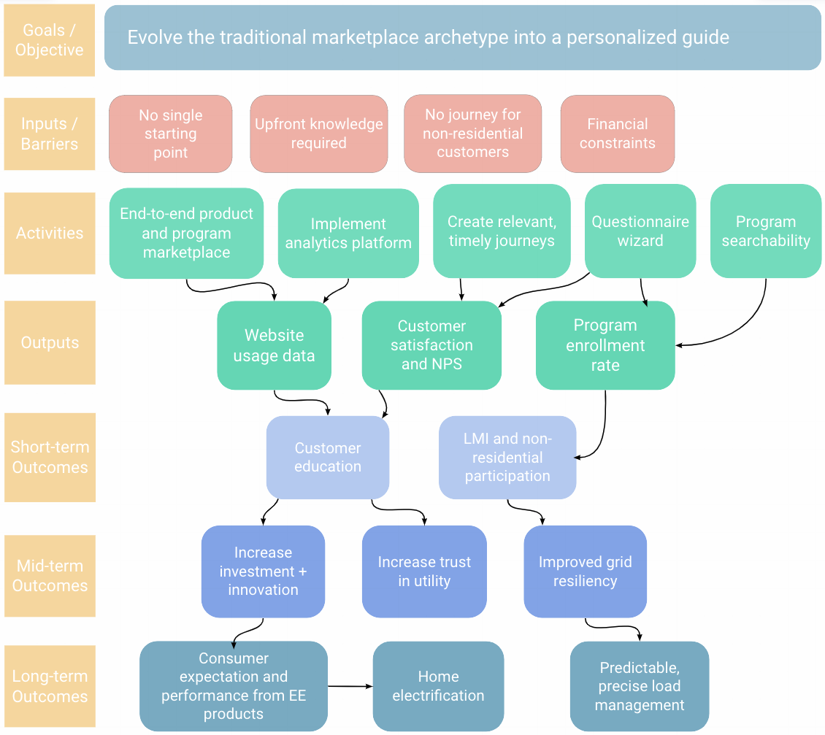

3. Process Flow Chart
The following diagram illustrates the flow for PG&E customers leveraging personalization innovations (outlined in the above Section 4. Innovation) to discover products and programs that best suit their goals.
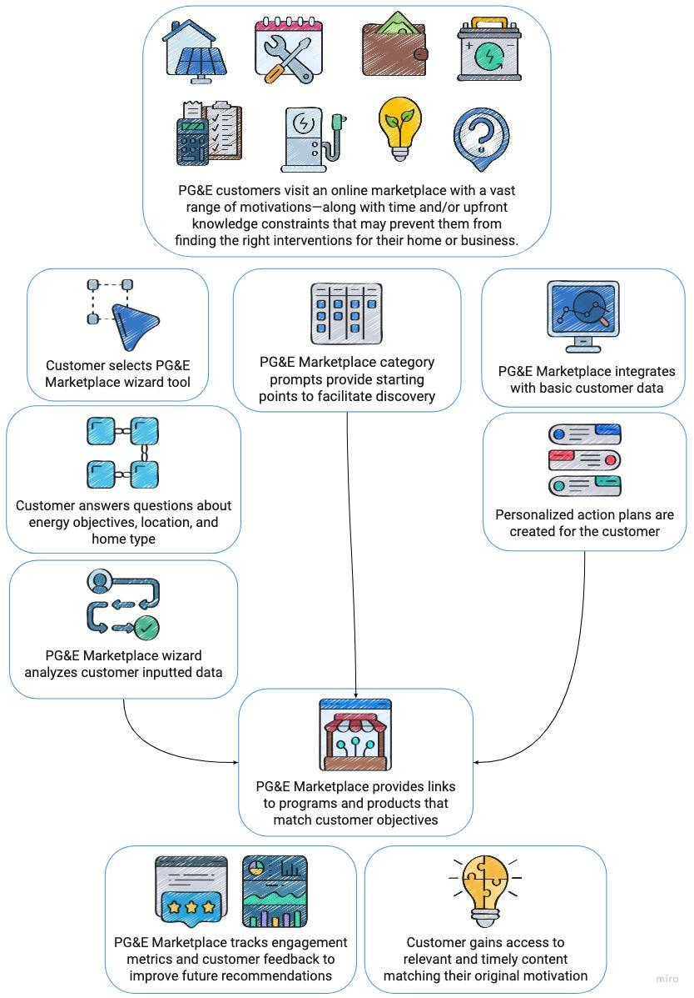

4. Incentive Tables, Workpapers, Software Tools
This section is not applicable to the PG&E Marketplace program.

5. Quantitative Program Targets
The PG&E Marketplace program does not have any quantitative program targets other than key performance indicators, which include customer satisfaction and QPL completeness.
Customer Satisfaction will be measured by quarterly customer surveys related to the satisfaction of using the site, information provided, and functionality—including Net Promoter Score.
QPL Completeness will be reviewed and measured on a monthly basis, with 90% complete product fields as the established baseline.

6. Diagram of Program
The following diagram outlines how PG&E Marketplace will cross-link to other PG&E properties and to external channels.
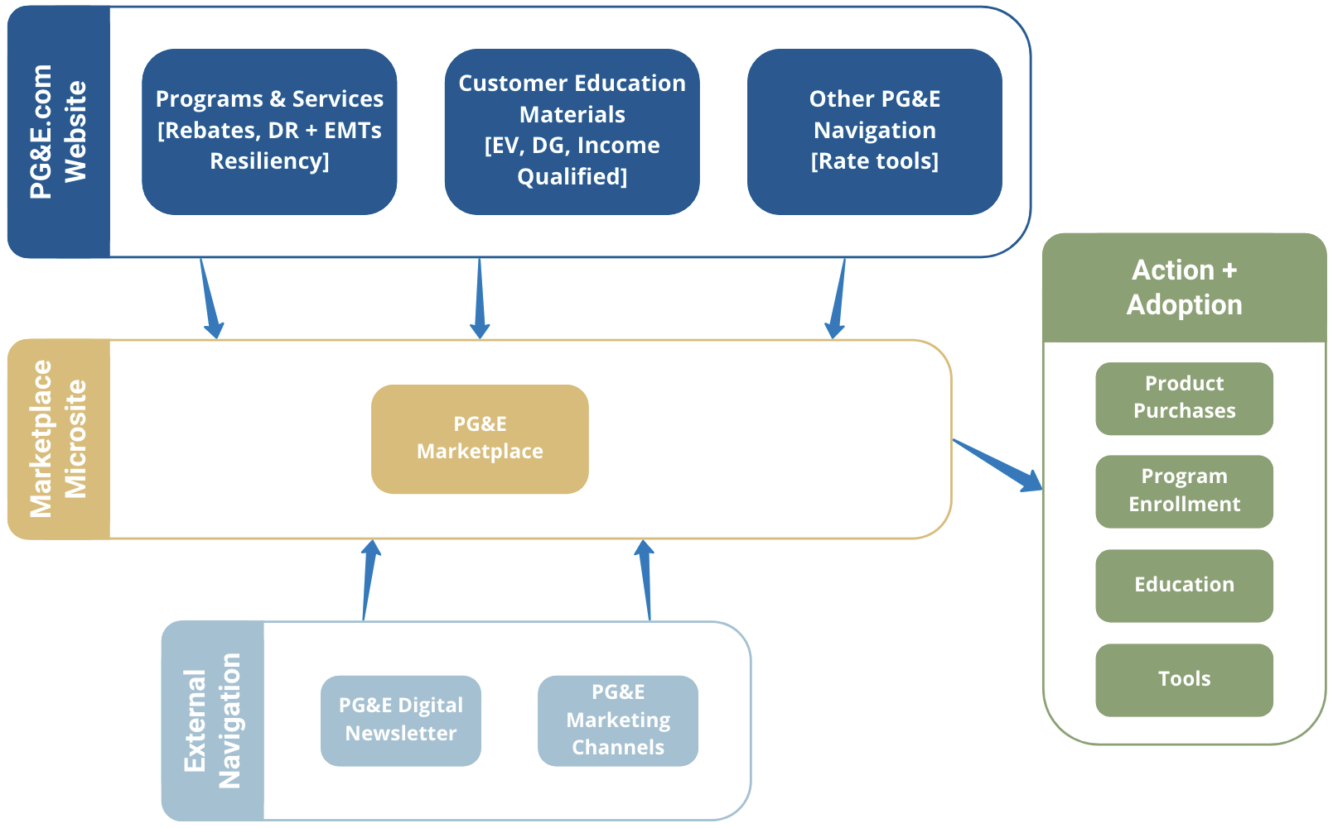

7. Evaluation, Measurement & Verification (EM&V)
ZappyRide and Bellawatt will comply with all CPUC and PG&E directives, activities, and requests regarding the Program and project evaluation, measurement, and verification (EM&V). The following describes the approaches and data that will be collected for ongoing program evaluation.
Project information will be gathered through website activity, tracked with the use of a third-party platform, such as Google Analytics. Customer data and product/program data that is collected, stored, and/or produced by the Marketplace website will be made available on a monthly basis—in both Excel and/or other relevant reporting tool.
In addition, customer surveys will be performed and reported on a quarterly basis. Customer surveys will focus on the customer’s satisfaction with the Marketplace functionality (visual appeal and ease of understanding), ability to drive awareness of Website products and programs and the influence the site had on the customer’s buying decision. At minimum, the survey will consist of rolling customer feedback gathering functionality on the Marketplace. Survey results will include customer complaints and resolution times.

8. Normalized Metered Energy Consumption (NMEC)
This section is not applicable to the PG&E Marketplace program.

9. Population-level NMEC Programs
This section is not applicable to the PG&E Marketplace program.

