Southern California Regional Energy Network

DRAFT

Implementation Plan

Public Agency DER DAC Project Delivery Program

First Filing Date: TBD

- Table of Contents
1. Program Budget and Savings Information 3
a. Program Information 3
b. Program Implementer 3
c. SOCALREN Business Plan Sector 3
d. Program Type 3
e. Intervention Strategies 3
f. Projected Program Budget 4
g. Savings Impact 4
h. Program Effectiveness 4
2. Implementation Plan Narrative 5
a. Program Description 5
b. Program Delivery and Customer Services 5
c. Program Design and Best Practices 5
d. Evaluation, Measurement, and Verification (EM&V): 5
e. Program Performance Metrics 5
f. Quantitative Program Targets 6
g. Pilots 6
h. Program Logic Model 6
i. Process Flow Chart 6
j. Diagram of Program 7
k. Additional information 8
l. For Market Transformation Programs Only 9
i. Quantitative Baseline and Market Transformation Information 9
ii. Market Transformation Strategy 9
3. Appendix: Supporting Information and Documents 10
a. Program Manuals and Program Rules 10
b. Incentive Tables, Workpapers, Software Tools 11

Program Budget and Savings Information

Program Information
Program Name | SoCalREN Public Agency Distributed Energy Resources Disadvantaged Communities Project Delivery Program
Program ID# | SCR-PUBL-B2

Program Implementer
Program Implementer | Yes
SOCALREN Only
SOCALREN – Statewide Lead
Other PA – Statewide Lead
Third Party | X
Other

- SOCALREN Business Plan Sector
SOCALREN Business Plan Sector | Yes
Residential
Commercial
Industrial
Agricultural
Public | X
Codes & Standards
Workforce Education & Training
Finance
Other

- Program Type
Program Type | Yes | No
Resource |  | X
Non-Resource | X

- Intervention Strategies
Primary Intervention Strategy | Yes | No
Upstream |  | X
Midstream |  | X
Downstream |  | X
Direct Install |  | X

- Projected Program Budget

Budget data on CEDARS?: | X | Yes |  | No | If No, then show below:

- Savings Impact
Savings Impact Data on CEDARS?: |  | Yes | X | No | If No, then show below:

There is no savings information because this program has been filed as non-resource.

- Program Effectiveness
Effectiveness Data on CEDARS?: |  | Yes | X | No | If No, then show below:

There is no program effectiveness information because this program has been filed as non-resource.

Implementation Plan Narrative

Program Description
Describe the program, its rationale, and objectives.

The objective of the Southern California Regional Energy Network’s (SoCalREN) Public Sector Programs is to identify and implement energy efficiency (EE) projects that yield electricity and gas savings. A key initiative for this sector is to serve disadvantaged communities (DACs) and ensure equal access to resources and expertise. In addition to EE, many public agencies have indicated interest in obtaining deeper energy savings and greater self-reliance through local renewable energy generation, energy storage, energy management systems and water efficiency technologies. While customers may have the interest and motivation to pursue these types of distributed energy resource (DER) strategies as part of their EE upgrades, they often lack the knowledge needed to take action. In response, the SoCalREN has developed a Public Agency Distributed Energy Resources Disadvantaged Communities Project Delivery Program (DER DAC Program) to address this market gap. Services from this program will increase involvement in IOU and state programs, reduce carbon emissions and offset energy consumption through renewables and other technologies. In addition, it will contribute to the SoCalREN vision of supporting ZNE communities. As a result, participating customers will see a more comprehensive approach for their facilities including an optimized solution for energy and cost savings.

SoCalREN’s aim for the DER DAC Program is to ultimately reduce carbon emissions and increase the sector’s investment in local distributed energy resources. The Program will do this by engaging DAC public agencies, educating them on potential DER strategies and supporting them as they develop these projects. The goal of this program is to continue to maximize EE opportunities while driving the integration of additional DER strategies and increasing the understanding of zero net energy pathways. SoCalREN has the following objectives for its DER DAC Program.

- Increase the number of DAC public agencies that engage their communities in DER
energy actions and strategies.
- Increase the ability of public agencies to meet local, regional, and state DER and DAC energy goals.
- Increase the number of public agencies who engage their constituents about energy and DER Programs and strategies, with a focus on disadvantaged communities.

The DER DAC Program has been designed for public agencies enrolled in the SoCalREN EE PDP (which is the initial in-take program, for additional details regarding the coordination between SoCalREN programs please see Section “j” below, Diagram of Progamt). Potential customers include cities, counties, school districts, tribes, water districts, sanitation districts and other special districts. However, public agencies serving DACs will be the main focus of this program, following CalEnviroScreen 3.0 mapping tools as per the SoCalREN program guidelines.

Program Delivery and Customer Services
Describe how the energy efficiency (EE) program will deliver savings (upstream, downstream, direct install, etc.), how it will reach customers, and the services it will provide.

The DER DAC Program has been designed to deliver energy savings and greenhouse gas emission reductions indirectly through the SoCalREN EE project delivery program. This supports the IOUs’ downstream intervention strategies and programs. DER projects will only be supported in conjunction with energy efficiency. This combined approach will reinforce the relationship between SoCalREN and its participants, increasing customer satisfaction and stimulating the identification of new energy efficiency projects. In addition, customer enrollment for the SoCalREN EE project delivery program will increase due to the additional services provided by the DER DAC Program. The DER DAC Program will only be available for public agencies that enroll in the Project Delivery Program and will act as an add-on service to energy efficiency projects that are being served through the Project Delivery Program.

The program will be available starting in 2019 with DAC public agencies. In the years to follow, it may be offered to all agencies enrolled in the SoCalREN EE PDP. The DER DAC Program will utilize a variety of marketing channels to engage potential customers such as the EE PDP, IOU partnership programs, strategic agency meetings and peer to peer workshops. The SoCalREN has already established strong relationships with utility Local Government Partnerships (LGP), Councils of Governments (COG) and other regional coordinators. These partnerships will be leveraged to understand agencies’ interest in DER and customize program offerings accordingly. Marketing and outreach will be done with DER DAC Program specific collateral. Offerings will be promoted via the SoCalREN website, social media and strategic external partners.

The program has focused its offerings on seven key strategies. Program services for each strategy are described below.

Strategies | Program Services
Demand Response (DR) | Educate customers on potential DR measures and available SCE DR programs for possible participation and support in accessing SCE rebates and advisory services.
Electric Vehicles (EV) Charging Stations | Provide information regarding general cost estimates for installing charging stations as well as information and support in accessing SCE rebates and advisory services.
Solar Water Heating | Provide information and support in accessing SoCalGas and SCE financial incentives for solar water heating systems.
Photovoltaic (PV) and Battery Storage Systems | Perform a high-level review of solar PV and battery storage which will provide information and support in accessing SCE pilots and progams.
Greenhouse Gas Emission (GHG) Reduction Options | Educate customers on their options to reduce GHG through the SCE renewable energy tariff program.
Permanent Load Shifting via energy storage | Provide information and support in accessing facility peak demand and possible load shifting benefits.
Water Efficiency | Conduct high-level review to identify possible water efficiency measures and support in identifying and accessing related incentives or rebates.

In addition to the services above, the program will offer project management support for each strategy. This includes working with third parties and programs to identify and secure additional resources that move the project through implementation. One example is financial support services. The program will educate customers on possible utility and non-utility financial options and support them with the applications if needed. In addition, the program will assist agencies in obtaining technical assistance to develop the project. This includes submitting applications for audits or technical assistance through programs such as the California Energy Commission Energy Partnership Program, Bright Schools Program Technical Assistance and School Project for Utility Rate Reduction Program. Finally, the program will help connect agencies to industry experts who can help move projects into completion. Possible services include engineering/calculations required for grant or rebate application submittals. Going forward, the program will explore the possibility of adding DER specific procurement services for its customers. This would provide competitive and transparent pricing for projects further enabling agencies to streamline the implementation process. Most importantly, these services will be provided to agencies at no-cost.

Program Design and Best Practices
Describe how the program overcomes the market barriers in its market sector and/or end use. Describe why the program approach constitutes "best practices" or reflects "lessons learned." Provide references where available.

Market Barriers
The existing SoCalREN Project Delivery Program supports energy efficiency, but lacks assistance for other synergistic technologies and energy self-reliance strategies. As a result, public agencies either have to navigate these projects on their own or pay for services, both of which are deterrents to project completion. The DER DAC Program addresses these barriers by providing pertinent and relevant information on DER technologies and supporting agencies as they secure the necessary financial and technical resources for implementation. The advisory support and information provided through this program is intended to educate and support the agency as they pursue EE and DER projects and greenhouse gas (GHG) emission reduction goals. The program is designed to work hand in hand with the agency and industry partners to support EE and DER project development and implementation. Information will be customized based on the agency’s initial interest and the characteristics of the facility, specifically as it relates to disadvantaged communities. It will then be presented to the agency in a preliminary report. If an agency is interested in pursuing a strategy after reviewing the information provided, the DER DAC Program will provide assistance in identifying technical support and/or financial resources (as described in Program Delivery and Customer Services section).

Best Practices
The program has identified several best practices and lessons learned which have been incorporated into the DER DAC Program design. First, as described by the Smart Electric Power Alliance, in order to reach State and Federal energy goals, there needs to be a baseline knowledge on DERs and how technologies can be effectively utilized. The DER DAC Program will provide this information through educational materials and references to available programs and resources for DER strategies that aim to build that baseline knowledge for public agencies. Second, the CPUC’s DER Action Plan highlights the importance of performing energy efficiency in conjunction with DERs to avoid unnecessary and costly grid infrastructure upgrades. Therefore, the DER DAC Program along the SoCalREN EE Project Delivery Program, will provide information and help identify financial and technical resources that support a combined DER and EE effort. Third, in order to address differences in public agencies’ understanding and expertise with DER projects, the Program will offer customized project management support and expertise as needed for each project. In addition, the program will
- Gather and ensure accuracy of available resources and programs to support ongoing project performance and savings persistence
- Coordinate with IOU customer representatives to communicate the benefits of non-energy efficiency IOU Programs for maximum impact
- Create and leverage tools and templates to streamline program and improve efficiency of services
- Lead training and development workshops for public agencies to learn about DER topics and build expertise for EE and DER projects

Evaluation, Measurement, and Verification (EM&V):
Describe any process evaluation or other evaluation efforts that the PA will undertake. Identify the evaluation needs that the PA must build into the program. These might include data collection strategies embedded in the design of the program or intervention to ensure ease of reporting and near term feedback, and/or internal performance analysis during deployment.

SoCalREN has incorporated evaluation efforts to help measure the impact of the DER DAC Program as an effective strategy. Specifically, this non-resource program will be evaluated in its ability to provide services, educate customers and funnel projects through energy efficiency programs. The program will embed data collection steps along the project completion timeline to indicate progress towards program metrics related to outreach, awareness and future adoption of DER opportunities in combination with EE. The program will also consider the ever-changing barriers that public agencies face when considering DER projects. Lastly, it will evaluate the potential market for funneled opportunities to IOU DER programs. The SoCalREN customer relationship database (CRM) will be used to record information and generate reports that indicate progress. In addition, the DER DAC Program will seek feedback from its customers annually. Analysis will be conducted to understand the impact program services have had on energy efficiency projects and how the program can improve. The EM&V plan will include an evaluation of the program process in its ability to provide outreach, awareness and the adoption of DER. The program will complete the following to ensure a successful EM&V strategy.

Program Process Evaluation:
- Mapping out the best practices for DER related topics
- Incorporating agency feedback
- Updating outreach strategy based on new programs and resources
- Re-assessing the potential market adoption of DERs in the public sector
- Evaluate driving factors in adopting DERs such as GHG impacts of DER and EE projects

Program Performance Metrics
Describe the program performance metrics. (metric, measurement method, frequency, etc)

The DER DAC Program is proposing the following key performance metrics to be tracked and reported on periodically throughout the program cycle.

No | Metric | Method | Frequency
1 | Number of DER projects where educational and informational services provided | Number of DER project proposals developed for agencies | Annually
2 | Number and type of DER projects (EV, PV etc.) supported with obtaining additional resources | Number of DER technical and financial resources identified and developed for agencies | Annually
3 | Agency satisfaction rating for projects where educational and informational services were provided and for those projects that were supported with additional resources | Integrate within project closeout surveys and annual public agency surveys | At Project Closeout and Annually
4 | External funds leveraged by agencies by type of strategy implemented | Amount of financial funds utilized by agencies for implementing DER strategies through DER Program intervention | Annually
5 | Rebates/incentives leveraged by agencies by type of strategy implemented | Amount of rebates/incentives obtained by agencies for implementing DER strategies through DER Program intervention | Annually

A customer database will be used to track this information to help show the impact of this program. The DER DAC Program will work hand in hand with SoCalREN EE PDP to obtain updates from the customer. This will be done on a quarterly basis and more frequently as needed. Once the information is gathered, it will be entered in the database and then used to generate reports. Metrics will support overall SoCalREN program goals for enrollment and engagement.

Quantitative Program Targets
Provide estimated quantitative information on the number of projects, companies, non-incentive customer services and/or incentives that the program aims to deliver and/or complete annually. Provide references where available.

[To be included in final draft that will be uploaded to EEstats and CEDARs]

Pilots
Please describe any pilot projects that are part of this program and explain what makes them innovative. The inclusion of this description should not replace the Ideation Process requirements currently agreed upon by the California Public Utilities Commission (CPUC or "Commission") staff and Investor Owned Utilities (IOUs). The Ideation Process is still undergoing refinements and will be further discussed as part of Phase III of this proceeding.

This section is not applicable.

Program Logic Model
Model should visually explain the underlying theory supporting the sub-program intervention approach, referring as needed to the relevant literature.
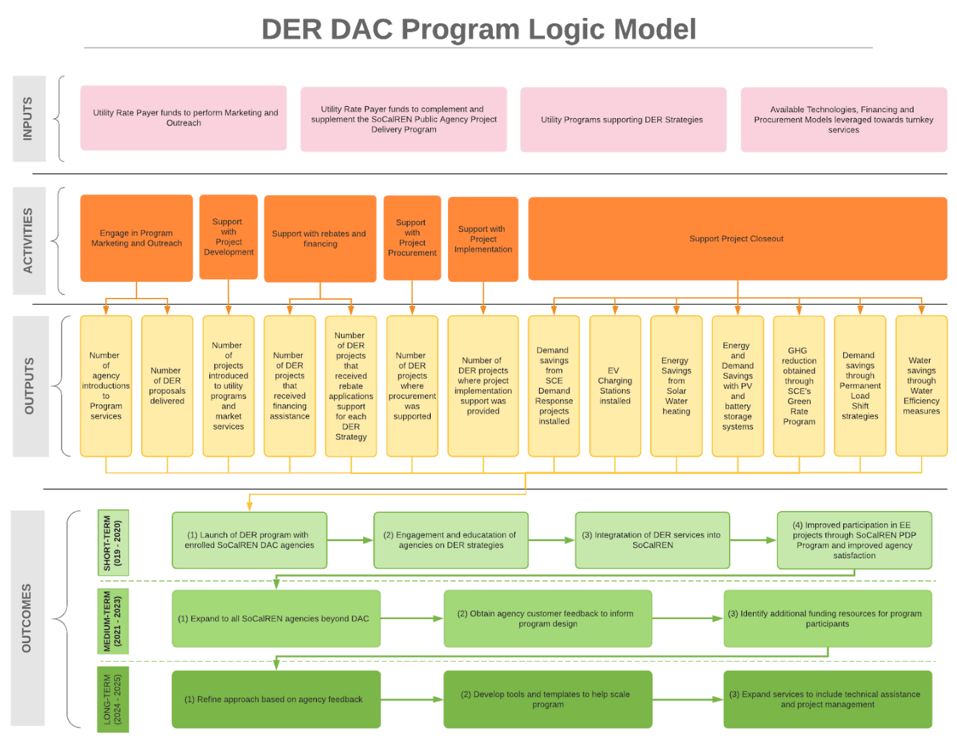

Process Flow Chart
Provide a sub-program process flow chart that describes the administrative and procedural components of the sub-program.
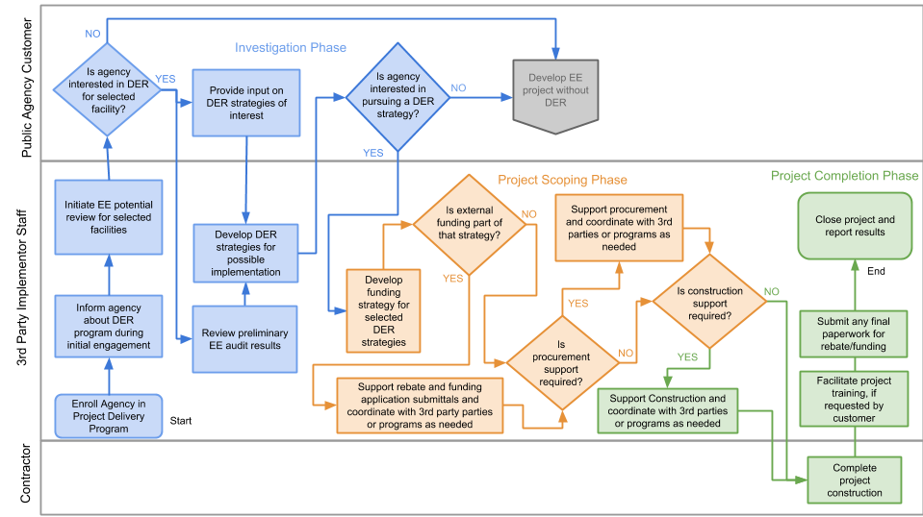

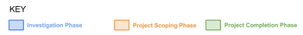

Diagram of Program
Please provide a one page diagram of the program including subprograms. This should visually illustrate the program/sub-program linkages to areas such as:
- Statewide and individual IOU marketing and outreach
- Workforce, Education and Training (WE&T) programs
- Emerging Technologies (ET) and Codes and Standards (C&S)
- Coordinated approaches across IOUs, and
- Integrated efforts across Demand Side Management (DSM) programs.
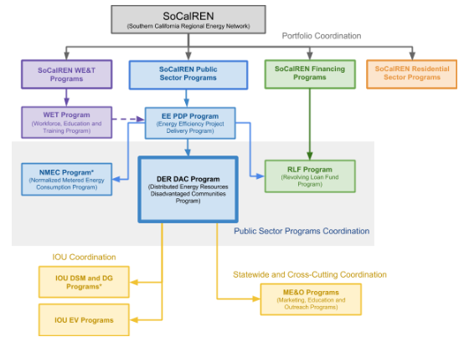

*Resource Program

Additional information
Include additional information as required by Commission decision or ruling. As applicable, indicate the decision or ruling, with page numbers.

This section is not applicable.

For Market Transformation Programs Only

Quantitative Baseline and Market Transformation Information
Provide quantitative information describing the current EE program baseline information (and/or other .relevant baseline information) for the market segment and major sub-segments, as available.

This section is not applicable.

Market Transformation Strategy
Provide a market characterization and assessment of the relationships and/or dynamics among market actors, including identification of the key barriers and opportunities to advance DSM technologies and strategies. Describe the proposed intervention(s) and its/their intended results, and specify which barriers the intervention is intended to address.

This section is not applicable.

Appendix: Supporting Information and Documents

Program Manuals and Program Rules
All programs must have manuals (brochures) for implementers and customers to clarify the eligibility requirements and rules of the program. At minimum, manuals should include:
A short description of supporting materials is provided below. Greater detail will be provided in the program manual. [Program Manual to be included in final draft that will be uploaded to EEstats and CEDARs]

Table 1. Supportive Materials Index
# | Information  Required | Short Description
1 | Customer Eligibility Requirements | SoCalREN EE Project Delivery Program enrolled customers who serve disadvantaged communities
2 | Eligible DER DAC Programs and Resources | Description of eligible IOU and State programs and resources on various DER topics covered by the DER DAC Program
3 | Inputs and Assumptions for DER Strategy Assessments | Detailed description on the inputs and assumptions needed to conduct the high level assessment of PV and battery storage systems and water efficiency measures.

Incentive Tables, Workpapers, Software Tools
Provide a summary table of measures and incentive levels, along with links to the associated workpapers.

The SoCalREN DER DAC Program will utilize analysis tools to inform Public Agencies about solar PV and battery storage systems and water efficiency measures options.

# | Tool Name | Short Description | URL link or location name
1 | REopt | REopt is a NREL developed decision support model used to optimize solar PV and battery storage systems for buildings. | reopt.nrel.gov
2 | Federal Energy Management Program (FEMP) Water Project Screening Tool | The FEMP Water Project Screening Tool is an Excel based tool that analyzes Facility water consumption data to identify applicable water efficiency measures | www.energy.gov/eere/femp/downloads/water-project-screening-tool

oehha.ca.gov/calenviroscreen/report/calenviroscreen-30
www.energy.ca.gov/efficiency/partnership
www.energy.ca.gov/efficiency/brightschools
www.spurr.org
sepapower.org/knowledge/distributed-energy-resources-101-required-reading-modern-grid/
www.cpuc.ca.gov/General.aspx?id=6442458159
IP Guidance from D.15-10-028: "It is in the implementation plans that we want to see at least one metric for each program/strategy/sub-sector/intervention strategy; more than one where appropriate…. Implementation plans will contain metrics, as already discussed. PAs are free to start with a clean slate in developing metrics and associated reporting requirements, but for all programs will continue to provide monthly cost reports, and for resource programs will provide monthly savings data as well."
Codes & Standards program, Emerging Technologies program, Workforce Education & Training program, etc.

