Full Quarterly CAEECC Meeting #37 Summary
Date: Wednesday February 22, 2023
Time: 11:30am - 1:30pm PT
On February 22, 2023, the California Energy Efficiency Coordinating Committee met for its thirty-seventh quarterly meeting via Zoom. There were 75 attendees, including representatives from 19 CAEECC Member organizations and 38 members of the public (see Appendix A for a full list of meeting attendees). This meeting was facilitated by Katie Abrams (Abrams) of Birch Road Consulting and supported by Michelle Vigen Ralston (Ralston) and Suhaila Sikand (Sikand) of Common Spark Consulting, and Susan Rivo (Rivo) of Raab Associates.
Supporting meeting materials are available at: www.caeecc.org/2-22-23-full-caeecc-mtg. Relevant materials include:
- Agenda ( Agenda (Posted 2-1-2023, rev. 2- 21-2023))
- Slide Deck (Slides (Posted 2-1-2023, rev. 3-1-2023))

Overview
Key Meeting Takeaways:
- California Air Resources Board (CARB) is now an ex-officio and California Public Advocates Office (CalPA) is taking a sabbatical for 2023. Membership now includes 21 Members—10 Program Administrators, 5 government entities, 5 implementers, and 4 advocates.
- Authorization of funds for the Compensation Pilot has yet to be confirmed or denied.
- Regardless of the status of the Compensation Pilot Authorization, CAEECC Members voted to continue with the launch of the Evolving CAEECC WG on March 17, 2023 when the Facilitation team will prep to release the application and begin recruitment for a June meeting kickoff
- The Facilitators put forth an initial proposed schedule for 2023 meeting locations, with a virtual meeting on 6/21/23, a hybrid (in person with a virtual conferencing option) meeting on 9/20/23, and a virtual meeting on 11/29/23. Covid verifications were discussed. The facilitation team will circulate a revised proposal on meeting location and covid verifications based on the discussion.
This meeting summary is intended to capture this meeting’s discussion of ideas, concerns, alternative options for proposals and consensus; it is a high-level summary and not a transcript.
Key acronyms used in this document include California Energy Efficiency Coordinating Committee (CAEECC), California Public Utilities Commission (CPUC), energy efficiency (EE), working group (WG), disadvantaged communities (DAC) and hard-to-reach (HTR) communities, justice equity diversity and inclusion (JEDI), CPUC’s Environmental and Social Justice Action Plan (ESJ Action Plan), Program Administrator (PA), Investor-owned utilities (IOU), Regional Energy Network (REN), community-based organization (CBO), market transformation (MT), and Compensation Task Force (Compensation TF).

Introductions and Background
Slides 2 - 13
Abrams and Sikand provided general reminders, a how-to for adding Facilitator emails into Gmail and Outlook inboxes, and Zoom etiquette. It was noted by Lara Ettenson, NRDC, during the meeting that the Outlook demonstration is specific to Apple computers and not PCs. The Facilitators offered personalized support if members using Outlook on PCs need help to categorize Facilitator emails appropriately.
To encourage a space of inclusion and diversity, Abrams reviewed meeting norms and CAEECC Groundrules (see Appendix B for the full list).
To achieve meeting objectives, the facilitation team developed the following agenda:
- Introduction and Background
- Session 1: 2023 CAEECC Planning
- Session 2: Wrapping Up Main Assembly
- Session 3: Optional Assembly with Relevant Updates
Abrams highlighted the new structure for Full CAEECC Quarterly Meetings with the introduction of the Main and Optional Assembly. This distinction is made to allow CAEECC Members to hop off the meeting for the Optional Assembly that contains relevant CAEECC updates that may not pertain to their work specifically.
Participants were asked to introduce themselves through the chat.

Session 1: 2023 CAEECC Planning
Slides 14 - 41

Membership Update
Abrams provided updates on Membership since December of 2022, including the addition of the California Air Resources Board (CARB) as an ex-officio and California Public Advocate's Office’s (CalPA) 2023 sabbatical from membership. CAEECC now has 21 Members, including 10 PAs, 5 government entities, 5 implementers, and 4 advocates (see image below). Abrams highlighted that as agreed upon in November 2022, new membership is on pause for 2023.
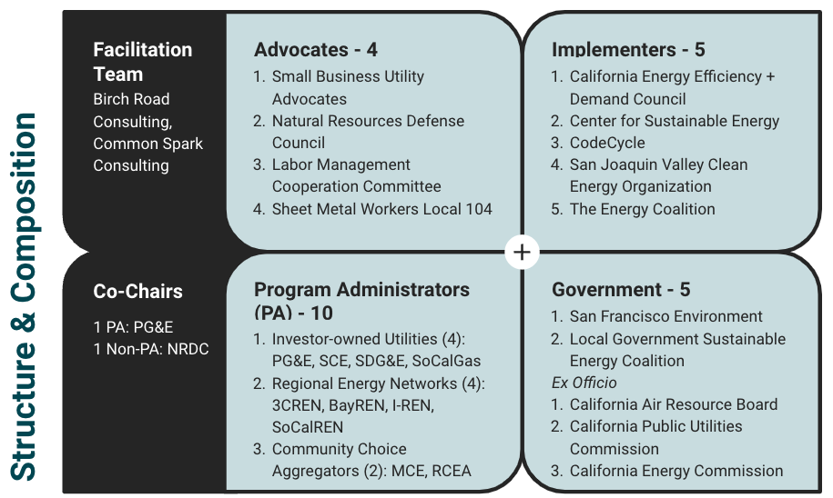
The image above deconstructs the current structure and composition of CAEECC. During the meeting, Lara Ettenson, NRDC, noted a typo within an organization’s name that has since been updated and is reflected in this image.
During the meeting, two notes were made about CPUC Energy Division (ED) staff, notably that staff members Nils Strindberg and Justin Galle will be departing from the CPUC and thus CAEECC. In addition, Emma Tome, CARB, introduced themselves as a new member of the ex-officio team. Due to audio issues, a written introduction was provided after the meeting and presented below:
“I am excited to join as an ex-officio member because I am part of the team working on building decarbonization regulations at CARB and we are very interested in staying connected to energy efficiency and equity efforts happening at CAEECC” (Emma Tome, CARB)

2022 Annual Evaluation Summary
Abrams introduced the results on the 2022 Annual Evaluation for CAEECC. This evaluation is required through the scope of the Facilitation Team, however, Abrams noted the transition from one Facilitation Team to another that occurred in August 2022. As such, the evaluation results are disaggregated by each Facilitation Team as it applies. In addition, Abrams noted the rating scale, from 1 (strongly disagree) to 6 (strongly agree) with 3.5 as the midpoint.
Overall, the Annual Evaluation showed an average meeting success of 4.9 out of 6. The table below provides the high level summary of results. Abrams dove into detail about each survey question available on slides 20 - 26.

 | New CAEECC Facil Team |  | Previous CAEECC Facil Team |  |  | Annual  Ave.
Question | 11/29 | 10/19 | 6/22 | 4/12 | 3/17
Overall, this Full CAEECC meeting was successful. | 5.0 | 5.0 | 5.1 | 4.6 | 4.9 | 4.9
Objectives of the meeting were clearly articulated on the agenda. | 5.3 | 5.3 | 5.3 | 4.9 | 5.3 | 5.2
Objectives of the meeting were accomplished. | 5.1 | 5.1 | 5.1 | 4.5 | 4.8 | 4.9
Presentations and background documents were clear and helpful. | 5.3 | 5.3 | 5.2 | 5.1 | 5.0 | 5.2
CAEECC Members (including PAs) were flexible in seeking outcomes that were potentially mutually agreeable, where applicable. | 5.0 | 5.0 | 5.2 | 4.7 | 4.9 | 5.0
The facilitators were effective in running the meeting (e.g., fostering a constructive and efficient forum, being impartial, and making sure no one dominated discussions). | 5.5 | 5.5 | 5.4 | 5.3 | 5.1 | 5.4
Overall, the online meeting format (WebEx) was smooth and effective. | 5.2 | 5.2 | 5.3 | 4.9 | 4.9 | 5.1
The survey also surfaced a few overall suggestions surrounding engagement generally, timing within meetings, scheduling of meetings, planning before meetings, audience of meetings, and technology used within meetings.
Moving forward, Abrams described a few facilitator takeaways including:
- Dropping the ‘Member Flexibility’ question where appropriate
- Staying on time to accomplish objectives
- Reducing information per slide and including more graphics
There was no CAEECC Member discussion on Annual Evaluations.

Compensation Pilot
Ralston provided a brief update on the status of the authorization of funds for the Compensation Pilot. As of yet, authorization has not been granted, however, the Facilitation Team continues to plan to pursue outreach for the Evolving CAEECC WG, including membership and an Application Review Cohort.

Discussion on Compensation Pilot
- Members discussed the CPUC CBO Compensation Pilot effort and how that effort may be interacting with the funding authorization.
- Members expressed disappointment that the authorization for funding is taking longer than expected.
A more comprehensive digest of the discussion is available in Appendix C.

Evolving CAEECC WG
Ralston provided a tentative timeline, pending authorization of funds for the Compensation Pilot, that presents an Application Review by June, three Evolving CAEECC WG meetings over Summer 2023, a Full Quarterly CAEECC meeting in September with a WG Discussion, a fourth Evolving CAEECC WG Meeting in October, a Full Quarterly CAEECC meeting in November, and an Evolving CAEECC WG meeting in January 2024.
Ralston also discussed the priority and sequence of topics for the Evolving CAEECC WG. She recalled that at the 11/30/2022 Full Quarterly CAEECC Meeting #36, CAEECC Members had elevated a desire to review the sequencing of topics from the Evolving CAEECC WG Prospectus. Ralston noted that the discussion from this meeting will be shared with WG members for their input and consideration. The proposed phases are as follows (note, during the meeting, Ralston clarified that within each Phase, topics would be presented and discussed concurrently):
Evolving CAEECC WG Proposed Sequence of Topics
Phase I
- Purpose, Objectives, Scope of CAEECC
Phase II
- Composition/Representation and Eligibility (CAEECC and WGs)
- Compensation
- Competency Building
- Recruitment & Retention
Phase III
- Facilitation
- Accountability & Reporting
- Additional Topics as needed
After discussion of the priority and sequence, Ralston tested for consensus if CAEECC can launch the Evolving CAEECC WG (as amended by Members during the meeting for clarity in the following statement): If, by March 17, 2023, the CPUC has yet to indicate through a Proposed Decision that it will authorize the Compensation Pilot funding, or if they reject such authorization, CAEECC Members hereby approve to launch the Evolving CAEECC WG regardless. No concerns were raised, and the Facilitation team noted that they will begin the process of launching the WG in mid-March based on the consensus reached today..
For simplification, after the meeting the facilitation team offers this summary: Regardless if the CPUC approves, denies, or has yet to address authorization of Compensation Pilot funding through a Proposed Decision by March 17, 2023, CAEECC Members approve the launch of the Evolving CAEECC WG on such date.

Discussion on Evolving CAEECC WG
- Members clarified that the sequence and priority of topics refers to the agenda for the Evolving CAEECC WG discussion to create recommendations in a final report and not the sequence for which actions/recommendations would be taken.
- Members extensively discussed whether or not the Evolving CAEECC WG should be held back until the Compensation Pilot is authorized. Members agreed that the Evolving CAEECC WG should begin its recruitment process by March 17, 2023 with or without word on the Compensation Pilot.
- A member raised clarification about what ‘alternative means such as workshops, focus groups, and public input’ might entail. The Facilitator clarified and recalled that such a process would allow interested stakeholders with key underrepresented voices to be heard by the Evolving CAEECC WG if unable or infeasible to fully participate in the WG.
A more comprehensive digest of the discussion is available in Appendix C.

CAEECC Hybrid Meeting Location
Sikand introduced the CAEECC Meeting Location Survey and results. She noted the purpose — to solicit feedback on whether CAEECC should meet in person with online video conferencing (what the facilitation team is referring to as hybrid) for Full Quarterly CAEECC Meetings. Sikand emphasized that at all CAEECC meetings, a virtual option will always be available, however this survey was meant to gather insight into in-person options and guidelines. Sikand noted the survey’s components included hybrid meeting start times, hybrid meeting locations, hybrid meeting COVID verifications, and suggestions and accessibility requests. Sikand noted that a ‘fully virtual’ response means a meeting like the one held on 2/22/23.
Sikand reviewed results from the surveys and presented the following Facilitator recommendations for discussion:
Facilitator Proposals for Hybrid Quarterly CAEECC Meetings
Start Time for Hybrid Meetings: 10am PT
Locations for Upcoming Quarterly CAEECC Meetings
- 6/21: Fully Virtual
- 9/20: Hybrid in NorCal - Bay Area
- 11/29: Fully Virtual
- Only CAEECC Members are allowed to join in-person for hybrid meetings
COVID Verifications (also subject to Locational verification requirements)
- Location meeting room is well ventilated and/or has open windows
- Attendee has shown no covid symptoms for the past 5 days
- Attendee has COVID Proof of Vaccination (at least 2 shots of Pfizer/Moderna; 1 shot of J&J)
- Attendee tests negative within the past 2 days (PCR or Antigen)
- Masks mandatory
Accessibility
- An appropriate microphone will be utilized and the environment will be tested for audio clarity to better support virtual attendees for hybrid meetings
In addition, Sikand highlighted suggestions from survey respondents to test and adapt, learn from others who’ve run hybrid meetings, provide food, continue to care for virtual attendees like we do now, keep it virtual as much as possible, and give a little extra time to get back to pre-covid environments. Sikand invited discussion on the Facilitator Proposal and noted the Facilitation Team would further build a plan based on the discussion.

Discussion on CAEECC Hybrid Meeting Location
- Members asked for clarification on the Facilitator Proposal for mask policy. Facilitator clarified the proposal is for mask mandatory policies.
- Members elevated that ‘no covid symptoms’ should apply to no covid/cold/flu like symptoms' to reduce risk of covid spread. While three members agreed, questions were raised about people with chronic illness or allergies and how this broadening of policy may affect their ability to join in-person. Members who initially agreed with the broadened proposal noted that other proposals, like required negative test and masks mandatory, would help reduce risk of covid spread.
A more comprehensive digest of the discussion is available in Appendix C.

Session 2: Wrapping up Main Assembly
Slides 42 - 46

Proposed Topics
Abrams outlined Proposed Topics for the 6/21/23 Meeting, including updates on the Evolving CAEECC WG and Compensation Pilot as well as on Business Plans and Applications (if applicable) during the Main Assembly. In addition, Abrams included PA Solicitation updates for the Optional Assembly. Abrams opened the meeting for CAEECC Member discussion, no Member discussion occurred.

Next Steps for Main Assembly
Abrams summarized the next steps based on the Main Assembly:
- Meeting summary will be posted in 5 business days
- Annual Evaluation: Facilitators to incorporate feedback in 2023 meeting design
- Compensation Pilot: Pending authorization from CPUC
- Evolving CAEECC WG: Facilitation team will move forward on March 17, 2023 with launching the WG.
- CAEECC Meeting Location: Facilitators to build a plan based discussion today

Meeting Evaluation
Abrams provided an overview of the Evaluation Survey from the 11/30/22 Full Quarterly CAEECC Meeting. In general, participants felt the 11/30/22 meeting was successful. Sikand reminded participants about this meeting’s evaluation survey, and invited submissions until March 1, 2023. Through a Zoom poll she also conducted a live meeting evaluation in which responses showed that participants felt the Main Assembly was inclusive, trusting, and effective.
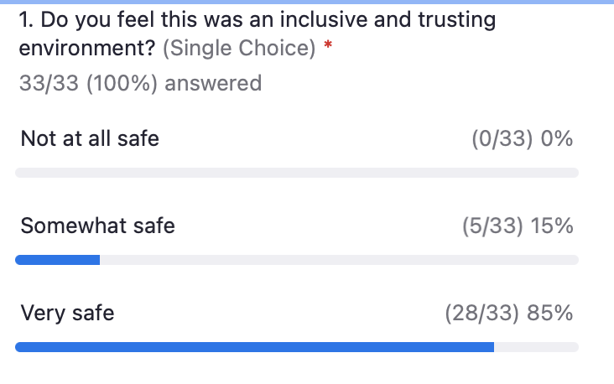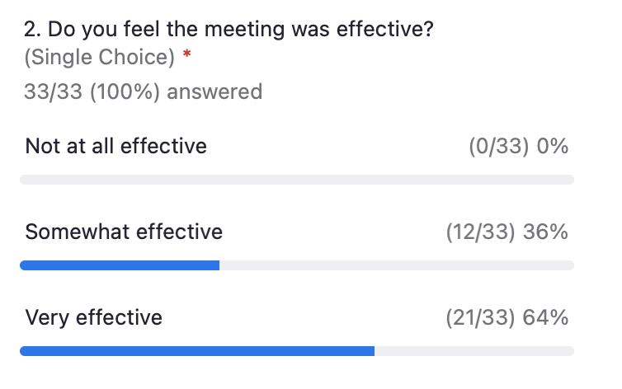

Session 3: Optional Assembly: Relevant Updates
Slides 47 - 89

Relevant highlights from Decision on Third Party Solicitations and Data Access
Jeorge Tagnipes and Justin Galle, CPUC, introduced the Third-Party Solicitation process addressed in Decision 23-02-002. They summarized key changes including:
- Two stage solicitations are no longer required to be the predominant approach
- Performance assurances are no longer a standard, non-modifiable term in third-party contracts
- EE Confidentiality Matrix is adopted
- Procurement Review Group (PRG) shall be informed of contract extensions, performance of existing programs, and certain contract requirements
- Final installation deadline for summer reliability market access program extended to March 31, 2024
- Strategic Energy Management (SEM) programs can be offered beyond the industrial sector
They also highlighted additional issues the decision addressed including the Commision Database Tools, California Analysis Tool for Locational Energy Assessment, and Data Sharing for EE Programs on slides 52 - 56.

Solicitations
Abrams introduced Matt Braunwarth, PG&E, who co-led the Third Party Solicitations topic for PG&E, SDG&E, SoCalGas, and SCE. Braunwarth and Abrams provided time for participants to review the timelines for each solicitation (specifically the stage of each program) and an overview of what is expected ahead. Braunwarth clarified that PG&E’s solicitation for Residential Load Management will be transitioning to a single-stage Request For Proposal (RFP) and will be preceded with a Request for Information (RFI) to help shape and inform the eventual RFP. View slides 58 - 62 for the solicitations.

Discussion on Solicitations
- A member asked for clarification on which solicitations might be moving from a RFA to a RFI or RFP in light of the recent CPUC Decision 23-02-002. Responses collected after the meeting are summarized below:
  - PG&E: most solicitations going forward will be assumed to be single-stage RFPs, and in one case we are experimenting with hosting a Request for Information (RFI) to help inform the RFP that follows (this summarizes their response during the meeting; additional details are available in appendix C on page 18)
  - SCE: no solicitations presented in the meeting will be transitioning to a one-stage process at this time
  - SoCalGas: no solicitations presented in the meeting will be transitioning to a one-stage process at this time
  - SDG&E: Will provide an update in the near future about solicitation process updates.
A more comprehensive digest of the discussion is available in Appendix C.

Market Transformation Administrator (CalMTA)
Margie Gardner, Resource Innovations, provided an update on the newly-created Market Transformation Administrator (CalMTA). CalMTA develops and manages market transformation initiatives with the oversight of an advisory board (the advisory board is currently in process of selection). Gardner specified that eventually, the CalMTA will be transitioned to a non-profit organization. Gardner outlined key leverage points and market interventions used by CalMTA to remove barriers to sustained, long-term efficiency as well as a timeline of events and activities, including the formation for the Market Transformation Advisory Board (MTAB) and development of Market Transformation initiatives (MTI). Gardner elaborated that another key task of the CalMTA is to discuss how MTIs can help support other policy goals such as greenhouse gas (GHG) reduction, workforce, education, and training (WE&T), among others. Gardner outlined the process for initiative development to implementation. Garder invited CAEECC Members to stay involved by signing up at www.calmta.org/get-in-touch.

CPUC Community Based Organization Compensation Pilot
Jesus Torres, CPUC, provided updates on the CPUC’s Community Based Organization Compensation Pilot (CBO Pilot), officially known as the Equity Initiatives and Clean Energy Access Grant Program. Torres noted that AB179 (Ting), appropriates $30M in funding to expand the scope of participation to include “community-based organizations that have not historically engaged with matters before the California Public Utilities Commission.” The program is split into five categories with three grant programs (slide ). Grantees must meet the eligibility criteria outlined on slide 75. Funding is available for expenditure until June 30, 2025 and must be spent by June 30, 2027.

Discussion
- The Facilitator noted another distinguishing feature between the Compensation Pilot and the Public Participation Grant which is Applicant Eligibility, noting that in the latter, individuals will not be eligible.
- A member raised concern about backboning the funding on the flawed Interventor Compensation, noting that the CPUC should call out its clear and present barriers for less-resourced organizations.
- A member requested an extension and clarification on comment periods to which the CPUC staff noted the characteristics of the two upcoming comment periods as noted in slide 86.
- A member raised concern about the amount of CBOs the CPUC has reached in its outreach efforts about this, noting that many of their partners were unaware. The CPUC responded that their list is extensive and will also look for ways to increase outreach.

Evaluation
Sikand conducted a live meeting evaluation through a Zoom poll to better understand the value and effectiveness of the Optional Assembly. Generally, participants felt the Optional Assembly was valuable and they’d be likely to return with the exception of one participant.
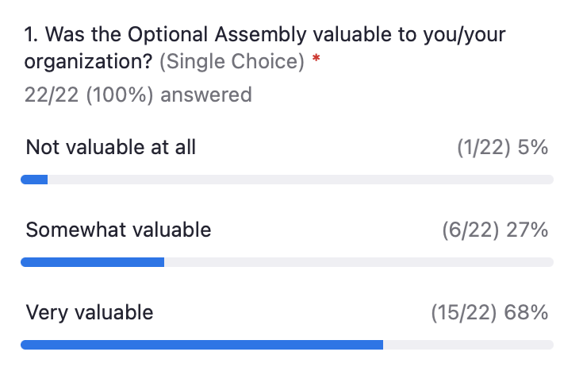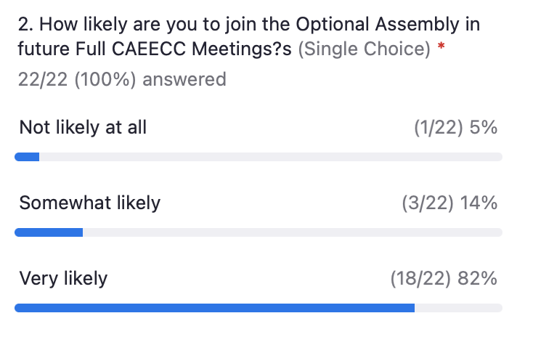

Appendix A: Attendees
Organization | Name
CAEECC Members
3C-REN | Alejandra Tellez
BayREN | Karen Kristiansson
Code Cycle | Dan Suyeyasu
CSE | Fabiola Lao
LGSEC | Demian Hardman-Saldana
IREN/WRCOG | Benjamin Druyon
MCE | Alice Havenar-Daughton
NRDC | Lara Ettenson
PG&E | Rachel Allen
PG&E | Matthew Braunwarth
Redwood Coast Energy Authority | Aisha Cissna
Small Business Utility Advocates | Ted Howard
SCE | Kellvin Anaya
SDG&E | Vanessa Garcia
SF Dept of Environment | Lowell Chu
SJVCEO | Kelsey Jones
SMW Local 104 | Randy Young
SoCalGas | Sebastian Garza
SoCalREN | Lujuana Medina
The Energy Coalition | Laurel Rothschild
Ex-Officio
CARB | Emma Tome
CPUC | Hope Christman
CPUC Energy Division | Justin Galle
CPUC Energy Division | Peter Franzese
CPUC Energy Division | Ely Jacobsohn
CPUC Energy Division | Alison LaBonte
CPUC Energy Division | Jessie Levine
CPUC | Christopher Moore
CPUC | Antoinette Siguenza
CPUC Energy Division | Nils Strindberg
CPUC Energy Division | Jason Symonds
CPUC Energy Division | Jeorge Tagnipes
CPUC | Jesus Torres
Other Interested Stakeholders
2050 Partners | Jennifer Barnes
3C-REN | Erica Helson
AMBAG | Amaury Berteaud
Cadmus Group | Priya Sathe
CALMTA | Stacey Hobart
CalPA | James Ahlstedt
City of Chula Vista | Dennis Gakunga
Clean Energy Counsel | Jeanne McKinney
DAC | Don Arambula
ESP Labs | Mike Myser
Franklin Energy | Brett Bishop
Frontier Energy | Nancy Barba
Frontier Energy | Margaret Marchant
FS Consulting | Frank Spasaro
Google | Chad Ihrig
MW Consulting | Mark Wallenrod
NEEA | Jeff Harris
NRDC | Julia de Lamare
OC Power | Steven Halligan
Ortiz Group | Melinda Lopez
Pacific Corp | Nancy Goddard
PG&E | Caroline Massad Francis
Resource Innovations/ CalMTA | Margie Gardner
Resource Innovations | Taqua Ammar
Resource Innovations | Laura Shapiro
San Diego Community Power | Sheena Tran
SDGE | Meredith Sweeney
SCE | Larry Tabizon
Silent Running | James Dodenhoff
SMW Local 104 | David Vincent
SoCalGas | Genia Hernandez
SoCalREN | Tessa Charnofsky
SoCalREN | Frederick Chung
SoCalREN | Fernanda Craig
The Energy Coalition | Natalie Espinoza
The Energy Coalition | Craig Perkins
Timber Cove Energy Solutions, LLC | Spencer Lipp
Yinsight | Carol Yin
Facilitators
Katie Abrams | Birch Road Consulting
Michelle Vigen Ralston | Common Spark Consulting
Suhaila Sikund | Common Spark Consulting
Susan Rivo | Raab Associates

Appendix B: Meeting Norms & Groundrules

Meeting Norms
To encourage a space of inclusion and diversity, meeting participants were asked to agree to the following meeting norms:
- Make space, take space (share the mic).
- Stories shared here stay here; what is learned here leaves here.
- Share your unique perspective: share your unpopular opinion.
- Generative thinking: "yes, and" instead of "yes, but".
- Listen from the "We", speak from the "I".
- Offer what you can; ask for what you need.
- Be inquisitive.
- Assume best intent and hold each other accountable.
- Be empowered to share impact.

Creating a space of inclusion and diversity

Appendix C: Discussions

Session 1 2023 CAEECC Planning

Compensation Pilot
- Lujuana Medina, SoCalREN: Asked if anyone was able to attend the CBO Pilot Workshop and if there’s any impact of that effort on this authorization.
  - Facilitator: Noted that a CPUC staff will chat today about this in the Optional Assembly. Summarized that the CBO Compensation Pilot is granted $30M from the legislature for engagement of CBOs at the CPUC. Initially, the timing of this effort was not known when we started the Compensation Pilot planning. Summarized that the initial ‘fast-track’ of the authorization that CAEECC was hoping for isn’t what is unfolding and that CAEECC will have to wait for a proposed decision to see where authorization lands..
  - Lujuana Medina, SoCalREN: Provided the powerpoint from the CPUC Equity Initiatives and Clean Energy Access Grant Program Webinar.
- Fabi Lao, Center for Sustainable Energy (CSE): Expressed disappointment that the authorization is taking longer than expected.
- Facilitator: Noted that the delay is not because the CPUC isn’t interested in this, but that they are likely working within their own internal requirements to examine the ability to authorize these funds.

Evolving CAEECC WG
- Fabi Lao, CSE: Suggested to switch ‘Recruitment and Retention’ with ‘Competency Building’.
  - Facilitators: Assumed the WG would discuss all four of these topics simultaneously.
  - Fabi Lao, CSE: Offered insight into their thinking that the WG should do recruitment prior to recruitment.
- Lara Ettenson, NRDC: Confirmed and clarified that no action would be taken for recruitment (for the ‘new’ CAEECC) until after this WG concludes.
  - Facilitator: Confirmed that these are topics for the priority to discuss each topic for building recommendations in a final report, not for actions taken within these topics.
- Fabi Lao, CSE: Thanked for the clarification. Asked what is meant by Recruitment and Retention in this context.
  - Facilitator: Answered that it’s the process by which CAEECC does Recruitment and Retention
- Lujuana Medina, SoCalREN: Clarified if the goal is to get folks engaged by March. Expressed that she doesn’t think it would be hard to reach folks who would want to participate who represent underrepresented voices.
  - Facilitator: Agreed, and noted that if CBOs need funding, then CAEECC doesn’t have an answer because of the current status on the Compensation Pilot
  - Lujuana Medina, SoCalREN: Suggested that this process shouldn’t be hindered by Compensation Pilot authorization and that the Compensation Pilot is like a bonus for the Evolving CAEECC WG. Suggests to kick off the WG without Compensation Pilot.
- Facilitator: Posed again a question for CAEECC Members if CAEECC approves moving ahead with the Evolving CAEECC WG even if authorization for funding is not set by mid-March.
- Lara Ettenson, NRDC: Agreed that the WG should get going at a certain date, however, that the Facilitation Team should wait until that date to move forward with recruitment so there’s no uncertainty about Compensation.
- Randy Young, Sheet Metal Workers (SMW) Local 104: Echoed Ettenson’s comments. Agreed to stick to the proposed timeline so the recommendations from the WG aren’t delayed.
- Facilitator: Proposed the cut-off date in mid-march be March 20, 2023 via the slides.
  - Lara Ettenson, NRDC: Proposed March 17th or 10th for a mid-march date via chat.
- Fabi Lao, CSE: Clarified what setting up separate public workshops might look like.
  - Facilitator: Noted that previously CAEECC discussed doing workshops or outreach or focus groups who may not want to commit to a nine month process. Suggested that if CAEECC moves forward without the Compensation Pilot, the recruitment team may want to be upfront about funding opportunities unrelated to this process (in an effort to be transparent and provide mutuality), the value proposition, and offer alternative engagement opportunities if full engagement is not feasible when engaging with underrepresented perspectives.
- Fabi Lao, CSE: Asked for clarification on how funding might be distributed, noting that reimbursement, while not ideal, might be a way to get folks compensated if authorization for the Compensation Pilot is confirmed.
  - Facilitator: Suggested that the recruitment team commits to do what they can to help them seek funding in any parallel opportunity.
- Facilitator: Asked if folks might not show up for the Evolving CAEECC WG if the Compensation Pilot is not authorized.
  - Lara Ettenson, NRDC: Disagreed that folks wouldn’t show up to the WG only due to the Compensation Pilot not being authorized because there’s other barriers besides funding. Noted, however, that its a phenomenal precedent. Suggested CAEECC should get going on the WG recruitment and maybe help CBOs on the technical side (as noted by participants in the CBO Pilot Webinar).
- Alison LaBonte, CPUC: Discussed that the motion is not looking like a simple ruling, it needs to go to a Commission Decision. Clarified that this community will see Proposed Decision (PD) first. Asked if the mid-march date is for reviewing the PD or the actual Decision for authorization confirmation.
  - Facilitator: Suggested the mid-march date be a deadline for the PD because PDs are usually indicative of where something like this may land.
  - Alison LaBonte, CPUC: Proposed text changes to reflect this clarification.
- Facilitator: Proposed March 17th as the mid-march deadline.
- Fabi Lao, CSE: Asked for a clarification that a resolution would be sufficient.
  - Lara Ettenson, NRDC: recalled that because it’s money, CPUC noted they’d need a ruling for authorization.
  - Nils Strindberg, CPUC: Recalled that ED was hoping that the motion could be adopted through a ruling, but that it’s likely going to be a decision.
- Facilitator: Posed rhetorically if the CPUC CBO Pilot is an appropriate alternative funding source. Sought consensus if CAEECC Members are comfortable moving forward with Evolving CAEECC WG even if funding (Compensation Pilot authorization) is uncertain.
  - Lara Ettenson, NRDC: asked if ex-officio can vote.
    - Facilitator: Confirmed that ex-officio cannot vote on this.
  - Facilitator assumed consensus.
- Alison LaBonte, CPUC: Asked about the next step for this group.
  - Facilitator: Clarified that the Facilitation Team will move forward with the steps laid out in the Compensation Pilot timeline.
  - Alison LaBonte, CPUC: Clarified that the sequence and priority topics for Evolving CAEECC WG wouldn’t change if Compensation Pilot funding is or is not authorized
- Facilitator: Asked the flip of LaBonte’s question, if the decline of authorization, would mean that Evolving CAEECC WG cannot launch. Consensus was agreed that the WG can launch with the acceptance, rejection, or undeclared status of the Compensation Pilot.

CAEECC Meeting Location
- Karen Kristiansson, BayREN: Asked for clarification if the Facilitator Proposal is for mask mandatory or mask recommended.
  - Facilitator: Clarified that the facilitator proposal is for mask mandatory and that slide 39 would be reposted showing the correct proposal (an earlier version of the deck showed “masks recommended” but that was an error).
- Lara Ettenson, NRDC: Proposed that ‘no covid symptoms’ covers sickness besides covid, such as colds and flus.
  - Fabi Lao, CSE: Agreed that covid-like means flu-like symptoms.
  - Randy Young, SMW Local 104: Raised concern that some people say they have allergies but it may actually be covid. Agreed with Ettenson’s proposal.
  - Facilitator: Noted Member thoughts and also raised concern for people with chronic allergy or other chronic symptoms.
  - Fabi Lao, CSE: Noted that as someone with chronic allergies, she uses covid testing to help determine if something is covid
  - Facilitator: Noted that a negative PCR or Antigen test is required within two days of the in-person option.
  - Lara Ettenson, NRDC: Raised that mandatory masks will help prevent covid as well.

Session 3: Optional Assembly

Third Party Solicitation Updates
- We will miss Justin too. Find posting for Justin's position "Senior Energy Efficiency Analyst" that is open right now until 3/1 for all three office locations at https://www.calcareers.ca.gov/CalHRPublic/Search/JobSearchResults.aspx#classid=1867 . You can find posting for backfill for Nils' position at this same link in the near future (within a week).

Solicitation Updates
- Laurel Rothschild, The Energy Coalition (TEC): Asked for clarification whether an RFA will move to a request for proposals (RFP) or RFI for each solicitation in light of the recent CPUC Decision on Third Party Solicitations, which states that two stage solicitations are no longer required.
  - Matt Braunwarth, PG&E: Responded that only the Residential Load Management solicitation is moving from RFA to RFI for PG&E. (After the meeting, for clarification he added the following) PG&E’s solicitation schedule is up to date reflecting solicitations that launched last year are two-stage RFA/RFP, that most solicitations going forward will be single-stage RFP, and in one case we are experimenting with hosting a Request for Information (RFI) to help inform an RFP that follows
  - Vanessa, SDG&E: Will connect back with more information.
  - Sebastian Garza, SoCalGas: After the meeting, Garza clarified that all the SoCalGas programs presented on the slide at the CAEECC meeting are complete or are currently in the “AL + Approval + IP” stage; there are no solicitations listed on the slide that are currently in the RFA or RFP stage.
  - Kellvin Anaya, SCE: After the meeting, Anaya indicated that no SCE solicitations are planned to move to a one-stage process as of yet.

CPUC CBO Pilot
- Facilitator: Distinguished another variation between the Compensation Pilot and the Public Participation Grant, which is the Applicant Eligibility (organizations only in Public Participation Grant).
- Lara Ettenson, NRDC: Raised concern about whether it’s beneficial that CBOs are transitioned to I-Comp until other barriers within I-Comp are alleviated.
  - Stephanie Green, CPUC: Noted this isn’t permanent funding so something needs to be available to turn folks to permanent funding. If this becomes successful, and CPUC can make a case for why this should be permanent funding, then that can change.
  - Lara Ettenson, NRDC: Suggested for the CPUC to at least call out the barriers of I-Comp so the work this Pilot is doing doesn’t get lost.
  - Jesus Torres, CPUC: Agreed and pointed out that in the meantime until there’s permanent funding, their team wants to ensure that CBOs know what the traditional funding mechanism is so they can become familiar.
  - Lara Ettenson, NRDC: Suggested their team works with the stakeholder group that’s trying to fix I-Comp.
- Lara Ettenson, NRDC: Asked if the CPUC could extend the timeframe for comments.
  - Stephanie Green, CPUC: Noted that there’s a big cross-section of CBOs involved in the process. Clarified that there’s two comment periods: this initial one due 2/27 and a longer 30 day comment period after the resolution is published. Noted that the timeframe is already crunched to get the funding setup for June 25.
  - Lara Ettenson, NRDC: Asked if the comment deadline will be shared with listservs like Energy Savings Assistance Program (ESAP).
- Lara: Suggested more outreach because a lot of partners didn’t know about the webinar and for NRDC to cross check the CBOs they work with to find ones that may not be aware.
  - Stephanie Green, CPUC: Noted the CPUC has a good reach of CBOs (through the Arrearages CBO Pilot stakeholder list) within webinars and focus groups, Disadvantaged Community Advisory Group (DACAG), and Low-Income Oversight Board (LIOB). Can look to see if they can host another interaction
  - Jesus Torres, CPUC: Noted their team also works with the CEC to distribute information to their list of CBOs.

