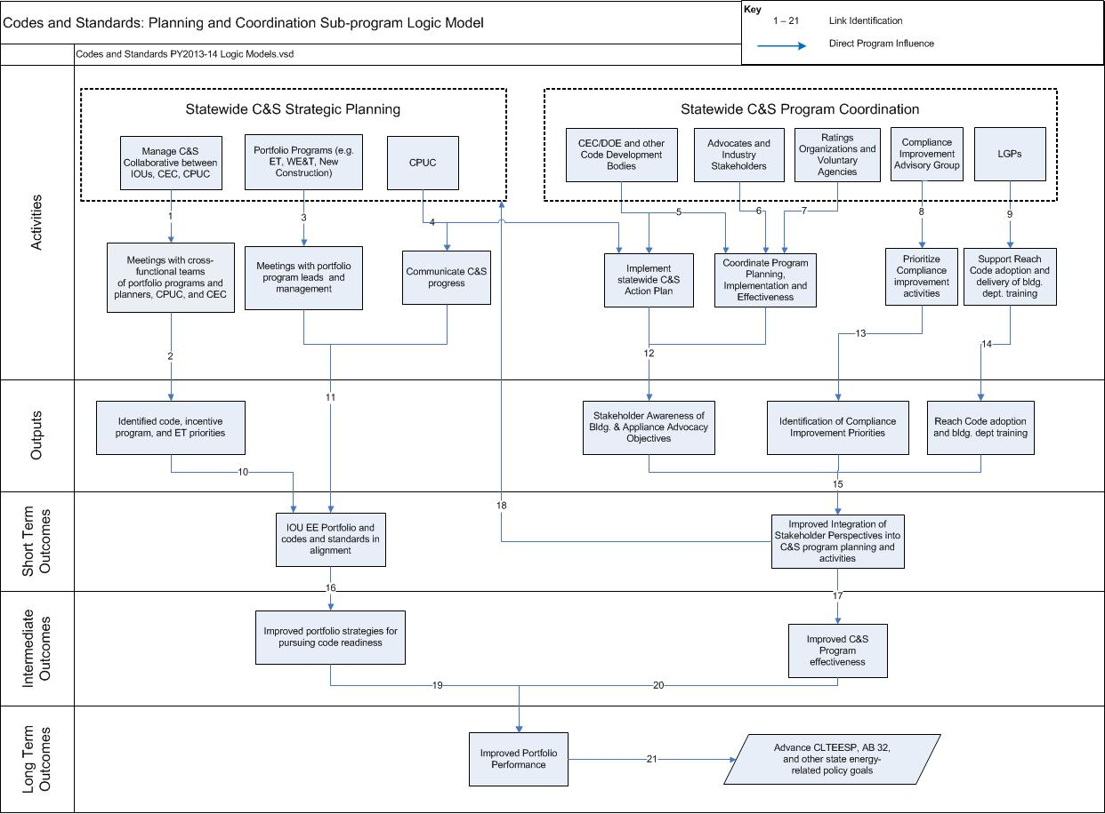

Codes and Standards: Planning and Coordination Program Theory and Indicators
Link | Program Theory/Activity | Potential Indicators
1 | IOUs P&C Subprogram provides a process that maintains a Codes and Standards Collaborative with CEC and CPUC for strategic planning and aligns portfolio planning activities to advance long term strategic goals | - P&C subprogram holds quarterly statewide strategic planning meetings with CEC and CPUC  - Communication with CEC and CPUC Collaborative members  - IOUs document subprogram activities’ alignment with California Long Term Energy Efficiency Strategic Plan (CLTEESP)
2 | IOUs establish cross-functional teams with portfolio programs, the CPUC, and the CEC, to identify codes readiness priorities and other C&S priorities relative to policy goals. | - Coordination meeting with portfolio programs including incentive, emerging technologies, and workforce education and training (WE&T) programs to identify C&S readiness priorities  - Coordination meeting with CEC to identify C&S priorities  - Coordination meeting with representatives from CPUC, and CEC to review C&S priorities relative to policy goals, for example: zero net energy (ZNE), AB 1109, and other Action Plan objectives.
3 | C&S Program coordinates with other portfolio programs to develop an integrated, forward-looking approach to align new construction program offerings with base code and reach code.  C&S program collaboration with the WE&T will prepare contractors and technicians to implement current codes, and prepare them with technical training on advanced technologies to improve code implementation | - Coordination meeting with new construction program managers  - Integrated plan that documents how new construction programs are aligned with base code and reach code requirements  - Coordination meeting with WE&T program managers  - Integrated plan that documents how WE&T training aligns with base code and reach code requirements.
4 | C&S program on-going communication with the CPUC will improve implementation of the C&S Action Plan | - C&S program monthly calls with CPUC personnel to share progress and discuss issues  - Progress report on implementing C&S Action Plan.
5 | C&S program on-going collaboration with state and federal code development bodies including CEC, DOE, ASHRAE, IECC and other code bodies will improve implementation and effectiveness of the C&S Action Plan and other building and appliance related code efforts | - C&S program meetings with CEC and DOE personnel and ASHRAE and IECC committee members to share progress and discuss issues  - Progress report on implementing C&S Action Plan  - C&S program periodic calls and meetings with other code development bodies to share progress and discuss issues  - Progress report on coordination with other C&S efforts
6 | C&S program on-going collaboration, and negotiation with building and appliance related code advocates and industry stakeholder will improve implementation and effectiveness of the C&S Action Plan and success of other C&S efforts | - Periodic calls and meetings with national industry stakeholders regarding building and appliances standards  - Progress report on collaboration and negotiation efforts, implementation of C&S Action Plan and work on other code efforts
7 | C&S program on-going collaboration and coordination with national ratings organizations and voluntary high performance programs will improve implementation and effectiveness of the C&S Action Plan and other C&S efforts | - Periodic calls and meetings with national ratings organizations (e.g. NFRC, CRRC) and voluntary programs (e.g. EnergyStar, CHPS, LEED) regarding building and appliances standards  - Progress report on collaboration and negotiation efforts, implementation of C&S Action Plan and work on other code efforts
8 | Creation and activity of Compliance Improvement Advisory Group will increase compliance activities coordination to improve compliance | - Quarterly meetings with Compliance Improvement Advisory Group regarding compliance improvement activities
9 | Communication and coordination with Local Government Partnership (LGP) will increase compliance activities coordination to improve compliance | - Quarterly updates to LGP Program regarding reach code adoption progress and delivery of training to building departments
10 | IOUs’ cross-functional teams’ coordination and agreement result in statewide codes and standards activities and proposals consistent with IOUs’ portfolio program goals | - Communication among team members including documentation of agreed upon goals and plans.  - Increased feasibility and code readiness of efficient products and practices  - IOU program portfolio goals alignment with statewide codes and standards (CEC) plans and activity, for example: ZNE, AB 1109, and other Action Plan objectives
11 | C&S Program coordination and collaboration with other portfolio programs, and communication to CPUC result in portfolio program goals consistent with statewide codes and standards activities and proposals | - Documentation of agreed upon goals and plans  - IOU program portfolio goals alignment with statewide codes and standards (CEC) plans and activity, for example: ZNE, AB 1109, and other Action Plan objectives
12 | C&S program on-going communication and coordination with all stakeholders leads to stakeholder awareness and understanding of the C&S Action Plan and advocacy, planning and activities. | - Progress report on implementing C&S Action Plan  - Documentation of agreed upon objectives, goals, and plans
13 | CIAG compliance improvement discussions and activities will result in prioritized code compliance improvement. | - Progress report on implementing C&S Action Plan  - IOU compliance improvement activities are aligned with statewide codes and standards (CEC) plans and activity, for example: ZNE, AB 1109, and other Action Plan objectives
14 | C&S program coordination with LGP Program training to building departments will improve understanding of reach code activities  Communication and coordination with Local Government Partnership (LGP) will increase compliance activities coordination and improve compliance | - Quarterly updates to LGP Program regarding reach code adoption progress and delivery of training to building departments  - Reduction in time for building officials to process paperwork  - Reduction in number of compliance mistakes due to resources and training
15 | Communication and coordination with CIAG, LGP and other stakeholders will improve integration of various perspectives into C&S planning and activities  Stakeholder awareness of C&S program advocacy objectives and goals leads to improved coordination and integration of planning and activities | - CIAG, LGP and other stakeholders recognition of C&S benefits, leading to support of activities to optimize codes through enforcement  - Documentation of integration of stakeholder perspective and objectives in C&S plans
16 | Portfolio program goals consistent with statewide codes and standards activities results in improved strategies for pursuing code readiness | - IOU EE programs support test method development and provide collected test data  - Increased market presence and acceptance of efficient products and practices based on IOU portfolio programs
17 | Coordination with all stakeholders will improve C&S program effectiveness | - Technical responses to comments and concerns voiced by stakeholders  - Improved program performance metrics including lower TRC and greater energy savings.
18 | Integration of various stakeholder perspectives into C&S planning and activities enhances statewide strategic planning | - Progress report on implementing C&S Action Plan  - Documentation of agreed upon goals and plans  - IOUs document subprogram activities’ alignment with Strategic Plan
19 | Improved portfolio strategies lead to improved portfolio performance | - Increased awareness and understanding of codes and standards by stakeholders  - Reduction of noncompliant practices and appliances
20 | Improved program effectiveness leads to improved portfolio performance | - Increased awareness and understanding of codes and standards by stakeholders  - Reduction of noncompliant practices and appliances  - Improved program performance metrics including lower TRC and greater energy savings
21 | Improved portfolio performance leads to advancement towards long term strategic goals | - State policy objectives are met to achieve environmental, macroeconomic, and other non-energy benefits

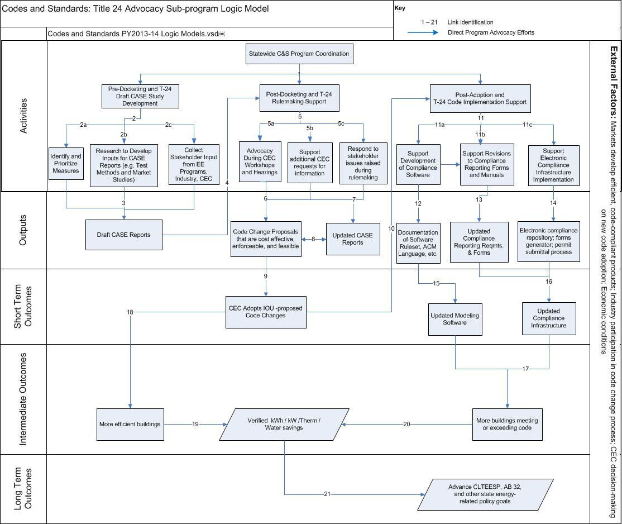

Codes and Standards: Title 24 Advocacy Program Theory and Indicators
Link | Program Theory/Activity | Potential Indicators
1 | C&S Program managers coordinate their program activities to present a united, statewide IOU C&S Program and conduct activities from pre-docketing through post-adoption of T-24 building standards. | C&S Program managers meetings and on-going communication
2 | C&S Program conducts full range of advocacy efforts during pre- rulemaking processes to support successful code change development through outreach and advocacy to stakeholders | - 2a. Initial IOU assessment of measures/products indicates level of measure code-readiness
- 2b. C&S Program documentation of market feasibility and cost-effectiveness
- Documentation of test methods and required test results
- 2c. C&S Program stakeholder meetings, outreach and on-going communication with IOU EE program managers, CEC staff and industry stakeholders
- Documentation of IOU run stakeholder meetings, including invitee list, attendee list and meeting notes
3 | C&S Program conducts initial assessment of code change opportunities based on feasibility, cost-effectiveness, market readiness and acceptance, availability of test methods and data, etc. | - Documentation of compliance research, market feasibility, potential energy savings, and cost-effectiveness  - C&S Program stakeholder meetings, outreach and on-going communication  - C&S Program supported test method development and test data  - Communication with CEC, standard organizations committee members and other stakeholders
4 | C&S program advocacy is presented at public CEC code proceedings | - Codes and Standards Enhancement (CASE) reports filed with CEC docket
5 | C&S Program conducts full range of advocacy efforts to support rulemaking processes and successful code change development | - 5a. Communication with CEC, standard organizations committee members and other stakeholders
 |  | - 5b. CASE reports include additional data, analysis and documentation based on comments raised during rulemaking
- 5c. Code enhancement support documents including compliance research, market feasibility, potential energy savings, and cost-effectiveness
- Written response to stakeholders’ comments and questions
6 | C&S program provides technical responses to stakeholder issues raised in public rulemaking proceedings, including responding to comments and concerns voiced by stakeholders | - Communication with CEC, standard organizations committee members and other stakeholders  - C&S Program input to stakeholder and CEC staff comments and questions on proposed code changes  - CASE reports documenting code change proposals that are cost-effective, feasible and enforceable
7 | CASE reports are revised and updated during the code proceeding process. | - CASE reports documenting code change proposals that are cost-effective, feasible and enforceable  - CASE reports include additional data, analysis and documentation based on comments raised during rulemaking
8 | CASE reports are updated to include proposed code change language and additional information presented during the public rulemaking proceedings | - CEC analysis and workshop discussions, public notices and scheduling of workshops  - Updated CASE reports filed with CEC docket
9 | IOU-proposed code change language is included in the CEC adopted Title 24 (T24) Standards | - Final published CASE reports  - Updated T24 Standards adopted and published by CEC
10 | After new T24 Standards are adopted C&S program initiates efforts to support the CEC in updating code compliance materials | - Communication with CEC, standard organizations committee members and other stakeholders
11 | C&S Program conducts full range of advocacy efforts to support successful code change implementation | - 11a. C&S Program supported compliance software development
 |  | - 11b. C&S Program developed revisions to compliance reporting forms and manuals
 |  | - 11c. C&S Program supported compliance electronic infrastructure development, including electronic repository, pre-processing of electronic documents, and electronic input to the permit process
12 | C&S program develops documentation to revise compliance software requirements to reflect the most recent code updates based on CASE Studies | - C&S program provides compliance software revisions documentation to the CEC
13 | C&S program develops updated compliance reporting requirements and forms to reflect the most recent T24 updates based on CASE Studies | - C&S program provides revisions to T24 Standards manual and forms to the CEC
14 | C&S program supports the CEC in developing a permit repository system, which generates and stores compliance forms | - Communication and meetings with CEC and other stakeholders on repository system development, including electronic repository, pre-processing of electronic documents, and electronic input to the permit process
15 | C&S program documentation of code compliance software revisions is accepted and approved by the CEC | - CEC approves and implements updated compliance software
16 | CEC compliance infrastructure is updated with new compliance manuals and forms, reporting requirements, and a new permit repository system | - CEC approves revised compliance reporting requirements  - CEC approves revised compliance manuals and forms  - CEC develops an electronic compliance repository and new electronic permit submittal process
17 | Improved compliance infrastructure, system and modeling software leads to more buildings meeting or exceeding T24 requirements | - Energy savings calculations submitted for permit approval with compliance rates
18 | New building efficiency (T24) standards lead to more efficient buildings | - Energy savings calculations submitted for permit approval
19 | More efficient buildings result in electric and gas energy savings, demand reduction, and water savings | - Energy savings calculations or building energy and water usage
20 | More buildings meeting or exceeding code result in electric and gas energy savings, demand reduction, and water savings | - Energy savings calculations or building energy and water usage
21 | Adopted and implemented codes lead to advancement towards long term strategic goals | - State policy objectives are met to achieve environmental, macroeconomic, and other non-energy benefits

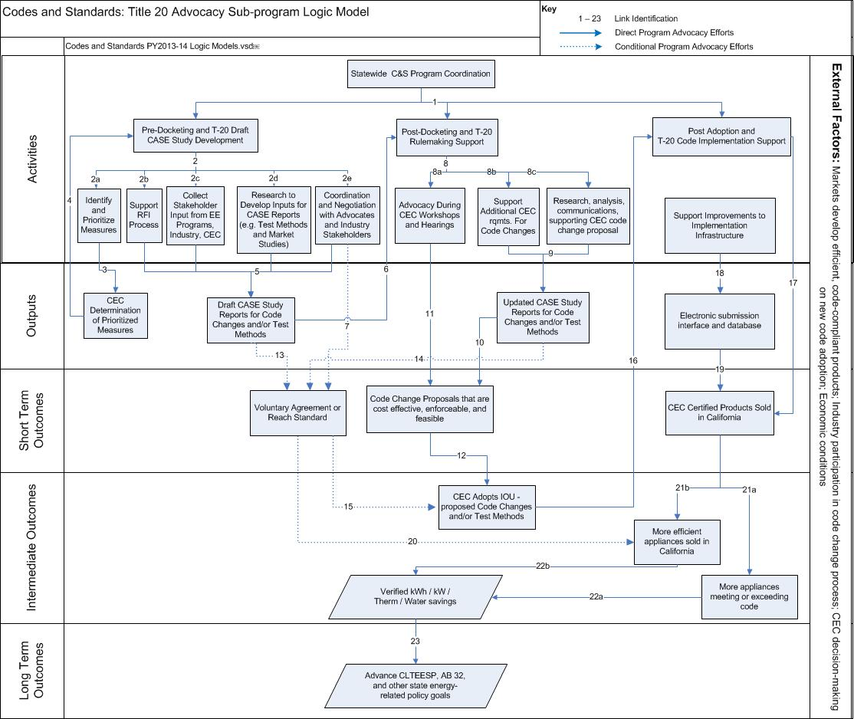

Codes and Standards: Title 20 Advocacy Program Theory and Indicators
Link | Program Theory/Activity | Potential Indicators
1 | C&S Program managers coordinate their program activities to present a united, statewide C&S Program and conduct activities from pre-docketing through post-adoption of T-20 appliance standards. | - C&S Program managers meetings and on-going communication
2 | C&S Program conducts full range of advocacy efforts during pre- rulemaking processes to support successful code change development through outreach and advocacy to stakeholders | - 2a Initial IOU assessment of measures/products indicates level of measure code-readiness
 |  | - 2b. C&S Program support to CEC T20 RFI process
 |  | - 2c. C&S Program stakeholder meetings, outreach and on-going communication with IOU EE program managers, CEC staff and industry stakeholders
- 2d. C&S Program documentation of market feasibility and cost-effectiveness
- Documentation of test methods and required test results
 |  | - 2e. Negotiation meetings with advocates and industry stakeholders
3 | IOUs share the code change screening results with the CEC and coordinate code change proposals with the CEC | - C&S program communications with CEC staff  - C&S program assessments and recommendations presented to CEC
4 | Initial CEC vetting of measures produces list of measures for consideration during the public rulemaking proceedings | - CEC analysis and workshop discussions of initial measures, public notices and scheduling of workshops  - Supporting documentation from C&S Program
5 | C&S Program conducts initial assessment of code change opportunities based on feasibility, cost-effectiveness, market readiness and acceptance, availability of test methods and data, etc. | - Documentation of compliance research, market feasibility, potential energy savings, and cost-effectiveness  - C&S Program stakeholder meetings, outreach and on-going communication  - C&S Program supported test method development and test data  - Communication with CEC, standard organizations committee members and other stakeholders
6 | C&S program advocacy is presented at public CEC code proceedings | - CASE reports filed with CEC docket
7 | C&S program advocacy is adopted voluntarily by industry or into local reach code ordinances | - Industry voluntary agreements and/or adoption of reach code standard based on IOUs C&S program negotiations
8 | C&S Program conducts full range of advocacy efforts to support rulemaking processes and successful code change development | - 8a. Communication with CEC, standard organizations committee members and other stakeholders
 |  | - 8b. CASE reports includes additional CEC requirements
 |  | - 8c. Code enhancement support documents (compliance research, market feasibility, stakeholder outreach, and cost-effectiveness analyses)
9 | CASE reports are revised and updated during the code proceeding process | - CASE reports documenting code change proposals that are cost-effective, feasible and enforceable  - CASE reports include additional data, analysis and documentation based on comments raised during rulemaking
10 | CASE reports are updated to include proposed code change language, test method requirements and additional information presented during the public rulemaking proceedings | - CEC analysis and workshop discussions, public notices and scheduling of workshops  - Updated CASE reports filed with CEC docket supporting code change proposals and test methods that are cost effective, feasible and enforceable
11 | C&S program provides technical responses to stakeholder issues raised in public rulemaking proceedings, including responding to comments and concerns voiced by stakeholders | - Communication with CEC, standard organizations committee members and other stakeholders  - C&S Program input to stakeholder and CEC staff comments and questions on proposed code changes
12 | IOU proposed code change language is included in the CEC adopted Title 20 standards | - Final published CASE reports  - Updated Title 20 Standards adopted and published by CEC
13 | IOUs draft CASE report recommendations is adopted voluntarily by industry or into local reach code ordinances | - Industry voluntary agreements and/or adoption of reach code standard based on draft CASE reports
14 | C&S program provides technical responses to stakeholder issues raised in public rulemaking proceedings, including responding to comments and concerns voiced by stakeholders, which are then adopted voluntarily by industry or into local reach code ordinances | - Industry voluntary agreements and/or adoption of reach code standard based on docketed, revised CASE reports
15 | Development of locally adopted reach code ordinances leads to integration of more efficient building practices into future CEC Rule-making | - Future CEC Title 20 code change proposal and IOU code enhancement proposals based on reach code influenced appliance standards
16 | After new Title 20 standards are adopted C&S program initiates efforts to support the CEC in updating code compliance materials | - Communication with CEC, standard organizations committee members and other stakeholders
17 | The adoption of stringent energy efficient standards accelerates market adoption of efficient technologies | - Increased market presence and acceptance of certified products  - Initial compliance rates
18 | C&S Program promotes development of infrastructure to ensure successful code change implementation | - C&S Program-supported electronic infrastructure development including electronic repository, pre-processing of electronic documents, and electronic input to the permit process
19 | Compliance electronic infrastructure is accepted and adopted by the CEC | - CEC approves and implements compliance electronic infrastructure
20 | Market adoption, accelerated by industry voluntary agreements and/or reach codes, leads to market acceleration | - Increased feasibility and market presence of efficient products and practices
21 | The adoption of stringent energy efficiency standards accelerates market adoption of efficient technologies | - 21a. Increased market presence and acceptance of efficient certified products  - 21b. Initial compliance rates
22 | As market presence of high efficiency models increases, more products sold automatically meet the code requirement and compliance increases | - 22a. Increased market presence of efficient products improved compliance rate  - 22b. Energy and water savings calculations with compliance rates
23 | Adopted and implemented codes lead to advancement towards long term strategic goals | - State policy objectives are met to achieve environmental, macroeconomic, and other non-energy benefits

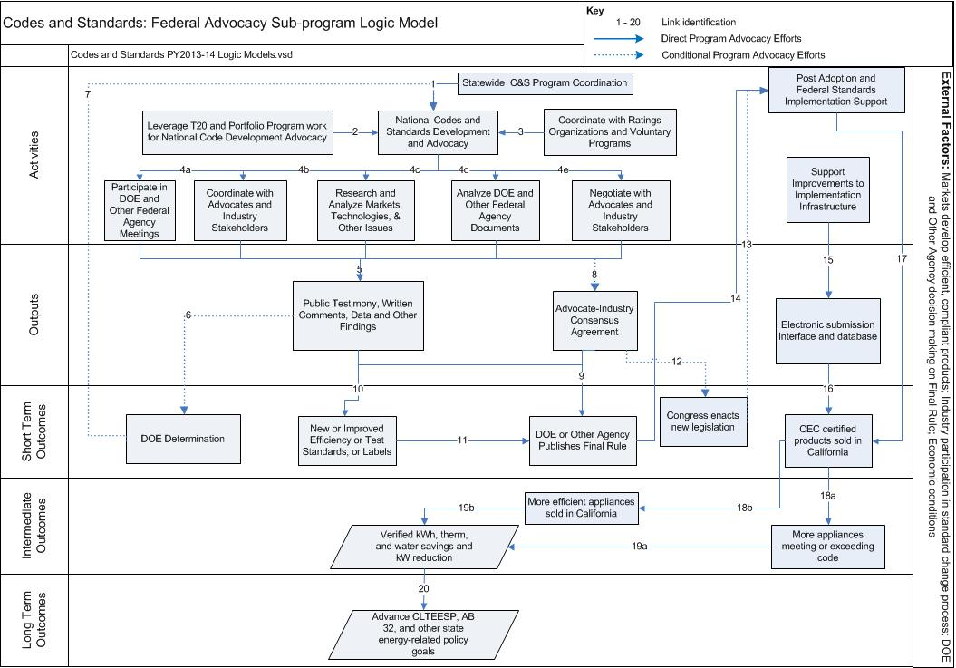

Codes and Standards: Federal Advocacy Program Theory and Indicators
Link | Program Theory | Potential Indicators
1 | C&S Program leverages the experiences and expertise of portfolio programs and Title 20 activities to identify areas for federal appliance standard improvement opportunities  Portfolio programs leverage C&S Program’s federal standards knowledge and expertise to identify new opportunities for programs | - Obtain market and technical information from portfolio programs  - Obtain market and technical information from the Title 20 sub-program  - Portfolio programs obtain federal appliance standards information from C&S Program
2 | C&S Program leverages the experiences and expertise of portfolio programs to identify areas for state appliance standard improvement opportunities  Portfolio programs leverage C&S Program’s state standards knowledge and expertise to identify new opportunities for programs | - Obtain market and technical information from portfolio programs.  - Portfolio programs seek and obtain state appliance standards information from C&S Program
3 | C&S Program coordinates with national ratings organizations (e.g. FTC) and voluntary programs (e.g. ENERGY STAR), including the development of test standards or labeling requirements | - Coordination with ratings organizations such as FTC  - Coordination with voluntary programs such as ENERGY STAR
4 | As part of C&S Program advocacy to DOE, C&S Program conducts research and testing, analyzes DOE documentation for key technical and policy issues, and coordinates with both energy-efficiency advocates and industry stakeholders on issues related to the federal appliance standard including the development of new industry test methods | - 4a. Participation in meetings, including providing public testimony  - 4b. Communication, including email and phone calls, with manufacturers, industry groups, and efficiency advocates  - 4c. Research documentation and analysis in reports and internal communications  - 4c. Participation in the development of industry test methods  - 4d. Notes on key issues and internal communication regarding DOE documentation  - 4e. Negotiation meetings with advocates and industry stakeholders
5 | C&S Program drafts IOU written comments submitted to DOE in advocacy of standards, participates in DOE public meetings, provides public testimony, and communicates with DOE staff and their consultants during the rulemaking. | - Percentage of DOE rulemakings for which written comments are submitted by IOUs  - Percentage of DOE meetings with IOU participation  - Communication, including email and phone records, with DOE staff and their consultants.  - Public testimony to DOE
6 | C&S Program comments and findings lead to DOE determination of which standards to consider for rulemaking | - DOE determination notice of standards considered for rulemaking  - Acknowledgment of IOU contributions in DOE determination notice
7 | DOE determination to pursue standards for rulemaking | - DOE determination notice  - DOE proceeds with rulemaking
8 | C&S Program coordinates with other energy efficiency advocates and industry stakeholders to develop a consensus agreement on new standards and/or testing requirements, through a negotiation process  C&S Program conditionally supports this pathway when it leads to quicker, greater energy savings than traditional rulemaking | - Communications, including email, phone records, conference calls and in-person meetings, with stakeholders  - Internal review, research, analysis and communication on potential negotiation positions  - Draft negotiation positions and final consensus agreement
9 | DOE uses consensus agreement from efficiency advocates and industry as the basis of their final rule | - DOE sets new federal standards based on standard levels and other provisions of consensus agreement
10 | C&S Program data, findings, comments and testimony support DOE appliance standards rulemaking to establish new or amended federal appliance standards, test procedures and/or labels. | - DOE Federal Register publications, technical documentation, and public meetings.  - C&S Program public testimony, written comments, and data in support of new or amended federal appliance standards, test procedures and/or labels
11 | DOE publishes final rule with new or amended appliance standards, or new or amended test procedure | - DOE Final Rule is published in the Federal Register
12 | Advocate-industry consensus agreement is finalized and provided to Congress for possible enactment through energy legislation | - Submittal of final consensus agreement to Congress
13 | Congress passes final energy legislation and President signs legislation into law  C&S Program initiates efforts for post adoption implementation support | - Final enacted legislation  - Communication with standard organizations committee members and other stakeholders to identify implementation support needs
14 | DOE publishes a Final Rule to integrate new standards and/or test procedures established by Congress, and related provisions, into the Code of Federal Regulations.  C&S Program initiates efforts for post adoption implementation support | - DOE Final Rule published in the Federal Register  - Communication with standard organizations committee members and other stakeholders to identify implementation support need
15 | C&S Program promotes development of, and improvements to, infrastructure to ensure successful code change implementation | - C&S Program supported electronic infrastructure development and improvement including electronic repository, pre-processing of electronic documents, and electronic input to the permit process
16 | Compliance electronic infrastructure is accepted and adopted by the CEC | - CEC approves and implements compliance electronic infrastructure
17 | The adoption of stringent energy efficient standards accelerate market adoption of efficient technologies | - Increased market presence and acceptance of certified products  - Initial compliance rates
18 | The adoption of stringent energy efficient standards accelerates market adoption of efficient technologies  The adoption of stringent energy efficient standards leads to more appliances meeting or exceeding code | - 18a. Initial compliance rates  - 18b. Increased market presence and acceptance of efficient certified products
19 | As market presence of high efficiency models increases, more products sold automatically meet the code requirement and compliance increases | - 19a. Increased market presence of efficient products demonstrates improved compliance rate  - 19b. Energy and water savings calculations with compliance rates
20 | Adopted and implemented codes lead to advancement towards long term strategic goals | - State policy objectives are met to achieve environmental, macroeconomic, and other non-energy benefits

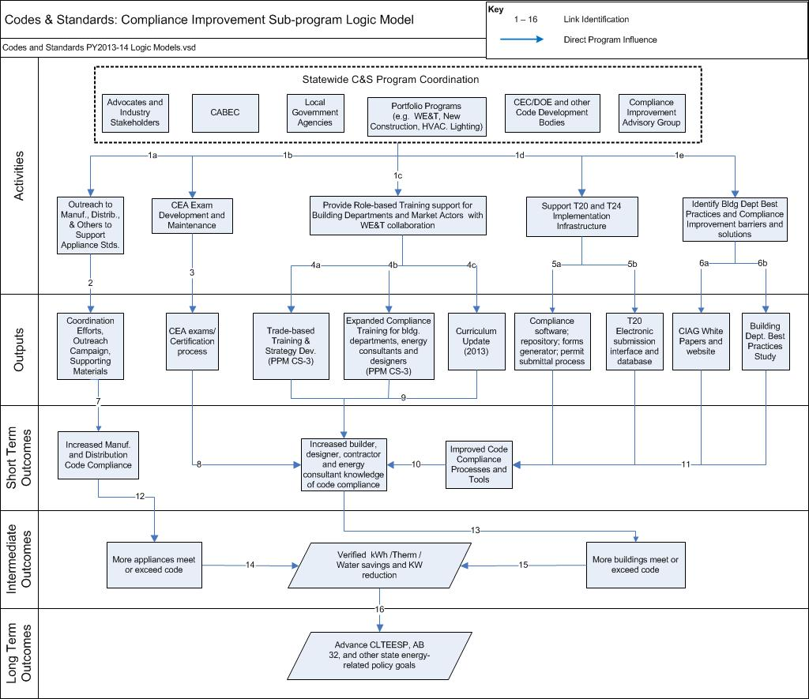

Codes and Standards: Compliance Improvement Program Theory and Indicators
Link | Program Theory | Potential Indicators
1 | C&S Program coordinates with advocates and industry stakeholders, CABEC, local government agencies, CEC/DOE/other code development bodies, Compliance Advisory Group (CIAG), other IOU portfolio programs, and other organizations | - Communication with collaborative members
1a | C&S program coordinates efforts with the appliance industry in improving code compliance through outreach to manufacturers, distributors and others to support appliance standards  C&S program supports CEC outreach efforts  C&S program staff attends trade shows, meetings and other outreach venues | - Number of manufacturers contacted  - Number of meetings  - Participation in trade shows  - Number of training sessions
1b | C&S Program supports Certified Energy Analyst (CEA) examination development and maintenance, and training programs for various industry groups  C&S program supports CABEC in developing technical and administrative guidelines to update the residential and nonresidential CEA examinations developed in 2010-2012 to properly test applicant CEAs under the 2013 standards and facilitating the roll out of the new certification process  C&S Program assembles and trains a team of subject-matter experts to prepare exam questions | - A trained team of subject-matter experts  - Set of exam questions  - Blueprint for exam preparation  - Alpha and Beta test developed  - Exam standards developed
1c | C&S program in collaboration with Workforce Education and Training sub-program (WE&T) prepare and deliver role-based training for building departments, energy consultants, designers, contractors and technicians to improve current code compliance | - Number of courses prepared  - Number of sessions delivered  - Number of course participants
1d | C&S program coordinates with the CEC/ DOE to provide T24 and T20 implementation infrastructure support  C&S Program identifies building department best practices, and compliance improvement barriers and solutions through a needs assessment | - Number of statewide/ CEC coordination meetings  - Needs assessment recommendations
1e | C&S Program assembles and facilitates the Compliance Improvement Advisory Group (CIAG). CIAG acts as ‘ear-to-the-ground’ to identify and prioritize compliance improvement initiatives for the C&S Program  CIAG members represent CEC, California State License Board (CSLB), architects, builders, home energy raters, contractors, energy consultants, compliance software developers, and building officials  C&S Program collaborates with a select group of building departments across the state to identify best practices for enforcing Title 24 | - An Advisory Group representative of key compliance improvement market actors  - Number of CIAG coordination meetings  - Number of participating building departments
2 | C&S Program coordinates with the CEC to conduct outreach to equipment manufacturers on existing code requirements, and to facilitate compliance from both a technical and administrative perspective  C&S Program assists manufacturers to ensure equipment sold in California meets the minimum technical requirements, and to successfully complete the certification process with the CEC  C&S Program staff write articles for CEC Blueprint and other publications addressing T20/T24 requirements | - Campaign supporting materials  - Number of manufacturers receiving assistance on use of CEC appliance database  - Number of distributors informed  - Number of articles published addressing T20/T24 requirements
3 | C&S Program assists CABEC with the design, implementation and marketing of the CEA certification process, incorporating inputs from CEC | - CABEC certification process website  - Number of certified Energy Analysts
4a | C&S Program collaborates with WE&T, CEC and major industry trade groups to develop and deliver enhanced workforce education and training to ensure proper installation, commissioning and maintenance as per code | - Needs assessment recommendations  - Number of industry-specific courses  - Number of training sessions  - Number of participants
4b | C&S Program develops and implements compliance training to building departments, energy consultants and designers that expands beyond classroom-based training to include live webinars and other activity-based online training | - Number of training sessions  - Number of courses developed  - Number of training sessions  - Number of participants
4c | C&S Program updates the current role-based building department and energy consultant training curriculum incorporating feedback from the CEC,WE&T and CIAG | - Updated curriculum to reflect 2013 Title 24 Standards
5a | C&S Program provides support to CEC/CPUC to develop a framework for an electronic repository database  C&S Program coordinates with the CEC and Emerging Technologies Program (ETP) on needs assessment study to explore the potential for developing electronic compliance forms and technology options for a pilot online permitting process | - Needs assessment recommendations
5b | C&S Program provides feedback and support to CEC/CPUC to develop an improved user interface for the CEC appliance database | - Interface improvement recommendations
6a | CIAG prepares white papers that identify and prioritize compliance-specific issues, propose solutions and recommend next steps for C&S Program consideration  C&S Program supports and maintains CIAG website that houses the white papers and collects feedback and disseminates information | - Issue-specific white papers (4-8)  - CIAG website
6b | C&S Program, using information obtained from needs assessment and gap analysis, develops and tests building department-specific tools, training and strategies for optimizing Title 24 enforcement  C&S Program works collaboratively with participating building departments to document best practices that are shared with local jurisdictions statewide | - Comprehensive best practices assessment and gap analysis report  - Tools, training materials and implementation strategies
7 | C&S Program outreach and coordination efforts results in increased awareness among manufacturers and distributors | - Increased number of certified products in CEC appliance database  - Increase in availability of compliant products
8 | Stringent CEA exam and certification process results in increased number of proficient energy analysts which leads to better code compliance | - Number of certified energy analysts  - Increased number of compliant buildings  - More accurate compliance documentation
9 | Effective role-based and trade-based training results in increased code compliance knowledge among builders, contractors and designers which leads to better code compliance | - Increase in standards knowledge of training attendees (pre and posttests)
10 | Improved processes and tools results in increased builder, designer, contractor and energy analyst code compliance knowledge | - Increased builder, designer, contractor and energy analyst knowledge of code compliance
11 | Best practices study; CIAG white papers and website; improved Title 20/Title 24 electronic submission interface and database; and improved compliance software, repository, forms generator and permit submittal process increase the effectiveness of code compliance processes and tools, and reduce the frequency of compliance errors | - Reduced number of compliance errors due to resources and training  - Reduced time for building officials to process paperwork
12 | Outreach and compliance support in appliance manufacturing and distribution channels results in more appliances meeting code and greater utilization of efficient appliances and technologies | - Reduction in number of noncompliant appliances in the market  - Increased utilization of efficient appliances and technologies
13 | Improved compliance infrastructure, system and modeling software leads to more buildings meeting or exceeding T24 requirements | - Energy savings calculations submitted for permit approval with compliance rates
14 | More effective enforcement processes, increased knowledge of code requirements throughout the market increases the number of appliances meeting or exceeding code, which results in verified kwh/ therm and water savings, and kw reduction | - Verified kwh savings  - Verified therm savings  - Verified water savings  - Verified kw reduction
15 | More effective enforcement processes, increased knowledge of code requirements throughout the market increases the number of buildings meeting or exceeding code, which results in verified kwh/ therm and water savings, and kw reduction | - Verified kwh savings  - Verified therm savings  - Verified water savings  - Verified kw reduction
16 | Adopted and implemented codes lead to advancement towards long term strategic goals | - State policy objectives are met to achieve environmental, macroeconomic, and other non-energy benefits

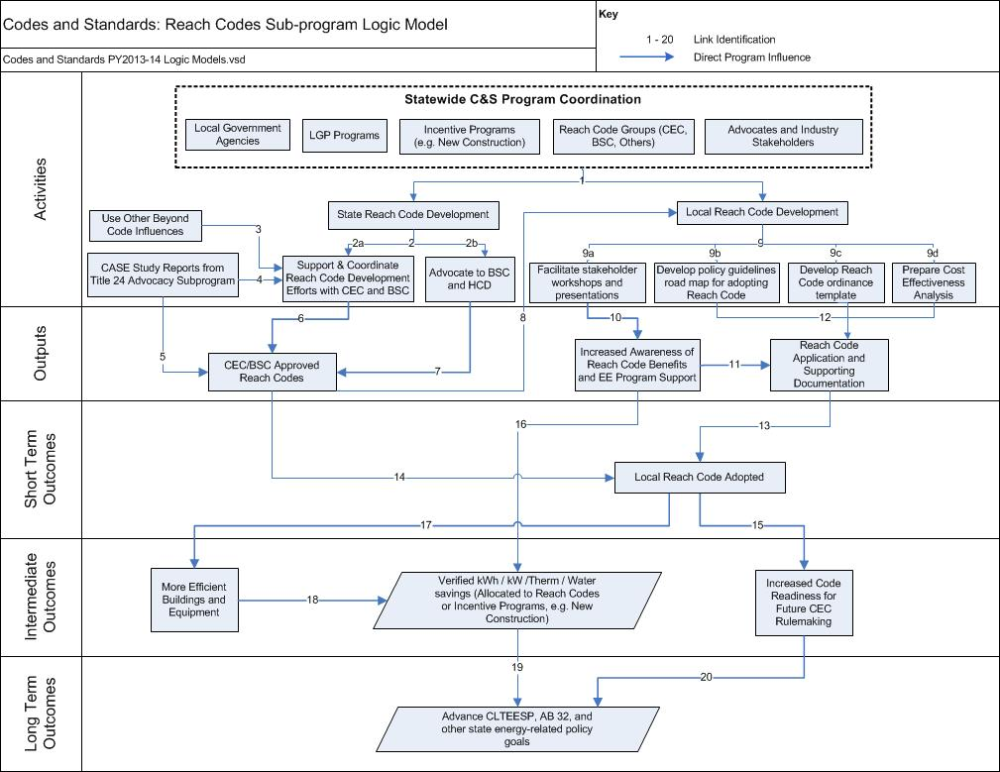

Codes and Standards: Reach Codes Program Theory and Indicators
Link | Program Theory | Potential Indicators
1 | C&S Program coordinates and supports internal and external efforts to drive reach codes development and adoption, using the resources offered by the IOU Energy Efficiency and Local Government Partnership programs; and working with the CEC, Building Standards Committee (BSC), and industry groups | - Communication and meetings with CEC, standard organizations committee members and other stakeholders for model reach code ordinances  - Communication and meetings with local jurisdictions to develop their reach code ordinances  - Quarterly updates to LGP (Local Government Partnership) program regarding reach code adoption progress and delivery of training to building departments  - Coordination efforts with local government agencies in conducting rulemaking process  - Coordination of reach code features with IOU energy efficiency program offerings where possible  - Coordinated C&S program and LGP outreach efforts to local jurisdictions  - Solicitation for stakeholder involvement and work with stakeholders
2 | C&S Program collaborates with CEC and BSC to provide support for developing local reach code ordinances to encourage buildings to achieve exemplary performance in the areas of energy efficiency | - 2a: Stakeholder meetings, outreach and on-going communication with CEC and BSC in development of statewide reach codes solutions such as CALGreen  - 2b: Communication with BSC and HCD to advocate the benefits of the reach code
3 | C&S Program supports the CEC/BSC CALGreen Tier 1 and Tier 2 standards development by leveraging C&S Program involvement in ASHRAE Standard 189 and other “beyond code” activities (e.g. CHPS) | - Stakeholder meetings, outreach and on-going communication with CEC and standards organization staff  - Participation in ASHRAE 189 committee meetings and other “beyond code” organization activities
4 | C&S Program CASE reports presented at reach code development meetings | - CASE reports include data, analysis and documentation for reach code development
5 | IOU proposed code change language is included in CEC adopted reach code standards | - Adoption of CEC-approved reach codes by BSC includes IOU proposed code change language
6 | C&S Program efforts support the development of energy efficiency reach standards by CEC and BSC | - Adoption of CEC-approved reach codes by BSC  - Support and contributions to CEC/BSC reach codes efforts, in particular CALGreen
7 | C&S Program advocacy to BSC and HCD to support adoption of energy efficient standards into CALGreen | - Advocacy for industry energy efficiency standards, such as ASHRAE Std 189, influence the CEC-approved reach codes adopted by BSC
8 | BSC adopted reach code (CALGreen) is used for the basis of local reach code development | - Local ordinance development begins with consideration of BSC adopted reach code (e.g. CalGreen Tier 1 or 2)  - Increase in regional code consistency (countywide or geographically contiguous jurisdictions)
9 | C&S Program conducts full range of advocacy efforts to support to rulemaking processes and ensure successful reach code development, completed in collaboration with the local government, CEC, BSC, and others | - 9a. Stakeholder meetings, outreach and on-going communication  - 9b. “Road Map” of policy guidelines for adopting reach code  - 9c. Reach code ordinance “template” that establishes clear definitions of when the ordinance is triggered  - 9d. Reach code cost-effectiveness documentation
10 | Stakeholder outreach by C&S Programs and LGP increase reach code awareness and knowledge | - Responses to requests for technical assistance from local government officials and stakeholders  - Input to stakeholder comments and questions on proposed code changes
11 | C&S Program supports local government officials in the reach code application process by responding to requests for technical assistance and support materials | - Technical support material and reach code policy and adoption guidance to local governments upon request
12 | Local governments conduct rulemaking process, develop ordinance with technical support from C&S Program | - Local ordinance adoption proceedings  - Reach code application developed with support from C&S Program
13 | C&S Program support leads to adopted local reach code ordnances | - Reach code ordinance adoption published by local jurisdictions
14 | CEC/BSC model reach code, with C&S Program proposed code change language, is adopted by local ordinances | - Reach code ordinance adoption published by local jurisdictions
15 | Development of locally adopted reach code ordinances leads to integration of more efficient building practices into future CEC rulemaking | - Increased acceptance and experience of reach code measures by builders, designers, and contractors prepares the market for future CEC reach codes
16 | Stakeholder outreach and technical support by LGP and C&S Programs increase awareness and knowledge of reach code and EE incentive program benefits, resulting in greater utilization of efficient appliances and technologies | - Increased utilization of efficient appliances and technologies  - Reduction of noncompliant practices and appliances
17 | Adoption of reach code ordinances leads to more efficient buildings and equipment | - Increased market acceptance of reach code requirements and practices throughout the state
18 | More efficient buildings result in electric and gas energy savings, demand reduction, and water savings | - Energy savings calculations or building energy and water usage
19 | Adopted and implemented codes lead to advancement towards long term strategic goals | - State policy objectives are met to achieve environmental, macroeconomic, and other non-energy benefits
20 | Increased market acceptance of building practices resulting from reach codes leads to advancement towards long term strategic goals | - Accelerated completion of state policy objectives to achieve environmental, macroeconomic, and other non-energy benefits

