Multifamily Strategic Energy Management
MCE01c

Implementation Plan

January 14, 2022
Version 1.0

Contents

Program Overview 3
Program Budget and Savings 3
1. Program and/or Sub-Program Name 3
2. Program / Sub-Program ID Number 3
3. Program / Sub-Program Budget Table 3
4. Program / Sub-Program Gross Impacts Table 4
5. Program / Sub-Program Cost Effectiveness (TRC) 4
6. Program / Sub-Program Cost Effectiveness (PAC) 4
7. Type of Program / Sub-Program Implementer (PA-delivered, third party-delivered or Partnership) 4
8. Market Sector (Including Multifamily, Low Income, Etc) 4
9. Program / Sub-Program Type (Non-Resource, Resource Acquisition, Market Transformation) 4
10. Market channel(s) (i.e., downstream, midstream, and/or upstream) and Intervention Strategies (e.g., direct install, incentive, finance, audit, technical assistance, etc.), campaign goals, and timeline. 4
Implementation Plan Narrative 5
1. Program Description: 5
2. Program Delivery and Customer Services: 5
3. Program Design and Best Practices: 7
4. Innovation 11
5. Metrics (EM&V) 11
6. For Programs Claiming To-Code Savings 18
7. Pilots: 18
8. Workforce Education and Training 18
9. Workforce Standards 19
10. Disadvantaged Worker Plan 19
11. Additional Information: 19
Supporting Documents 20
1. Program Manuals and Program Rules 20
2. Program Theory and Program Logic Model: 20
3. Process Flow Chart 21
4. Incentive Tables, Workpapers, Software Tools 21
5. Quantitative Program Targets 22
6. Diagram of Program 23
7. Evaluation, Measurement & Verification (EM&V): 23
8. Normalized Metered Energy Consumption (NMEC): 23
9. Program Modifications from the California SEM Design Guide 23

Program Overview
MCE is launching a Program (Program) to serve multifamily residential customers within its service territory with a goal of achieving low cost/no cost energy savings which are sustained by making cultural changes and adopting best practices. Strategic Energy Management (SEM) is a holistic, whole property approach that uses Normalized Meter Energy Consumption (NMEC) methodology and dynamic baseline model(s) to determine eligible energy savings from all Program activity at the property. SEM moves the energy management conversation beyond capital equipment upgrades to focus on how internal processes, systems and policies can be improved to save energy. Savings are realized year over year as participants develop a culture of continuous improvement. The Program is designed to help properties identify and implement energy savings opportunities that they would not have implemented absent program support. Participating properties form a cohort and progress through a series of facilitated workshops together. Workshops teach participants how to map energy usage across their respective properties and to develop a list of opportunities for potential energy savings. Savings estimates and customer incentives for operations and maintenance (O&M), retro-commissioning (RCx) and behavioral measures will be calculated using post-measurement NMEC data. Savings estimates and customer incentives for common area, property, and in-unit projects will follow applicable custom program protocols.
The Program will collect information on existing customer conditions, energy performance data, program intervention, implemented and planned projects, and will collect energy and production data to develop energy savings estimates to support the verification of program influence and program savings.
The Program budget and savings information are summarized in the sections below.

Program Budget and Savings

Program and/or Sub-Program Name
Multifamily SEM Program

Program / Sub-Program ID Number
MCE01c

Program / Sub-Program Budget Table
MF SEM | 2022 | 2023
Admin | $72,096 | $78,729
Direct Implementation Non-Incentive (DINI) | $592,631 | $631,823
Incentives | 45,167 | $49,024
EM&V | $- | $-
Total | $709,894 | $759,576

Program / Sub-Program Gross Impacts Table
Program Goals | 2022 | 2023
Net kWh | 1,245,999 | 1,381,598
Net Therms | 31,149 | 30,304
Total System Benefits (TSB) | $919,600 | $1,062,659

Program / Sub-Program Cost Effectiveness (TRC)
Program ID Number | 2022 TRC | 2023 TRC
MCE01c – Multifamily SEM | 1.21 | 1.30

Program / Sub-Program Cost Effectiveness (PAC)
Program ID Number | 2022 PAC | 2023 PAC
MCE01c – Multifamily SEM | 1.30 | 1.40

Type of Program / Sub-Program Implementer (PA-delivered, third party-delivered or Partnership)
Third Party

Market Sector (Including Multifamily, Low Income, Etc.)
Multifamily

Program / Sub-Program Type (Non-Resource, Resource Acquisition, Market Transformation)
Resource Acquisition

Market channel(s) (i.e., downstream, midstream, and/or upstream) and Intervention Strategies (e.g., direct install, incentive, finance, audit, technical assistance, etc.), campaign goals, and timeline.
Market Channel: Downstream
Intervention Strategy: Technical Assistance, Incentive
Campaign Goals: Refer to supporting documents section 5
Timeline: Refer to supporting documents section 9

Implementation Plan Narrative

Program Description:
Describe the Program, its rationale, and objectives.
The Program will provide a comprehensive approach based on individual customer needs. The Program will act as a single point of contact (SPOC) for multifamily property managers and tenants, connecting and leveraging available resources and funding sources pertaining to energy efficiency, renewable energy, and sustainability goals and needs.
The Program is designed to provide individualized services to residential multifamily property managers to identify energy efficiency opportunities, develop and evaluate implementation options, and provide value in the form of coaching, technical assistance, tenant engagement, and savings incentives. With a single customer-facing Program for multiple residential multifamily customers, the Program can leverage the same platform, streamline the customer offer and experience, reduce administrative costs, and improve cost effectiveness. With one program umbrella, the Program can serve a property manager’s entire portfolio concurrently.
The Program is an area where MCE’s flexibility can greatly address participation barriers in tenant/owner situations. MCE takes a phased approach with multifamily upgrades, allowing property managers to plan larger projects that take advantage of maximum incentive levels but are implemented over time, as tenants turn over. A combination of light touch, bundled, and customized measures help accommodate the specialized needs of each multifamily property.
The Program will address market barriers by providing:
  - Customized technical assistance to overcome challenges associated with the diversity of building types, ownership types, and billing configurations, and to help with analyzing potential upgrade measures
  - Property Management Employees and tenant engagement
  - Energy tracking model
  - Assessment of low cost/no cost, behavioral, and capital opportunities throughout the property
  - A range of participation options to best meet the current needs and abilities of properties

Program Delivery and Customer Services:
Describe how the energy efficiency Program will deliver savings (upstream, downstream, direct install, etc.); how it will reach customers and the services that the Program will provide. Describe all services and tools that are provided.
The Program will deliver downstream energy savings through meter-based energy efficiency calculation s.
Prospective Participant Outreach:
Prospective Program participants will be contacted and introduced to the Program at a high level to gauge their interest and business needs. Collateral which is specific to the property manager need will be used to educate the property managers about the benefits of participation and help them identify best-fit solutions for their business. The account managers will ensure that customers are supported as they move through the Program. The Program will focus on customer satisfaction as repeat participation and word-of-mouth are key Program savings strategies.
The Program will leverage multiple outreach strategies, directed towards property managers, to drive awareness of energy efficiency offerings and engagement with the Program. This includes a data-driven analysis of savings potential and past participation, paired with qualitative information on the prospective participant’s decision-making process and market pressures to determine the best candidates for outreach. Based on this analysis, the Program will reach out to property managers directly with marketing messages and direct account management. Additionally, it will work with industry organizations and vendors to drive awareness of the Program.
Direct potential participant outreach will be the key tactic to drive customer participation. MCE is uniquely positioned to support targeted this outreach, owing to strong relationships with energy-savvy property managers, community organizations supporting sustainability activities, and an account management team emails and phone calls to create and sustain relationships and drive Program participation. The strategies outlined below will be continuously built upon by the outreach team as the account managers continue to engage deeper in the market. Regular review of these resources will be conducted by the Program Administrator to assess relevance, and to make sure there are adequate resources to drive the desired results.
Lead generation will come from a variety of sources including:
  - Direct to customer marketing.
  - Earned media and collaborations with other sustainability-based organizations and offerings.
  - MCE account managers.
  - Manufacturers, distributors and vendors serving these segments.
  - Trade organizations.
Core to the Program approach in supporting the prospective participant’s journey in energy efficiency is the SPOC concept. The Program team will be well-informed of all energy efficiency and decarbonization Programs available to a multifamily property. In addition, the team will be able to speak to other programs and opportunities that support the sustainability goals of multifamily property managers. This will help eliminate confusion about multiple Program offerings and will coordinate with existing statewide and local government Programs to avoid overlapping outreach activities.

Trade Associations and Community Organizations:
Trade associations are trusted partners in the business community and provide another avenue for reaching target sectors. The Program will reach out to local trade associations, chambers of commerce, and business leader groups to raise Program awareness.
Support Tactics:
Other marketing tactics that will support Program engagement and management include:
  - Collateral which includes educational materials that convey the energy and non-energy benefits associated with custom projects and other offerings. These materials will educate customers about the long-term benefits of energy efficiency, available incentives, and other Programs that may help reduce energy consumption and provide bill savings. Program participant collateral will include:
    - Program overview
    - Residential specific info sheets
    - Measure specific info sheets

  - Web content which the program will use the MCE website to promote the Program and provide valuable information to property managers and other stakeholders. Initial content includes incentive details, FAQs, and high-level Program information and will be supplemented by case studies and other collateral as developed. Property managers visiting the website will be able to access the customer portal as well as contact information to reach Account Management.
Services Provided:
  - Single Point of Contact – Provide personalized attention, follow–through, and assistance in identifying solutions that meet customers’ needs, budget, and levels of readiness for change.
  - Energy Coaching – A skilled energy coach will lead the Program and be a direct contact to the participants in the Program to support them in EEM implementation, planning, data collection etc.
  - Technical Assistance – The Program will offer technical assistance to property managers to help them understand the full scope of available resource conservation options and guide customers through the process from project identification to completion.
  - Incentives – Financial incentives provided to off-set costs of energy efficiency measures.
  - Engagement Support – Provide guidance and tools on the effective engagement of staff and tenants towards a goal of energy saving identification and implementation
  - Energy Tracking - Create energy modeling to establish a statistical model for the property that correlates energy consumption to the key energy drivers while adhering to the most up-to-date guidance from the California Public Utilities Commission (“CPUC”).

Program Design and Best Practices:
Describe how the Program meets the market barriers in the relevant market sector/end use. Describe why the Program approach constitutes “best practices” or reflects “lessons learned”. Provide references where available.
Program Design:
The Program is designed to meet the needs of a diverse range of residential multifamily properties through cohort style engagement. During the first-year, multifamily property managers will be brought together to participate in the Program. The cohort will create an energy efficiency and decarbonization community, encourage peer-to-peer learning, and provide intrinsic motivation to make changes that will save energy and money.
The following elements each support the Services Provided in the previous section through:
  - One-on-one events: Includes an energy scan to identify energy efficiency opportunities and engage Program participants’ employees in energy efficiency, energy modeling and data collection discussions, and an Energy Management Assessment (“EMA”). The EMA is interactive one-on-one activity with the participant designed to evaluate participant’s energy efficiency organizational culture engagement level to gain mutually decided upon action items that target to improve participant’s participation, organization-wide engagement, and promote an energy efficiency culture.
  - Collaborative group workshops: Implementer will facilitate discussions, activities, and workshops to introduce and teach energy management core concepts in a lively and engaging manner.
  - Energy management coaching: Implementer will work closely with each participant on a one-on-one basis to help them apply the principles and concepts of continuous improvement applied to energy management within their property. Implementer will communicate with the energy champion and the executive sponsor on a regular basis to track and assess progress. This will include conducting scheduled one-on-one events, ad-hoc remote meetings, and site visits.
  - Measurement of energy savings
  - Residential tenant engagement in addition to common area energy savings, the Implementer will provide residential tenant engagement activities which will achieve savings from the residents in the multifamily units through the following engagements:
  - Seasonal resident engagement workshops which provide training and education on energy efficiency, behavior changes, and available Programs for reducing energy use.
  - Virtual turn down and tune up assessments using a virtual tool to review in-unit equipment and potential energy use reductions.
  - Monthly communication and marketing materials kits provided to property managers to encourage energy reduction practices.

Market Barriers:
Property managers may face similar challenges in participating in energy efficiency Programs. Many have challenges understanding how best to evaluate and implement cost-effective energy efficiency improvements due to limited bandwidth and/or hesitation to adopt new technologies. In addition, property managers in residential segments have unique operations and variable conditions driving complexities in Program ease of use, priorities, opportunity identification, and value quantification. Due to competing priorities for resources within a property manager’s business, it is a challenge to gain the attention of key decision-makers without having a succinct and proactive energy efficiency strategy that will bring financial and operational benefits to a customer immediately and in the years to come. Improving the efficiency of the equipment and operations driving their business is often not the priority of the property or maintenance staff or contractors.
To overcome these barriers, residential Multifamily property owners, property managers and tenants need a multifaceted approach – not solely an incentive or rebate offer – tailored to meet their specific and unique requirements. This Program design will introduce a tiered approach to Program participation so the relationship can begin at the level most appropriate for the individual customer given their priorities, energy savings opportunities, and internal decision-making process and timing. Table 1 details how the Program will minimize the barriers of participation.

Table 1. Market Barrier, Risks, and Risk Management Strategies
Market Barrier | Risk | Risk Management  Strategies | Impacted Stakeholder
Fear of property owner retaliation | - Property managers may be hesitant about putting time and financial resources towards energy efficiency out of concern that it will conflict with the priorities of the property owner. | - Property owners, property managers and operations staff will all play an active role in the SEM decision-making process | - Property Manager
Lack of control over any significant upgrades made to the individual units | - The property owner will often have limited control over the energy use behavior of occupied units. | - Tenant energy use is assessed and included in the SEM process as well as tenant involvement through Group Residential Workshops | - Property Owner  - Property Manager
Concerns about sharing personal information | - With a competitive housing market, the data and personal information which needs to be shared for this Program is very sensitive and participants may be hesitant to share it. | - Energy use data from buildings is reported to the State of California for benchmarking and available to the public on a state website. | - Property Owner  - Tenants
Financial constraints | - Energy efficient upgrades can be quite costly. Multifamily property owners face difficulty in receiving loans for energy efficiency upgrades, as the risk–adverse underwriting market and lack of existing valuation for energy efficiency upgrades often results in high interest rates. | - SEM targets low-cost/no-cost operational savings requiring little or no financial commitment or risk. | - Property Owner
Difficulty in Accessing Decision Makers | - The majority of large market–rate properties are managed by property management companies. Within the structure of these companies, it can be difficult to communicate with property owners, who are often the primary decision makers on capital improvements spending. | - SEM is structured to identify and engage with an executive sponsor (ex. property owner) before the Program begins. Their awareness and engagement throughout the 2-year process promotes the communication and prioritization of their business and energy goals. | - Property Owner  - Project Manager
Contractor Limitations | - There is a perception among some contractors that rebate Programs are difficult to navigate the process. Therefore, some contractors give customers an out–of–pocket discount to avoid referring projects to existing rebate Programs. | - SEM targets low-cost/no-cost operation improvements and savings. Rebates are awarded to building owners. Building owners will work directly with contractors that may be needed for improvements (example: boiler tune up) and the Program will assist building owners and contractors with any rebates or incentives that may be available. | - Property Owner  - Property Manager  - Contractor
Negative Customer Experience | - Negative feedback regarding the quality of some Programs leads to reluctance to participate in MCE’s Programs. | - The main target of the Program is building owners, property managers and building staff. Tenant feedback will be requested and incorporated to improve the effectiveness of the Program. Tenant participation will be promoted through Residential Workshops and tenant participation is optional. | - Property Owner  - Property Manager  - Building Staff  - Tenants

Strategic Energy Management:
SEM Programs have proven to be a successful approach to significantly reducing energy consumption in the residential sector and will be a suitable format to overcome market barriers discussed above. Because establishing an SEM approach in a residential setting requires a broad set of skills and a significant commitment of staff time, external technical assistance is critical for assisting the process. Energy efficiency Programs across the US and Canada have demonstrated that they can be a determining factor in the implementation of SEM by providing targeted assistance.

The Program will be offered in a cohort-style format and will have a subset of objectives in addition to the overall Program objectives. The primary objectives over long-term engagement are to help Program participants:
- Implement low cost/no cost energy efficiency projects and save energy, with a focus on behavioral, retro- commissioning and operational measures.
- Establish a robust, continuous Energy Management System (EnMS) at the property that impacts their culture in a positive way.
- Quantify and report property-wide energy performance.
- Getting property owners to talk to one another - participants learn more by hearing from, and talking to, their peers.
- Achieving a balance between saving energy and building EnMS practices.
The Program will use a cohort format for training workshops and a mix of individual and cohort property activities. Individual coaching sessions will be held and will include regular check-in meetings and availability to the participant on an as needed basis.
Property activities include conducting an energy opportunities Treasure Hunt and recording findings in an Opportunity Register. The energy coach and technical staff help identify and provide technical project management support for implementation of behavioral, retro-commissioning, and operational, as well as capital, custom and deemed energy efficiency projects
During the first year, participants will begin establishing EnMS practices and identify, implement, and track organizational and operational changes that will help save energy at their properties. During the second year, participants will solidify and advance those practices, often resulting in greater energy savings. In addition, participants’ efforts in the early years are primarily focused on reducing energy waste by increasing operational efficiencies and implementing low-cost/no-cost solutions through operations and maintenance (O&M).
Program Services Provided:
Once signed up for the Program, engagement with property managers will include:
- Kick-off meeting to lay out clear Program expectations
- Cohort or individual property workshops with clearly defined learning objectives and well facilitated peer-to- peer learning that include strategies on:
  - Developing SEM
  - Identifying and Implementing Energy Savings Projects (focused on low cost/no cost)
  - Employee and Tenant Engagement
  - Persistence of Savings
  - Tracking Energy Performance
  - Energy Management Assessment
  - Designing and Implementing an Energy Management Information System

- On-site or Virtual “Energy Treasure Hunt” to guide and introduce concepts to facilities that help them identify, track, prioritize, and estimate savings from O&M, retro-commissioning, capital projects, and other opportunities.
- On-site and remote support for: goal development, employee and tenant engagement, energy map development, energy data collection and data logging, project savings persistence strategies, as well as annual updates to key activities.
- Development of an energy savings regression model and annual updates to meet the requirements of a separate M&V guide.
- Implementation of an “Energy Management Assessment” to assess progress on customer EnMS and plan future improvements.
- Identification, scoping and technical support for project implementation
- Where appropriate, support in defining and implementing an “Energy Management Information System” to better track, report, and make decisions on energy data.
Detailed in Section 9 of the Supporting Documents are more details on how the Program will optimize the SEM offering to best serve the customers in MCE’s service territory.

Innovation
N/A

Metrics (EM&V)
Describe any process evaluation or other evaluation efforts that the Program Administrator (PA) will undertake. Identify the evaluation needs that the PA must build into the Program. These might include:

- Data collection strategies embedded in the design of the Program or intervention to ensure ease of reporting and near-term feedback.
- Internal performance analysis during deployment
- Performance metrics

The primary objective of the evaluation, measurement, and verification (EM&V) activities is to estimate the energy impacts of the Program. This EM&V plan provides information on the EM&V activities including data collection, data analysis, adjustments, and reporting. The following flow chart provides a high-level overview for the major activities.
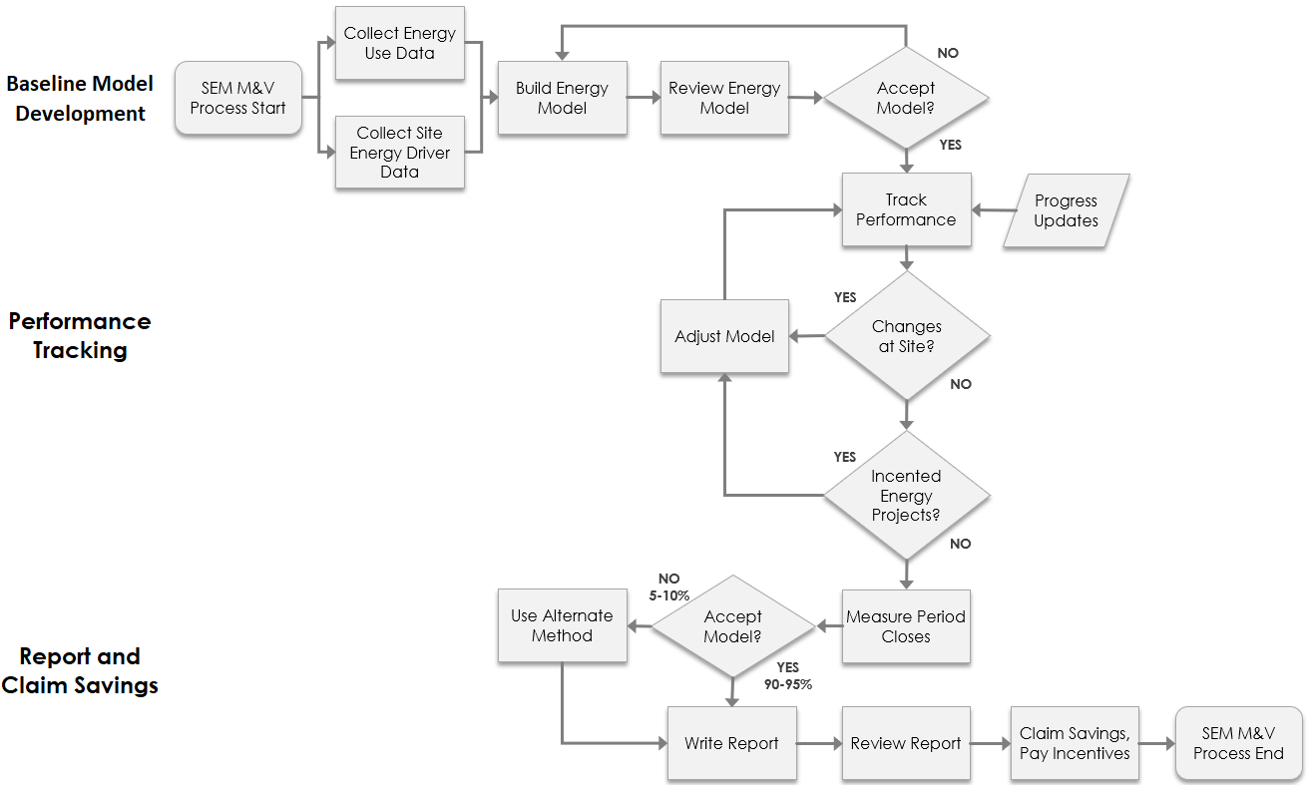
Data Collection
The Program’s EM&V approach is based on the California Industrial M&V Guidelines v2.02, California NMEC Rulebook, International Performance Measurement and Verification Protocol (IPMVP) Option C – Whole Property guidelines, ASHRAE Guideline 14:2014. The IPMVP Option C guidelines defines the measurement boundary as the whole property and requires measurement utilizing revenue grade meters; whole-building utility energy meters qualify as revenue grade meters. The Program will also monitor static factors such as equipment and operations within the measurement boundary to identify if any non-routine adjustments are required.

There are two types of data collection during the Program. First, the team will collect energy data and other quantitative data to estimate the kWh energy impacts of the Program. Second, the team will track qualitative observations related to the SEM projects and feedback from participant buildings to inform the results of the quantitative assessment.
Quantitative Data Collection
Table 2 outlines the data collection requirements for the participant properties. The Program will review data on an ongoing basis to determine if any additional data or refinements are necessary.
Table 2. Data Collection Requirements for Participant Buildings
Data Description | Desired Interval | Pre-SEM Data Collection | Post-SEM Data Collection | Data Source | Update Frequency
Interval meter data (primary) | 15/30-minute | 1-2 years | Program duration | PA and Customer | Monthly
Monthly billing data (If interval is not available) | Monthly | 1-2 years | Program duration | PA and Customer | Monthly
Weather data | Daily | Covering the interval data timeframe | Program duration | Officially recognized internet weather data site(s) | Monthly
Participant property characteristics including address, building age, major equipment, square footage, enrollment date, dates of behavioral intervention, and common area operating hours | Multiple | n/a | Program duration | PA and customer | Minimum – beginning of the Program and once at the end  Ideal – monthly
Production at industrial sites, occupancy data for commercial and residential buildings | Same as energy use data, if available | Same as energy use data, if available | Same as energy use data, if available | Customer records | Monthly or as needed
Customer ID, meter numbers(s), services address(es) | One time | n/a | n/a | PA and Customer | Upon enrollment
Participation data from other Programs, including dates and estimated savings of energy savings measures | During and the end of the SEM measurement year | n/a | n/a | PA | Minimum - at beginning and end of measurement period Ideal – monthly
Equipment and Instrumentation
No additional metering equipment is required at the participating properties. For properties with existing interval meters, the Program will use the corresponding interval data. For properties without interval meters the team will utilize monthly billing data. Customer-owned submeters installed prior or during the SEM engagement may be used if the properties is complex enough to warrant sub-metering breakout or metering with revenue grade meters (as outlined in the IPMVP) to collect the necessary data.
Qualitative Data Collection
In addition to meter data and other quantitative indicators of energy use, the Program will collect data from the participants (the individual properties enrolled) to document energy efficiency awareness and practices before and during the Program. Data collection is designed to capture any changes in production, owner and occupant behavior, attitude, or actions that affect energy consumption. Data will be collected from multiple points including regular feedback from energy champions, property managers, self-reporting tools, and electronic and phone surveys. The data collection will include documentation of:
- Production changes including production mix or addition of new products
- Schedule changes including shutdowns or unusual events
- Any retrofits or maintenance activities
- System setting changes such as set points and heating or cooling schedules
- Occupancy changes such as tenant, production, or staffing changes
- Specific questions regarding participating employees’ understanding of energy efficiency and any activities performed to save energy before the Program
- Strategies the organization employed to save energy with the objective of identifying behavior changes and equipment upgrades
- Energy champion and executive sponsor responses when asked if they observed any other impacts on their operations, such as increased customer traffic or a change in overall employee and tenant engagement.

The goal of the qualitative data collection is to help inform how much the Program influences awareness and behavior. In addition, the qualitative data will provide context for the source of energy savings by telling a story with corroborating evidence about what activities led to the savings. Depending on the level of detail collected from participants, the Program may be able to show resolution around what activities or actions happened within a specific timeframe that may correlate with a measurable drop in normalized energy intensity.
Data Analysis
The boundary of all measures is the whole property, which could mean a single property or group of buildings depending upon available utility information. Statistical analysis will be done using statistical software such as JMP®, eSight®, or other which utilize standard statistical techniques. Models will be transferred into Excel for ease of use for participants and containing all relevant data for evaluation. The following is an overview of the data analysis activities to estimate the energy impacts of the Program:
- Identify available metering. As participants enroll into the Program, they will need to identify what type of utility data (monthly or interval) is available, as this will determine what type of analysis will be performed.
- Assess baseline data for validity. As participants’ models are developed, the Program will conduct an analysis to determine if adequate baseline data exists for the analysis and if any data is missing. If adequate data is not available, the PA team may make recommendations for additional data collection or alternative EM&V approaches.
- As necessary, aggregate meter level data to properties or site level data. Using the customer level ID or similar utility site identifier, the Program will aggregate individual meters into whole businesses or whole building, as appropriate. In situations where the individual meters have misaligned meter read dates for similar monthly billing periods, the whole business or whole building meter level data will be aggregated based on the monthly billing periods from the individual meter with the largest energy consumption.
- Estimate Program Energy Savings. The analysis will use an avoided energy use method where a baseline statistical model is created, ideally using two full years of monitored data prior to implementation. Then the actual monitored data recorded during the Program are used in a standard least squared regression to create an adjusted baseline. The difference between the adjusted baseline and measurement period energy use is the avoided energy use, or the SEM energy savings, shown below:
$$Avoided energy use \left(SEM Energy Savings\right)= Measurement period energy use-Baseline model prediction ±Non routine adjustments$$

Based on this formula, SEM energy savings includes any activity, project, or change within the measurement boundary at a participant property resulting in energy savings. There are several exceptions to projects captured within the measurement boundary that would not be allocated to SEM Program savings:
- Energy projects incentivized through other PA offerings
- Fuel switching (from electricity to natural gas)
- Installing alternative energy generation equipment such as solar, combined heat and power, wind, etc.
For all participants:
Preliminary modeling employing stepwise regression is used to evaluate the statistical significance of various independent variables in relation to energy usage. This is followed by successive manual changes to the model’s specification to identify a model with good predictive performance and a reasonable number of predictors given the sample size. The distribution of each variable in the model is examined for suitability in regression modeling. A time series plot of each variable is analyzed to identify trends and relationships between data sets. The strength of association between variables is evaluated using bivariate correlations as well as partial correlations and associated scatter plots.
The performance of the model is assessed through a variety of statistical measures including overall fit (R²), coefficient of variance, autocorrelation of the regression residuals, X‐Y plot of actual vs. predicted values and a time series plot of actual vs. predicted values is superimposed. If necessary, PA will incorporate routine and non-routine adjustments to improve model performance (see adjustments section below).
The Program reviews each model per PA’s internal QA/QC document, and reports the final:
- data issues,
- model specification,
- sign and significance (including t-statistic) of the coefficients,
- residual plots, and
- statistical metrics: R², adjusted R², F-ratio probability, sample size (N), ratio of N to predictors, first-order autocorrelation, CV/RMSE, and the maximum CUSUM as a percent of annual energy use.
For participants with interval data:
The interval for the final model will be determined based on a combination of timing with concurrent Program year, preference from the participant, and quality of the data at the chosen interval. To estimate the electric savings ordinary least-squares regression statistical technique will be used to create baseline models. Models will be created through investigating independent variables including production, dry bulb and wet bulb temperature, relative humidity, hours of operation, day of week, time of day, process loads, sales/transaction data, or occupancy. In addition, binary indicator variables informed by qualitative data collection will be considered where applicable. Step-wise regression analysis techniques will be used to iteratively compare all logical combinations of independent variables. Autocorrelation will be considered and tested to determine if the model autocorrelation will affect the final savings analysis.
For participants with monthly data:
In models where the billing period varies, the analysis may employ a weighted least-squares regression technique based on ASHRAE Guideline 14-2014, section 2.3 for Day Adjusted Models. Models will be created through investigating independent variables including, but not limited to, relative humidity, hours of operation, day of week, time of day, sales/transaction data, tenant percentages, or general occupancy. In addition, binary indicator variables informed by qualitative data collection will be considered where applicable. All non-indicator variables will be divided by the number of days in the monthly billing period. Depending on the actions taken by the participants with only monthly data available, there may not be high enough savings to provide a statistically significant measurement of savings using monthly data. Not all projects, however, require such a high level of statistical confidence in the savings. In these cases, the savings estimates using monthly data is the best option available and the Program team will work to achieve the highest accuracy using all data available.
Model Validity
Before energy baseline models are approved to track energy performance, they are subject to multiple reviews. The first review is performed by Program Administrator against a stringent set of statistical criteria and analysis listed below as well as the guidelines outlined in the CA Industrial SEM M&V Guide v2.02.

Overall Model
Performance Statistic | Typical Limits | Explanation
R² | > 0.75 | The proportion of energy use during the baseline period that can be explained by movements of the model’s predictors. An R² of 0.95 means that 95% of period-to-period variations in energy use in the baseline period are explained by the model’s predictors.
Coefficient of Variance of RMSE | <0.2, 0.1, 0.05 | CV of RMSE is RMSE divided by average energy use over the baseline period. The lower the CV, the smaller the regression residuals (prediction errors) are relative to predicted energy. Threshold of 0.2 used for daily models, 0.1 for weekly, and 0.05 for monthly.
Autocorrelation | <0.5 | Autocorrelation is a measurement (ranging from -1 to +1) of the serial correlation of regression residuals. High autocorrelation can cause a model to over-predict or under-predict for stretches of time and is more common in high frequency (e.g., daily) models. Autocorrelation leads to underestimated standard errors of the regression coefficients, so a model’s t-values need to be large (well above 2.0) to assure their relevance when autocorrelation is high (e.g., above 0.5).

Predictors
Item | Typical Limits | Explanation
t-stat | |t| > 2.0 | The ratio of a predictor’s estimated coefficient to its standard error. Large t-ratios (>2.0) suggest that the variable is a useful predictor.
p-value | p < 0.05 | Small p-values (<0.05) indicate a predictor is statistically significant (unlikely to be zero).

CUSUM Baseline
Item | Typical Limits | Explanation
Maximum Variance (Daily/Weekly Models) | <|1%-1.5%| | This maximum variation in the CUSUM during the baseline period shows the noise in the model baseline. This is a good indicator of the “sensitivity” of the model at detecting future changes (i.e. savings). While not all models will meet this guideline, if savings achieved by the property greatly exceeds the baseline noise, this method gives a high confidence in the measured savings. For instance, if the baseline variation is 3% but the property saves 8%, the savings trend will extend well outside the normal baseline and therefore savings can be claimed. If a model follows the typical limits of CUSUM variance, SEM savings can be easily detected even as low as 1.5 % savings. Additional statistical tests can be performed on an as needed basis. The variation in model baseline will also be supported with a fractional savings uncertainty test
Maximum Variance (Monthly Models) | <|1%-2.5%|

Energy baseline models are also subject to review by the participant. During this, the participant is asked to examine the model to assure they understand how it works and to confirm that each predictor makes sense within the context of the property’s energy profile. Once the implementer and participant approve the model, it is then presented to the PA for review. The PA may want to engage third party with statistical expertise, such as their evaluation contractor, to assist in this review.
Adjustments for Energy Consumption Changes
If significant changes are made to the property during the measurement period, such as added/removed space, equipment, or changes to operations such as tenants moving in/out or production changes, the modelers will investigate ways to account for the effects of the change. Changes will be tracked throughout the Program and incorporated in the model prediction where possible.
If participants undergo an energy saving project incentivized through another PA Program, then reported realized savings from that project will be removed from the SEM savings. If a reported capital project appears to have been over- or under-estimated, the SEM Program team will review the project with the capital project implementation team to determine the accuracy of claimed savings. The Program will receive periodic reports from PA C&I project tracking on incentivized projects and associated savings calculations.
Alternative Savings Analysis
If the standard modeling method does not lead to an effective model that meets the goals of calculating energy savings and providing feedback to the SEM participants, alternative modeling methods may be used to measure savings from the SEM Program. The following modeling methodology will be considered:
- Intervention step models
  - Regression modeling over both the baseline and the measurement period, which allows changes that occur after the baseline period to be incorporated in the analysis.
  - This method is used when a participant makes large or drastic changes during involvement with the SEM Program and the baseline time period cannot be compared to the measurement period.
- Mean model
  - Applied when there is insufficient variation in the energy use at the property to create a standard regression model.
- Backcast Model
  - Applied when the baseline period is too uncontrolled to create a valid model, but the customer begins to control processes and energy usage in the reporting periods which allows for a model to be created. The modeled data can then be cast backwards onto the baseline data to determine how much less efficient the uncontrolled processes were.
- Project based engineering calculations
  - If none of the other modeling methods produce a model capable of measuring savings at a property, the savings will be calculated with engineering calculations using values from data logging where necessary.
- Population Based Modeling
  - Modeling methodologies applied to the pre- and post-treatment time periods applied consistently across a large group of customers.
Claiming Savings
The PA will utilize a 5-year measure life as outlined by the statewide SEM guidelines for savings achieved through the SEM Program. Savings achieved will be shown graphically using a Cumulative Sum (CUSUM) graph, which sums the difference between the actual energy use and the predicted energy use over time. The diagram below illustrates how SEM savings will be quantified to determine Program savings and incentive payments. These savings will be applied towards meeting SEM Program goals and will be submitted to state regulators towards overall Program energy reduction targets. Note that yearly savings are calculated from the original baseline set prior to a participant entering the Program.
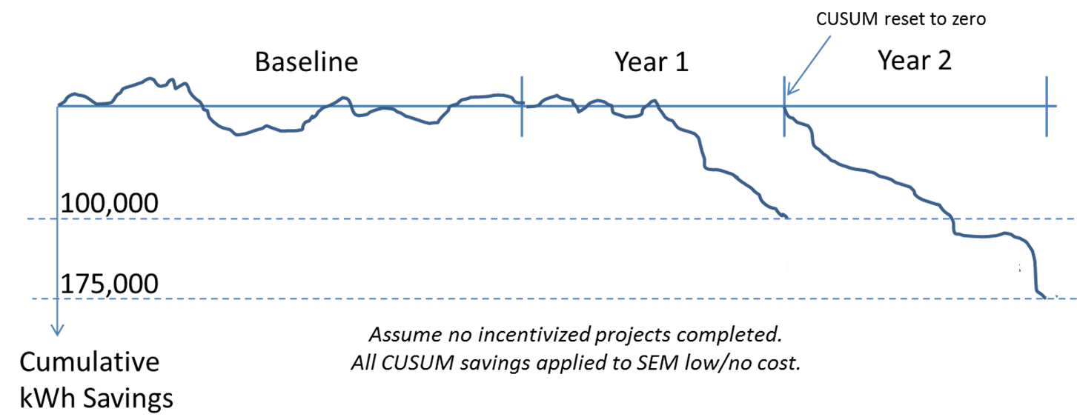

For Year 1 – 100,000 kWh – used for determining incentives, applied towards Program goal, submitted to PUC
For Year 2 – 75,000 kWh - used for determining incentives, applied towards Program goal, submitted to PUC
For additional years – use same process, reset CUSUM to zero and measure incremental savings
Demand Savings
Peak demand savings will be quantified using the statewide demand calculator developed by the CPUC for quantification of demand savings. Additional loadshape profiles will be added to the demand calculator as needed depending on participating participant building types.
Results Reporting
The PA will maintain the energy models each year the Program is offered and will prepare an annual report for each participant at the end of each Program year. These reports will contain the baseline model, CUSUM graph, savings and incentives earned, statistical rational, and calculations. If a model is not viable, the report will contain the rational, calculations, and data for individual activities leading to energy savings and incentives earned. Savings from the SEM initiative will be reported under the SEM Program. In addition to the annual reports, the PA will review progress monthly with the participating as models become available, summarizing savings achieved for each participant, and for the Program.

For Programs Claiming To-Code Savings
N/A

Pilots:
Please describe any pilot projects that are part of this Program, and explain the innovative characteristics to these pilots. The inclusion of this description should not replace the Ideation Process requirements currently agreed by Commission staff and IOUs. This process is still undergoing refinements and will be further discussed as part of Phase III of this proceeding
N/A

Workforce Education and Training
N/A

Workforce Standards
As required in Decision 18-10-008, the Program will require the following:
  - All HVAC projects receiving an incentive of $3,000 will require that all workers participating in installation, modification, and maintenance of HVAC measures on projects that meet the criteria outlined in this decision to meet one of the following criteria:
    - Completed or enrolled in an accredited HVAC apprenticeship.
    - Completed at least five years of work experience at the journey level as defined by the California Department of Industrial Relations, passed a practical and written HVAC system installation competency test, and received credentialed training specific to the installation of the technology being installed.
    - Have a C-20 HVAC contractor license from the California Contractor’s State Licensing Board.
    - All of the above requirements apply to all of the individuals that perform the installation work, not to the contracting firm itself.
  - All lighting controls projects receiving an incentive of $2,000 will require that California Lighting Controls Training Program (CALCTP) certification for technicians installing lighting controls projects.

Disadvantaged Worker Plan
N/A

Additional Information:
Include here additional information as required by Commission decision or ruling (As applicable. Indicate decision or ruling and page numbers)
N/A

Supporting Documents
Attach the following documents in Word:

Program Manuals and Program Rules
See attachment

Program Theory and Program Logic Model:
Model should visually explain underlying theory supporting the sub-Program intervention approach, referring as needed to the relevant literature (e.g., past evaluations, best practices documents, journal articles, books, etc.).

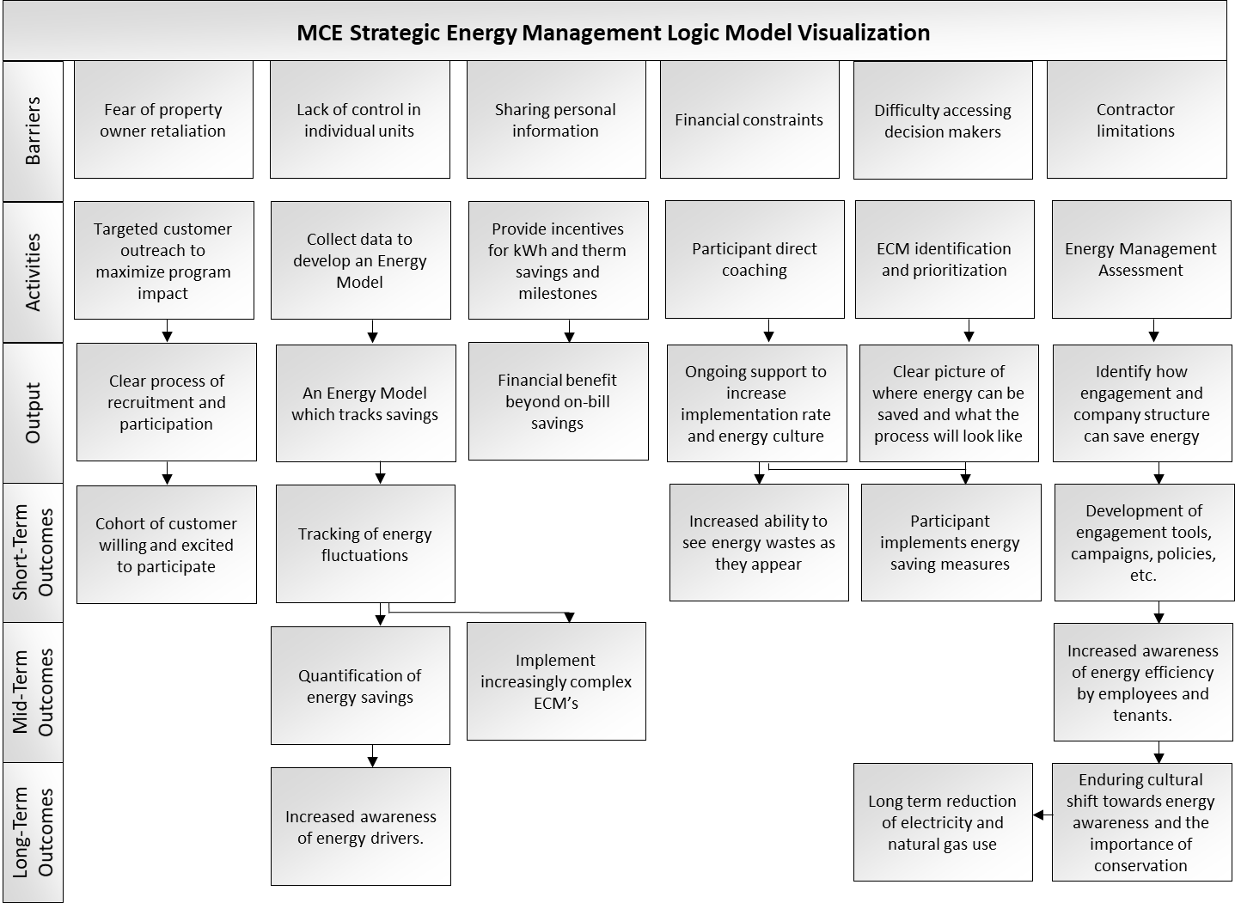

Process Flow Chart
Provide a sub-Program process flow chart that describes the administrative and procedural components of the sub-Program. For example, the flow chart might describe a customer’s submittal of an application, the screening of the application, the approval/disapproval of an application, verification of purchase or installation, the processing and payment of incentives, and any quality control activities.
The incentive path starts with customer engagement and explanation of the Program and identification of potential sustainability projects. The process flow for the SEM platform is detailed below.

SEM:

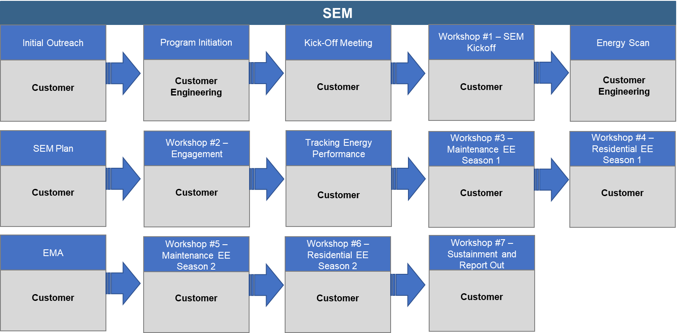

Incentive Tables, Workpapers, Software Tools

SEM:
Customer incentive payments will be of two kinds:
  - Milestone incentive payments: Milestone incentives will be paid to customers based on progress made in the Program, primarily for meeting deadlines for providing energy and relevant variable data.
  - Performance incentive payments: Performance incentives will be paid to customers based on energy savings calculated through the energy consumption adjustment model.
Milestone incentives are paid throughout the Program, based on the customer’s ability to meet deadlines and criteria. There are 5 milestones throughout the two-year engagement period. Payment for meeting each milestone will be:

Milestone | Quantity | Rate
Initial: Energy and Relevant variable Data and Workshop Attendance | 1 per participant | $2,000 per participant
Subsequent: Updated Data and Opportunity Register | 4 per participant | $1,000 per participant
Performance Based Payments. These payments involve the total Program energy savings and peak demand reduction goals for the Program’s BRO, customized retrofit projects and various activities and tasks associated with SEM implementation. MCE will pay for actual savings resulting from Projects, not forecasted savings. BRO measure savings payments will be paid twice throughout the two-year engagement period.

Payment for savings will be:

Category | $ / kWh | $ / Therm
BRO Measure Savings | $0.03 | $0.25

Quantitative Program Targets
Provide estimated quantitative information on number of projects, companies, non-incentive customer services and/or incentives that Program aims to deliver and/or complete annually. Provide references where available.
See table below.
Program Goals | 2022 | 2023
Net kWh | 1,245,999 | 1,381,598
Net Therms | 31,149 | 30,304
Total System Benefits (TSB) | $919,600 | $1,062,659
Number of Participants | 7 | 7

Diagram of Program
Please provide a one-page diagram of the Program including sub-Programs.
This should visually illustrate the Program/sub-Program linkages to areas such as:
- Statewide and individual IOU marketing and outreach
- WE&T Programs
- Emerging Technologies and Codes and Standards
- Coordinated approaches across IOUs
- Integrated efforts across DSM Programs
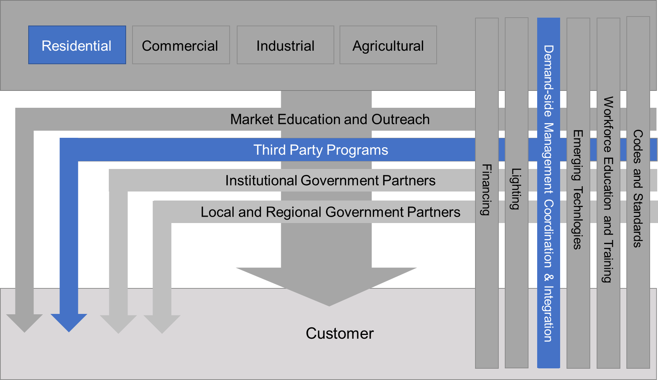

Evaluation, Measurement & Verification (EM&V):
N/A

Normalized Metered Energy Consumption (NMEC):
N/A

Program Modifications from the California SEM Design Guide
The Program’s SEM component will be modified to fit the MCE Multifamily customer base, leverage best-practices and ensure cost-effective delivery. These modifications include schedule changes, workshop spacing, shifting workshop topics, EMA timing, and milestone incentives and payment timing.
These changes are intended to increase Program effectiveness:
- Workshop spacing changes encourage participation
- Shifting workshop topics to improve learning and accelerate savings opportunities
- EMA and energy map timing allows the Program to detect improvements earlier and encourage action

# | Workshop/Event/Milestone | Timing
1 | Group Property Manager Workshop – Kick-off building a foundation | Month 1
2 | One-on-One Activity - Energy Scan | Month 2 - 3
3 | One-on-One Activity - Review and Prioritize Opportunities -- SEM Plan | Month 3 - 4
4 | Group Property Manager Workshop - Engaging Your Tenants in Saving Energy | Month 5
5 | One-on-One Activity - Measuring Energy and Modeling Energy Performance | Month 5
6 | Group Maintenance Workshop - Learning about energy efficiency - Season 1 | Month 6 -7
7 | Group Residential Workshop - Learning about energy efficiency - Season 1 | Month 6 -7
8 | One-on-One Event - Energy Management Assessment | Month 9
9 | Group Maintenance Workshop - Learning about energy efficiency - Season 2 | Month 9 - 10
10 | Group Residential Workshop - Learning about energy efficiency - Season 2 | Month 9 - 10
11 | Group Property Manager Workshop - Sustaining Energy Reductions / Report Out | Month 12
12 | Savings Report - Year 1 energy Reduction Reporting | Month 14

MCE service territory includes all of Marin County and Napa County, unincorporated Contra Costa County and Solano County, and the cities of Benicia, Concord, Danville, El Cerrito, Fairfield, Lafayette, Martinez, Moraga, Oakley, Pinole, Pittsburg, Pleasant Hill, Richmond, San Pablo, San Ramon, Vallejo and Walnut Creek
Burgess, J et al. 2014, Industrial Strategic Energy Management Initiative. Consortium for Energy Efficiency: https://library.cee1.org/content/cee-industrial-strategic-energy-management-initiative/

