
Guidance on Designing and Implementing
Energy Efficiency Market Transformation Initiatives
Ken Keating, Consultant to Energy Division
California Public Utilities Commission
Edited by Cathy Fogel, Energy Division
December 9, 2014

California policy makers have sought to create increasingly larger savings for energy efficiency programs as the State stretches to meet aggressive strategic goals. One strategic tool to make steady progress toward long-term goals is referred to as market transformation. Market transformation is both complementary to existing programs and supplements them in markets where traditional programs have had limited success. Both are necessary for a balanced statewide portfolio that pursues all cost effective energy efficiency the mandate of the investor owned utilities (IOUs) and the California Public Utilities Commission (CPUC) under Public Utilities Code 381.
To advance market transformation, the IOUs and the CPUC must build from a common definition and understanding of market transformation initiatives. In addition, they should base interventions on established guidelines for planning, designing, and carrying out market transformation initiatives in order to comply with the expectations of the Commission. The purpose of this document is to begin the dialogue that will provide a common understanding.
Defining Market Transformation
Many entities have defined market transformation and what it should accomplish. In 2009, the CPUC expanded its previous view of market transformation (changes noted in italics):

Market transformation is long-lasting, sustainable changes in the structure or functioning of a market achieved by reducing barriers to the adoption of energy efficiency measures to the point where continuation of the same publicly-funded intervention is no longer appropriate in that specific market. Market transformation includes promoting one set of efficient technologies, processes or building design approaches until they are adopted into codes and standards (or otherwise substantially adopted by the market), while also moving forward to bring the next generation of even more efficient technologies, processes or design solutions to the market.”

A shorter alternative might be paraphrased from several sources
“Market transformation is designed to induce sustained increases in the adoption and penetration of energy efficient technologies and practices through structural changes in the market and in behaviors of market actors.”
Another option is to define market transformation as sustained market effects. Market effects in turn are defined as structural and institutional changes in a delineated market as a result of strategic intervention. Market effects differ from spillover in that the intervention impacts the structure of the market, rather than simply increasing energy efficient technology purchases by participants (participant spillover) or by nonparticipants (nonparticipant spillover). Thus market transformation successes are a subset of interventions leading to market effects that are sustainable, even if the intervention is modified, refocused, or reduced.
Market Transformation Key Concepts
A useful guide to market transformation initiatives needs to be detailed enough to provide step by step guidance, but abstracted enough to allow for the details to be modified to align with any given specific market. Key market transformation concepts include “markets-based,” “barriers and opportunities,” “strategic planning,” “story for sustainability,” and “long-term perspective.”

Many authors have identified key elements in market transformation targeting, planning and design. The following are key concepts gleaned from several sources:

Steps to Market Transformation Planning

- Establish clear linkage between planned MT initiative and Strategic Goals – Since MT initiatives are expensive long-term investments, MT initiative must clearly support the Strategic Goals.

- Establish likely target markets based on knowledge of the technology, the consumers, the potential savings, and the market to be addressed.

- Have a good characterization of the market – actors, influences, value-added opportunities, barriers to entrance and to efficiency measures, competitors and potential partners. This should probably include a market operation diagram.

  - Establishing a baseline will provide metrics to track changes in the market

- Strategically design the intervention in terms of the barriers and opportunities, as well as the resources and the tactics to be used. This requires overall coordination of the intervention.

  - Lay out the program theory or logic and make sure it matches at least some parts of the market operation characterization, establishes interim and long-term metrics that can be tracked from the baseline.
  - Prepare an explicit description of how and what program interventions will result in lasting/sustainable, and cost-effective changes across the market -- the market transformation “story.”

- If possible, use a market-based advisory group to help shape and revise the program in response to market changes.

- Match the evaluation strategy to the program logic – always remember that the unit of analysis is the whole market, not just those touched by the program intervention.
Each of the underlined concepts is explained in more detail below.
- Targeting
Although energy efficiency program implementers have had less experience with selecting, designing, implementing, and evaluating market transformation initiatives, logically consistent criteria for deciding when to follow a market transformation strategy do exist. Picking the best targets for market transformation interventions requires considerable thought.

A composite set of guidelines would simplify to:

- There must be a clearly defined and manageable market;
- The market must represent a large enough opportunity to justify the resources and the long term commitment required to create the desired change;
- There must be a “story” that logically and defensibly links the present to the future state of the market,
- The measure or service ideally has strong non-energy benefits to help its acceptance and the sustainability in the market;
- Although the savings in aggregate may be large, they are generally small at each transaction, making market transformation the preferred strategic choice;
- The savings are able to be projected to be cost-effective over the longer time horizon.

Knowing what to target is a key question in market transformation planning. Another is distinguishing between resource acquisition programs and market transformation initiatives. Because many of the attributes of a solid market transformation intervention should also be part of the best acquisition program designs – such as cost-effectiveness, knowledge of the target market, measuring savings with sufficient confidence, and the ultimate goal of achieving energy savings – the question arises about whether the distinction between the two efforts is real and important. But there are nuances that differ between resource acquisition and market transformation initiatives, such as cost-effectiveness over the long term versus the short-term, and important differences in the required depth of knowledge about the market. There are also substantive differences as well. These distinctions, if they are not made clear, can cause confusion in designing market transformation efforts. The most important and foundational aspect of the market transformation paradigm is the focus on the market, not the program. From that most of the other distinctions will follow. Table 1 synopsizes the most common distinctions.
Table1: Distinctions between Resource Acquisition and Market Transformation
 | Resource Acquisition | Market Transformation
Scale | Program | Entire defined market
Target | Participants | All consumers
Goal | Near-term savings | Structural changes in the market leading to long term savings
Approach | Save energy through customer participation | Save energy through mobilizing the market
Scope of Effort | Usually from a single program | Results from effects of multiple programs or interventions
Amount of Program Administrator's control | PAs can control the pace, scale, geographic location, and can identify participants in general | Markets are very dynamic, and the PAs are only one set of actors. If, how, where, and when the impacts occur are usually beyond the control of the program administrators.
What is tracked, measured, and evaluated | Energy use and savings, participants, and free-ridership | Interim and long term indicators of market penetration and structural changes, attribution to the program, and cumulative energy impacts.
Timeframe for cost-effectiveness | Usually based on 1st year or cycle savings | Is usually planned over a 5 -10 year timeframe

- Characterization of the Market
Academics define a market as a system for voluntary exchanges of certain goods and services between individuals or groups, according to rules. At its simplest level, a market involves manufacturers, sellers of products or services, and consumers, but most are far more complex. They involve wholesalers, distributors, professionals who deliver the product to consumers, as well as associations of interested parties, and even regulators. Utilities are only big players in the energy market. They and their programs will generally be tangential to other markets.

Before we can develop hypotheses about how to influence a market and design programs to do so, we need a solid understanding of our market of interest. A market characterization is more than a simple description of the market. It also involves knowledge of who influences who, how profits are made, where added value occurs, how pricing is done, and where the barriers and potential leverage points might be. This often involves looking at the market from the perspectives of those who are making a living in it.

The results of market characterization research can be described in text or reflected in a market operation diagram. Two models of market diagrams are provided below. Figure 1 is a supply side market diagram for the motors market and Figure 2 diagrams the California residential new construction market.

As can be seen from these two examples, it can be very important in some markets --where there is concentrated market power, for instance -- to know something about market flows and market shares. This is the case with the motors market. These types of data can be gathered from census shipment sources, interviews with knowledgeable industry experts, and distributors. In dispersed markets, like the California residential new construction market, the market information that one needs to design an intervention will need to address understanding who makes the decisions and who supplies the services needed.

In performing a market characterization study, the approximate market must be delimited and samples taken of knowledgeable informants from each important facet of the market. This is done to avoid biases or limited perspectives that may be advanced by some market actors. Look for drivers of decisions and follow the money. Determine if there are associations that can provide leverage, or aggressive new competitors who may align with your initiative to gain market share. Look for non-energy benefits which may accompany and propel the energy efficient choices.

The market characterization should clarify the barrier to diffusion of the energy efficiency measure or practice in question, going beyond “awareness,” “cost,” or “consumer demand is missing.” These are typical reasons given by market actors, but these aren’t always the main barriers. Initial cost or incremental cost aren’t barriers at all if the product is seen as having value – or no Lexuses or BMWs would be sold. A solid market characterization study, often national in scope, can lead to the identification of potential members of the intervention advisory committee (see below).

Figure 1: Supply Side Structure of the Industrial Motor Market 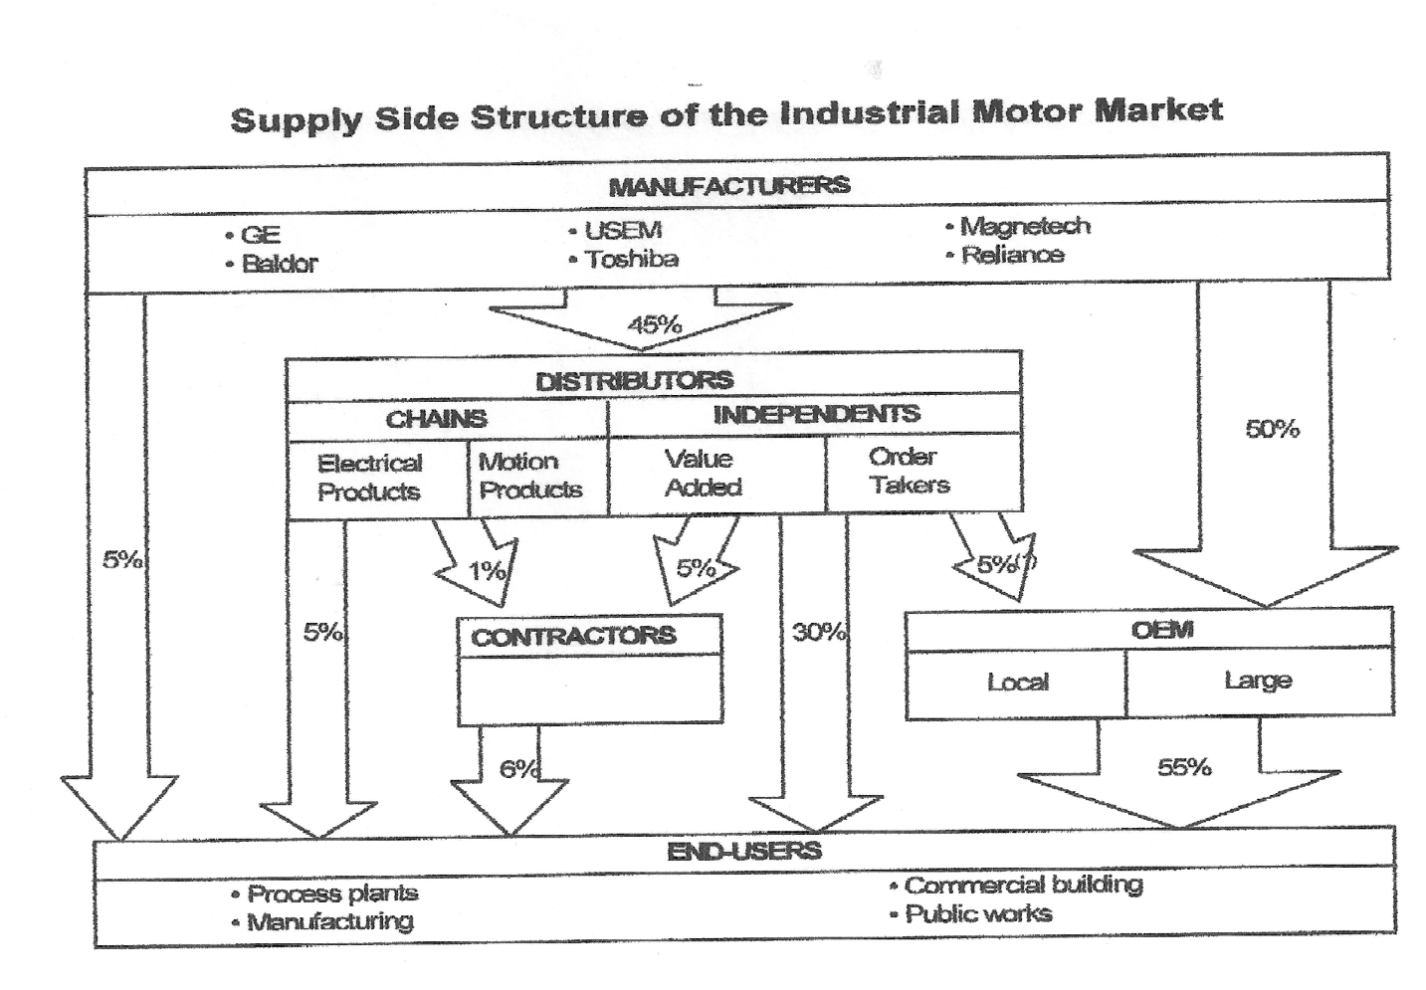
Figure 2: California’s Residential New Construction Market

- Baseline

At the time that the market is being characterized, it is important to gather information on baselines for potentially important efficiency indicators, such as sales, prices, availability, stocking practices, in order to be able to document change at a later time. It is important to get a market baseline, not a program baseline, since the market is the target. After each of the important baselines are captured in the market characterization, follow-up work to measure changes in the baseline metrics will need to be replicated at intervals consistent with how fast the market is changing. The baseline information is utilized within the strategic planning process to identify the appropriate metrics of progress toward the strategic goals.

- Strategically Design the Intervention

4.1 Understanding the Market

Understanding the market that may be a target is the first area of focus for planning. The next area of focus is designing an appropriate set of activities to strategically interact with the market. As part of this, it is important to spend time understanding what appropriate program targets could be and to develop a program logic and metrics in line with this understanding.

Once the market is understood, and the target measure or behavior is determined, the design of the program – using insights from social science, marketing, and the experience of market informants – can proceed. A good market transformation program consists of a series of strategic interventions involving solid knowledge of the market and coordination with other market actors, and is pursued using well defined market tools and tactics. A well-designed market-based program will recognize and use market forces, find allies, promote competition and share risks. A market-based program approach is also frequently tied to non-energy benefits that can make the desired product or service a preference in the market. This is where having a large set of tools at the program designer’s disposal is important. Well-designed market transformation programs are not about incentives, but rather are about strategic partnerships with market actors seeking similar goals for their own purpose. A good design looks for points of leverage and identifies the barriers that must be addressed.

The literature has established a list of common strategic tools for consideration. Such suggestions for strategic program design include:

- Link energy efficiency to other needs that customers value highly-- new products can succeed only if they meet real customer needs.
- The market must be defined clearly enough to be targeted;
- The market must be characterized so that program administrators can understand the opportunities and barriers as well as the relationships in the market;
- Identify a baseline for the targeted measure or practice, to be tracked over time;
- Use the value-added chain to influence downstream adoption of energy efficiency.
- Seek to apply market leverage by working with natural allies.
- Identify a market/product nexus that that produces large enough savings to justify the resources (in other words, ensure that large technical potential is available)
- Establish a coherent market and program theory, usually captured in a logic model, that connects the expected actions with the desired outcomes
- Focus on early adopters in opening markets for innovative products, such as products that provide both energy and non-energy benefits.
- Use different approaches to attract early adopters and achieve mainstream markets.
- Continue to measure and monitor key market indicator even after a particular market has been transformed for ongoing progress tracking; address unintended consequences or new barriers identified through this monitoring.

The type of interventions in market transformation initiatives may need to be different depending on the stage in the adoption process when the intervention occurs. Most market transformation efforts will be targeted at the innovation and early adoption phases of developing markets. We have included an example of varying the strategy with the level of penetration in the market in Appendix A.

Finally, remember that, “market transformation isn’t just the product of highly structured programs. It results from focused application of specific interventions in the market – and a certain amount of luck.”

4.2 Understanding Barriers

Much of the literature on market transformation has dealt with the barriers and market failures that are seen as targets for the strategic intervention. While not all market transformation activities will address barriers – and it can be a faster and smoother phenomenon when the barriers are actually small – understanding what constitutes the key barriers to progress is an important part of the planning. Eto, Prahl and Schelgel set out 14 traditional market barriers in 1996. In 2001, EPRI collapsed these into just eight overarching barriers.

We believe that the fourteen original barriers are important for program planners to understand, and the original source is recommended for greater understanding, but simplicity calls for using a list similar to EPRI’s for purposes of practical program planning.

Figure 4: Types of Market Barriers
Eto, et al List of Market Barriers | EPRI’s List of Market Barriers
Information search costs; | Access to information
Performance uncertainties;  Asymmetric information; | Performance uncertainties – risks
Access to financing | Access to financing
Split incentives; | Split incentives – who pays is not who gains
Bounded rationality – (frustrated by old rules of thumb);  Organizational practices or custom; | Decision-making – rules of thumb, habits, organizational decisions
Inability to separate product features – in particular for pricing;  Inability to reverse an EE decision. | Product or service features -- can’t separate efficiency features, not easily reversed
Hassle or transaction costs;  Hidden costs; | Transaction costs
Externalities not visible;  Mis-pricing due to regulation; | Mispricing of energy or other products in the market due to regulation and/or failure to include externalities.
Product or service unavailability;

4.3 Intervening to Address Barriers

Market transformation interventions are selected as much by the opportunities to leverage and change markets as by the need to focus on barriers that are keeping efficiency from rising to a competitive position in a particular market. Not all markets are broken; not all markets are filled with big barriers. But making sure barriers are reduced, removed, or avoided in the future will prepare the way for sustained market transformation. Therefore knowledge and targeting of important barriers identified in the market characterization study is often a core element in planning the market intervention. One example of how barriers, interventions and metrics of success line up is derived from the EPRI handbook.

Figure 5: Examples of Market-Effects Based Performance Assessment

4.4 Building a Program Theory or Logic Model

Just as it is often useful to flow chart what the operation of the underlying market looks like, program designers must also document how the program elements are intended to work together, which aspects of the market and which barriers, if any, the tactics will target. This documentation process is called a “program logic model.” Building a program logic model serves several purposes: 1) to test the reasonableness of the linkages; 2) to look for any barriers or leverage points that are inadvertently missed; 3) to see how the pieces fit together; 4) and, to establish an a priori version of what the intervention was designed to do for the sake of the evaluation and attribution. A logic model would typically be updated once the strategic intervention has been initiated and the program starts to come together.
Since market transformation is planned to take place over a long period of time (as long as 2, 5, or 10 years), a good market transformation “story” will always have interim goals and expected metrics of progress that are tied to the logic of the program intervention. These metrics may change, because markets are very dynamic, and some logical links may be dropped. However, without interim metrics to look at progress and adjust the tactics used, there would be a risk of continuing investments when it should be clear that interventions need to be dropped, changed or simply abandoned.
One mistake planners should avoid is starting with what the program tactics would traditionally be, and then looking for possible results, and calling those results the goals for which we need metrics. Rather, it is important to design program intervention to aim at the outcomes that are desired for the intervention. Planners also should look at what would be interim indicators of market progress—the desired market effects. After these metrics have been identified, planners should decide what tactics will be needed to advance the metrics. This basic sequence of steps is sometimes ignored.
There are several models for how to lay out a logic model. One tabular approach is found in Appendix A. Additional models are offered in Rosenberg and Hoefgen. Another that has been used successfully by KEMA (2009) is inserted below.
Figure 6: Model Logic Model- Residential New Construction (CA) — Desired Outcomes and Links to IOU Programs

  - The Market Transformation Story
A final step in designing a set of strategic interventions is building a market transformation “story.” A market transformation story assembles the whole picture of the market and the planned strategy in order to justify the interventions; explain the logic of the interventions; identify the barriers, opportunities and metrics; and identify the tactics and resources to be used. The market transformation story will vary from one market intervention to the next, but it will always include the logical connections between the market effects desired and the interventions of the program. Program planning due diligence requires that the “story” of any market transformation initiative be rigorously reviewed to see where logical links may be tenuous or barriers underestimated. Getting feedback from an advisory committee can be a good reality check on linkages that are stretched too far.

A key to the “story” is to establish what market effects are expected to be accomplished by the program interventions. These desired market effects are the postulated goals that will help determine the program metrics, and the tactics and points of intervention in the market. They will also help decide how long to stay in the market.

Some market effects are only produced after a series of long term interventions. In addition, the relative ambition of the targeted market effects will vary from market to market, depending on the relative strength of the program in the market, the willingness to spend resources while waiting, the availability of program intervention resources, and other factors.

Examples of the types of reduced barriers and structural and institutional changes—
or desired market effects— that might be targeted in the market by the program interventions include:

Figure 7: Examples of Types of Desired Market Effects

- A competitive market in which the efficient option battles for market share
- Reduced or eliminated price premiums for the basic technology
- New role players in the market to support and sustain the product
- Establishment of new competitors in the market who thrive on the product.
- Adoption as a voluntary standard by industry or government
- Market perceptions of the product as a status product
- End-users requesting or demanding the product
- Risks to private market actors are reduced or removed

Notably, “awareness” is not on this list. This is because, while most market transformation initiatives much increase awareness, awareness itself is a very short term measure and is not strongly related to action. Positive perceptions are much more important than awareness, in and of itself.

In sum, the “market transformation story” is what tells us where program planners want to go and the steps needed to get there. And as previous authors have noted, “the point here is that there is not a single criterion or set of indices to be met in determining whether and when to reduce program support to a given market. Rather, the combination of a solid program plan and timely monitoring of current market conditions provide the basis on which to make decisions regarding exit strategies and alterations of other elements of program design and delivery.”

- Advisory Group
In the California program environment, transparency and openness are valued. For an optimal market transformation program planning environment, we recommend that program designers bring in individuals, stakeholders, and private sector companies to form a sounding board and an idea generator. By its nature, this type of collaboration takes time, but since market transformation efforts are long term projects, the loss of time to get the right connections made will almost always outweigh any need for urgency. Sometimes, it may not be possible to involve competitors in an open discussion, but their willingness to provide data on market structure would be enhanced if they understood how their needs might mesh (or not) with the market transformation effort. Organizations of service providers are generally more receptive, but even manufacturers have been known to come to the table for motors programs, Energy Star ® windows programs, and manufactured housing in the Pacific Northwest. Such broad collaboration occurs when a significant portion of manufacturers see synergies between their corporate goals and what the market transformers have in mind. Early feedback from involved market actors can be invaluable.
Since markets are not transformed at the same rate and speed, it is important that we resist the urge to have a one-size fits all market transformation guidance. Instead, the market transformation guidance and discussions should be specific to the markets and players in that market.
- Evaluation Strategy
Evaluations, at their simplest, test the assumptions of the planners against in-field results. Market transformation planners have characterized a market and laid out a program theory and logic. They should have identified the interim and long term goals, or desired market effects, to measure progress in the market. They have a hypothesis of cost-effectiveness that depends on declining costs and expanding impacts from the high cost initial intervention. There are assumptions of causes and changes. The evaluation will need these assumptions to guide measurements in the field.
Just as market transformation metrics for success will be based on the whole market, the evaluation will focus on the market changes, and hopefully, the desired market effects of the program. To avoid a narrow and misleading focus on the “program” in a much larger and very dynamic market, organizations across the country have even taken to calling the evaluations – Market Progress Evaluation Reports (MPERs). This focus on the change in the market is as important for cost-effectiveness as it is for other metrics. Because Total Resource Cost (TRC) cost-effectiveness depends not only on the cost of the intervention, but the incremental cost of the measure or service, it is important for many market transformation interventions to assume a declining cost structure for the measure over time, not just reduced per unit administrative costs. As noted above in the section on market effects, one good metric of progress is reduced unit costs over time.
The ultimate measure of market transformation success is whether the effects can be sustained over time, at least at a target level of efficiency, so that funding can either be shifted or less expensive support of the market can be substituted. Sustainability implies long lasting impacts that don’t need continuous subsidization. The timeline for this can be long though, so evaluators are often asked what indicators of sustainability might be used in the interim or mid-term. A review of the literature indicates that there are multiple potential metrics of sustainability.These are generic, and each initiative would need to develop its specific indicators for sustainability.
Figure 8: Potential Indicators of the Probable Sustainability of Market Effects
- Is someone making money by offering it?
- Has a private market developed to continue the facilitation?
- Has the profession or trade adopted it as a standard practice?
- Would it be difficult or costly to revert to earlier equipment or practices?
- Are product performance issues resolved?
- Have more efficient codes and standards been adopted?
- Has the product achieved a dominant market share, pushing out less efficient options?
- Does customer awareness make the targeted measure the likely choice?
- Is there widespread availability of the product with the necessary infrastructure of service providers?
- Is the price of the product competitive and becoming even more competitive?

- Conclusion

This paper can only emphasize the most important points about planning and implementing a market transformation initiative. In trying to be concise and also stay away from details that can distract from the bigger picture, we have not provided examples from the thirty years of national experience with market transformation. Many of those examples can be found among the much more extensive reference material that forms the backbone of this paper. Here the emphasis has been on recognizing that market transformation is a distinct tool for achieving energy efficiency. It isn’t the default strategic choice, but one that can be highly effective if used properly. It can be risky and take a long time to pay off at times; and it may be necessary to abandon initiatives that are not showing signs of being effective. The knowledge of markets and the relationships formed with market actors can pay off with unexpected opportunity and even help resource acquisition programs.

The CPUC, the CEC, non-governmental entities, private sector market actors and the IOUs will need to continue to work together to achieve some strides in market transformation. For many markets, market transformation may be the only strategic option. It will take a continual effort over several portfolio cycles and will require alignment of policy direction and appropriate metrics and rewards for the implementers. But the potential benefits of concerted market transformation initiatives make this well worth the effort.

References
EPRI, (2001): “Market Transformation: A Practical Guide to Designing and Evaluating Energy
Efficiency Programs.” Electrical Power Research Institute, Palo Alto, Ca. Report 1001492.

Eto, J., Prahl, R. and Schlegel, J. (1996): “A Scoping Study on Energy Efficiency Market
Transformation by California Utility DSM Programs.” Lawrence Berkeley National Laboratories, UC #1322; LBNL 39058.

Herman, P., Feldman, S., Samiullah, S. and Mounzih, K. (1997): “Measuring Market
Transformation: First You Need a Story…” Proceedings of the 1997 International Energy Program Evaluation Conference, Chicago, IL.

Hewitt, David, (2000): “Elements of Sustainability.” Proceedings of the 2000 Summer Study on
Energy Efficiency in Buildings. American Council for an Energy Efficient Economy, Vol. 6.

Keating, K., Goldstein, D., Eckman, T. and Miller, P. (1998): “Wheat, Chaff, and Conflicting
Definitions of Market Transformation.” American Council for an Energy Efficient Economy (ACEEE) Proceedings of the 1998 Summer Study on Energy Efficiency in Buildings, Vol. 7 pp. 7.157 – 7.169.

KEMA (2009): “Phase I Report: Residential New Construction (Single Family Home) Market
Effects Study” California Institute for Energy and the Environment, Berkeley, CA

NMR Group, Inc. (2013) A Review of Effective Practices for the Planning, Design,
Implementation, and Evaluation of Market Transformation Efforts.
<http://calmac.org/publications/FINAL_NMR_MT_Practices_Report_20131125ES.pdf>

Prahl, R. and Keating, K. (2011): “Planning and Evaluating Market Transformation: What the
Industry has Learned, and Possible Implications for California.” Prepared for CPUC Workshop on Market Transformation, November 7, 2011, CPUC-ED San Francisco, CA

Rosenberg, M. (2009) “Market Effects and Market Transformation: Their Role in Energy
Efficiency Program Design and Evaluation” Presentation Prepared for CIEE and the California Public Utilities Commission <http://uc-ciee.org/planning-evaluation/7/336/105/nested>

Rosenberg, M. and Hoefgen, L. (2009): “Market Effects and Market Transformation: Their Role
in Energy Efficiency Program Design and Evaluation.” California Institute for Energy and the Environment, Berkeley, CA

Sebold,F., Fields, A., Skumatz, L., Feldman, S., Goldberg, M., Keating, K. and Peters, J. (2001):
“A Framework for Planning and Assessing Publicly Funded Energy Efficiency.” Pacific Gas and Electric, San Francisco, CA. Study # SW040.
APPENDIX A: Matching Program Type to Product Life Cycle
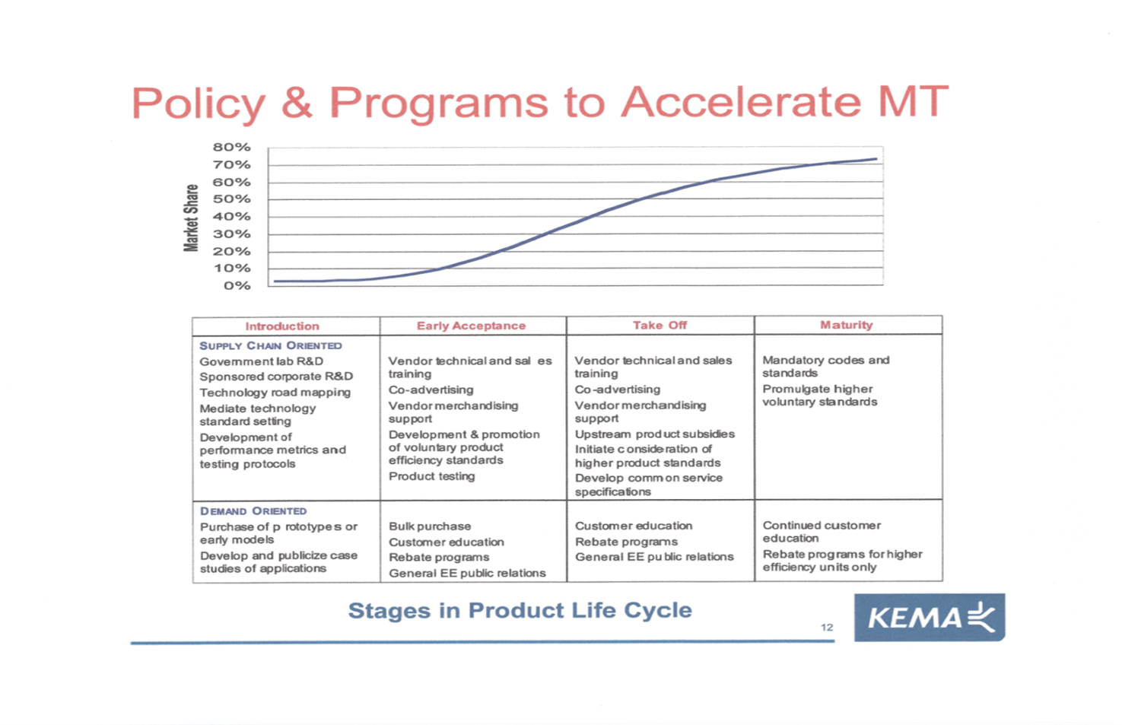

D.09-09-047 at 89
EPRI (2001); Sebold et al., (2001); Keating, et al., (1998); Rosenberg and Hoefgen (2009).
Throughout the paper, we use as our basic resources the references found at the end of this paper. In the text we paraphrase the most germane thoughts from them for the purpose of providing guidance.
Our source materials provide significantly greater detail on what could be important attributes of a target market.
Derived from Sebold et al., and Keating, et al. ops cit.
We are only including here the newly constructed residential buildings. Additions, remodels, and renovations, which are part of new construction codes, involve different market actors and dynamics.
Rosenberg and Hoefgen, op cit. p.47
KEMA, 2009, op.cit., p.8.
EPRI, op. cit.; Prahl and Keating (2011)
EPRI (2007), p. 7-1., emphasis added.
Eto, Prahl and Schlegel (1996) pp 13-16
EPRI, (2001).
EPRI, op. cit., p. 5-7
Op.cit. Pp. 49 and 60.
KEMA (2009), op cit., p.20.
The term “story” is used to distinguish the “selling of an initiative” from the dry presentation in a logic model. A story fills in the details, the interactions, and the real market details. Herman, P., Feldman, S., Samiullah, S. and Mounzih, K. (1997): “Measuring Market Transformation: First You Need a Story…” Proceedings of the 1997 International Energy Program Evaluation Conference, Chicago, IL
Rosenberg and Hoefgen (2009, p. 53).
It is overly simple to consider total disengagement from markets. There are valid reasons for reducing, not ending support, or changing the type of support. Most market engagements continue to support increasing efficiencies over time.
Hewitt (2000); Rosenberg and Hoefgen (2009).

