Energy Efficiency Summer Reliability Program
AKA
Peak Power Rewards Program
Implementation Plan

Sunrun, Inc.

March 6, 2023
Version 1.0

Table of Contents
Program Overview 2
Program Budget and Savings 2
Implementation Plan Narrative 3
1. Program Description 3
2. Program Delivery and Customer Services 4
3. Program Design and Best Practices 4
4. Innovation 5
5. Metrics 5
6. To‐Code Savings 5
7. Pilots 6
8. Workforce Education and Training 6
9. Workforce Standards 6
10. Disadvantaged Worker Plan 6
11. Additional information 6
Supporting Documents 7

Program Overview
The PG&E Energy Efficiency Summer Reliability (EESR) program (aka, Peak Power Rewards Program) will support PG&E’s summer reliability efforts by providing sustained and scheduled customer load shifting/modification services to PG&E during the 2023 summer period.

Program Budget and Savings
- Program and/or Sub-Program Name: Energy Efficiency Summer Reliability Program (aka, Peak Power Rewards Program)
- Program / Sub-Program ID number: TBD
- Program / Sub-program Budget Table
Program ID Budget Category | 2023 Budget
Administration | $60,000
Marketing, Education, and Outreach | $100,000
Implementation (Direct Implementation Non-Incentive) | $3,990,000
Incentives | $6,375,000
Total | $10,525,000

- Program / Sub-program Gross Impacts Table
Metric | 2023
Annual kWh Savings (Gross) | N/A, see discussion below
Peak Demand Savings (kW) (Gross) | 30,000 kW (target)
Net Peak Demand Savings (kW) (Net) | TBD, see discussion below

The EESR Program is primarily a load-shifting program intended to provide greater grid reliability during the summer (August through October) net-peak hours of 7-9 p.m. While load shifting programs may or may not generate energy savings, the program is expected to provide some energy efficiency benefits via the smart thermostat. PG&E intends to contract with a third-party evaluator to conduct Evaluation, Measurement, and Verification (EM&V) of the program, which would determine the energy savings delivered in 2023 as compared to the customer’s baseline usage in 2022. These results will be reported once the program has concluded and EM&V has been completed.

- Program / Sub-Program Cost Effectiveness (TRC): N/A
- Program / Sub-Program Cost Effectiveness (PAC): N/A
- Type of Program / Sub-Program Implementer: Third-Party Delivered
- Market Sector(s): Residential
- Program / Sub-program Type: Resource Acquisition
- Market channel(s): Downstream
- Intervention Strategies: Incentives paid directly to end-use customers. Direct install strategy whereby customer self-installs an energy-efficient Google Nest thermostat.

Implementation Plan Narrative

1. Program Description
The EESR Program (aka, Peak Power Rewards Program) addresses potential energy supply shortages during the evening “net-peak” periods in the 2023 summer months. The program will directly address California Governor Newsom’s July 30, 2021 Proclamation of a State of Emergency stating “it is necessary to take immediate action to reduce the strain on the energy infrastructure, increase energy capacity, and make energy supply more resilient this year to protect the health and safety of Californians.”

The EESR Program will support summer reliability efforts by providing sustained and scheduled customer load shifting/modification services to PG&E during the 2023 summer period. The program will target residential single-family customers within PG&E’s service territory with existing Sunrun-contracted battery storage systems connected to on-site solar systems. During the implementation period (August thru October 2023), Sunrun will dispatch the batteries each day during the net-peak hours of 7:00 p.m. to 9:00 p.m. to provide a block of capacity to PG&E. Sunrun will aggregate behind the meter battery storage to provide a virtual power plant to PG&E via an Application Programming Interface (API), scheduled ahead and dispatched remotely. The program will provide the participants with a one-time enrollment incentive of $750 and a self-install smart thermostat. Sunrun will receive performance payments for actual capacity delivered as measured at the sub-meter level.

Objectives:
- Combine energy efficiency (EE) with behind-the-meter clean battery storage systems.
- Deliver electric net peak (7 p.m. to 9 p.m.) demand reductions through EE and clean energy storage from August 1, 2023, to October 31, 2023.
- Develop a new, long-term customer program structure that consolidates siloed behind-the-meter distributed energy resource technologies into a single customer experience that could provide customer solutions optimized around a range of objectives (e.g., energy bill savings, reliability, Public Safety Power Shutoff and wildfire resiliency, alleviation of distribution-constrained areas, capital investment deferral, carbon reduction, etc.)

2. Program Delivery and Customer Services
This program targets Sunrun’s residential customers within PG&E’s service territory with solar PV and battery storage systems. The goal is to enroll up to 7,500 customers into the program to deliver 30 MW of capacity in the summer of 2023. Sunrun will market the program to its customers using an omnichannel method consisting of a press release, media post, email, and text. The program is designed as an “opt-out” program, which will increase customer engagement and the overall conversion rate to participate in the program. All eligible customers will receive an email explaining the program's benefits and an option to “opt-out” if they are not interested in participating. This program is not designed to address hard-to-reach customer groups specifically.

Customer services provided by this program include Sunrun remotely controlling the customer’s battery to discharge daily from 7:00-9:00 pm from August 1 through October 31, 2023, in exchange for a one-time participation incentive payment of $750 and a free smart thermostat. The customer’s participation in the program will deliver capacity to the electric grid during the summer months. The batteries will be programmed to maintain enough backup capacity to be used at home in the event of a power outage.

3. Program Design and Best Practices
The key program strategies and tactics to reduce barriers for targeted customers are:
- Using “opt-out” enrollment: The residential solar industry tends to see little engagement post-activation. To address this lack of engagement, Sunrun plans to run an “opt-out” campaign to enroll participants in this program: participants will be automatically enrolled and presented with a straightforward and concise unenrollment process if choosing to opt-out of the program. Opt-out enrollment is reasonable for this program design because participants have a financial upside for taking action, with no financial downside. Sunrun’s existing customer contracts allow them to auto-enroll customers into demand reduction programs. Sunrun expects this approach to lead to a higher level of customer participation in the program, resulting in more energy being delivered to the grid during the net peak in the summer months.
- Using an API to remotely dispatch batteries: Using an API to remotely dispatch batteries will provide a hassle-free and consistent experience for the customer, so they do not need to program the battery. It will also provide a reliable dispatch for the utility from 7:00-9:00 p.m. daily (Monday through Sunday).

The Sunrun software platform is critical to the strategy, administration, and implementation of the EESR Program. The software will provide the necessary analytic tools to bridge the flow of information between PG&E and the evaluator. The Sunrun software will:
- Collect battery inverter data from the program participants;
- Track delivery of savings from the customer’s inverters or gateway device; and
- Provide eight (8) 15-minute incremental data points for each day from the Participating Customers using data directly from the customer's inverter or gateway device.

4. Innovation
The EESR program has the following innovative elements in the technology, market strategy, and delivery approach:
Technology
This program uses a novel combination of technologies, including strategies integrating energy efficiency with distributed generation. Each program participant has solar PV systems to generate electricity to charge their battery storage systems. The stored solar energy will be discharged daily to reduce demand on the electric grid. Each customer will also have a smart thermostat capable of delivering energy savings by being programmed to pre-cool the home before the net-peak period of 7:00-9:00 pm when the battery discharges. In addition, the delivery approach includes technology that allows dispatch to be scheduled ahead of time to ensure consistent delivery.
Market Strategy
The EESR program uses creative incentives for customer participation in a program allowing a 3rd party to control their battery for the set of behaviors defined under the EESR program. Each participant will receive a $750 incentive for agreeing to the daily discharge of their battery for 3 months and a Google Nest Thermostat valued at approximately $120.
Delivery Approach
The EESR program utilizes a new strategy for customer engagement and enrollment by being an “opt-out” versus an “opt-in” program. Existing Sunrun customers will be educated on the program and its benefits via email and a website landing page, with an option to “opt-out” if they do not wish to participate. Sunrun’s contract with its customers allows it to enroll customers into demand response and similar types of programs unless they actively decline to participate. This approach should increase the number of participants in the program and the benefits delivered.
The program delivery strategy also includes comprehensive, integrated site-specific energy solutions across demand-side resources such as energy efficiency, demand response, and distributed generation, as described above.

5. Metrics
The following are the metrics that will be used to track program progress:
- 30,000 kW delivered to the grid during net peak demand times (7:00-9:00 pm);
- 7,500 customer enrollments; and
- Customer satisfaction (measured via a customer satisfaction survey).

6. To‐Code Savings
This section is not applicable to this program.

7. Pilots
This section is not applicable to this program.

8. Workforce Education and Training
The EESR program does not have a direct component for workforce education and training, but it indirectly addresses the objectives of growing job opportunities and on-the-job training.

9. Workforce Standards
Sunrun will adhere to all applicable requirements for workforce standards.

10. Disadvantaged Worker Plan
The EESR program does not have a direct component for targeting disadvantaged workers, but it indirectly addresses the objectives of growing job opportunities and on-the-job training.

11. Additional information
This section is not applicable.

Supporting Documents
Attached in PDF Format

- Program Manual and Program Rules
A program manual containing rules for participation is provided with this implementation plan.

- Program Theory and Program Logic Model
Below is the Program Logic Model for the EESR Program.

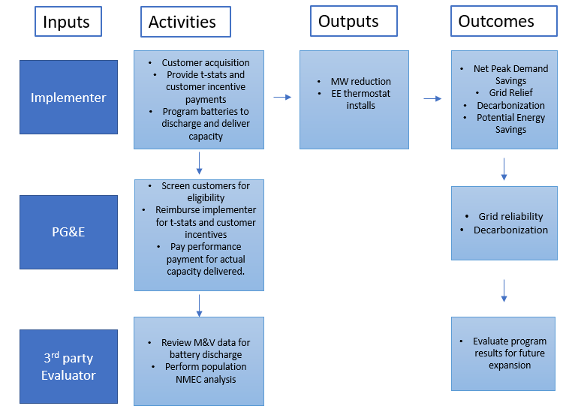

- Process Flow Chart

The following graphic illustrates the process flow for the EESR program.

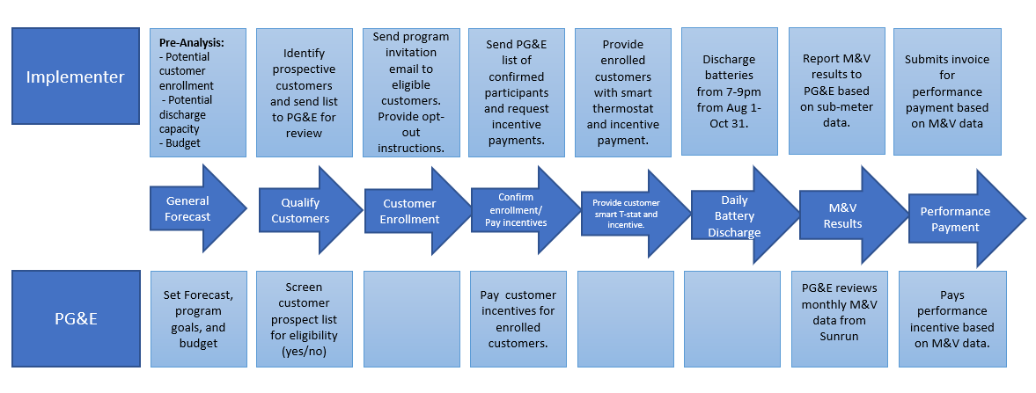

- Incentive Tables, Workpapers, Software Tools

Sunrun will provide each participant with a one-time payment of $750 and a smart thermostat for agreeing to dispatch their battery daily from 7-9 pm from August 1 through October 31, 2023. The program-level Population NMEC M&V plan describes the approach and associated software tools for calculating actual payable savings to the implementer for their performance payment. Workpapers are not part of the program plan. This program is delivering only demand reductions during the net peak period.

- Quantitative Program Targets

During the 3-month period from August – October 2023, PG&E anticipates that the program will deliver 30 MW of capacity from discharging the batteries of up to 7,500 program participants.

- Diagram of Program
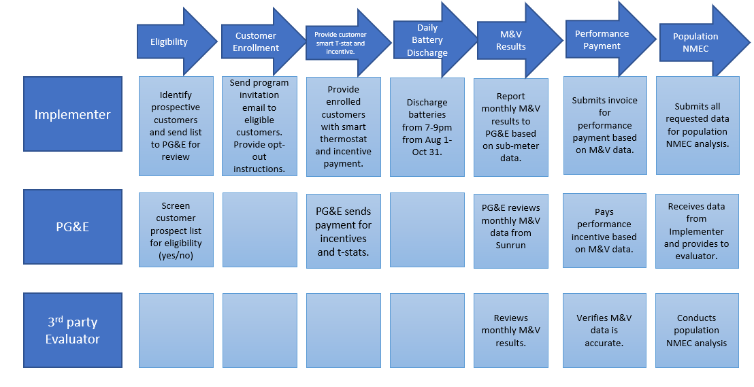

- Evaluation Measurement & Verification (EM&V)

PG&E cannot claim any savings for the program toward its energy efficiency program goals. Given the potential for customer-sited, behind-the-meter programs involving generation and storage to provide grid relief during peak periods, PG&E intends to engage a third-party evaluator to conduct a formal “Early M&V” study. Details on this planned study are provided in the M&V Plan.

- Normalized Metered Energy Consumption (NMEC)

The Energy Efficiency Summer Reliability Program Population-Level NMEC M&V Plan is provided with this Implementation Plan.

Defined as the hours between 7:00-9:00pm, for the purposes of this program.
Proclamation of a State of Emergency 7-30-21, available at https://www.gov.ca.gov/wp-content/uploads/2021/07/Energy-Emergency-Proc-7-30-21.pdf.
Early M&V is a process whereby program administrators are permitted to undertake a study process akin to an impact evaluation that “seeks to validate key savings assumptions and to better understand how savings are achieved for the purpose of improving programs.” See Decision 10-04-029 (April 21, 2010), p. 25.)

