Southern California Regional Energy Network

Implementation Plan

  - SoCalREN Multifamily Finance Subprogram

  - First Filing Date: 11/19/2019
  - Revision Filing Date: mm/dd/2019

Table of Contents
1. Program Budget and Savings Information 3
a. Program Information 3
b. Program Implementer 3
c. SoCalREN Business Plan Sector 3
d. Program Type 3
e. Intervention Strategies 3
f. Projected Program Budget 4
g. Savings Impact 4
h. Program Effectiveness 4
2. Implementation Plan Narrative 5
a. Program Description 5
b. Program Delivery and Customer Services 5
Marketing and Outreach 6
c. Program Design and Best Practices 7
d. Evaluation, Measurement, and Verification (EM&V): 9
e. Program Performance Metrics 10
f. Quantitative Program Targets 10
g. Pilots 10
h. Program Logic Model 11
i. Process Flow Chart 12
j. Diagram of Program 14
k. Additional information 14
l. For Market Transformation Programs Only 15
i. Quantitative Baseline and Market Transformation Information 15
ii. Market Transformation Strategy 15
3. Appendix: Supporting Information and Documents 16
a. Program Manuals and Program Rules 16
b. Incentive Tables, Workpapers, Software Tools 16

Program Budget and Savings Information

Program Information
Program Name | SoCalREN Multifamily Finance Subprogram
Program ID# | SCR-FIN-C2

Program Implementer
Program Implementor | Yes
SoCalREN Only | X
SoCalREN – Statewide Lead
Other PA – Statewide Lead
Third Party
Other

- SoCalREN Business Plan Sector
SoCalREN Business Plan Sector | Yes
Residential | X
Commercial
Industrial
Agricultural
Public
Codes & Standards
Workforce Education & Training
Finance
Other

- Program Type
Program Type | Yes | No
Resource |  | X
Non-Resource | X

- Intervention Strategies
Primary Intervention Strategy | Yes | No
Upstream |  | X
Midstream |  | X
Downstream | X
Direct Install |  | X

- Projected Program Budget

Budget data on CEDARS?: | X | Yes |  | No | If No, then show below:

- Savings Impact
Budget data on CEDARS?: | X | Yes |  | No | If No, then show below:

- Program Effectiveness
Budget data on CEDARS?: | X | Yes |  | No | If No, then show below:

Implementation Plan Narrative

Program Description
The Multifamily Finance Program (MFF Program or Program) broadens access to finance for more multifamily property owners/contractors for energy efficiency upgrades by allowing a financial institution partner to modify its underwriting criteria and accept more risk than it would otherwise on qualified projects. The program design incorporates a credit enhancement that will reduce the borrowing rate for the borrower and the design incorporates features that make the program process easy for the borrowers, financial institutions, contractors, and the administrator, therefore encouraging investments in energy efficiency.
This Program addresses the funding market barrier, thus promoting more long-term energy benefits for multifamily housing through funding the implementation of comprehensive energy efficiency upgrade measures. The Program aims to (1) assist property owners and property managers with making informed decisions about the cashflow associated with energy efficiency improvements, (2) offer credit enhancements to decrease market-based interest rates and (3) facilitate additional whole-building energy efficiency measure installations, further encouraging investments and market participation in energy efficiency.
The Program provides a credit enhancement for loans to fund the installation of a set of energy efficiency measures recommended through an energy assessment conducted by the Multifamily Program staff and property owner’s contractor. The credit enhancement absorbs any losses before the lending partner does and funds revolve as loans amortize.
The Program offers three financial products: Capital Lease, Equipment Finance Agreement (EFA), and Energy Service Agreement (ESA). A Capital Lease is a lease-agreement in which the lessor (“financial institution”) agrees to transfer the ownership rights to a lessee (“borrower”) at the end of the lease term. In many ways the Capital Lease resembles a closed-end loan where the financial institution is the owner of the installed energy efficiency equipment until the capital lease is paid in full. Alternatively, an Equipment Finance Agreement is a financing option where the borrower retains ownership of the financed equipment throughout the term of the loan. For an Energy Service Agreement, the borrower enters into an agreement with a service provider (“contractor”) and in return receives the output (saved energy) from the energy equipment. The service provider is paid back for its investment through a portion of the energy cost savings that the project incurs over a specified period of time.

Program Delivery and Customer Services
The Program goals are shown in the following table below:

Program Goals | 2019 | 2020
1. Funded Financial Projects | 0 | 40
2. Funded DAC Financial Projects | 0 | 10 (25%)
3. Finance Proposals | 0 | 100
4. Educational Webinars | 1 | 4
5. Contractor Sales Webinars | 0 | 10
6. Web Site | 0 | 1

The Program will fund a total of 40 projects with 25 percent (10 financial projects) to disadvantaged communities (DAC). Additional goals include delivering 100 finance proposals for multifamily energy efficiency projects, 5 educational webinars for contractors, financial institutions, and multifamily owners/managers, and 10 one-on-one contractor sales training webinars. In addition, the SoCalREN program website will be updated with promotional materials for the program.

Marketing and Outreach
Generating awareness and interest in the SoCalREN Multifamily Finance Program requires a variety of complementary efforts – from educational webinars and marketing collateral to enrollment meetings with financial institutions and one-on-one sales training presentations with contractors. Both the Program team and participating contractors act as the Program’s primary sales force, using the various finance offerings to sell cost-effective retrofit services to multifamily properties.
Multifamily Finance Program Educational Webinar
The MFF Program will leverage existing SoCalREN ME&O programs to invite multifamily property owners/managers and contractors to attend educational webinars discussing program features, benefits, financial products, finance proposals, eligibility criteria, process from application to financing
disbursement, and repayment process. The webinar will also introduce program participants to
a Finance Tracking System, which connects borrowers and contractors with financial institutions. The webinar will be recorded, and a link will be available on the SoCalREN MFF Program webpage.
Financial Institution Enrollment Meetings
The MFF Program will perform enrollment meetings with financial institutions to discuss financial institution eligibility criteria, credit enhancement structure, finance application requirements, Finance Tracking System, and the Lender Agreement. Subsequent negotiation conversations will be set up for interested financial institutions to finalize a Lender Agreement agreed to by the Program Administrator and the Financial Institution. Upon full execution of the Lender Agreement, financial institutions are enrolled to finance approved projects in the Multifamily Program.
One-on-One Finance Sales Trainings for Contractors
As the intent of the MFF Program is to be contractor driven, One-on-One Sales Training webinars will be conducted to further support contractors in using the financial products to sell energy efficiency projects to their customers. The educational webinar is focused on training contractors to convince their customers to utilize the financing options to facilitate installation of more comprehensive retrofit projects.
Engagement Channels
Specific marketing and outreach strategies employed to engage target audiences include:
Marketing and Event Collateral: A customer facing MFF Program overview and other marketing and event collateral will be provided to educate financial institutions, property owners and managers, and contractors about the various finance offerings. Project finance proposals will be sent to property owners and managers and contractors for all approved projects in the Multifamily Program. A draft proposal will be sent when the initial savings are modeled (“Assessment Conducted”) and a final proposal will be sent, along with the project reservation letter, when the project scope is approved (“Assessment Completed”).
Toll-Free Phone Support: The MFF Program provides toll-free support for program inquiries and finance requests. The toll-free line is available on weekdays from 9:00 a.m. to 5:00 p.m. The toll-free phone number and hours of operation will be prominently featured in program collateral.

Web-Based Digital ME&O: The existing SoCal REN program website will include a webpage on MFF.

Program Design and Best Practices
The goal of the MFF Program is to connect multifamily property owners, property managers, and contractors with financial institutions to fund the installation of energy efficiency projects and increase participation in the Multifamily program, including DAC and HTR properties, and ultimately save energy, improve tenant comfort, and reduce ongoing maintenance costs.

The implementation process begins with market education to multifamily property owners, property managers, and contractors. The MFF Program will also perform one-on-one presentations and meetings to financial institution for enrollment. Thereafter, finance proposals will be developed on an ongoing basis for every approved Multifamily project and submitted to multifamily property owners, property managers, and contractors. To further facilitate program participation, one-on-one finance sales training will be provided to contractors. To maintain engagement with multifamily property owners, property managers, and contractors throughout the process, periodic communications will be sent at various stages of loan application and funding.

Multifamily Finance Program Educational Webinars: Program launch begins with an educational webinar for Multifamily Property Owners/Managers and contractors to educate them on the program features, benefits, financial products, finance proposals, eligibility criteria, process from application to loan disbursement, and loan repayment process. The webinar also introduces program participants to the Finance Tracking System, which connects multifamily property owners, property managers, and contractors with financial institutions. The webinar will be recorded, and a link will be available on the SoCalREN MFF webpage.

One-on-One Enrollment Meetings with Financial Institutions: The MFF program will meet one-on-one with financial institutions to present the program features and benefits, credit enhancement structure, eligibility criteria, process from application to loan disbursement, loan repayment process, and negotiate types of projects and finance criteria for the financial institution to fund. The result of these negotiations will be executed lender agreements triggering financial institution enrollment in the program.

Multifamily Finance Proposals: Multifamily Finance Proposals will be prepared and sent to the relevant property owner/manager(s) and contractor(s) for all approved projects in the Multifamily Program. Two proposals will be sent. The first is after the intake assessment is completed and potential energy savings estimates are calculated through the energy model. This draft proposal shows the impact of project financing for all retrofit opportunities identified during the assessment. Providing financing information at this stage helps in the sales process by encouraging customers to take advantage of beneficial financing terms to fund more comprehensive retrofits than what they would otherwise consider with just incentives. Once the customer finalizes their project scope, a final finance proposal is provided with the commitment letter.

The finance proposal provides information on available financing options through the program. Each finance proposal includes:
- Project Summary: Description of provided information
- Project Cost Overview: Project Cost, Multifamily Program Incentives, and Net Amount to be Financed
- Project Savings Estimates: Annual energy cost savings, lifecycle energy cost savings for a period of 10 years, and 6-month cost of delay
- Monthly Payment Estimates: 3 Term options with varying Net Monthly Cash Flow
- Next Steps: Instructions to request a finance application

One-on-One Sale Trainings with Contractors: As the intent of the MFF Program is to be contractor driven, sales training will be conducted to support contractors in using the financial products to sell energy efficiency projects to their customers. Much of the information discussed in this training will be focused on techniques to convince their customers to utilize below market rate financing options to fund more comprehensive project scopes.

Ongoing Engagement: To maintain engagement with multifamily property owners, property managers, and contractors, Program staff will communicate with customers periodically throughout the application process to keep them updated on status. For example, if a finance application has not been started or an application has not been completed, Program staff will follow up with the customer to better understand the delays and to assist the customer through the process.

All implementation activities will be gauged and adjusted to ensure effectiveness. Continuous customer feedback mechanisms and metrics tracking will be used to ensure implementation methods maintain effectiveness.

Market Barriers
The MFF Program addresses the following market barriers and implements best practices to mitigate these potential barriers:

Barrier | Solution
Lack of capital | Program addresses this issue directly through providing credit enhancements which attract capital from financial institutions that do not usually service the multifamily segment, thereby increasing funding for energy efficiency upgrades.
Lack of awareness of financing options | Program holds education webinars to inform participants of the Multifamily program of the availability of financing at below-market interest rates and sends finance proposals for every Multifamily project, to ensure all participants are offered financing options.
Burdensome process to secure funding for energy efficiency improvements | Program services are seamlessly integrated into the Multifamily Program process. After a project is approved in the Multifamily Program, a finance proposal is sent to the participant and contractor along with the project approval notification. Borrower simply needs to confirm interest in financing and a link is provided for a 1-page finance application with quick communication of finance decision from financial institution.
Lack of contractor training to use financing to sell energy efficiency projects | Program provides finance sales training to contractors to use the financial products to convince multifamily property owners and managers to move forward with installation after finance approval.

Best Practices
As the goal of this program is to overcome the access of funding barrier, the program design has been developed based on the leasons learned from other credit enhancement and PACE financing programs.

Evaluation, Measurement, and Verification (EM&V):
Performance and outreach metrics are collected throughout the MFF Program process for all participants. SoCalREN gathers information during the outreach phases, collecting data on potential customers reached, and effectiveness of outreach approaches.
The MFF Program eligibility is the same as the SoCalREN Multifamily Program, therefore all approved projects are offered financing via a Multifamily Finance Proposal. The number of proposals issued and percent conversion from proposal to finance application will be a tracked metric.
Once a finance application is submitted, the Program will track the number of finance applications that are approved and declined by financial institutions. When a project is complete, final financed amount, credit enhancement amount, market interest rate, blended interest rate, monthly payment amount, and monthly credit enhancement repayment amount are determined and tracked.
Throughout the project finance process, the information, data and metrics captured are stored in the Program Finance Tracking System. A dashboard report is maintained within the Tracking System so current statuses can easily be reviewed by the Program Administrator.
Once the financial institution disburses the financing to the contractor, the repayment is serviced by the financial institution with repayments of the credit enhancement occurring over the term of the financial product. Monthly bank analysis reports will be reconciled to track the credit enhancement repayment transactions, credit enhancement payments to date, remaining credit enhancement balance and credit enhancement losses/deficiencies by project.

Program Performance Metrics
The following table demonstrates the methods for evaluation and measurement, as well as the process for tracking the metrics listed.
Metric | Data Collected
Marketing | # of attendees at educational webinars, # of financial institution meetings, # of contractor sales trainings
Direct Implementation | # of executed lender agreements; # of contractor enrollments
Project Finance Proposals | # of Finance Proposals provided
Project Finance Applications | # of finance applications initiated; % of proposals converted to finance applications; # of finance applications approved; # of finance applications denied
Credit Enhancements Disbursed | # of funded financial products; Amount of credit enhancements disbursed
Credit Enhancement Repayments | Loan loss ratio of all loans by financial institution; Amount of credit enhancements repaid; Amount of credit enhancement losses or deficiencies

Quantitative Program Targets
For 2019 and 2020, the MFF Program has a goal to fund Multifamily Program energy efficiency projects as further defined in Table 1. This level of activity will help increase the number of properties participating in the Multifamily Program, including HTR and DAC properties (with a goal of 25 percent of projects being delivered in DAC territories), and increase the percent energy savings by site through funding the installation of more comprehensive projects.
Table 1: MFF Program Goals
Program Goals | 2019 | 2020
1. Credit Enhancement Disbursements | 0 | $750,000
2. Funded Financial Projects | 0 | 40
3. Funded DAC Financial Projects | 0 | 10 (25%)
4. Finance Proposals | 0 | 100
5. Educational Webinars | 1 | 4
6. Contractor Sales Webinars | 0 | 10
7. Web Site | 0 | 1

Pilots
There are no pilots planned for the MFF Program.

Program Logic Model
The Logic Model for the SoCalREN MFF Subprogram is below:
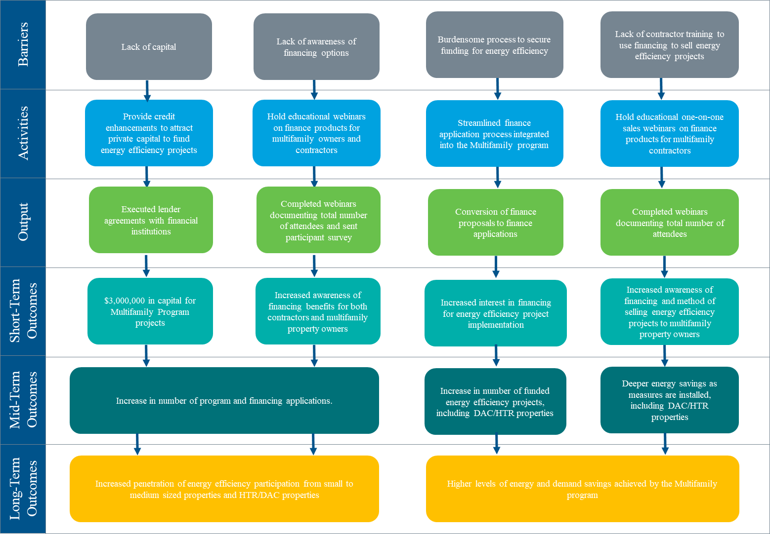

Process Flow Chart
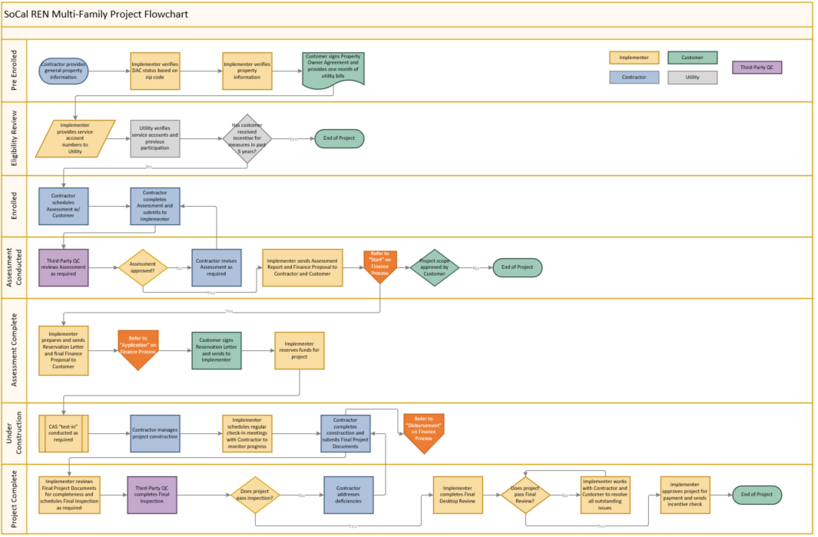

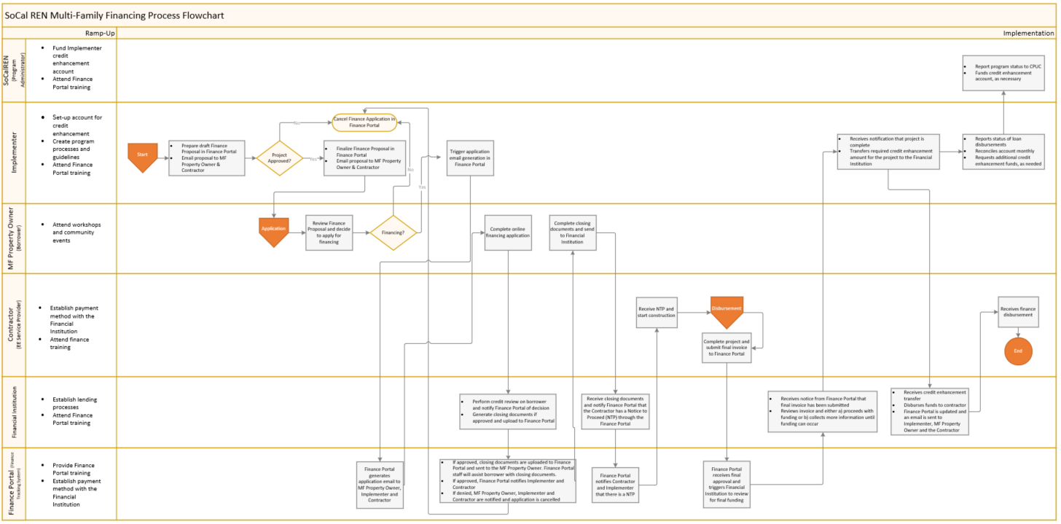

Diagram of Program
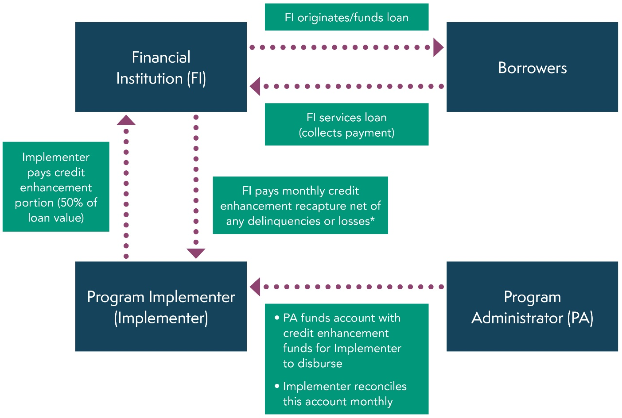
*Delinquent payments subsequently collected by FI will also be transferred to Implementer.

Additional information
N/A

For Market Transformation Programs Only

Quantitative Baseline and Market Transformation Information
Provide quantitative information describing the current EE program baseline information (and/or other relevant baseline information) for the market segment and major sub-segments, as available.

Not applicable for the MFF Subprogram.

Market Transformation Strategy
Provide a market characterization and assessment of the relationships and/or dynamics among market actors, including identification of the key barriers and opportunities to advance DSM technologies and strategies. Describe the proposed intervention(s) and its/their intended results, and specify which barriers the intervention is intended to address.

Not applicable for the MFF Subprogram.

Appendix: Supporting Information and Documents

Program Manuals and Program Rules
N/A

Incentive Tables, Workpapers, Software Tools
N/A

IP Guidance from D.15-10-028: "Describe how the energy efficiency (EE) program will deliver savings (upstream, downstream, direct install, etc.), how it will reach customers, and the services and [sic] it will provide."
IP Guidance from D.15-10-028: "It is in the implementation plans that we want to see at least one metric for each program/strategy/sub-sector/intervention strategy; more than one where appropriate…. Implementation plans will contain metrics, as already discussed. PAs are free to start with a clean slate in developing metrics and associated reporting requirements, but for all programs will continue to provide monthly cost reports, and for resource programs will provide monthly savings data as well."
Codes & Standards program, Emerging Technologies program, Workforce Education & Training program, etc.

