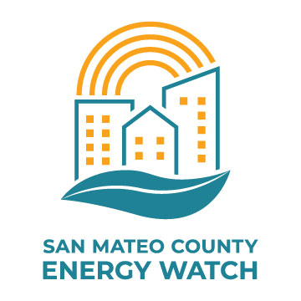

Program Implementation Plan

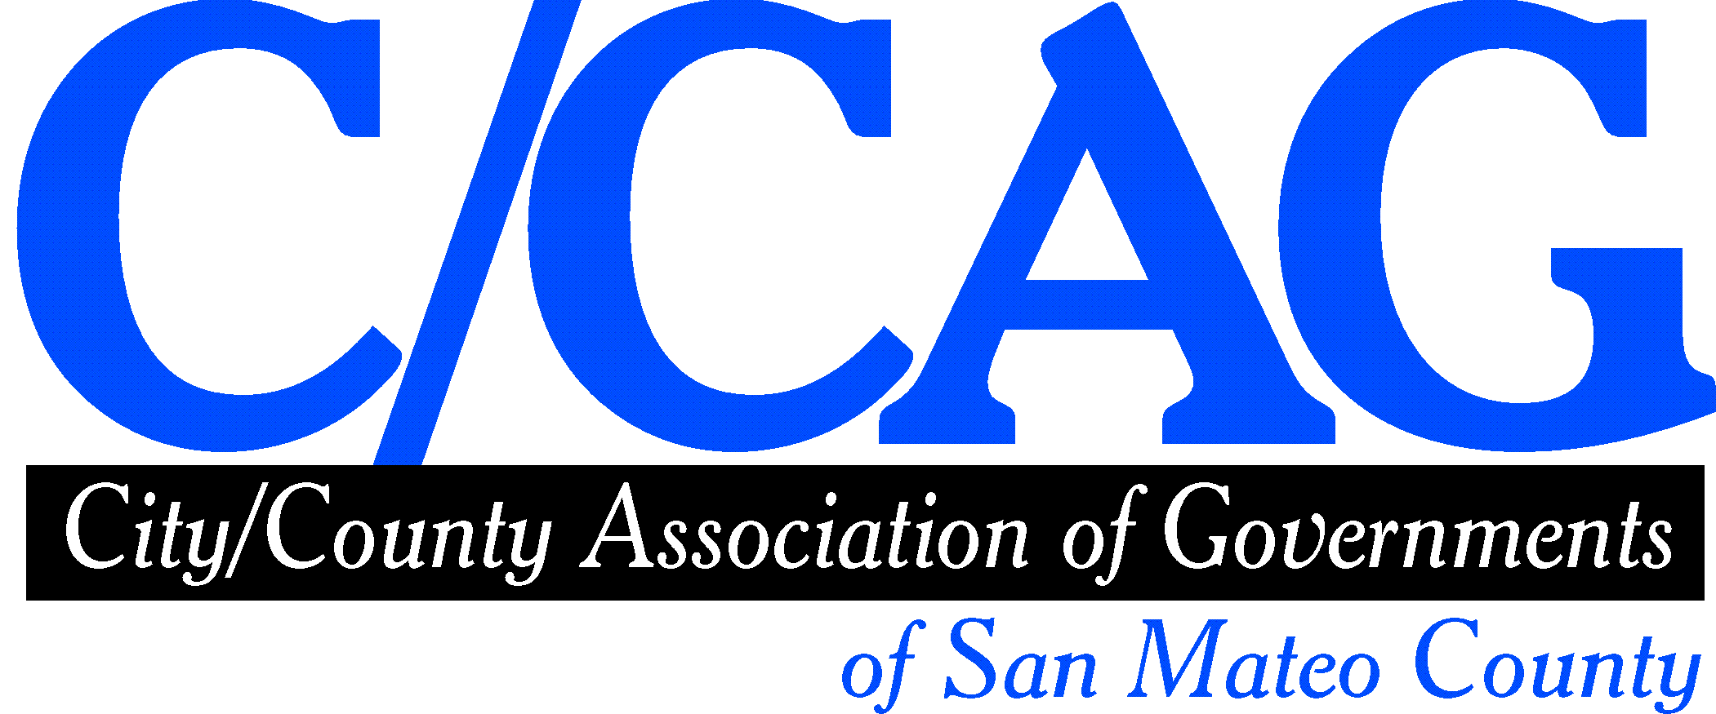
Version 1.6
Program ID: EEGA_CODE_#9
July 30, 2020

Table of Contents
Program Overview 3
Program Budget and Savings 3
Implementation Plan Narrative 3
Program Approach 3
Supporting Energy-Saving Projects 4
Build Capacity to Save Energy 4
Program Delivery and Customer Services 4
Municipalities, Special Districts, and K-12 Public School Districts 4
Hard-to-Reach Small and Medium Businesses 5
Innovation 5
Technology 5
Collaborative Marketing 6
Customized Reports 6
Key Performance Indicators (KPIs) as Metrics 6
Workforce Education and Training 7
Workforce Standards 7
Disadvantaged Worker Plan 7
Supporting Documentation 8
Program Logic Model (see attached) 8
Diagram of Program 10
Process Flow Chart 11
Quantitative Program Targets 11
Customer Eligibility Requirements (from Program Policies and Procedures Manual) 12
Appendix A: Implementation Plan Management 14
Appendix B: Guidance for the Implementation Plan Change Summary Form 16
Appendix C: New Innovation Definition (2.0) for Energy Efficiency Programs Designed and Implemented by Third Parties 18
Context 18
Proposed Definition 18

Program Overview
The San Mateo County Energy Watch Program (SMCEW) is a non-resource Local Government Partnership program serving the Public and Commercial market sectors across the geographic territory of San Mateo County. Specifically, SMCEW will assist public agencies, K-12 public schools, and small, hard-to-reach businesses in accessing energy efficiency programs, trade professional options, and financing opportunities. SMCEW will provide coordination, outreach, referrals, and educational resources to help community members pursue energy efficiency projects. The Program will launch a new public facilities quarterly working group. Through the Regionally Integrated Climate Action Planning Suite (RICAPS) initiative, SMCEW will assist cities in meeting GHG reduction goals by developing annual community inventories and hosting a monthly working group to support energy efficiency and other measures in climate action planning.

Program Budget and Savings
SMCEW is a non-resource program. As such, it is not evaluated specifically on energy savings. SMCEW will work closely with Resource Program Implementors (RPIs) to help them meet their energy efficiency cost-effectiveness and total savings goals. To ensure that referrals are of high value to RPIs, SMCEW staff will solicit their input on targeting customer segments.

The following table depicts the three-year budget of the SMCEW program:

PROGRAM BUDGET
 | Activity, Deliverable, Milestone. | Year 1 | Year 2 | Year3 | Totals |  | Category | Cost %
T&M | Program Design and Development | $ 25,500 | $ 7,700 | $ 6,900 | $ 40,100 |  | ADMIN | 9.45%
 | Administration (invoicing - reporting - security reviews) | $ 9,600 | $ 8,400 | $ 7,100 | $ 25,100 |  | MARKETING | 10.32%
 | Marketing Materials Development (website update, collateral, promotion) | $ 44,400 | $ 28,500 | $ 27,400 | $100,300 |  | DINI | 80.23%
 | CRM and Mobile Tools (adapt existing software and hardware to meet our needs) | $ 32,250 | $ 19,500 | $ 15,000 | $ 66,750
 | Referral Generation (municipalities, schools and SMB-HTR only - lower target); Facilities Working Group) | $ 93,085 | $111,785 | $112,685 | $317,555
 | Referral Evaluation (municipalities, schools and SMB-HTR only - lower target) | $ 71,565 | $ 91,665 | $101,615 | $264,845
 | Climate action planning support - RICAPS working group and technical assistance | $ 54,500 | $ 53,000 | $ 49,850 | $157,350
TOTALS |  | $330,900 | $320,550 | $320,550 | $972,000

Implementation Plan Narrative

Program Approach
SMCEW will focus on two main components to champion the implementation of energy saving projects in San Mateo County: Supporting Energy-Saving Projects and Building Capacity to Help Save Energy. These components are described in more detail, below.

Supporting Energy-Saving Projects
For Municipalities, Special Districts, and K-12 Public Schools, SMCEW will leverage well-established and growing relationships.

Public agencies are increasingly concerned about energy resilience and reducing GHG emissions. SMCEW will help agencies partner with PG&E’s RPIs as well as community partners to consider how to integrate energy efficiency into all projects, including: demand management, EV charging, solar, battery storage, and other DER projects at targeted facilities. SMCEW will start conversations with benchmarking analysis and/or energy action plans and will refer agency staff to RPIs so they can get the information they need to make decisions and green-light projects.

For Hard-to-Reach Small- and Medium-Size Businesses (HTR SMBs), SMCEW will target those that unnecessarily use energy during peak evening hours to help shave demand from the ramp-up period. As a trusted partner working in collaboration with other trusted voices (e.g. local governments, community-based organizations, and business associations), we are uniquely positioned to engage these businesses. Over three years, the program will touch thousands of small businesses in San Mateo County by dropping in to talk with them, communicating virtually, or engaging them through local partners. The program will offer on-the-spot benchmarking and rate analysis (referred to PG&E customer service reps). Based on their energy-saving potential and interests, we will point businesses to programs offered by PG&E’s RPIs and community partners to help them to implement and finance energy-saving projects.

Build Capacity to Save Energy
SMCEW will help schools and municipalities develop and implement energy or climate action plans (EAPs or CAPs) to support energy reduction initiatives. We will develop benchmarking reports and community GHG inventories to help municipalities analyze progress toward climate goals. This is a powerful framework for ongoing action. Our Regionally Integrated Climate Action Planning Suite (RICAPS) program introduces innovative concepts and supports collaborative action. Our monthly RICAPS working group meetings are an effective format to help staff learn about emerging energy technologies and provides the opportunity to share information and collaborate on projects. We will add a countywide working group for facilities staff to share best practices in energy management strategies and facilitate group purchasing.

Program Delivery and Customer Services

Municipalities, Special Districts, and K-12 Public School Districts
SMCEW will set up meetings with municipalities, special districts, and school districts to discuss energy saving and energy management opportunities. In the meetings, SMCEW staff will present the results of benchmarking analysis as well as RPI remote audits, when available.

To date, SMCEW has served all 20 cities in San Mateo County as well as the County government. Moving forward, we intend to more deliberately engage special districts, including SamTrans, Caltrain, water agencies, etc. Beyond office buildings and community centers, we will target facilities like corporation yards, wastewater treatment plants, and other industrial facilities.

To date, SMCEW has benchmarked all 174 public schools and provided support for accessing Proposition 39 funds. Although many energy efficiency projects were accomplished via Prop 39, we will identify districts that have significant opportunity and inclination to go deeper.
We are partnering closely with San Mateo County Office of Education (SMCOE) to engage school districts by offering benchmarking, energy action plans, and “no-touch” audit tools to show school districts when they can cost-effectively find energy savings, and showing how energy efficiency is an integral part of climate resilience.

Hard-to-Reach Small and Medium Businesses
SMCEW will target businesses considered “hard-to-reach" by PG&E. In addition, municipal economic development directors will help us target businesses in secondary business districts, strip malls, and other places where facilities haven’t been kept up as well.
SMCEW plans to coordinate outreach with two other Office of Sustainability (OOS) programs serving businesses: the San Mateo County Green Business Program (which targets HTR businesses) and BayREN’s new commercial program (which targets medium-size businesses).

SMCEW’s strategy for marketing and targeting customers, doesn’t depend on PG&E employees generating information for the program. Using mobile tools, our outreach team will look up businesses in Energy Insight to inform daily canvassing efforts and/or conversations with decision-makers at businesses. We will offer businesses these opportunities:
- Rate analysis: We will connect interested businesses with PG&E to see if a different rate would make sense. This is a quick way to start the journey toward more deliberate energy management.
- Benchmarking: Our outreach team will set up Portfolio Manager accounts for business owners using mobile tools. We will have them share permissions to give SMCEW ongoing visibility to their data and progress.
- Financing and funding through other County programs. In particular, BayREN’s new commercial program currently offers microloans for amounts less than $2,500. The Green Business Program currently offers a “prebate” of $500 to offset the cost of one or more projects (including EE projects) a business needs to complete in order to be certified as a Green Business.
- Referrals to PG&E RPIs and trade professionals.

Innovation
Program innovation is centered around Technology, Collaborative Marketing, and Customized Reports/Plans.

Technology
Moving forward, SMCEW intends to set up a customer relationship management (CRM) database and mobile devices for data input in the field to support door-to-door canvassing in disadvantaged community business districts. The software tools will enable our outreach team to document new customer information. The mobile devices will enable our outreach team to input customer contact information into our database from the field. Team members can also access Energy Insight to check on current energy use data, get customers signed up for remote auditing tools, and benchmark businesses on the spot by via Portfolio Manager.
The CRM database will make it easier for us to track progress over time and engage referred customers as needed to help overcome barriers to implementing projects through RPIs.

Collaborative Marketing
SMCEW will collaborate with a collection of RPIs and community organizations to present a robust picture of a customer’s energy management opportunity. The first step of any energy management journey will be energy efficiency, but will also include solar plus battery, EV charging, etc. By including these additional elements, we will capitalize on customer concerns about service continuity, and connect them to partners that can provide solutions.

Customized Reports
SMCEW will develop Energy Action Plans for school districts and benchmarking reports for public agencies and small businesses as a tool for outreach, education, and planning. These plans will be tailored for each customer, providing a starting point for engaging with decision makers and enabling customers to promote EE opportunities within their organization.

Key Performance Indicators (KPIs) as Metrics
Customer contacts (“touches”) and other KPI metrics will be tracked through the CRM database. KPIs will include both active actions (speaking directly to customers) and passive actions (customers reached through program partners or by targeting marketing). The complete list of KPIs is below:

KPIs: Public Agencies
Type | Target
“Touches” | ACTIVE: 14 meetings per year  PASSIVE: 4 emails per year
Referrals | Year 1: 4 referrals  Year 2: 11 referrals  Year 3: 12 referrals
Benchmarking Reports | 14 reports each year
Community GHG inventories | 21 Community-scale GHG emission inventories per year
RICAPS Working Group Meetings | 12 meetings per year
Facilities Working Group Meetings | 10 meetings over the three-year contract

KPIs: School Districts
Type | Target
“Touches” | ACTIVE: 16 meetings each year  PASSIVE: 4 emails each year.
Referrals | Year 1: 3 referrals  Year 2: 11 referrals  Year 3: 12 referrals
Benchmarking Reports | 16 reports each year
Energy Action Plans | 8 Energy Action plans delivered each year
Facilities Working Group Meetings | 10 meetings over the three-year contract

KPIs: Hard-to-Reach Small and Medium Businesses
Type | Target
“Touches” | ACTIVE: 500 in-person "touches" each year  PASSIVE: 1,000 HTRS SMBS reached through partners each year
Referrals | 50 referrals each year
Benchmarking Reports | Benchmarking for 25 SMBs each year

Workforce Education and Training
Though workforce development is not one of the primary goals of the SMCEW program, we acknowledge the expanding need for leaders and professionals in California’s transition to a clean energy future. Since the way ratepayers use energy will change over time, the workforce needs to keep pace to support the change.

SMCEW will promote training for internal staff as well as program partners. Internally, the County of San Mateo, contracted implementer for SMCEW, has training goals for all staff, which should be related to work assignments. Externally, SMCEW will promote workforce education with a focus on equity by partnering with PG&E’s training programs, the San Mateo County Community College District and its programs, the San Mateo County Office of Education, and the County Office of Sustainability.

Workforce Standards
As a non-resource program, SMCEW will support workforce standards regarding the process of referring customers to RPIs and the interactions customers have with those implementers. We will solicit feedback from customers, and will pass along any feedback to RPIs to help remove barriers to participation and improve the success of the program.

Disadvantaged Worker Plan
Equity and inclusion are primary filters for SMCEW program decisions. To support employment opportunities for disadvantaged workers, SMCEW will adhere to PG&E’s contracting requirements and will coordinate with RPIs and outside agencies to promote employment opportunities.

Supporting Documentation

Program Logic Model
SMCEW has developed this logic model based on past experience with the same customer segments, and an anticipation of the opportunities presented moving forward.
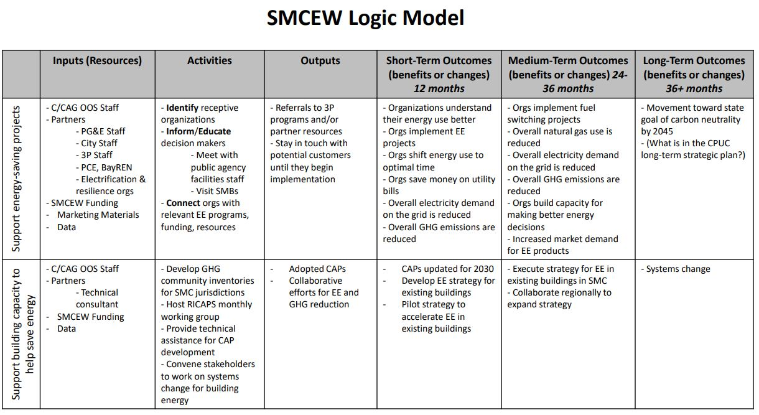

Diagram of Program
This diagram shows how both parts of the program work together to drive energy-saving projects. 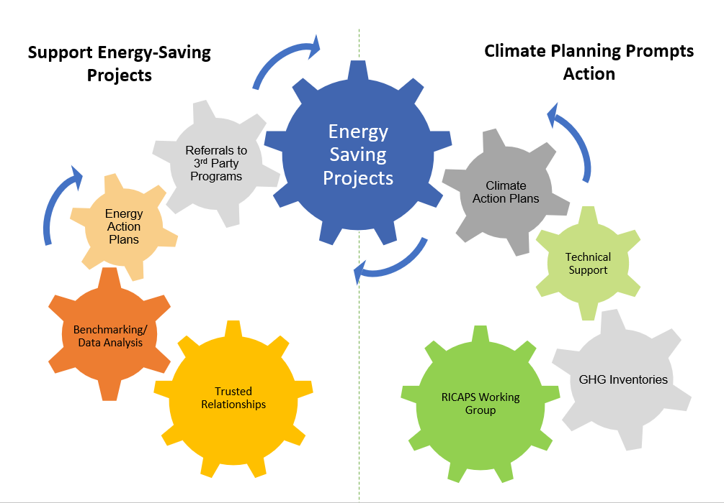

Process Flow Chart
The following flow chart describes the key components of the sub-program: Supporting Energy-Saving Projects.
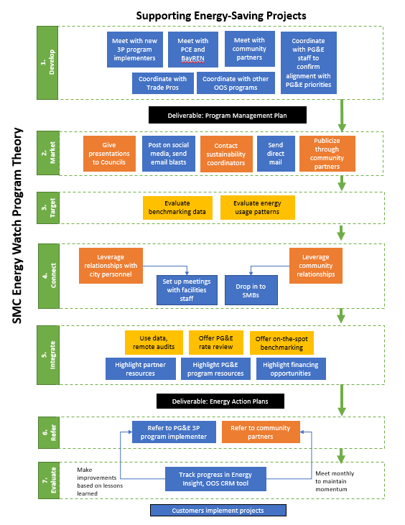

Quantitative Program Targets
Estimates of the number of referrals are described in the “Key Performance Indicators as Metrics” section above.

Evaluation, Measurement & Verification (EM&V)
SMCEW will meet regularly with program partners to discuss customer progress and identify ways we can remove barriers and improve the collaboration with RPIs. Based on the tracking and follow-up evaluations, we will refine the program over time to improve its effectiveness. We will monitor our “conversion rate” to judge our effectiveness over time in delivering referrals that convert to high TRC completed projects.

To monitor our effectiveness in engaging hard-to-reach small businesses, SMCEW will use data from our CRM database. In particular, SMCEW can track the number of businesses engaged, how many are still currently operating, the percentage interested in being referred to RPIs, what businesses types are referred most often, etc. The database will make it easier for us to help overcome barriers to implementing projects through RPIs.

Customer Eligibility Requirements (from Program Policies and Procedures Manual)
SMCEW offers services to local governments, special districts, K-12 public schools and school districts, and small and medium businesses in San Mateo County that are customers of PG&E. (This includes Peninsula Clean Energy customers.)
The definition of a small or medium business is one that annually has less than 20 kW of electricity demand and/or 10,000 Therms of natural gas demand.

Quality Assurance and Quality Control Plan
Verification
Describe at a minimum the percentage of inspections to be conducted, the inspection agent and who will pay inspection costs
N/A – Handled by PG&E third party program implementers.

Tracking customer complaints
SMCEW shall maintain a log of all customer complaints it receives and notify PG&E and C/CAG’s executive director within 24 hours. SMCEW shall retain that log in electronic form for at least three years after the end of the contract term or receipt of final payment, whichever is later. SMCEW will record any complaints and the resolution status in Monthly Reports.

Resolving customer complaints
PG&E third party implementers have detailed plans in place for handling customer complaints. If C/CAG and/or OOS staff learn about a customer complaint, staff will coordinate with the customer and implementer to make sure the issue is adequately resolved within an appropriate timeframe. Staff will keep Program Manager, Kim Springer and Executive Director, Sandy Wong informed and will coordinate with them to develop additional strategies for resolving the situation if necessary.

Avoiding double dipping
C/CAG and OOS staff count on PG&E’s RPIs to provide guidance to customers about appropriate rebates and incentives.

Dispute resolution procedures (applies to subcontractors and customers)
N/A

Additional Services – Climate Action Planning Support
Regionally Integrated Climate Action Planning Suite (RICAPS) monthly working group sessions
Group attendees include sustainability and planning staff from jurisdictions in San Mateo County (and occasionally other counties), as well as representatives from local community-based organizations with an environmental focus. At our monthly meetings, we bring in experts to present best practices for implementing projects to achieve aggressive climate action goals, including energy management, energy efficiency, community engagement, and community resilience. We support working group members in working collaboratively to establish pilots and implement new initiatives.

RICAPS climate action tools
We are finalizing our RICAPS climate action plan template for 2030, which commits jurisdictions to even more aggressive energy reductions at their own facilities.

GHG community inventories
SMCEW will continue to develop annual community GHG inventories for all jurisdictions in San Mateo County because municipalities use the results to assess if they are on track to achieve their climate action goals. The inventories provide justification for municipalities to implement projects within their own facilities, as well as in the community. (PG&E funding pays for the energy portion of the inventories; C/CAG contributes funding for the non-energy portions of the inventories.)
Technical support
Our consultant, DNV GL, can support municipal staff in updating their CAPs to achieve 2030 GHG reduction goals, understand their GHG inventories, and run calculations to determine the most high-impact energy strategy for their city. (Funding for this service is provided by Peninsula Clean Energy.)

RICAPS working group for facilities staff
SMCEW will build on the original RICAPS working group format to create a quarterly gathering for municipal and school district staff responsible for facilities. Presentations will help staff learn about emerging energy technologies and provide the opportunity to share information and collaborate on projects. We will share best practices in energy management strategies, facilitate group purchasing, and introduce participants to resources from PG&E’s Pacific Energy Center to help increase technical knowledge.

Appendix A: Implementation Plan Management
Pursuant to CPUC D.15-10-028, the PAs are required to maintain current implementation plans on the California Energy Data and Reporting System (CEDARS). The following information provides guidance to the PAs for implementation plan submission, change management, and related program fund shifting.

CEDARS is designed to show the current implementation plans on each program’s webpage. The PAs are directed to follow this process and to ensure that the data in their implementation plans are consistent with the CEIs and annual budget advice letter (ABAL) filings and, in some cases, Program Definitions Table data. The “PIP Addenda” process that was a function within the Energy Efficiency Group Application (EEGA)/EE Stats for past program cycles has been discontinued, and all PIP-related addenda have been archived. Implementation plan change management will now be a function of the CEDARS platform.

Managing Implementation Plans on CEDARS
CPUC D.15-10-028 discussed the requirements for implementation plans within the rolling portfolio framework; namely, that such plans would be maintained on an online system (CEDARS). The system displays each program on its own webpage, controls versioning, and alerts the Energy Division and subscribers and when implementation plans change occur.

The PAs may change implementation plans as needed without further Energy Division review; the CEDARS system issues a notification to Energy Division staff, and other subscribers, when changes are made.
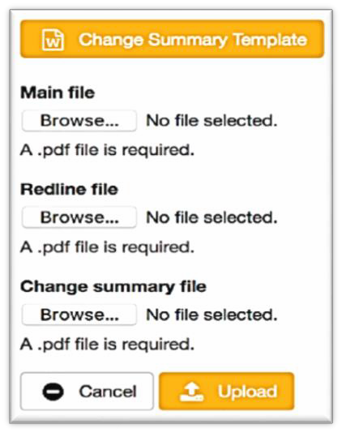

Figure 1: Screenshot of implementation plan upload/change dashboard on CEDARS.

The new process for maintaining implementation plans in the CEDARS is as follows:

- Logon to CEDARS using your PA login and navigate to the filing dashboard for the appropriate program.
- Click the link to download the Change Summary Template. Click Replace Implementation Plan and upload the following three documents:
- A “clean” version (.pdf) which will become the current official implementation plan version.
- A red-lined version (.pdf) of the implementation plan containing all changes since the program was first introduced, and
- A completed Implementation Plan Change Summary form (.pdf) in Appendix C below.
CEDARS will not accept implementation plan revisions unless all three files are uploaded as .pdf files. The Energy Division staff and other subscribers will receive a system-generated notification when implementation plan changes have been uploaded, but they are not required to approve the documents in the system.

In many cases, changes to program implementation include fund shifts, which are indicated in the Implementation Change Summary Form note below. Decision 15-10-028 removed the requirement to file advice letters for fund shifting; however, fund shifts will likely require updates to annual compliance filings. In such cases, the PAs are directed to submit revised CEI inputs for that budget year, plus revisions to other compliance filing documents, such as appendices and the program definitions table.

(End of Appendix A)

Appendix B: Guidance for the Implementation Plan Change Summary Form
The Energy Division developed an Implementation Plan Change Summary Form to accompany all implementation plan changes uploaded to CEDARS. This online form is available on CEDARS and should be used to document any required changes to the implementation plan and uploaded to CEDARS as a pdf file.

General Program Information: Complete the top section of the form. If the implementation plan belongs to a subprogram, use the subprogram budget for the “Current Program Budget.”

Program Name |  | Date
Subprogram Name(s) |  | PA Name
Program ID |  | PA Program Contact
Current Program Budget |  | Past Program Budget (if applicable)

Trigger requiring change to implementation plan: Select one of the following triggers requiring a change to the implementation plan.
- Changes to eligibility rules
- Changes affecting incentive levels
- Fund shifts
- Changes to Program Theory/Logic Models
- Addition or elimination of programs and/or sub-programs
- Changes in program targets
- Changes in program target customers
- Change in sub-program approach
- Changes in incented measures
- Changes in adopted program performance metrics (PPMs)s / market transformation indicators (MTIs)
- Other Commission–Directed Changes

Driver of change: Content for change driver(s) should be specific and succinct.

Description of change: Change descriptions should clearly indicate what area(s) of program implementation is changing, such as program financial/budget detail, logic models, eligibility rules, marketing plans, target sectors, etc.

IMPORTANT: Some changes will require updates to CEI and the Program Definition Table. D.15-10-028 requires consistency among these filings. It is the PA’s responsibility to keep that information current in order for the system to accept program savings claims.

Budget change: Budget change should indicate any other program budget(s) involved in the fund shift (money shifted from one program to another), measure incentive/rebate changes, changes to PA budgets or other budget items, and other relevant budget details. Revised budgets should be consistent with CEI in annual compliance filings.
Implementation plan section and/or wording changed or replaced: Cite specific implementation plan section(s) to be changed or replaced.

Replacement language or information: Summarize replacement content or relevant information within this change version.

Revised energy savings (if any): indicate revised energy savings associated with the change(s).

Other implementation plan changes required: Identify if the implementation changes require changes to the Program Definitions Table or Cost Effectiveness inputs.

(End of Appendix B)

Appendix C: New Innovation Definition (2.0) for Energy Efficiency Programs Designed and Implemented by Third Parties

Context
Since the current definition of “innovation” was developed in 2007, the EE Procurement Review Group (EE-PRG) proposed to update the definition. The intent in doing so was to simplify the definition that will be included in upcoming third-party requests for abstract (RFAs) and requests for proposal (RFPs) and to provide guidance for what bidders need to include in their submissions to enable the IOU, Independent Evaluator, and EE-PRG reviewers to sufficiently assess the feasibility of the opportunity.

Proposed Definition
To be “innovative,” the proposal must demonstrate that the program will ultimately increase the uptake of cost-effective energy efficiency by advancing a technology, marketing strategy, or delivery approach in a manner different from previous efforts.

Such strategies would ideally be scalable and replicable across sectors, segments, and technologies and seek to integrate other demand side technologies where feasible, such as demand response and distributed generation, to minimize lost opportunities in conformance with the guidance established by the Commission. While each innovative program may not individually be cost-effective, the intent is to lead to cost-effective savings over time. See examples below as guidance.
To demonstrate that a proposed program is innovative, the bidder must include:
- A clear and concise rationale in the RFA and RFP stages for why new combinations of proven technologies, updated or re-designed marketing strategies, or modified delivery approaches (including using new relationships or partnerships) would yield greater uptake savings than previous models;
- A high-level analysis in the RFA stage and a detailed analysis in the RFP stage showing how the innovative approach will yield increased savings and/or participation beyond existing strategies; and
- Metrics that will be used to track progress.
**All innovative ideas, rationale, and analysis will be protected under the proprietary/confidentiality clause found in Section ##. Each IOU will also provide a process to file a complaint in the event the bidder believes the clause was violated**

Examples of Innovative EE Programs
General examples of “technology” innovation could include, but are not limited to:
- A measure that is no longer considered “emerging technology” but not yet fully in the
- market,
- A more advanced energy-saving technology, or
- A novel combination of technologies, including strategies that integrated EE with other demand side technologies such as demand response and distributed generation.
General examples of “market strategy” innovation could include, but are not limited to:
- Online systems or new software strategies that support and promote comprehensive energy resource management,
- Creative incentives or prizes for participation, or
- Embedded in other transactions (e.g., in post office mailers when moving)
General examples of “delivery approach” innovation could include, but are not limited to:
- A new strategy for customer engagement and enrollment,
- A competition (e.g., “golden carrot” used for refrigerators),
- A new partnership/relationship to reach different/additional customers,
- A new approach to customer targeting that allows the program to focus on high-value savings opportunities or to specifically reach key customer groups,
- A more streamlined implementation process, or
- A strategy that addresses a persistent market barrier.
- A program delivery strategy that promotes comprehensive integrated site-specific energy solutions across demand side resources such as EE, demand response and distributed generation.
For Emerging Technologies Programs, which are not a customer-facing program, innovation or innovative concepts that yield measurable improvements upon past IOU implementation may include but are not limited to the following:
- A new or improved partnership/relationship or process to reach different/additional stakeholder(s) that can assist in identifying, evaluating, and/or introducing emerging technologies.
- A new or improved process(es) for identifying, evaluating and/or introducing EE technologies that have the capability to promote comprehensive integrated energy solutions across other demand side resources such as demand response and distributed generation.
- Development of a new or improved process(es) to:
  - More efficiently support, among other things, the timely discovery, screening, assessment, and demonstration of new EE technologies and solutions for consideration for inclusion into the program portfolio.
  - Reduce the lack of information, performance uncertainty and/or other barriers related to customer adoption of emerging technologies.
  - More efficiently identify and vet measures that are suited to unique needs of DAC and HTR customers.
  - Increase access to and use of ET findings and recommendations by EE Program Implementers.

An innovative Emerging Technology Program design may include any of the above elements, but is not limited to those any of the above elements. In addition, an innovative Emerging Technology Program design is not limited to specific measures and can include novel combinations of demand side technologies such as energy efficiency, distributed generation, and demand response program interventions for energy efficiency program intervention.

(End of Appendix C)

Updates to Energy Divisions’ Memorandum: New Guidance for EE Program Implementation Plan Submission, Change Management, and Related Program Fund Shifting, June 28, 2017 as described in CEDARS.
D.15-10-028, section 3.2.2.4, p. 63.
Emerging Technology (ET) program technologies would not be part of this approach as it would be pursued within the ET program.
Emerging Technology (ET) program technologies would not be part of this approach as it would be pursued within the ET program.

