Statewide Residential HVAC Quality Installation and Quality Maintenance Program
Implementation Plan

March 27, 2023

Page Intentionally Left Blank

Contents
Program Overview 1
Program Budget and Savings 1
1. Program and/or Sub-Program Name 1
2. Program / Sub-Program ID number 1
3. Program / Sub-program Budget Table 1
4. Program / Sub-program Gross Impacts Table 2
5. Program / Sub-Program Cost Effectiveness (TRC) 2
6. Program / Sub-Program Cost Effectiveness (PAC) 2
7. Type of Program / Sub-Program Implementer (PA-delivered, third party-delivered or Partnership): 2
8. Market Sector 2
9. Program/Sub-Program Type 2
10. Market channel(s) (i.e., downstream, midstream, and/or upstream) and Intervention Strategies (e.g., direct install, incentive, finance, audit, technical assistance, etc.), campaign goals, and timeline 2
Implementation Plan Narrative 3
1. Program Description 3
2. Program Delivery and Customer Services 3
3. Program Design and Best Practices 3
4. Innovation 4
5. Metrics 4
6. For Programs claiming to‐code savings 5
7. Pilots 5
8. Workforce Education and Training 5
9. Workforce Standards 5
10. Disadvantaged Worker Plan 5
11. Additional information 6
Supporting Documents 6
1. Program Manuals and Program Rules 6
2. Program Theory and Program Logic Model 8
3. Process Flow Chart 9
4. Incentive Tables, Workpapers, Software Tools 10
5. Quantitative Program Targets 10
6. Diagram of Program 12
7. Evaluation, Measurement & Verification (EM&V) 13
8. Normalized Metered Energy Consumption (NMEC) 21

Program Overview
The Statewide Residential HVAC Quality Installation and Quality Maintenance (QI/QM) Program provides multi-tiered incentives for Quality Maintenance Plans, Quality Maintenance Calls, Quality Bids, and Quality Installations and provides extra incentives, training, and tools to Quality HVAC Contractors who routinely provide higher-quality services. An Industry Advisory Panel will help determine standards for services, verification requirements, outreach and training, particularly for HVAC Contractors who serve Disadvantaged Communities (DAC) and Hard-to-Reach (HTR) customers.

Program Budget and Savings
- Program and/or Sub-Program Name
Statewide Residential HVAC Quality Installation and Quality Maintenance Program
- Program / Sub-Program ID number
SDGE_SW_HVAC_QIQM SDGE4136
- Program / Sub-program Budget Table
Cost Category Description | 2023 Program Budget ($) | 2024 Program Budget ($) | 2025 Program Budget ($) | 2026 Program Budget ($) | Total Program Budget ($)
Administrative | $345,000 | $345,000 | $345,000 | $405,000 | $1,440,000
Marketing & Outreach | $345,000 | $345,000 | $345,000 | $345,000 | $1,380,000
Direct Implementation -  Incentives | $723,824 | $4,947,873 | $5,090,061 | $3,728,242 | $14,490,000
DI-Non-Incentive | $2,484,375 | $1,763,750 | $1,763,750 | $1,703,750 | $7,715,625
DI-NI -  Maximum KPI | $335,625 | $671,250 | $671,250 | $671,250 | $2,349,375
DI-NI - Innovation Bonus | $0 | $75,000 | $75,000 | $75,000 | $225,000
Total EE Budget | $4,233,824 | $8,147,873 | $8,290,061 | $6,928,242 | $27,600,000
EE/DR Budget | $58,145 | $26,285 | $26,285 | $26,285 | $137,000
Total Budget | $4,291,969 | $8,174,158 | $8,316,346 | $6,954,527 | $27,737,000
- Program / Sub-program Gross Impacts Table
Projected Net Savings | 2023 | 2024 | 2025 | 2026
Forecast kWh | - | - | - | -
Forecast kW | - | - | - | -
Forecast Therms | - | - | - | -
Total System Benefit | - | - | - | -
- Program / Sub-Program Cost Effectiveness (TRC)

2023 | 2024 | 2025 | 2026
- | - | - | -
- Program / Sub-Program Cost Effectiveness (PAC)

2023 | 2024 | 2025 | 2026
- | - | - | -
- Type of Program / Sub-Program Implementer (PA-delivered, third party-delivered or Partnership):
Third-Party Delivered
- Market Sector
Residential Single Family and Multifamily
- Program/Sub-Program Type
Market Support
- Market channel(s) (i.e., downstream, midstream, and/or upstream) and Intervention Strategies (e.g., direct install, incentive, finance, audit, technical assistance, etc.), campaign goals, and timeline
Downstream, Midstream, Incentive, Technical Assistance

Implementation Plan Narrative
- Program Description
The Statewide Residential HVAC Quality Installation and Quality Maintenance Program provides multi-tiered incentives for Quality Maintenance Plans, Quality Maintenance Calls, Quality Bids, and Quality Installations. These multi-tiered incentives will be provided with the objective of both educating end-use customers on the value of quality HVAC services and delivering improved training for HVAC industry contractors and technicians on providing and selling HVAC services across all four IOU territories.
- Program Delivery and Customer Services
The Statewide Residential HVAC Quality Installation and Quality Maintenance Program will educate and offer improved trainings for HVAC licensed contractors and technicians to help transform the residential market for Quality HVAC services by incentivizing Quality Maintenance Plans, Quality Maintenance Calls, Quality Bids, and Quality Installations at basic “Quality Service” tier or the “Enhanced Quality Service” tiers, and provide extra incentives, training, and tools to “Quality Contractors”, who routinely provide higher quality services. The program will have an Industry Advisory Panel to help determine standards for services, verification requirements, outreach and training, particularly for HVAC installation contractors and technicians who serve Disadvantaged Communities and hard-to-reach customers. The program will also comply with the CPUC HVAC workforce standards and promote its disadvantaged worker policies.
The Implementer will coordinate with statewide program offerings as part of their engagement with Program stakeholders to address overlap with projects that could be eligible for other statewide programs, including but not limited to Residential HVAC, Plug Load and Appliance, Residential New Construction, and Technology and Equipment for Clean Heating (TECH) programs.
- Program Design and Best Practices
The Statewide Residential HVAC Quality Installation and Quality Maintenance Program design was determined based on the need for increased awareness and market support for quality HVAC installation and quality maintenance across the state, as well as increasing cost-effectiveness of energy efficient HVAC technologies. The Program will implement a tiered incentive structure based on standards developed by an Industry Advisory Panel for quality bids, installations, maintenance plans, and maintenance calls for participating contractors. The purpose of these incentives is to encourage contractors to strictly adhere to industry and program standards for installation and maintenance of energy efficient HVAC technologies and to educate their customers on the value of said technologies.
The Program will be administered statewide, however there will be a focus on recruiting and trainings contractors and/or technicians who are considered Disadvantaged Workers (DAW) and who serve or operate within Disadvantaged Communities (DAC) or Hard-to-Reach (HTR) markets. In this way, the Program strives for market transformation within DAW, DAC, and HTR communities and households through increased adoption of energy efficient HVAC technologies within those demographics.
- Innovation
The Program will help transform the installation and maintenance market by helping HVAC Contractors differentiate their higher-value services, justify premium fees, and inspire all participating HVAC Contractors to improve the quality of their HVAC services. The Program will not market to consumers directly but will provide HVAC Contractors with the tools and information to market these services themselves without program intervention.
Program Innovations to be implemented include:
- Industry Advisory Panel is responsible for helping the Implementer determine standards for service, verification requirements, and outreach and training, particularly for HVAC contractors who serve Disadvantaged Communities and hard-to-reach customers.
- Multi-Tiered services with varying incentive levels
  - Quality Services (aka, basic services)
  - Enhanced Quality Services
  - Quality Contractor
- Quality Service Reports
- Utilizing proven HVAC industry contractor tool (e.g., Visual Service)
- Leveraging other EE, demand response, and financing opportunities

- Metrics
Program Performance:
- Incentivized services provided to customers.
- Number of licensed HVAC Contractors and/or Technicians trained on how to perform Quality Services.
- Percent of the total number of participating HVAC contractors who received an “Enhanced” or “Quality Contractor” tier incentive in the last year that previously received a lower tier incentive.
- Customer Recognition of Value.
- Contractor Knowledge about Quality Installation and Maintenance.
Marketing:
- Number of market actors reached through partner networks and partner communications channels.
Compliance:
- Reporting accuracy
- HTR/DAC penetration
- Diverse Business Enterprise expenditures
- Contractors/Technicians considered Disadvantaged Workers
Customer Satisfaction:
- Complaints received.

- For Programs claiming to‐code savings
N/A
- Pilots
N/A
- Workforce Education and Training
The Program will provide Technician and Contractor Training to program participants. This shall include identifying detailed training requirements for different quality services and tiers, designing, and producing training materials, developing and implementing training evaluation tools, signing up training participants, delivering training, and producing data for tracking the training provided.
- Workforce Standards
The Program will emphasize “Begin the Journey (Tier I),” “Advance the Average (Tier II),” and “Elevate the Champions “kicker” (Tier III)” tiers. The workforce standards are different for each of these tiers. The Program’s Advisory Panel will further define the tiers during the program’s implementation period.
Tier I: This is an entry-level tier for quality services. The expectation is that participating HVAC Contractors will have very few qualifications that one might expect from the other tiers. Participants will be required to be licensed C-20 contractors, but there is no requirement that they have achieved any other quality certifications. Workers who deliver services are likely technicians with little to no experience. The Program attempts to address this gap in service. Through clear step-by-step standards and verifications, along with focused training, the program aims to ensure that the HVAC Contractors and their technicians will become more qualified throughout their participation in the Program.
Tier II: This middle tier will provide more sophisticated skills in providing enhanced quality HVAC services. Participants are required to be licensed C-20 contractors, but there is no requirement that they have achieved other quality certifications. They will receive training in the skills they may lack in the measurements, adjustments, system design, and salesmanship required for quality services. Technicians will be expected to have some basic skills but receive training on more advanced ones. Participants will be encouraged and supported in achieving certifications such as North American Technician Excellence (NATE) or National Comfort Institute (NCI).
Tier III “kicker”: This elite tier will require that HVAC Contractors and their technicians already be highly skilled. They must demonstrate that they have consistently provided high-quality services and that their installed and maintained systems are performing better than average. Many of these workers may have advanced certifications, such as NATE and NCI, and while these are not required for the Program, they will be part of the evidence considered to evaluate their qualification for the “Quality Contractor” moniker.
- Disadvantaged Worker Plan
The Program will focus on HVAC contractors who have a high percentage of workers (e.g., technicians) who fall into the CPUC definition of “Disadvantaged Worker”.
The Program will also perform analyses to identify and provide targeted outreach to HVAC contractors who are: located in Disadvantaged Communities, DBE-certified, or a small business. This will be accomplished through specialized value propositions and cross-promotions delivered through multi-channel communications specifically intended to promote the benefits of quality HVAC services within these targeted demographics. This will present challenges—it would surely be easier to identify the few very large HVAC contractors in the state to get a large number of installations with minimum outreach effort, but such an approach would fail to transform the market. To advance participating HVAC Contractors’ quality services, the Program intends to actively seek out this previously untapped part of the market.
The team seeks to deliver a program that can address the intersectional barriers inhibiting disadvantaged workers and businesses from participating in the energy efficiency industry. Disadvantaged communities are heterogeneous, with potentially different geographic and social factors that can be defined in a variety of ways.
- Additional information
N/A

Supporting Documents
- Program Manuals and Program Rules

A summary of program processes and rules are presented below. As required, the full program manual will be uploaded in the California Energy Data and Reporting System (CEDARS). The manual will comply with CPUC implementation plan template guidance document, V2.1, May 2020.

Eligible Measures
Site eligibility – Verification of sites receiving services in the Program are customers who have qualified to receive products and services will take place through review and approval of a Site Eligibility Application. This document shall record Program participation, facilitate easy completion, and contain relevant customer information, including at a minimum: Customer Name, Address, E-mail Address and Phone Number, Service Account Number, and information needed to assess DAC and HTR status. All residential single and multifamily buildings in California’s IOUs’ service territories are eligible sites for this program.

Participant (Contractor) eligibility –

At a minimum, participants will be required to be licensed C-20 contractors This will be
verified by the program implementor during initial contractor enrollment. The contractor
must also meet the following CPUC requirements:

- Install all measures in accordance with all applicable federal, state, and local laws building codes, manufacturers' specifications, and permitting requirements.
- If a contractor performs the installation or improvement, the contractor must hold the appropriate license for the work.
- A rebate or incentive can only be provided if the contractor certifies that the improvement or installation has complied with any applicable permitting requirements, including from California Building Standards Code (California Code of Regulations Title 24).
- If a contractor is the recipient of a rebate or incentive offered by an energy efficiency program specifically for the purchase or installation of air-conditioning or heat pump units, and their related fans, the rebate or incentive will be paid only if the customer or contractor provides proof of permit closure.
- Follow workforce standards pursuant to D.18-10-008.11

Contractors shall, provide and maintain in effect the insurance policies and minimum limits of coverage specified below, and such additional coverage as may be required by Applicable Laws, with insurance companies which are authorized to do business in the state in which the services are to be performed and which have an A.M. Best's Insurance Rating of not less than A-:
- Worker's Compensation Insurance with the statutory limits required by the state having jurisdiction over Implementer's employees.
- Employer's Liability Insurance with limits of not less than:
  - Bodily injury by accident - $1,000,000 each accident
  - Bodily injury by disease - $1,000,000 policy limit, and
  - Bodily injury by disease - $1,000,000 each employee.
- Commercial General Liability Insurance: Per occurrence limit of not less than $1,000,000 and annual aggregate of not less than $2,000,000 exclusive of defense costs, for all coverages.
- Commercial Automobile Liability Insurance Covering bodily injury and property damage with a combined single limit of not less than $1,000,000 per occurrence.
- Umbrella / Excess Liability Insurance written on an "occurrence," not a "claims-made" basis, providing coverage excess of the underlying Employer's Liability, Commercial General Liability, Pollution Liability Insurance, and Commercial Automobile Liability insurance, on terms at least as broad as the underlying coverage, with limits of not less than $10,000,000 per occurrence and in the annual aggregate.
- Cyber insurance covering:
  - Liability arising from theft, dissemination and/or use of Confidential Information stored or transmitted in electronic form, and
  - Liability arising from the introduction of a computer virus into, or otherwise causing damage to, a customer's or third person's computer, computer system, network or similar computer related property and the data, software and programs stored thereon. Such insurance will be maintained with limits of no less than $2,000,000 per claim and in the annual aggregate, and may be maintained on a stand-alone basis, or as part of any errors and omissions coverage.
Measure Eligibility – Industry Advisory Panel will provide guidelines to determine standards for service and measure eligibility.

- Program Theory and Program Logic Model

Program Theory
The Statewide Residential HVAC Quality Installation and Quality Maintenance (QI/QM) Program provides multi-tiered incentives for Quality Maintenance Plans, Quality Maintenance Calls, Quality Bids, and Quality Installations and provides extra incentives, training, and tools to Quality HVAC Contractors who routinely provide higher-quality services. An Industry Advisory Panel will help determine standards for services, verification requirements, and outreach and training, particularly for HVAC Contractors who serve Disadvantaged Communities (DAC) and hard-to-reach customers.
The Program objectives are to educate end-use customers on the value of quality HVAC services, provide improved training for HVAC industry contractors and technicians on providing and selling HVAC services, build partnerships with HVAC industry organizations, and improve beneficial HVAC technologies towards greater cost-effectiveness.
The Program will do this across all four IOUs by providing education and downstream incentives directly to residential HVAC installation, service, and maintenance contractors and technicians for providing quality maintenance or installation services to residential end-use customers.

Program Logic Model:
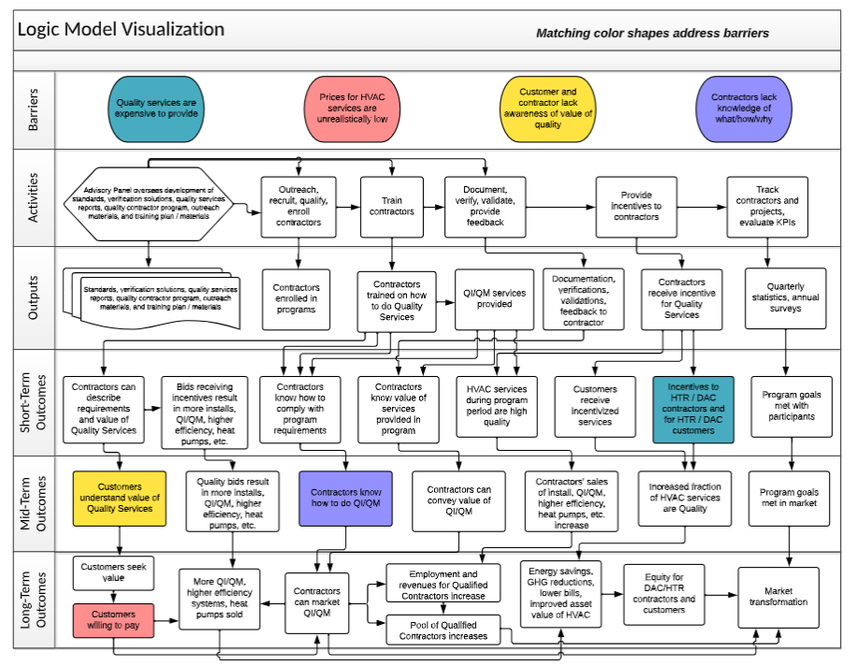

- Process Flow Chart
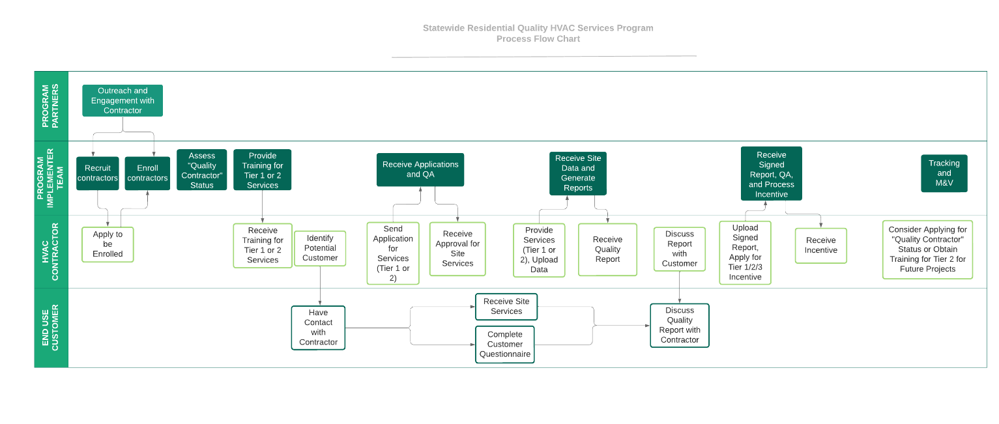

- Incentive Tables, Workpapers, Software Tools
The Program will provide incentives to participating HVAC contractors who deliver quality maintenance or installation services according to program-defined standards to end-use customers. The following services will be incentivized through the Program:

- Quality Services: upon verification, these services earn a flat incentive per bid, installation, or maintenance plan or call.
- Enhanced Quality Services: Qualified HVAC contractors who provide these verified services receive an incentive that depends on the service provided, up to a per project maximum.
- Quality Contractor: HVAC Contractors enrolled in the program receive a flat “kicker” per bid, installation project, maintenance plan, or maintenance call – above and beyond the quality services incentives.

Detailed incentive tables as well as information on workpapers and software tools will be provided once guidelines are set by the Technical Advisory Panel.
- Quantitative Program Targets

Quantitative program goals are listed in the following table:
Quality Residential HVAC Services Goals | Goal Description | 2023 | 2024 | 2025 | 2026 | Total
- Program Performance: Sub-Objective #5: Access to capital | Number of incentivized services provided to customers. | 2,275 | 11,379 | 11,706 | 6,826 | 32,186
- Program Performance: Sub-Objective #2: Supply | Number of licensed HVAC Contractors and/or Technicians trained on how to perform Quality Services. | 102 | 370 | 368 | 160 | 1,000
- Marketing: Sub-Objective #3: Partnerships | Number of market actors reached through partner networks and partner communications channels. | 1,733 | 6,300 | 6,300 | 5,775 | 20,108
- Program Performance: Sub-Objective #4: Innovation and Accessibility – Contractor Progress | Percent of the total number of participating HVAC contractors who received an “Enhanced” or “Quality Contractor” tier incentive in the last year that previously received a lower tier incentive. | 8% | 15% | 15% | 15% | 15%
- Compliance: Disadvantaged Workers | Percent of services performed by workers who meet the CPUC criteria for “Disadvantaged Worker.” | 10% | 20% | 20% | 20% | 20%
- Compliance: Reporting Accuracy | The variance between the monthly forecasted and actual expenditures. | 20% | 20% | 20% | 20% | 20%
- Customer Satisfaction: Complaints Received | Number of currently enrolled HVAC contractors generating valid complaints on more than 5% of their associated projects divided by the total number of enrolled HVAC contractors program to date. | 2% | 2% | 2% | 2% | 2%
- Compliance: Diverse Business Enterprise | DBE spending does not include DR expenditures. | 119,778 | 599,124 | 616,313 | 359,385 | 1,694,600
- Program Performance: Sub-Objective #4: Innovation and Accessibility: Customer Recognition of Value | Average response on an annual survey of participating customers on a likert-scale question (0=no value; 100=extreme value) about value received from HVAC services, MINUS baseline response (average response of non-participant HVAC service customers in a survey conducted during program ramp up). | N/A | 10 | 10 | 10 | 10
- Program Performance: Sub-Objective #4: Innovation and Accessibility: Contractor Knowledge about Quality | Average score (0-100) on annual assessment of participating HVAC contractors' awareness, knowledge, attitudes, and behavior about Quality HVAC Services, MINUS baseline score (average score achieved by non-participating HVAC service contractors in a survey conducted during program ramp up.) | N/A | 10 | 10 | 10 | 10

- Diagram of Program

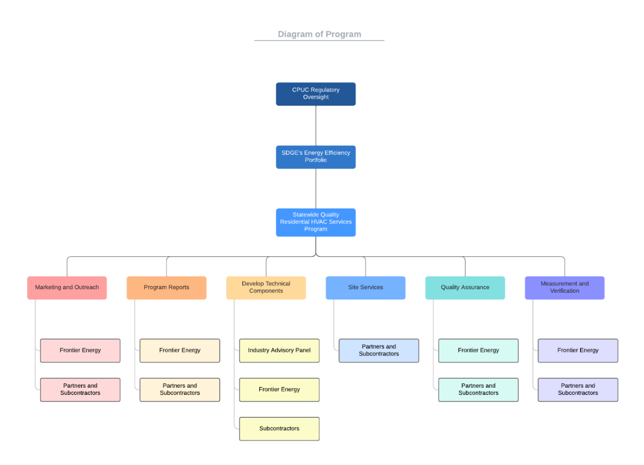

- Evaluation, Measurement & Verification (EM&V)

Introduction
This Measurement and Verification Plan describes the objectives and approaches used to verify the performance of the Quality Residential HVAC Services Program, implemented by Contractor. It describes the performance indicators and metrics that will be measured, and the processes used to measure them. It identifies the schedule for reporting the results of the assessments, and the individuals responsible for carrying them out.
Baseline
The baseline to which this program will be measured is the current state of the market for HVAC services, considering three distinct categories of contractors:
Tier | “Begin the Journey” | “Advance the Average” | “Elevate the Champions”
Who | The vast majority of contractors | A minority of contractors | A very small fraction of contractors
Quality Practices | Do not currently provide higher-quality services | Sometimes provide higher-quality services | Routinely provide higher-quality services
Market | Do not even attempt to offer quality services | Offer quality services inconsistently because they cannot charge enough to make a profit | Have trouble finding a market for quality services

All three categories of contractors find that customers don’t recognize the value of higher quality services, which leads to a “race to the bottom”: customers are only willing to pay an unrealistically low price for these services, customers do not hold contractors accountable for providing these services, contractors are not motivated to provide these services, and the outcome is a failed market for these services.
Program Objectives and Approaches
Per Decision 21-05-031, Market Support programs are “programs with a primary objective of supporting the long-term success of the energy efficiency market by educating customers, training contractors, building partnerships, or moving beneficial technologies toward greater cost-effectiveness.” More specifically, the objectives of this program are:
- Educating customers and contractors on the value of higher-quality HVAC services.
- Educating contractors on how to deliver and convey the value of higher-quality HVAC services.
- Building partnerships within the HVAC contractor eco-system to support contractors who are attempting to improve the quality of their HVAC services.
- Reducing the cost of providing higher-quality services.
These objectives are delivered by:
- Defining standards for quality services that are achievable by all contractors.
- Offering incentives to encourage contractors to improve the quality of their services and to lower their costs to provide them.
- Conducting meaningful outreach to contractors via industry partnerships (with a special emphasis on hard-to-reach contractors and contractors serving hard-to-reach customers).
- Training contractors on how to carry out basic and advanced quality services.
- Providing materials designed to help contractors convey the value of quality to their customers and influence customers’ choices.
- Providing branding and other market support to help excellent contractors differentiate themselves in the market.
- Verifying that standards for quality are being met in incentivized projects.
Metrics and Performance Indicators
The Key Performance Indicators (KPIs) and metrics defined for this program are shown in Table 1. This describes the indicators that will be measured through routine program reporting, as well as the indicators that will be measured through a set of market surveys. Taken together, these proposed program performance indicators and metrics will measure the success of the program in achieving its objectives.
Table 1: Metrics and KPIs Assessed Through Program Reporting; Data Collected
KPI | KPI Definition | Scoring and Monitoring Mechanism | Data Collected
- Program Performance: Sub-Objective #5: Access to capital | Number of incentivized services provided to customers. | - Tabulate the total number of services for which incentive payments are sent.  - Collected from program tracking data. | Monthly reporting:  - Monthly and YTD number of services approved for payment of incentive.
- Program Performance: Sub-Objective #2: Supply | Number of licensed Contractors and/or Technicians trained on how to perform Quality Services. | - Tabulate the total enrollment and completion of program-provided HVAC quality services training.  - Collected from program tracking data. | Monthly reporting:  - Monthly and YTD number of individuals receiving training.
- Marketing:  Sub-Objective #3: Partnerships | Number of market actors reached through partner networks and partner communications channels. | - Tabulate the total number of HVAC market actors reached through identified partnerships.  - Collected from program tracking data | Monthly reporting:  - Monthly and YTD number of HVAC market actors reached through partner networks
- Program Performance:  Sub-Objective #4: Innovation and Accessibility – Contractor Progress | Percent of the total number of licensed contractors who received an “Enhanced” or “Quality Contractor” tier incentive in the last year that previously received a lower tier incentive. | - HVAC Contractor receives a “Basic,” “Enhanced,” or “Quality Contractor” tier incentive for each service provided, based upon the rigor of the services provided (per program standards for each service type and tier, defined in collaboration with the Advisory Panel) and their current status as a Quality Contractor (per program qualifications for a Quality Contractor, defined in collaboration with the Advisory Panel).  - Tabulate the number of contractors who received an “Enhanced” or “Quality Contractor” tier incentive in the last year.  - Identify how many of these contractors had ever received a lower tier incentive.  - Divide the latter by the former.  - Collected from program tracking data. | Monthly reporting:  - number of contractors receiving Enhanced Quality and Quality Contractor incentives in the last 12 months;  - number of these contractors who had received a lower-tier incentive;  - Numerator: count of contractors that received “Enhanced” or “Quality Contractor” tier incentive in the last year that previously received a lower tier incentive  - Denominator: count of contractors that received a basic “Quality Services” incentive in the last year.
- Compliance: Disadvantaged Workers | Percent of services performed by workers who meet the CPUC criteria for “Disadvantaged Worker.” | - Via survey, enrolled contractors will provide zip codes of residence and completed anonymous surveys regarding other Disadvantaged Worker criteria for technicians and contractors employed by the company.  - Using CalEnviroScreen 4.0 and results of survey, determine the percentage of technicians and contractors employed by each company that meet the CPUC criteria for “Disadvantaged Worker.”  - Tabulate the total number of services performed for each Contractor (participating company).  - Multiply that total by the percentage of “Disadvantaged Workers” employed by company to get a proxy estimation of number of services performed by workers who meet the CPUC criteria for “Disadvantaged Worker.”  - Divide by count of total projects completed in the month.  - True up survey conducted bi-annually.  - Collected from program tracking data. | Monthly reporting:  - Enrolled contractor worker zip codes and completed surveys.  - YTD number of incentive payments made for services workers who meet the CPUC criteria for “Disadvantaged Worker.”  - YTD services performed.  - Numerator: proxy estimation of services provided by Disadvantaged Workers obtained via survey for the month.  - Denominator: Total number of completed projects for the month.
- Compliance: Reporting Accuracy | The variance between the monthly forecasted and actual expenditures. | - Calculate the absolute value of the difference between actual and forecast monthly total expenditures.  - Divide by the monthly forecast expenditures provided to Company from the Implementer.  - Collected from program financial data. | - Monthly reporting:  - Monthly expenditures;  - Monthly expenditure forecast;  - Numerator: absolute value of difference between actual and forecasted monthly total expenditures.  - Denominator: forecasted expenditures for the month.
- Customer Satisfaction: Complaints Received | Number of currently enrolled contractors generating valid complaints on more than 5% of their associated projects divided by total number of enrolled contractors program to date. | - Review complaints to assess validity.  - Tabulate the Program to Date (PTD) number of valid complaints received for work by each contractor.  - For each currently enrolled contractor, tabulate the number of services—PTD—that received complaints.  - Divide by their total services completed—PTD.  - Tabulate the total number of contractors for which this ratio is > 5%.  - Divide this by the total number of currently enrolled contractors.  - Data based on complaint data and program tracking data. | Monthly reporting:  - Monthly and PTD number of complaints received;  - Monthly and PTD number of contractors generating complaints on > 5% of projects;  - PTD total number of enrolled contractors;  - Numerator: count of contractors that have valid complaints on > 5% of their projects.  - Denominator: count of total number of currently enrolled contractors.
- Compliance:  Diverse Business Enterprise | DBE spending not including DR expenditures. | - Tabulate monthly payments made to subcontractors that are DBEs.  - Based on program financial data. | Monthly reporting:  - Monthly payments made to DBEs.
- Program Performance: Sub-Objective #4: Innovation and Accessibility: Customer Recognition of Value | Program Validates Effectiveness of Program Interventions: Average response on an annual survey of participating customers on a Likert scale question (0=no value; 100=extreme value) about value received from HVAC services, MINUS baseline response (average response of non-participant HVAC service customers in a survey conducted during program ramp up). | - Conduct baseline survey of customers prior to program launch to create non-participant sample frame.  - Conduct annual survey of customers participating in the last year.  - Analyze demographics of participants and re-sample from non-participant sample frame to match.  - Tabulate participant and non-participant scores on question about value provided.  - Calculate the difference in scores between participants and non-participants. | Annual reporting:  - Participant score on annual survey;  - Non-participant score on initial survey;  - Difference in scores;  - Report analyzing results of survey.
- Program Performance: Sub-Objective #4: Innovation and Accessibility: Contractor Knowledge about Quality | Program Validates Effectiveness of Program Interventions: Average score (0-100) on annual assessment of participating contractors' awareness, knowledge, attitudes, and behavior about Quality HVAC Services, MINUS baseline score (average score achieved by non-participating HVAC service contractors in a survey conducted during program ramp up.) | - Conduct baseline survey of contractors prior to program launch to create non-participant sample frame.  - Conduct baseline survey of participating contractors as they are enrolled.  - Conduct annual survey of contractors participating in the last year.  - Analyze demographics of participants and re-sample from non-participant sample frame to match.  - Tabulate participant and non-participant scores on questions about awareness, knowledge, attitudes, and behavior.  - Calculate the difference in scores between participants and non-participants. | Annual reporting:  - Participant score on annual survey;  - Non-participant score on initial survey;  - Difference in scores;  - Report analyzing results of survey.

Measurement and Verification Using Quarterly Reporting
The plan for the program includes a thorough process of evaluating and reporting on these KPIs and metrics. The program will collect a large amount of data on the contractors participating in the program, the work that is performed by those contractors, and the customers who are the recipients of that work. Table 1 above identifies data collected. A tracking system will be used that facilitates the efficient and accurate entry and validation of contractor, project, and customer information. It is a simple matter to define periodic reports that will be generated as needed and automatically to report on program operations. During the design phase of the program, specific reports will be defined to report on the values of KPIs 1-8.
During the implementation phase of the program, monthly reports will be generated automatically, reviewed internally for consistency and accuracy, and uploaded as required to the CPUC program portal. After review by the CPUC, the program will respond promptly to questions submitted by the CPUC. Upon receipt of any Data Requests from the CPUC, the program will generate custom reports required to provide the information that the CPUC requires. The program implementation team will conduct these tasks, particularly the sub-team that is responsible for data tracking and reporting. The results will be reviewed and evaluated by the Program Manager and the Technical Lead.
Measurement and Verification Using Customer and Contractor Surveys
During program ramp up (in the first half of program year 1), the program implementers will conduct a baseline survey of non-participating contractors and IOU customers prior to launch of the program. Program implementers will also conduct a baseline survey of contractors as they are enrolled. Near the end of each program year, the program implementers will conduct surveys to report on the values of KPIs 9 and 10. These surveys will be administered using a combination of online, postcard, and telephone survey methods. The survey instruments, sample frames, targeted sample sizes, and selected samples are to be reviewed and approved by Company. This effort will share many characteristics with the California Market Effects Evaluation Protocol.
- The Customer Survey will primarily measure whether customers received value and understand the value of HVAC services they received. These are measured by an Awareness, Knowledge, Attitudes, and Behavior (AKAB) survey that asks what level of value customers received from any HVAC services they have been provided in recent months. By asking these questions of participating customers, as well as other similar customers who received HVAC services throughout the program period, it will be possible to comment on changes in the market due to the program.

KPI #9 will be scored based upon answers to a question about the amount of value households received from HVAC services recently provided (on a scale from 0=no value to 100=extreme value). The baseline (non-participant) score will be based upon the average response from a random sample of households that are identified as having received some sort of HVAC service in the previous year (identified either through an in-survey screener question, or through development of a sample frame of customers identified as having recently received a service). Note that we may need to go back further than one year in order to obtain an adequate sample size. Efforts will be made to minimize the potential for self-selection bias in identifying this sample. The participant score will be based upon the average response from as many as possible of the households that received services in the last year for which an incentive was paid in the QIQM program. The difference in scores will be calculated and will range from 0 to 100. The program goal is that the difference will be at least 10 points, where the participant score is higher than non-participant.
This survey will also ask questions such as: in what way did the service provide or fail to provide value; whether the customer ended up deciding on a "better" or "best" system due to the Customer Report; whether the customer regards the technician and contractor with respect due to his/her professionalism, and values his/her advice; whether the customer would be willing to pay more and tolerate longer service calls in order to receive such higher quality services; and whether the customer felt that the service provided a "solution."
- The Contractor Survey will primarily measure whether contractors can describe requirements and value of quality services and are providing such services. These are measured by accuracy on survey that asks about their awareness, knowledge, attitudes, and behavior about the requirements for Quality Maintenance, Quality Bid, and Quality Installation services, and what benefits offering this service could have for their business. By asking these questions of participating contractors early in their program participation and annually, as well as other similar non-participating contractors who provided HVAC services throughout the program period, it will be possible to comment on changes in the market due to the program.

KPI #10 will be scored based upon answers to a question about awareness, knowledge, attitudes, and behavior about Quality HVAC Services, and the answers will be scaled to provide a score ranging from 0=no awareness or knowledge and bad attitudes and behavior to 100=profound awareness and knowledge and supportive attitudes and behavior. The baseline (non-participant) score will be based upon the average response from a random sample of contractors that are identified as having provided some sort of HVAC service in the previous year (identified either through an in-survey screener question, or through development of a sample frame of contractors identified as having recently provided a service). Note that we may need to go back further than one year in order to obtain an adequate sample size. Efforts will be made to minimize the potential for self-selection bias in identifying this sample. Responses from the baseline survey of contractors as they are enrolled will be used to analyze and describe the findings from the non-participant survey, although they will not be an accurate representation of the program’s baseline, since they are already being influenced by the program upon enrollment. The participant score will be based upon the average response from as many as possible of the contractors that received incentives in the Quality Residential HVAC Services program in the last year. The difference in scores between the non-participants surveyed prior to program launch and the annual participant surveys will be calculated and will range from 0 to 100. The program goal is that the difference will be at least 10 points, where the participant score is higher than non-participant.

The survey will also ask questions such as: whether the contractor does not consider a service complete until a solution is provided, whether the contractor routinely evaluates customer satisfaction feedback, including perceived value of the service, whether customers have access to user-friendly materials and tools (calculators, charts, case studies, analysis, etc.) to help them decide whether or not to invest in improving the performance of their HVAC systems; and what standards of quality they intend to provide to their customers in the future, and how prepared they feel to do so. The survey will include questions designed to assess what impact the program had on the contractors’ decision or ability to provide quality services.
Because the impacts of this Market Support program are expected to be often indirect and long-term, it will be important to design these surveys very carefully. A nuanced understanding of the market for these services and the motivations and abilities of the contractors and customers is necessary to gain a clear understanding of the impact of the program. Several of the questions noted above resulted from a detailed analysis of the best indicators of Market Transformation for Quality Maintenance programs.
The Contractor will develop draft and final survey questions. Within the California Energy Efficiency Evaluation protocols, and referring to the California Market Effects Protocol, a confidence level of 90% will be used to determine, during the survey design, the minimum sample sizes required for each sample. We will analyze the expected variation in the responses to select a sample size that will allow us to identify the difference in responses between participants and non-participants that we are 90% confident that we can reject as being the result of mere chance. The non-participant samples will be drawn randomly, but designed so that the samples match the intended program participant samples in terms of factors such as location, customer HTR/DAC status, system type, and type of service received for customers, and location, contractor Disadvantaged status, company size, and type of services offered. If necessary and appropriate, a sample of responses will be randomly redrawn from the non-participant sample frame each year, designed so that the non-participants and participants are as well matched as possible. The analysis may include a randomized block design, where sub-samples of participants are compared to sub-samples of non-participants that fit in the same demographic or project characteristic groups.
The surveys will be distributed using an appropriate combination of online, postcard, and telephone survey methods. Adequate follow-ups will be conducted to ensure that the minimum sample size is achieved, and that non-response bias is minimized. Table 1 identifies data collected. The results of the survey will be analyzed and documented in an M&V report, after the end of each program year. These tasks will be conducted by the program implementation team, particularly the sub-team that is responsible for M&V, under the direction of the Technical Lead. The results will be reviewed and evaluated by the Program Manager and the Technical Lead.

Process Improvement
Should the results of the monthly reports or surveys indicate that the program is not achieving its objectives, the program implementers will (in collaboration with SDG&E or the CPUC, as appropriate) implement continuous process improvement modifications to the program design and provide adequate documentation of any changes. If necessary, the program will conduct additional M&V activities to gather more detail on why the metrics are not being met. This may consist of surveys or interviews with participants, or Voice of the Contractor or Voice of the Contractor focus groups.
- Normalized Metered Energy Consumption (NMEC)

Not applicable

EE/DR Budget is part of the EE+DR Funding set aside.
Heinemeier, K. 2018. “Transforming the Way We Measure Transformation: Indicators of A Transforming Market for Quality Maintenance.” Proceedings of the ACEEE Summer Study. This analysis included a detailed review of the Impact Evaluation of the 2013-14 Commercial HVAC Quality Maintenance programs, and identification of factors that “bear a reasonable likelihood of occurring within a few years if the market transformation initiative is on course but are relatively unlikely to occur in the absence of intervention.”—a definition taken from Prahl, R., and K. Keating. 2014. Building a Policy Framework to Support Energy Efficiency Market Transformation in California. These factors were prioritized through a survey of 145 contractors.
California Energy Efficiency Evaluation Protocols: Technical, Methodological, and Reporting Requirements for Evaluation Professionals, TecMarket Works, 2006.

