Energy Equity Indicators – Interactive Story Map
This story was made with Esri's Story Map Journal.
Read the interactive version on the web at https://arcg.is/1KmKzG.
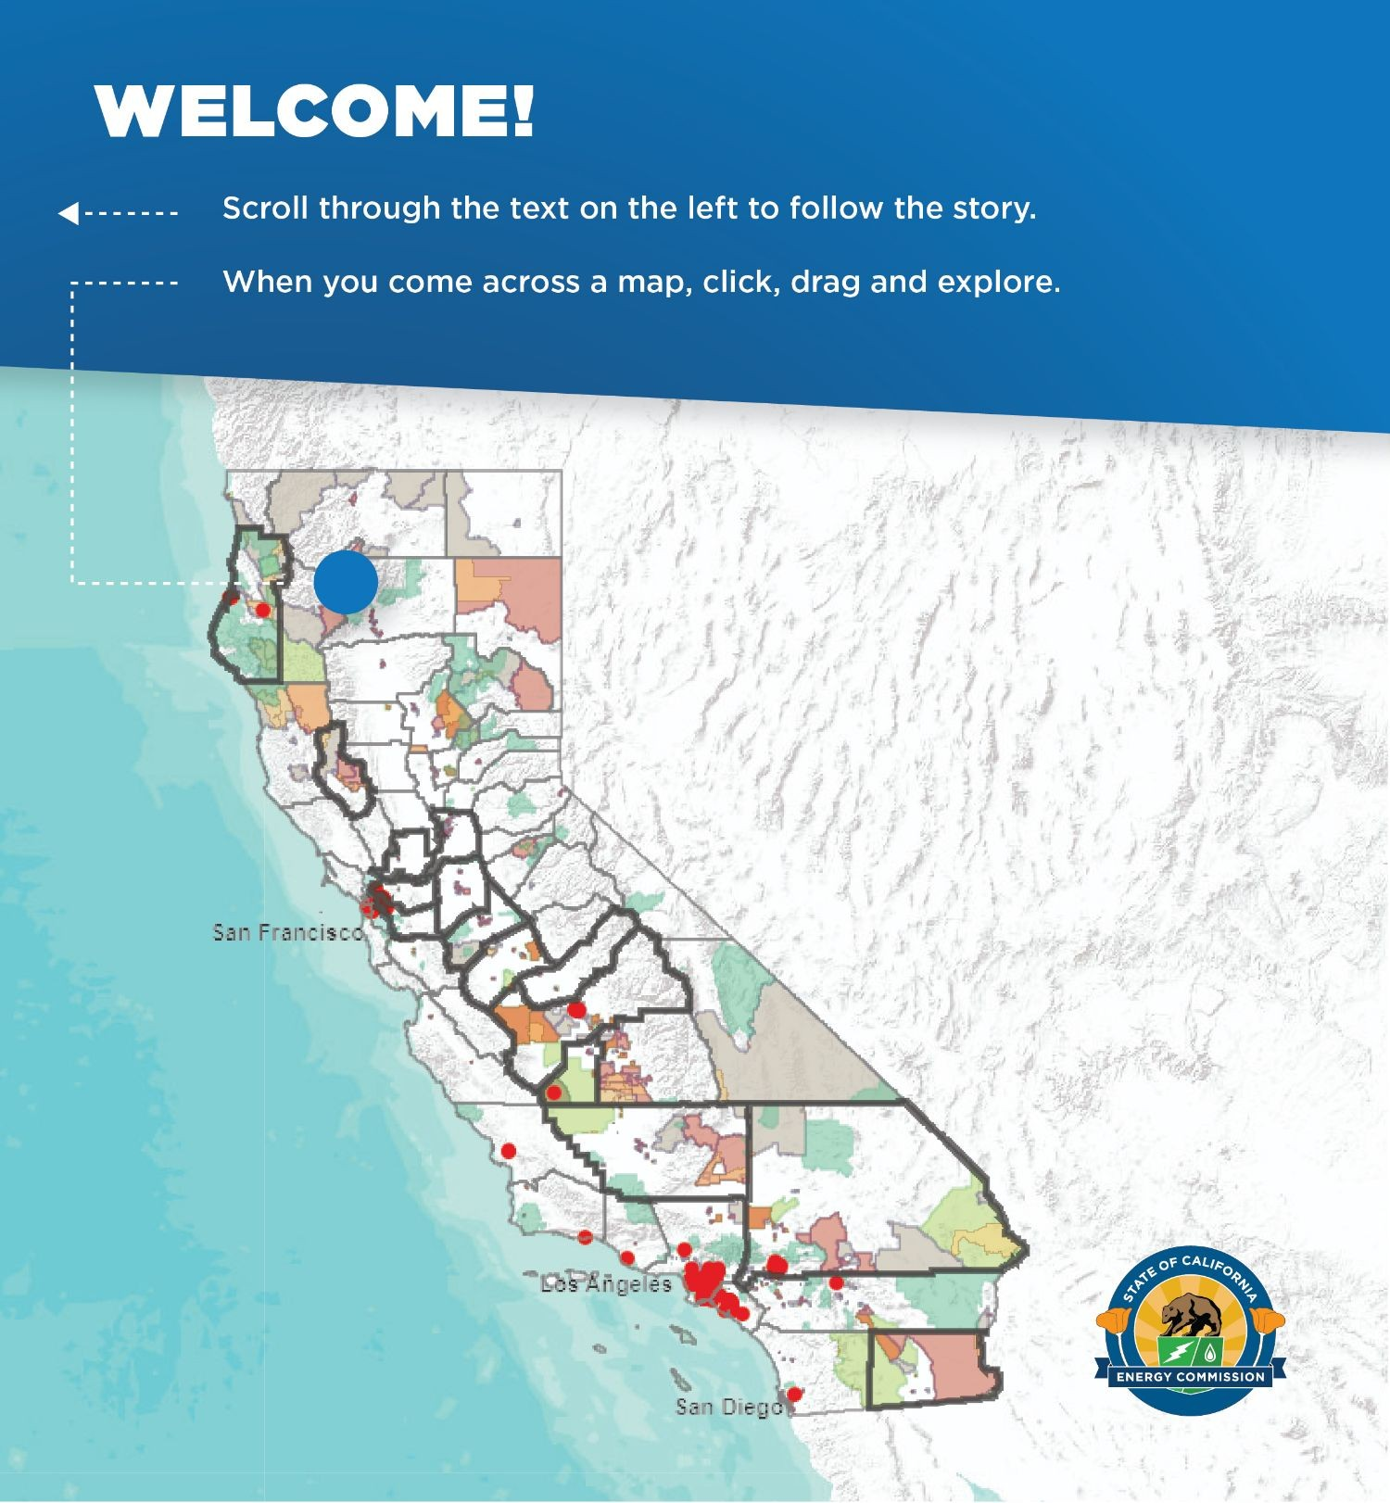

Together with the California Energy Commission’s Energy Equity Tracking Progress report, [1] this interactive story map launches a set of energy equity indicators to identify opportunities and track progress for advancing the recommendations in the SB 350 Low- Income Barriers Study. Going forward, staff plans to add map applications and widgets for selected data layers; for example, see the sample interactive mapping application.

- The Energy Commission Tracking Progress reports provide sector-speciﬁc summaries of California's progress toward a cleaner energy future, with links to additional resources.
Information and metrics are updated regularly. The reports are available at http://www.energy.ca.gov/renewables/tracking_progress/.

Table 1: Energy Commission Low-income Barriers Study Recommendations and Associated Indicators
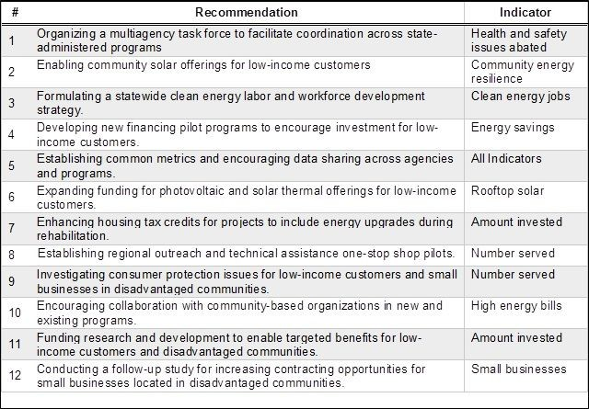
In December 2016, the California Energy Commission adopted the Low-Income Barriers Study, Part A: Overcoming Barriers to Energy Eﬃciency and Renewables for Low-income Customers and Small Business Contracting Opportunities in Disadvantaged Communities (Barriers Study). The study, mandated by Senate Bill 350 (De León, Chapter 547, Statutes of 2015), included 12 recommendations (Table 1) to address barriers to clean energy investment in California’s low-income and disadvantaged communities.

Source: California Energy Commission

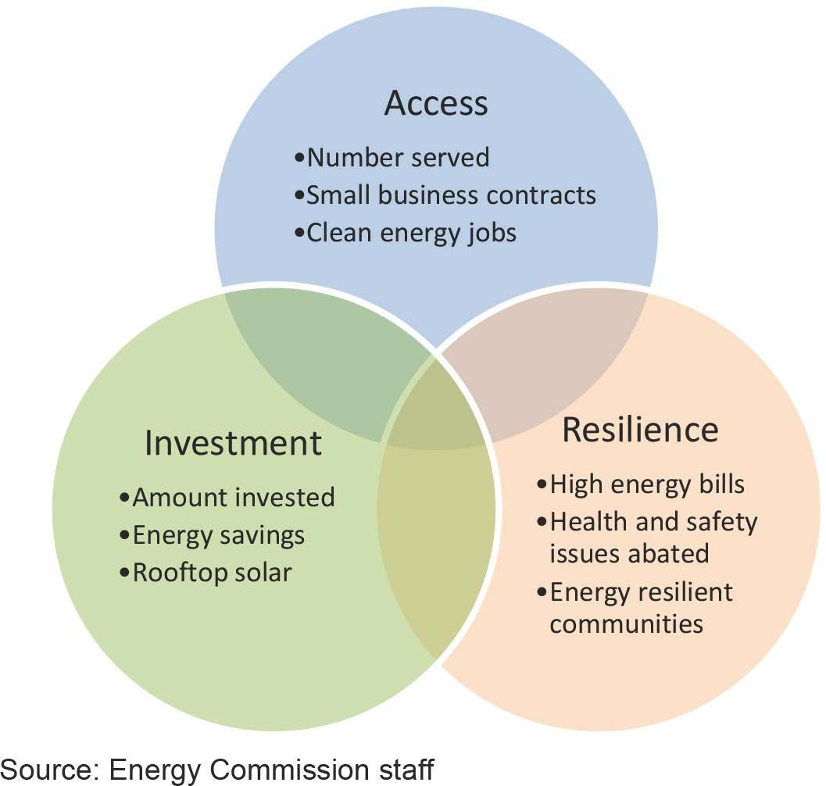
Figure 1: California Energy Equity Objectives and Indicators
Building on the recommendations from the Barriers Study, Energy Commission staff identiﬁed a set of indicators to measure progress toward the following objectives for low-income residents and disadvantaged communities.

Access. Advance access to clean energy, including actions to increase availability of product selection options, access high-quality jobs, expand small business contracting opportunities, and improve access to non-debt ﬁnancing offerings.

Investment. Increase clean energy investment in low-income and disadvantaged communities, including technology development and demonstration funding, infrastructure investments, emergency preparedness, technical assistance, and local capacity building. Capacity building includes workforce development, small business development, outreach, and education for clean energy.
Resilience. Improve local energy-related resilience, deﬁned as energy services to support the ability of local communities to recover from grid outages and enjoy affordable energy in a changing climate. Local energy resilience includes energy reliability, energy affordability, health, and safety.

Figure 1 uses a Venn diagram to illustrate how the indicators map to each objective, recognizing some indicators help advance more than one objective. For example, energy savings result from investment and access to energy eﬃciency. Energy savings can also improve resilience if designed to help match energy demand with supply. This Venn diagram hints there are likely to be other interactions and beneﬁts ﬂowing from each indicator.

Source: California Energy Commission staff

Table 2: Clean Energy Equity Indicators Relationships to Energy Equity Objectives
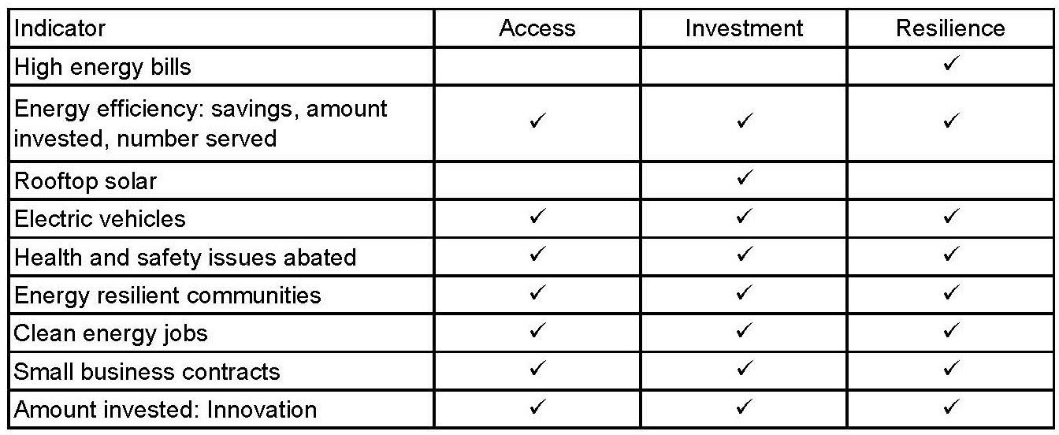
Another view of the objectives advanced by each indicator is shown in Table 2, which groups the indicators by energy resource starting with a consumer’s bill moving out to public health, jobs, and innovation.

Source: California Energy Commission staff

Figure 2: Comparison of Low-Income Eligibility for Energy Programs (2017)
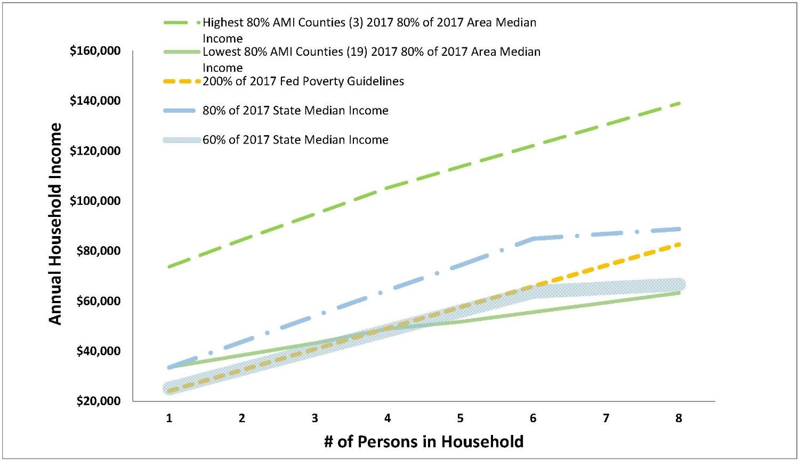
One of the key drivers of recommendations from the Energy Commission’s Barriers Study is to align program eligibility requirements. Figure 2 provides examples of eligibility requirements as translated to income per household. [2] This ﬁgure shows information for 2017. Three counties reached the highest 80 percent Area Median Income threshold. These counties were in urban areas, suburban areas, or both. Nineteen counties reached the lowest 80 percent Area Median Income threshold.
These counties were primarily in rural areas. [3]

Source: Energy Commission staff based on data from U.S. Dept. of HHS and U.S. Dept. of HUD

- Additional information on income eligibility requirements for affordable housing is available online at http://www.hcd.ca.gov/grants-funding/income-limits/state-and-federal-income- limits.shtml.

- Area Median Income is determined by the U.S. Department of Housing and Urban Development (HUD) by county annually.

Figure 3: California Tribal Lands, SB 535 Disadvantaged Communities, and Low-income Communities
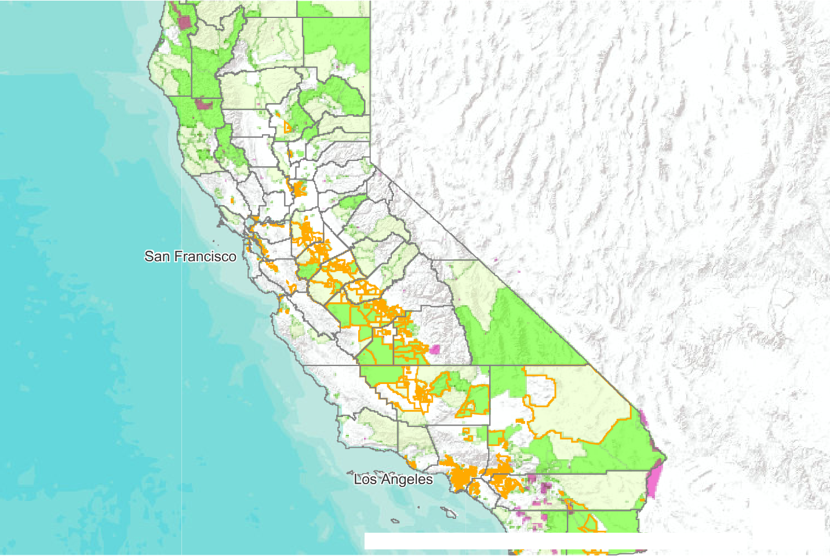
Sources: Esri, USGS, NOAA | BIA Paciﬁc Regional Oﬃc…

DDisadvantaged
CCommunity (SB 535 3.0)

TTribal Land
CCensus Tract Median HHousehold IIncome/Statewide
MMedian Household IIncome (Less Than 60%)
CCensus Tract Median HHousehold IIncome/Statewide
MMedian Household IIncome (60 to 80%)

Census tracts with median income at or below 60 percent of statewide median income are likely to include many households that meet the income eligibility requirements for clean energy programs serving low-income customers.

For example, many of the census tracts that are eligible for funding for Senate Bill 535 disadvantaged communities [4] have a median household income that is 60 percent or less of the statewide median income. However, many rural census tracts with a median household income at this level or below do not meet the deﬁnition of disadvantaged communities. In many cases this is because communities have good environmental quality, but is also subject to a number of other

complicating factors, such as being located on tribal lands. By highlighting opportunities to expand access to clean energy in areas at or below 60 percent of statewide median income, these indicators aim to simplify matchmaking between unmet low-income community needs and available program funding. For 2011-2015, statewide median income was $61,818 per household per year. [5] Sixty percent of the 2011-2015 statewide median income is about $37,000. The median household income in the census tracts identiﬁed as low income is about $31,000.

Source: U.S. Census Bureau 2010 census tract boundaries; 2011-2015 American Community Survey (ACS) 5-year estimates; Bureau of Indian Affairs Paciﬁc Regional Oﬃce 2017; CalEnviroScreen 3.0, 2017

- Disadvantaged communities are deﬁned as California census tracts facing the highest environmental burdens, as determined by economic, environmental, and socioeconomic factors including low income, high unemployment, poor health conditions, air and water pollution, and hazardous wastes. SB 535 (De León, Chapter 830, Statutes of 2012) directs the California Environmental Protection Agency (CalEPA) to identify disadvantaged communities for funding, and as of April 2017, CalEPA uses the top scoring 25 percent of communities using the CalEnviroScreen
3.0 tool to make this determination.

- American Community Survey (ACS) 5 Year Estimates (2011-2015) – California Census Tracts: https://www.census.gov/programs-surveys/acs/.

Table 3: California 2015 Investor-Owned Utility Low-Income Customer Statistics
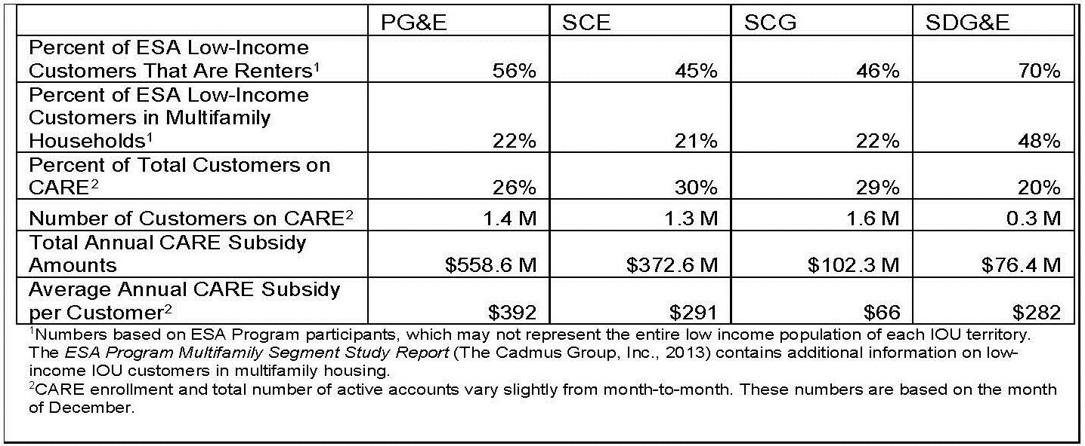
Table 3 illustrates the percentage of California low-income investor-owned utility customers that are renters and live in multifamily housing, as estimated by participants in the Energy Savings Assistance (ESA) and California Alternative Rate for Energy (CARE) programs for 2015. This table highlights the importance of state agencies designing clean energy programs that target renters, with particular

focus on addressing the unique challenges associated with multifamily buildings. Both arrangements require careful consideration of beneﬁts for building owners in addition to tenants. The numbers shown in this table may not represent the entire low-income and disadvantaged population of each utility, as Southern California Edison has separately reported that 40 percent of households are in disadvantaged communities, have subsidized electric rates, or both. [6]

Challenges to increasing energy investment in low-income areas, especially in multifamily housing, include diverse building characteristics and needs, complex ownership and ﬁnancial arrangements, and limited budgets with restricted opportunities to take on additional debt. The Barriers Study recommended developing a comprehensive multifamily building distributed energy resource action plan to help identify detailed strategies to address these challenges. To inform this action plan and updates to this Tracking Progress report, benchmarking data for the state’s largest multifamily buildings will be considered once they are made publicly available as required by Assembly Bill 802 (Williams, Chapter 590, Statutes of 2015).

Source: California Public Utilities Commission ESA/CARE information

- Presentation by Adam Smith of Southern California Edison at Integrated Energy Policy Report workshop on August 29, 2017. Slide 10. Available at http://docketpublic.energy.ca.gov
/PublicDocuments/17-IEPR-09
/TN220908_20170825T132632_SCE_Climate_Resilience_and_Disadvantaged_Communities.pdf.

Figure 4: Low-income Areas With Highest August Electricity Bill (SCE, 2014)
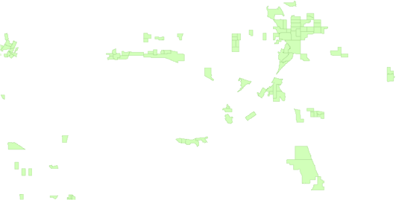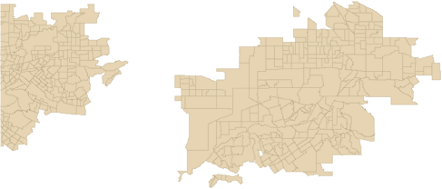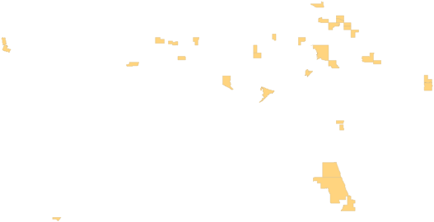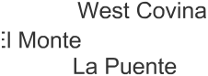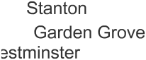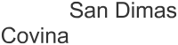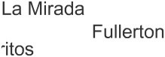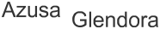
Sources: Esri, USGS, NOAA | US Census Bereau and E…

22001144 SCE August Electric BBill Within a Low-income CCensus Tract Multifamily MMean is at Least $300

22001144 SCE August Electric BBill Within a Low-income CCensus Tract Single
FFamily Mean is at Least
$$330000
AAdditional Cooling
DDegree DDays Greater
TThan 1,300 per Census TTract Expected by Mid CCentury
CCensus Tract Median HHousehold IIncome/Statewide
MMedian Household IIncome (Less Than 60%)

In the Southern California Edison (SCE) service territory, many low-income census tracts with low energy savings from existing energy eﬃciency programs also have August electricity bills of $300 or more. The average SCE August 2014 bill amount for low-income census tracts was about $148 for

multifamily residences and about $270 for single-family homes. Greater awareness and access to energy eﬃciency programs, as well as development of new energy eﬃciency pilots focusing on these low-income areas, can strengthen energy resilience by improving affordability and relieving energy burden. The 2016 bill statistics for SCE, San Diego Gas & Electric Company (SDG&E), and Paciﬁc Gas and Electric Company (PG&E) on the summer bills by climate zone for CARE and non-CARE customers indicate the upper range of summer CARE bills rises above $300 in the following Title 24 building climate zones: 10 (Riverside and other inland Southern California areas west of mountains), 11 (Red Bluff and other areas of the northern Sacramento Valley, 13 (Fresno and other areas of the southern San Joaquin Valley), 14 (inland San Diego County near Palmdale and High Desert east of the San Bernardino mountains), and 15 (Palm Springs, Salton Sea, and Colorado desert regions of southeastern California).

Figure 4 shows low-income census tracts in the SCE service territory with the top 20 percent of accounts with August 2014 electricity bills averaging $300 or more. This information can be used to identify high-priority areas for energy eﬃciency upgrades to improve energy affordability for low- income customers. If a census tract has fewer than 100 accounts, it is not included.

This map also shows census tracts expected to have 1,300 or more additional cooling degree days per year on average during the 2035-2064 period compared to the 1961-1990 period. Statewide, about 990 additional cooling degree days per year are expected on average during the 2035-2064 period compared to the 1961-1990 period. [7] For comparison, the average number of cooling degree days in San Bernardino from 1961-1990 was 1,360. [8] The number of cooling degree days indicates how often local temperatures reach above 65 degrees and by how many degrees that base temperature is exceeded.

Source: Energy Commission analysis based on CPUC historical data, CalAdapt for cooling degree days; U.S. Census Bureau 2010 census tract boundaries; 2011-2015 ACS

- Energy Commission staff analysis using data from the Cal-Adapt Cooling Degree Days tool. HadGEM2-ES (warm/Dry) climate model. RCP 8.5. cal-adapt.org.

- Energy Commission staff analysis using data from the Cal-Adapt Cooling Degree Days tool. Observed Data for the City of San Bernardino (Incorporated and Census Designated Places, 2015). cal-adapt.org.

Figure 5: Low-income Energy Affordability Data: Riverside County (2015)
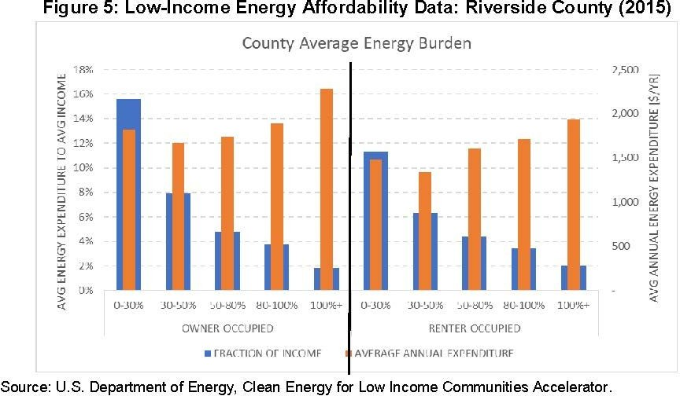

Figure 5 shows low-income areas of Riverside County (with 80 percent or less of area median income) pay between 4 percent and 15 percent (or so) of average income for energy (about
$1,500-$1,800 per year on average). [9] These data for Riverside County include areas served by SCE and areas served by Riverside Public Utilities.

Source: U.S. Department of Energy, Clean Energy for Low Income Communities Accelerator

- The orange bars represent the average energy expenditure in dollars per year by percentage of area median income. The blue bars represent the average percentage of customer income devoted to energy expenses for the same area median-income segments.

Figure 6: Trend in Frequency and Temperature of Extreme Heat Days in San Bernardino Through Midcentury From HadGEM2-ES (warm/dry) Climate Model
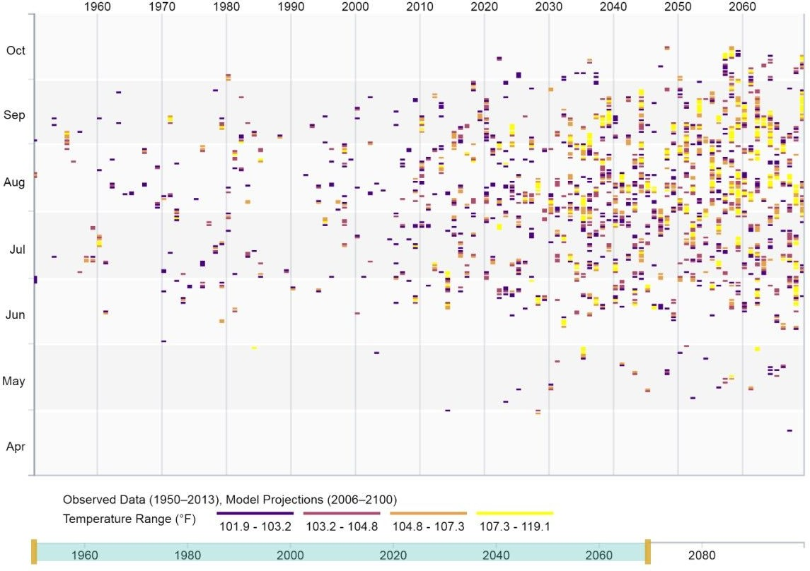
The average number of days with a high above 101.9 degrees Fahrenheit in San Bernardino was 4.3 from 1961-1990. From 2035-2064, this number is expected to increase to 30. [10] This scenario suggests that some areas with high August electricity bills are expected to have even larger bills as the number of extremely hot days increases over the next several decades and drives additional cooling demand.

Source: Cal-Adapt Extreme Heat Tool. www.cal-adapt.org, RCP 8.5 Scenario. HadGEM2-ES (warm/dry) climate model

- Cal-Adapt Extreme Heat tool. RCP 8.5. cal-adapt.org.

Figure 7: California Estimated Average Monthly Expenditure by Fuel Type (2015)
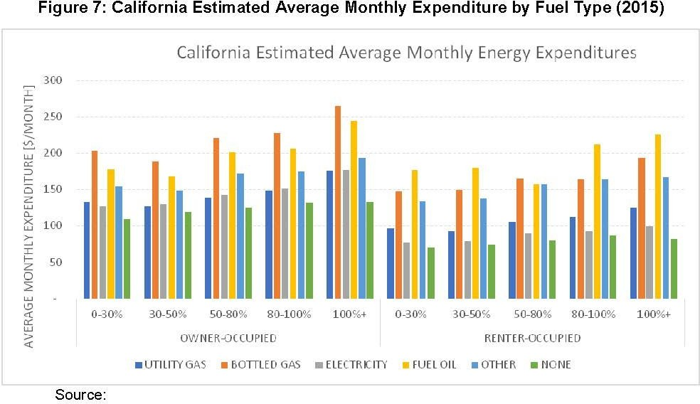

As illustrated by Figure 7, propane, fuel oil, and other fuels are generally more expensive than electricity and natural gas on a statewide average basis. For example, estimated average monthly energy expenditure ($/month in 2015) for heating with bottled gas or fuel oil in California range from about $150 per month to more than $250 per month. Estimated energy expenditures for heating with utility gas in California ranges from less than $100 per month to about $175 per month.

Source: U.S. Department of Energy, Clean Energy for Low Income Communities Accelerator

Figure 8: Use of High-Cost Heating Fuels in Low-income and Tribal Areas (2016)
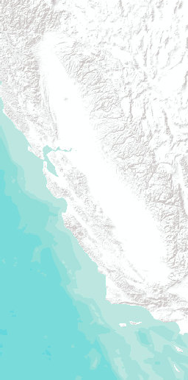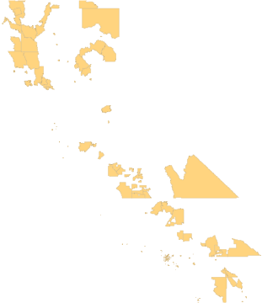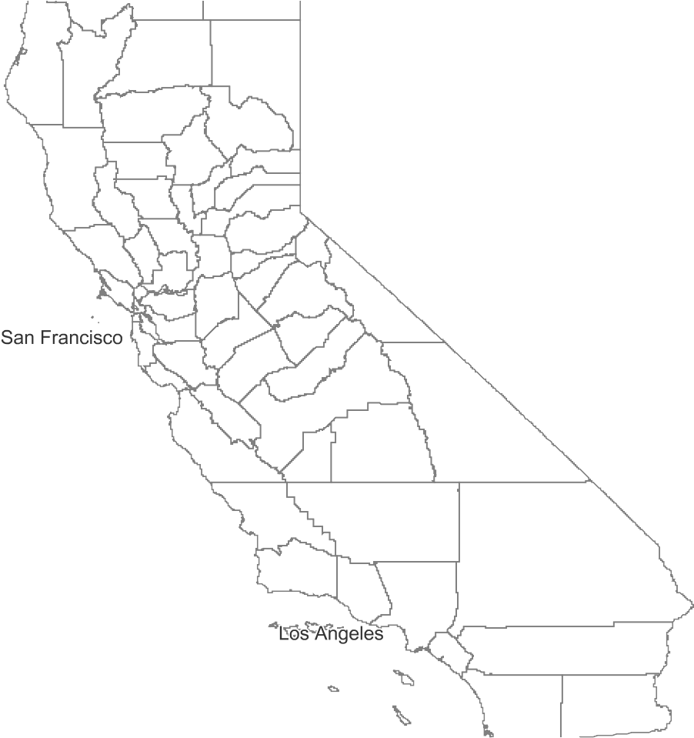
Sources: Esri, USGS, NOAA | BIA Paciﬁc Regional Oﬃc…
TTribal Land TTop 20% Number of Households Per
LLow-income Census Tracts That do Not UUse Natural GGas, Solar, or Electricity as
aa Heaating Fuel. (Less Thaan 60% of the SStatewide Median Income)

Many rural and tribal areas have a high number of households that do not use natural gas or electricity for heating, which may result in a high winter energy bill and lead to indoor air quality issues. Figure 8 shows use of high-cost heating fuel in low-income areas.

Source: U.S. Department of Energy, Clean Energy for Low Income Communities Accelerator;
U.S. Census Bureau 2010 census tract boundaries; 2011-2015 American Community Survey (ACS) 5-year estimates; Bureau of Indian Affairs Paciﬁc Regional Oﬃce 2017

Figure 9: Low-income Areas with Low Residential Energy Savings (Net Reported GWh) for Humboldt County (PG&E 2016-2017 Rolling Portfolio)
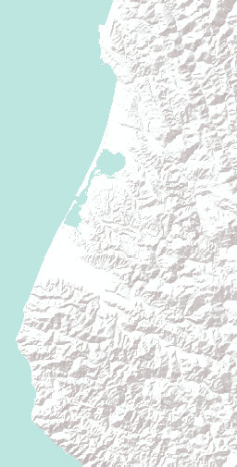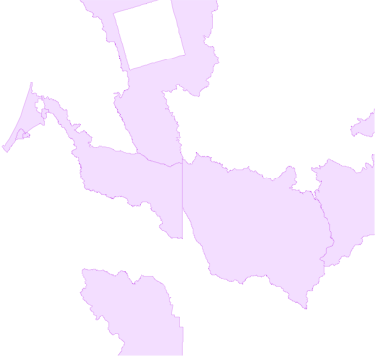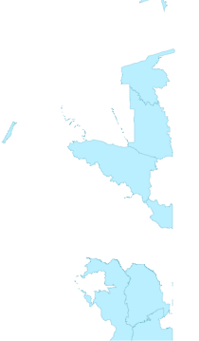
Sources: Esri, USGS, NOAA | US Census Bereau and E…

CCEDARS Residential kWh per Year by
ZZIP Code is less than 655 (lowest 20%) aand Intersects Census Traact Mediaan
HHousehold Income/Statewide Median HHousehold Income (Less Than 60%)
7700% of Structures Built Before 11998899
WWithin Census Tract Median Household IIncome/Statewide Median Household IIncome (Less Than 60%)

The Barriers Study included recommendations for a series of new energy upgrade ﬁnancing pilots. The pilot programs would include the cost of health and safety measures required to accomplish energy eﬃciency upgrades. The energy savings indicator can be used to help track the effect of these programs to increase energy savings in low-income communities. Staff plans to add data for other areas of the state in updates of this indicator. Moreover, staff plans to track trends in energy savings across low-income and disadvantaged communities annually. Figure 9 shows energy savings from the 2016-2017 rolling portfolio of IOU energy eﬃciency investments.

Sources: CPUC – California Energy Data and Reporting System (CEDARS), May 18, 2018; U.S. Census

Bureau 2010 census tract boundaries; 2011-2015 American Community Survey (ACS) 5-year estimates

Figure 10: Low-income Areas with Low Residential Energy Savings (Net Reported GWh) for SCE Portions of Los Angeles Area (2016-2017 Rolling Portfolio)
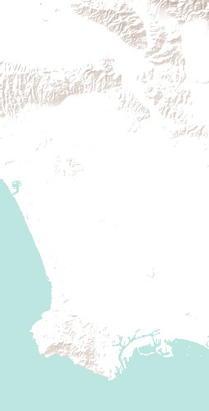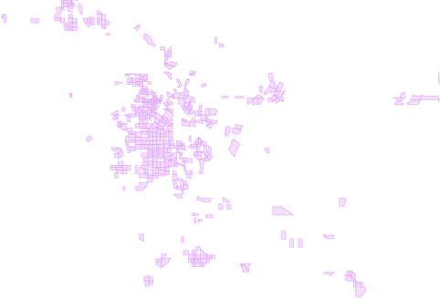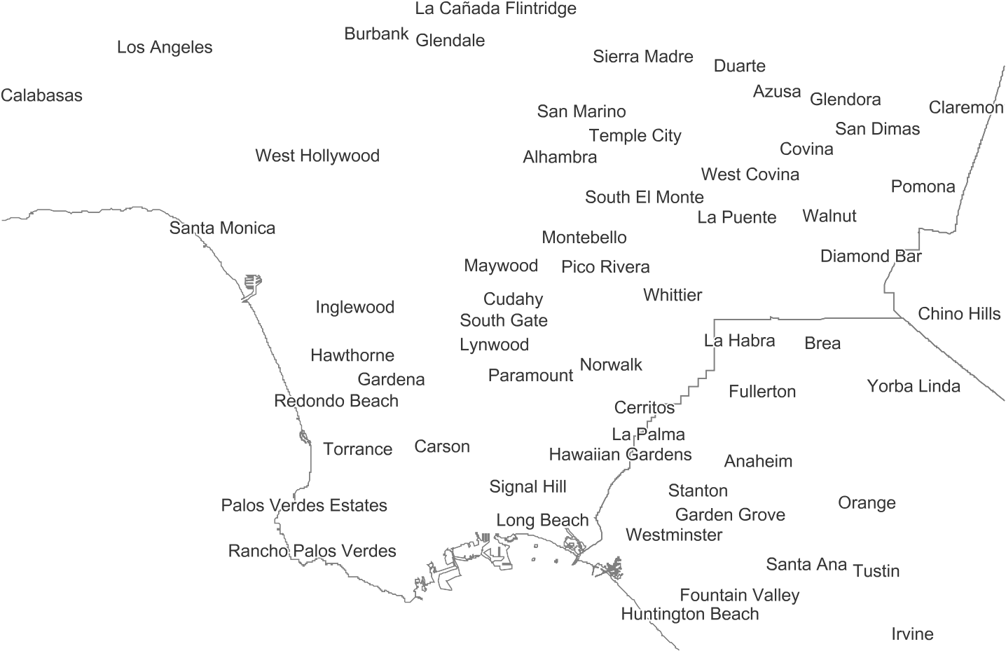
Sources: Esri, USGS, NOAA | US Census Bereau and E…

CCEDARS Residential kWh per Year by
ZZIP Code is less than 655 (lowest 20%) aand Intersects Census Traact Mediaan
HHousehold Income/Statewide Median HHousehold Income (Less Than 60%)
7700% of Structures Built Before 11998899
WWithin Census Tract Median Household IIncome/Statewide Median Household IIncome (Less Than 60%)

Improving energy eﬃciency in the SCE service territory is a high priority to help maintain energy reliability as work to permanently close the Aliso Canyon natural gas storage facility moves
forward. [11] Figure 10 highlights low-income areas with low residential energy savings (net reported GWh) for SCE Portions of Los Angeles Area (2016-2017 Rolling Portfolio).

Identifying areas with low energy savings can indicate which areas may beneﬁt from additional

energy eﬃciency upgrade investments and improved program offerings.

Sources: CPUC – California Energy Data and Reporting System (CEDARS), May 18, 2018; U.S. Census Bureau 2010 census tract boundaries; 2011-2015 American Community Survey (ACS) 5-year estimates

- For further information, please see the 2017 Integrated Energy Policy Report, available online at http://www.energy.ca.gov/2017_energypolicy/.

Figure 11: Areas With Lowest IOU Energy Eﬃciency Investments (2016-2017)
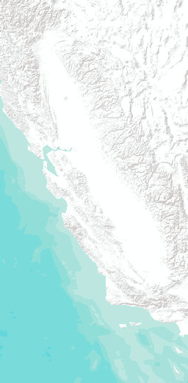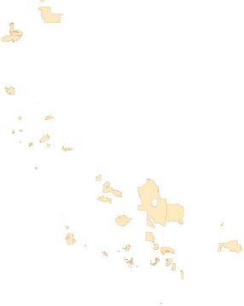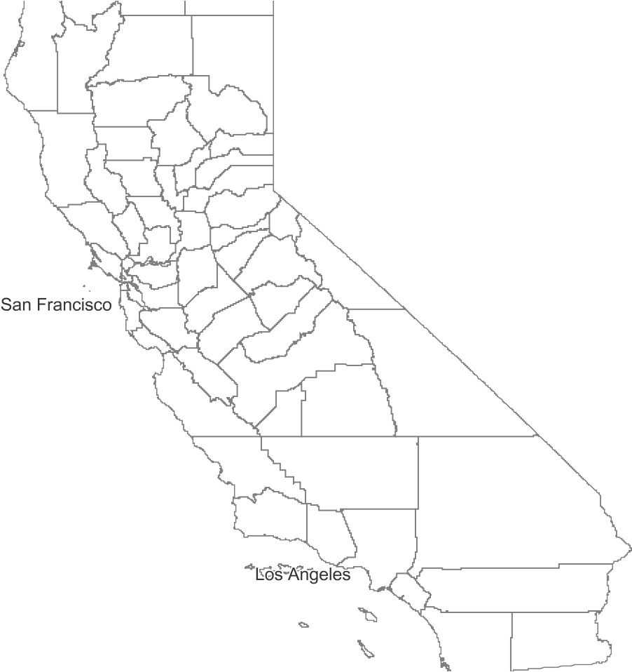
Sources: Esri, USGS, NOAA | US Census Bereau and E…

CCEDARS Total Expenditures Per 1,000 PPeople PPer ZIPP Code Less Than $5,000 ((Lowest 20%)) That Intersect 70% of
SStructures Built Before 1979 Per Low- iincome Census Tract
CCEDARS Number of Records Per 1,000 PPeople PPer ZIPP Code is Less Than 1.6 ((Lowest 20%)) That Intersect 70% of
SStructures Built Before 1979 Per Low- iincome Census Tract

Figure 11 shows low levels of participation and low levels of investor-owned electric utility energy eﬃciency investments near low income areas that are also near areas more than 70 percent of structures built before 1979. The locations for eﬃciency investments shown in this ﬁgure have
$5,000 or less per 1,000 people. Also, for 2016 and much of 2017, on average about 8 households per 1,000 people per zip code in the investor-owned electric utility service areas participated in energy eﬃciency programs. This ﬁgure highlights areas with 1.6 or less (lowest 20 percent) participating household per 1,000 people per zip code (shown in solid beige). The locations noted on this map may be good candidates for energy eﬃciency upgrades. These locations may also highlight opportunities for launching additional regional service centers or one-stop shop pilots to improve market delivery and streamline services, potentially driving increased participation in energy eﬃciency programs and resultant eﬃciency savings. Publicly owned utility (POU) territories have been excluded from this analysis.

Source: CPUC – California Energy Data and Reporting System (CEDARS); U.S. Census Bureau 2010 census tract boundaries; 2011-2015 American Community Survey (ACS) 5-year estimates; ESRI zip codes – 2015 population estimate

Figure 12: Low-income Areas With Low Solar Capacity Per Capita, Long Beach (2017)
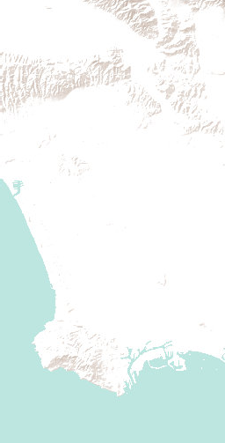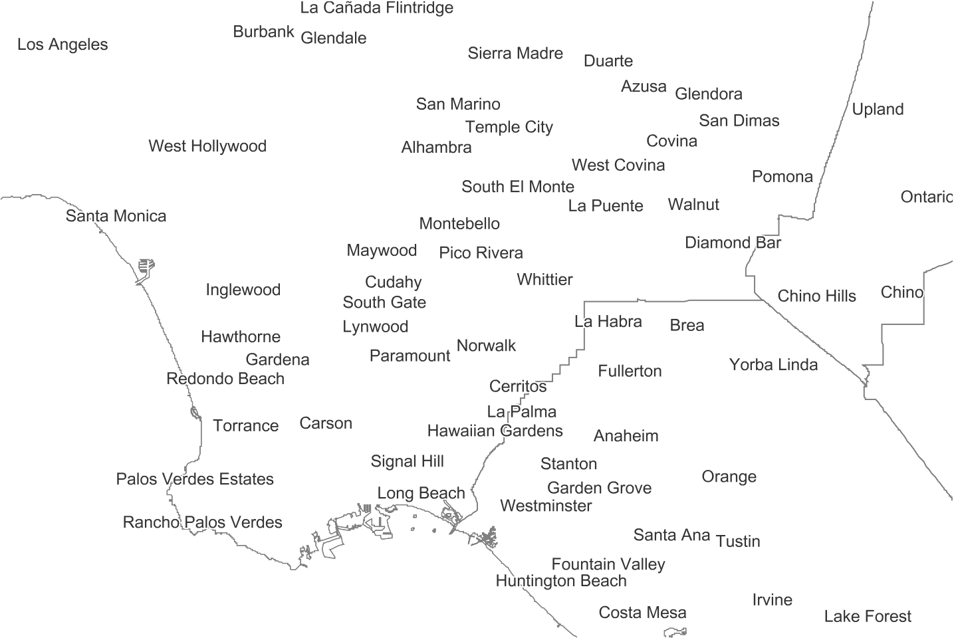
Sources: Esri, USGS, NOAA | US Census Bereau and E…

LLow-income Census Tract With More TThan 400 PG&E, SCE, or SDG&E
MMultifamily Accounts That Intersect
NNEM System Size AC Per 1,000 People
PPer ZIPP Code is Less Than or Equal to 50
NNEM System Size AC Per 1,000 People
PPer ZIPP Code is Less Than or Equal to 50

Figure 12 and Figure 13 show low-income census tracts with the lowest number of installed kilowatts of rooftop photovoltaic system capacity per thousand people in investor-owned utility territories.
The average number of multifamily accounts per zip code (indicated by red triangles) is about 1,220. The average number of multifamily accounts per zip code in investor-owned electric utility areas (SCE, SDG&E, and PG&E) is about 660. Publicly owned electric utility data are not displayed. These maps include net-energy-metering (NEM) rooftop solar capacity installed in investor-owned utility service territories. This information can be used to identify high-priority areas for expanding rooftop solar access and tracking low-income customer adoption of rooftop solar. Increasing access to rooftop solar for low-income customers can reduce energy burden, especially in summer months, if energy use coincides with periods of sunshine or rooftop solar is combined with energy storage that can be discharged after the sun sets.

Source: California Distributed Generation Statistics; Energy Commission analysis based on CPUC historical data; U.S. Census Bureau 2010 census tract boundaries; 2011-2015 American Community Survey (ACS) 5-year estimates; Esri zip codes

Figure 13: Low-income Areas With Low Solar Capacity Per Capita, San Bernardino (2017)
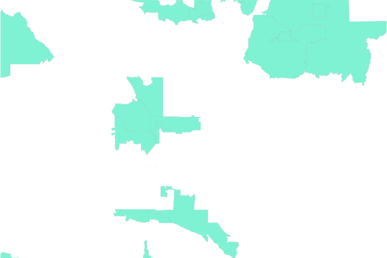
Sources: Esri, USGS, NOAA | US Census Bereau and E…

LLow-income Census Tract With More TThan 400 PG&E, SCE, or SDG&E
MMultifamily Accounts That Intersect
NNEM System Size AC Per 1,000 People
PPer ZIPP Code is Less Than or Equal to 50
NNEM System Size AC Per 1,000 People
PPer ZIPP Code is Less Than or Equal to 50

Figure 13 highlights low-income areas with low solar capacity per capita in the San Bernardino area, with red triangles noting areas with more than 400 multifamily accounts. This ﬁgure shows data for investor-owned utility service areas.

Source: California Distributed Generation Statistics; Energy Commission analysis based on CPUC historical data; U.S. Census Bureau 2010 census tract boundaries; 2011-2015 American Community

Survey (ACS) 5-year estimates; Esri zip codes

Figure 14: Self-Generation Incentive Program Opportunities for Further Investment
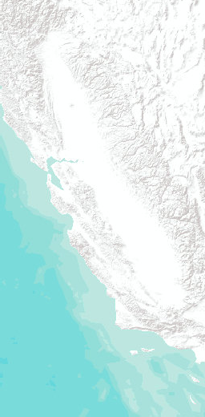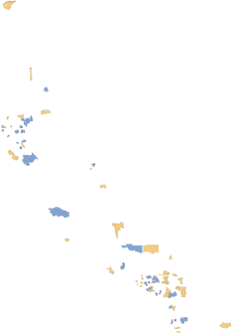
Sources: Esri, USGS, NOAA | CPUC | US Census Berea…

TTotal Expenditures Per 11,000000 People Per ZIP
CCode Less Than $435 ((Lowest 20%)) Per Census TTract
Does Not Intersect Census Tracts Where Median Household Income/Statewide Median Household Income (Less Than 60%)
Intersects Census Tracts Where Median Household Income/Statewide Median Household Income (Less Than 60%)
NNumber of Records Per 11,000000 People Per ZIP
CCode Less Than (Lowest 2200%) Per Census Tract
Does Not Intersect Census Tracts Where Median Household
Income/Statewide Median Household Income (Less Than 60%)
Intersects Census Tracts Where Median Household
Income/Statewide Median Household Income (Less Than 60%)
CCensus Tract Median HHousehold IIncome/Statewide
MMedian Household IIncome (Less Than 60%)

In addition to rooftop solar, other renewable self-generation technologies, including associated energy storage, are eligible for incentives in California. As directed by the CPUC, California’s investor- owned utilities have invested about $250 million in completed systems using the following self- generation technologies for businesses and homes: wind turbines; fuel cells, gas turbines, microturbines, and internal combustion engines using renewable fuels; and associated eligible energy storage systems. The statewide average investment per zip code per 1,000 people is about
$54,800, with the lowest 20 percent per 1,000 people receiving $435 or less per 1,000 people through April 17, 2018. In low-income areas, the average investment per 1,000 people is about
$21,400 during this period. Of the zip codes in investor-owned utility service territories with the lowest 20 percent of SGIP investments per 1,000 people per zip code, those zip codes in low-income areas are shown in Figure 14. These areas indicate opportunities to expand outreach and raise awareness of available renewable self-generation incentives for residential and commercial customers in California’s investor-owned utility service territories.

Source: California Self-Generation Incentive Program. https://www.selfgenca.com/; U.S. Census Bureau 2010 census tract boundaries; 2011-2015 American Community Survey (ACS) 5-year estimates

Figure 15: Opportunities Related to Electric Vehicles in San Diego
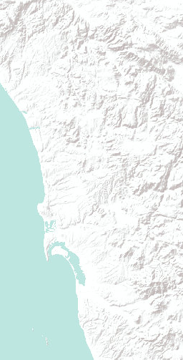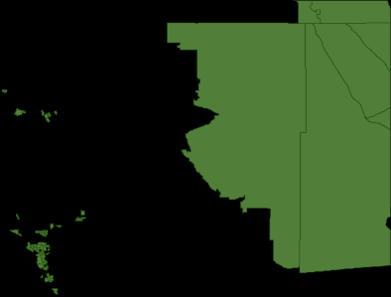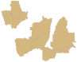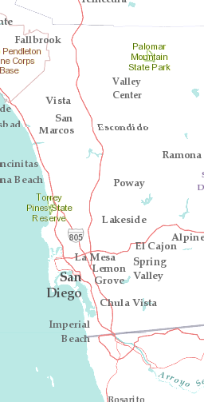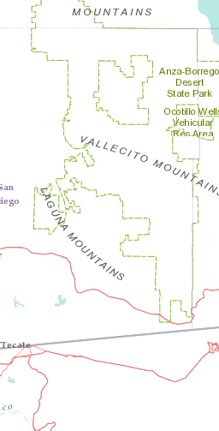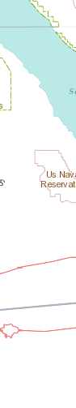
Sources: Esri, USGS, NOAA | Sources: Esri, Garmin, US…

EExisting Public EElectric VVehicle Charging
SStations
NNEM NNumber of
AAddresses Served Per ZZIP Code More Than
22,220000 (Highest 2200%), and IIntersects Personal EV
CCount per ZIP CCode
GGreater Than or Equal to 7700 (Highest 2200%)
CCensus Tract Median HHousehold IIncome/Statewide
MMedian Household IIncome (Less Than 60%)

As illustrated in Figure 15, areas of high electric vehicle (EV) EV counts per zip code coincide with areas of high net-energy metering (NEM) participation in San Diego, indicating rooftop generation during the day may be pulled from the grid at night to charge EVs. This suggests a potential opportunity for investment in distributed energy storage as rate structures move to reward midday energy use when rooftop solar generation is plentiful.
The areas with high NEM and high EV counts per zip code in this ﬁgure average more than 2,600 NEM addresses served per zip code. The NEM data are for investor-owned utility service territories.

Public charging stations in San Diego are available along major transportation corridors, providing important infrastructure to encourage growth of electric vehicle (EV) transportation ownership and car-sharing options across highly populated areas of the region, including low-income areas along these corridors. Expansion of transportation electriﬁcation may provide signiﬁcant non-energy beneﬁts for disadvantaged communities near these corridors due to a reduction in associated localized air pollutants. Car-sharing programs and other clean transportation options may have the added beneﬁt of reducing parking effects from employees of local businesses in the region.

Sources: Energy Commission staff analysis; Department of Motor Vehicles; California Distributed Generation Statistics; U.S. Census Bureau 2010 census tract boundaries; 2011-2015 American Community Survey (ACS) 5-year estimates; Esri zip codes

Figure 16: Number of Cumulative Plug-in Electric Vehicle Sales as of 2016 by County
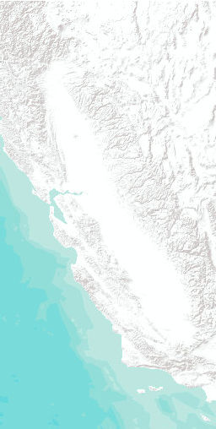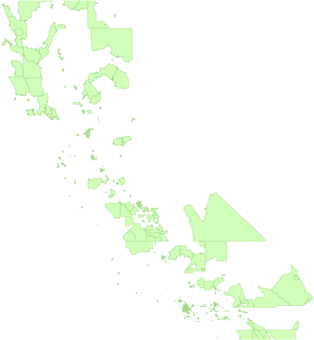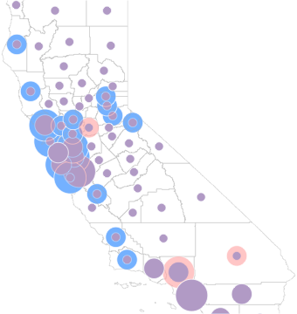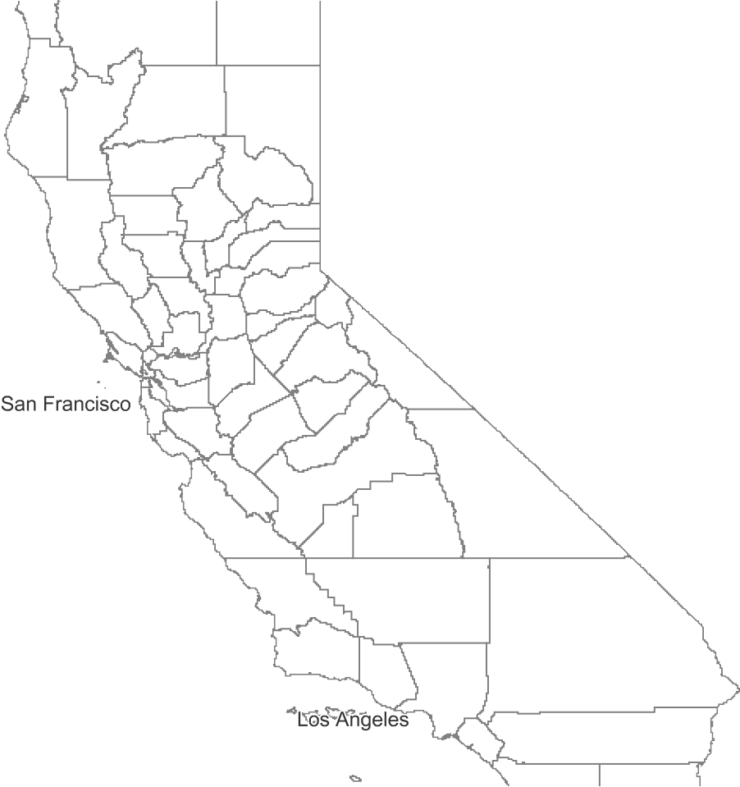
Sources: Esri, USGS, NOAA | US Census Bereau and E…

NNumber of PEVs Per CCounty
Number of PEV 2016

> 7,681 – 34,098

> 1,593 – 7,681
1 – 1,593
PPercent PPEV by
PPopulation PPer County PEV_by_Population_2016_Pct
> 0.36 – 0.71

> 0.16 – 0.36
0.01 – 0.16
CCensus Tract Median HHousehold IIncome/Statewide
MMedian Household IIncome (Less Than 60%)

Figure 16 shows the number of plug-in EV sales in 2016 aggregated, or assembled, at the county level, including both total number of sales and levelized by population. The average number of plug- in EVs per county in 2016 was about 2,020. The average percentage of plug-in EVs per person by county in 2016 was about 19 percent. The indicators are placed in the center of each county but represent data for the whole county. The number and percentage of EV ownership are lower in the Central Valley than in other parts of the state, suggesting an opportunity for programs to focus on this region to provide greater access to EVs, and supporting charging infrastructure, through

ownership or car-sharing incentives.

Source: Department of Motor Vehicles; U.S. Census Bureau 2010 census tract boundaries; 2011-2015 American Community Survey (ACS) 5-year estimates. Semicircles are placed in the center of each county but represent data for the whole county

Figure 17: Clean Vehicle Rebate Program Incentive Opportunities in Low-income Areas
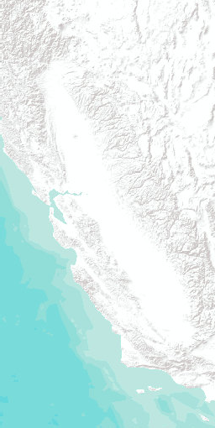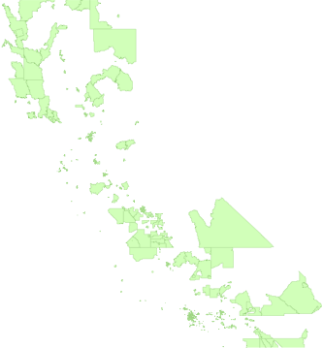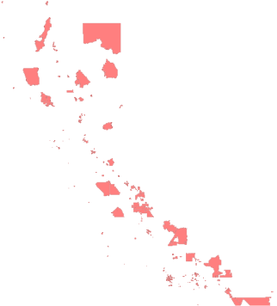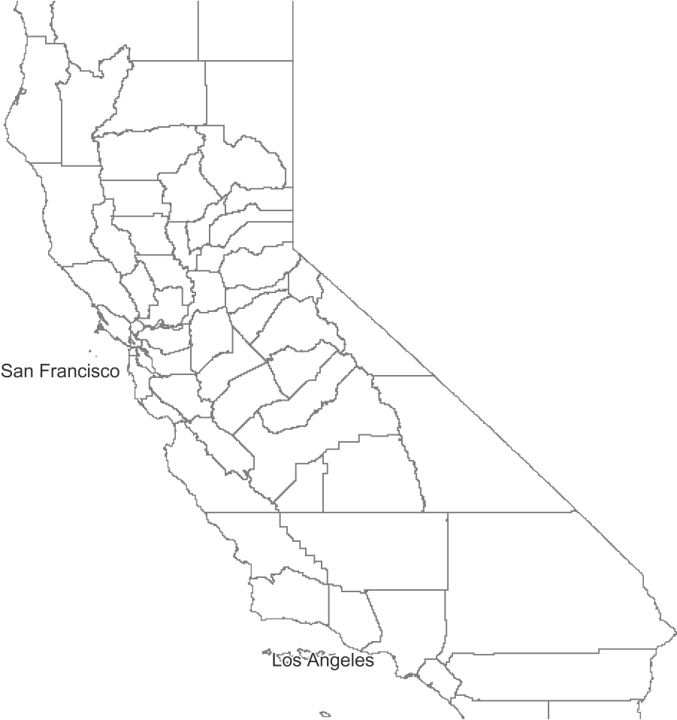
Sources: Esri, USGS, NOAA | US Census Bereau and E…

CCVRP Lowest 20% Rebate Dollars /
PPopulation on Census Tracts Where
MMedian Household Income/Statewide MMedian Household Income (Less Than 6600%)
CCensus Tract Median Household IIncome/Statewide Median Household IIncome (Less Than 60%)

Incentives have been a key driver of growing EV sales and adoption. Over the ﬁrst ﬁve years of the program, roughly three-quarters (>74 percent) of eligible vehicle purchases and leases received Clean Vehicle Rebate Program (CVRP) rebates. [12] This ﬁgure highlights low-income census tracts with the lowest uptake of CVRP funding, indicating opportunities for additional investment to

promote EV adoption in these communities. One example area is the Central Valley, which has low- income areas with low sales and low uptake in EV incentives.

As of March 2016, higher-income consumers became ineligible to participate in the CVRP, and low- to-moderate-income consumers became eligible for increased rebate amounts. [13] This approach may promote opportunities to increase access to clean transportation and associated air quality beneﬁts in low-income and disadvantaged communities. Similarly, the CVRP Public Fleet Rebate Program offers increased rebates for electric vehicle ﬂeets to public agencies in disadvantaged communities. The maximum rebate amount is $7,000 for fuel-cell EVs, $4,500 for battery or range- extended EVs, and $3,500 for plug-in hybrid EVs. [14]

Source: California Clean Vehicle Rebate Project; U.S. Census Bureau 2010 census tract boundaries; 2011-2015 American Community Survey (ACS) 5-year estimates

- Center for Sustainable Energy (2018). California Air Resources Board Clean Vehicle Rebate Project, Rebate Statistics. Data last updated April 11, 2018. Retrieved April 2018
from https://cleanvehiclerebate.org/eng/rebate-statistics.

- More information on CVRP income eligibility: https://cleanvehiclerebate.org/eng/income- eligibility

- For additional information, visit https://cleanvehiclerebate.org/eng/pfp.

Figure 18: ARFVTP Funds Invested of EV Infrastructure by County
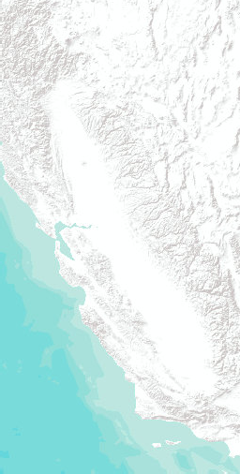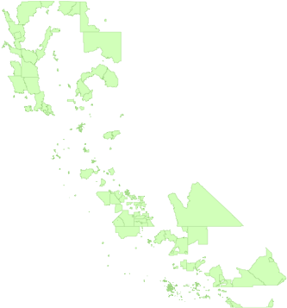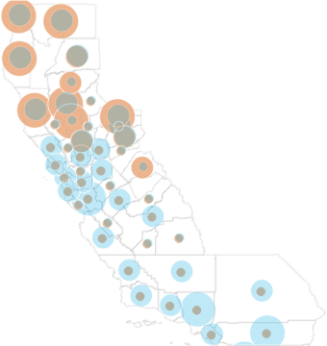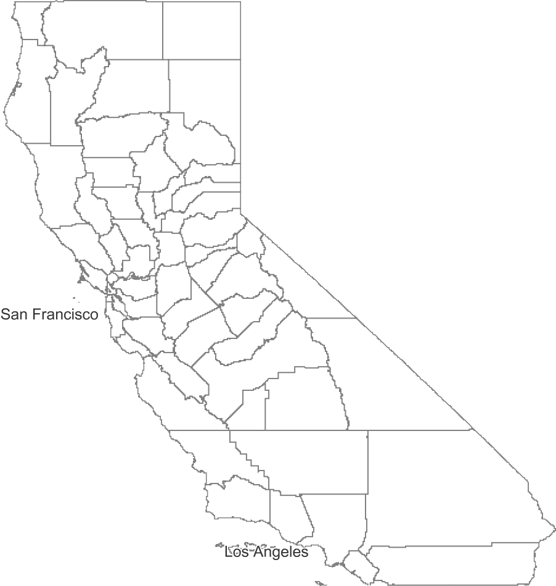
Sources: Esri, USGS, NOAA | US Census Bereau and E…

AARFVTP Funds Invested ((By County))
Estimate
> 2,500,000 –
10,000,000
> 500,000 –
2,500,000
0 – 500,000
AARFVTP Funds Invested PPer PPerson (By County)
Estimate_by_Pop2016

> 5.85 To 24.03

> 3.46 To 5.85
0.11 To 3.46
CCensus Tract Median HHousehold IIncome/Statewide
MMedian Household IIncome (Less Than 60%)

In January 2018, Governor Edmund G. Brown Jr. announced a new target of 5 million zero-emission vehicles (ZEVs) in California by 2030 and proposed a new ZEV initiative to provide $2.5 billion over eight years. [15] California uses a variety of strategies to expand access to clean transportation and to ensure adequate infrastructure is in place to support the growing number of EVs, including the CVRP described above.

Figure 18 shows the amount invested through one of these programs, the Alternative and

Renewable Fuel and Vehicle Technology Program (ARFVTP). This competitive grant program provides as much as $100 million each year for clean transportation projects. Through 2017, the program has invested more than $600 million for more than 540 clean transportation projects. The average investment per county is $1.3 million. The average investment per person per county is $4.

Source: California Energy Commission; U.S. Census Bureau. Semicircles are placed in the center of each county but represent data for the whole county

- See http://www.ebudget.ca.gov/2018-19/pdf/BudgetSummary/ClimateChange.pdf
and https://www.gov.ca.gov/2018/01/26/governor-brown-takes-action-to-increase-zero-emission- vehicles-fund-new-climate-investments/.

Figure 19: Asthma-Related Emergency Room Visits by County (2015)
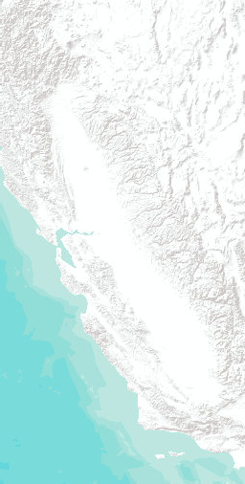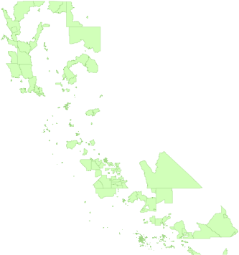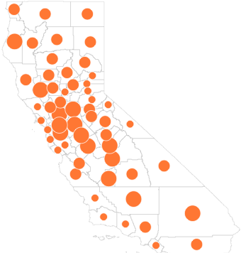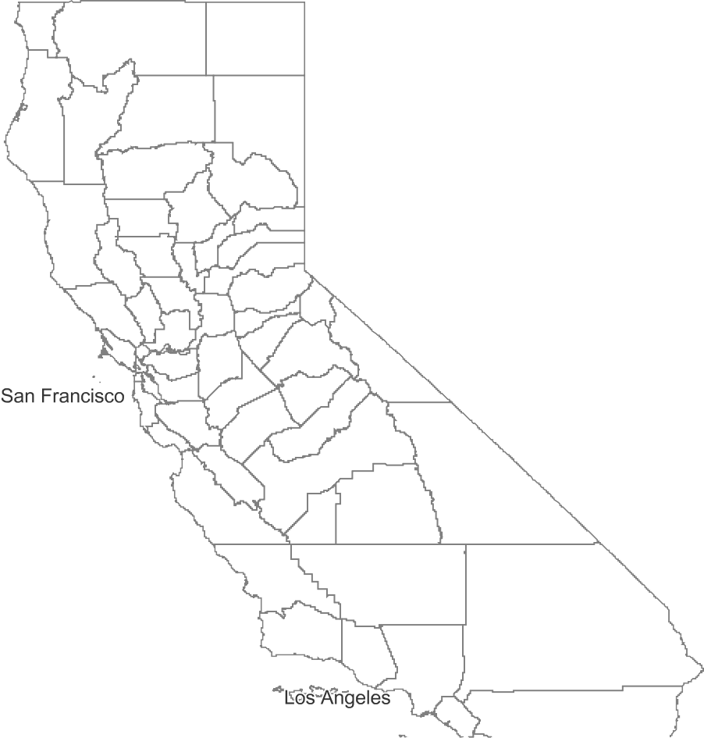
Sources: Esri, USGS, NOAA | US Census Bereau and E…

PPercent Emergency
DDepartment Visits DDue tto Astthma by 2015
PPopulation PPer County
Percent Asthma ER Visits
/ Population 2015
> 0.6 – 0.91
> 0.4 – 0.6
0 – 0.4
CCEDARS Total
EExpenditures per 1,000 PPeople PPer ZIPP Code is
LLess Than $5,000 ((Lowest 20%)) that iintersect 70% of
SStructures Built Before 11997799 Per Low-income
CCensus Tract
CCensus Tract Median HHousehold IIncome/Statewide
MMedian Household IIncome (Less Than 60%)

The Barriers Study recommended steps to heighten coordination among energy, housing, and other programs to address health and safety issues facing California’s low-income and disadvantaged communities. Two health and safety indicators were selected for this initial Tracking Progress report to help identify high-priority locations for energy-related actions to improve local resilience: asthma and heat-related illness.

Based on a 2016 study by Drehobl and Ross, the Barriers Study reported that high energy bills relative to income may drive low-income households to make do with insuﬃcient heating or cooling, which can increase the incidence of asthma, especially in children. [16] Figure 19 shows counties in California with a high number of emergency room visits for asthma in 2015, shown as large red circles. The average percent of ER visits due to asthma in 2015 was about 0.5 percent of ER visits per county population. This map also shows the counties with the lowest investment from investor- owned electric utility energy eﬃciency programs, as represented by the orange dashed areas.

Areas with poor air quality, such as the San Joaquin Air Basin in Central California, experience high numbers of asthma-related emergency room visits. Such areas may experience periods with little mixing of air between altitudes and serve as major traﬃc corridors for passenger vehicles and freight. A 2015 study supported by CARB reports asthma-related hospital visits are elevated in populations living near areas with high traﬃc-related air pollution. [17] This information is useful for targeting areas to implement clean vehicle and sustainable freight programs, as well as energy eﬃciency upgrades.

Source: California Environmental Health Tracking Program; CPUC – California Energy Data and Reporting System (CEDARS), U.S. Census Bureau; Esri zip codes. Circles are placed in the center of each county but represent data for the whole county

- Scavo, Jordan, Suzanne Korosec, Esteban Guerrero, Bill Pennington, and Pamela Doughman. 2016. Low-Income Barriers Study, Part A: Overcoming Barriers to Energy Eﬃciency and Renewables for Low-Income Customers and Small Business Contracting Opportunities in Disadvantaged Communities. California Energy Commission. Publication Number: CEC-300-2016-009-CMF, page 13. This statement is based on information provided in Drehobl, Ariel and Lauren Ross. 2016. Lifting the High Energy Burden in America’s Largest Cities: How Energy Eﬃciency Can Improve Low Income and Underserved Communities.

- Delﬁno, Ralph J., M.D., Ph.D., and Michael J. Kleeman, Ph.D., University of California, Irvine, University of California, Davis. April 7, 2015. Risk of Pediatric Asthma Morbidity From Multipollutant Exposures. Contract No. 10-319. California Air Resources Board Final report. https://www.arb.ca.gov
/research/apr/past/10-319.pdf.

Figure 20: Heat-Related Illness by County (2015)
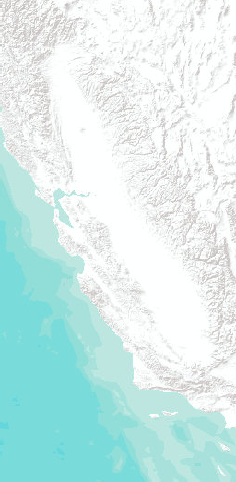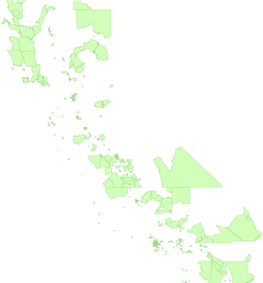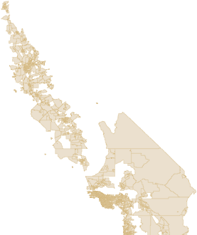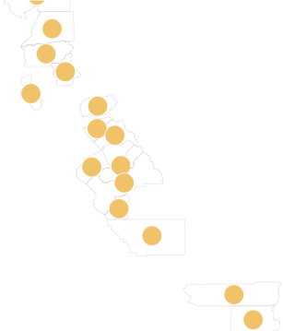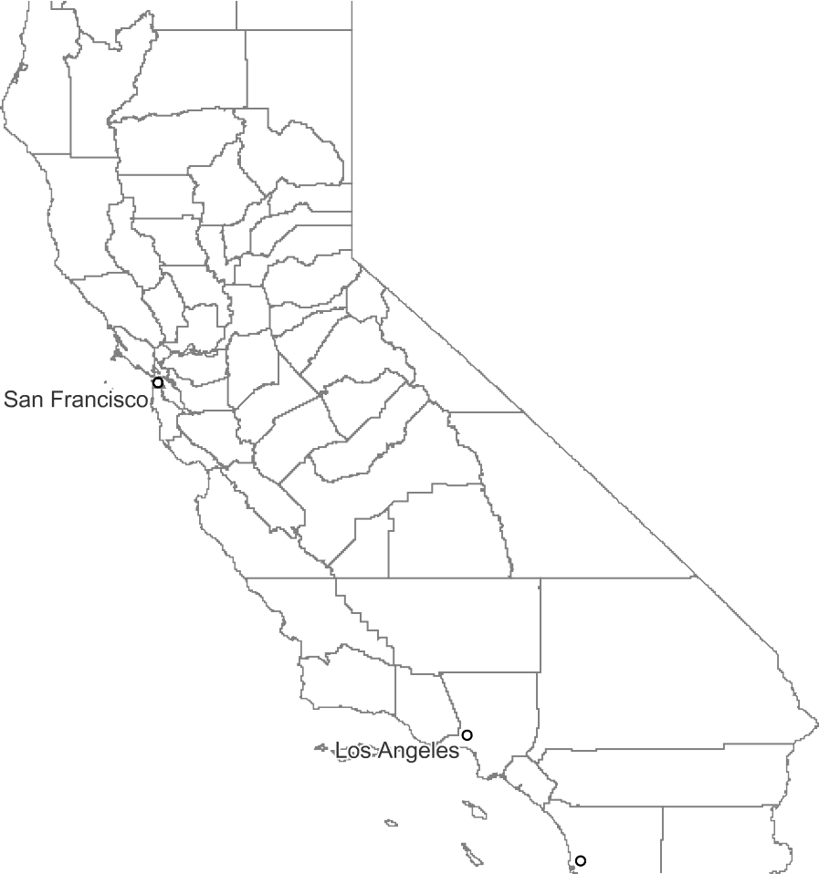
Sources: Esri, USGS, NOAA | US Census Bereau and E…

2255% California Counties WWith the Highest
NNumber of Emergency
RRoom Visits Due to Heat PPer 10,000 PPeople
Heat 2015 Crude Rate Per 10,000 People
21 – 79
AAdditional Cooling DDegree DDays Are At
LLeast 1,000 per Census TTract Expected per Year oon Average 2035-2064
CCensus Tract Median HHousehold IIncome/Statewide
MMedian Household IIncome (Less Than 60%)

Figure 20 shows potential opportunities in the Central Valley and Southern California deserts for energy eﬃciency investments to alleviate heat-related illness and improve the eﬃciency of space cooling. The number of emergency room visits due to heat was about 15 per 10,000 people on average statewide in 2015. This ﬁgure also shows areas expected to see more than 1,000 additional cooling degree days (average daily temperature minus 65 degrees) per year on average by midcentury (2035-2064) compared to 1961-1990 due to climate change.

Sources: California Environmental Health Tracking Program; CalAdapt; U.S. Census Bureau; Circles are placed in the center of each county but represent data for the whole county

Figure 21: PG&E Non-CARE Disconnections (2016)

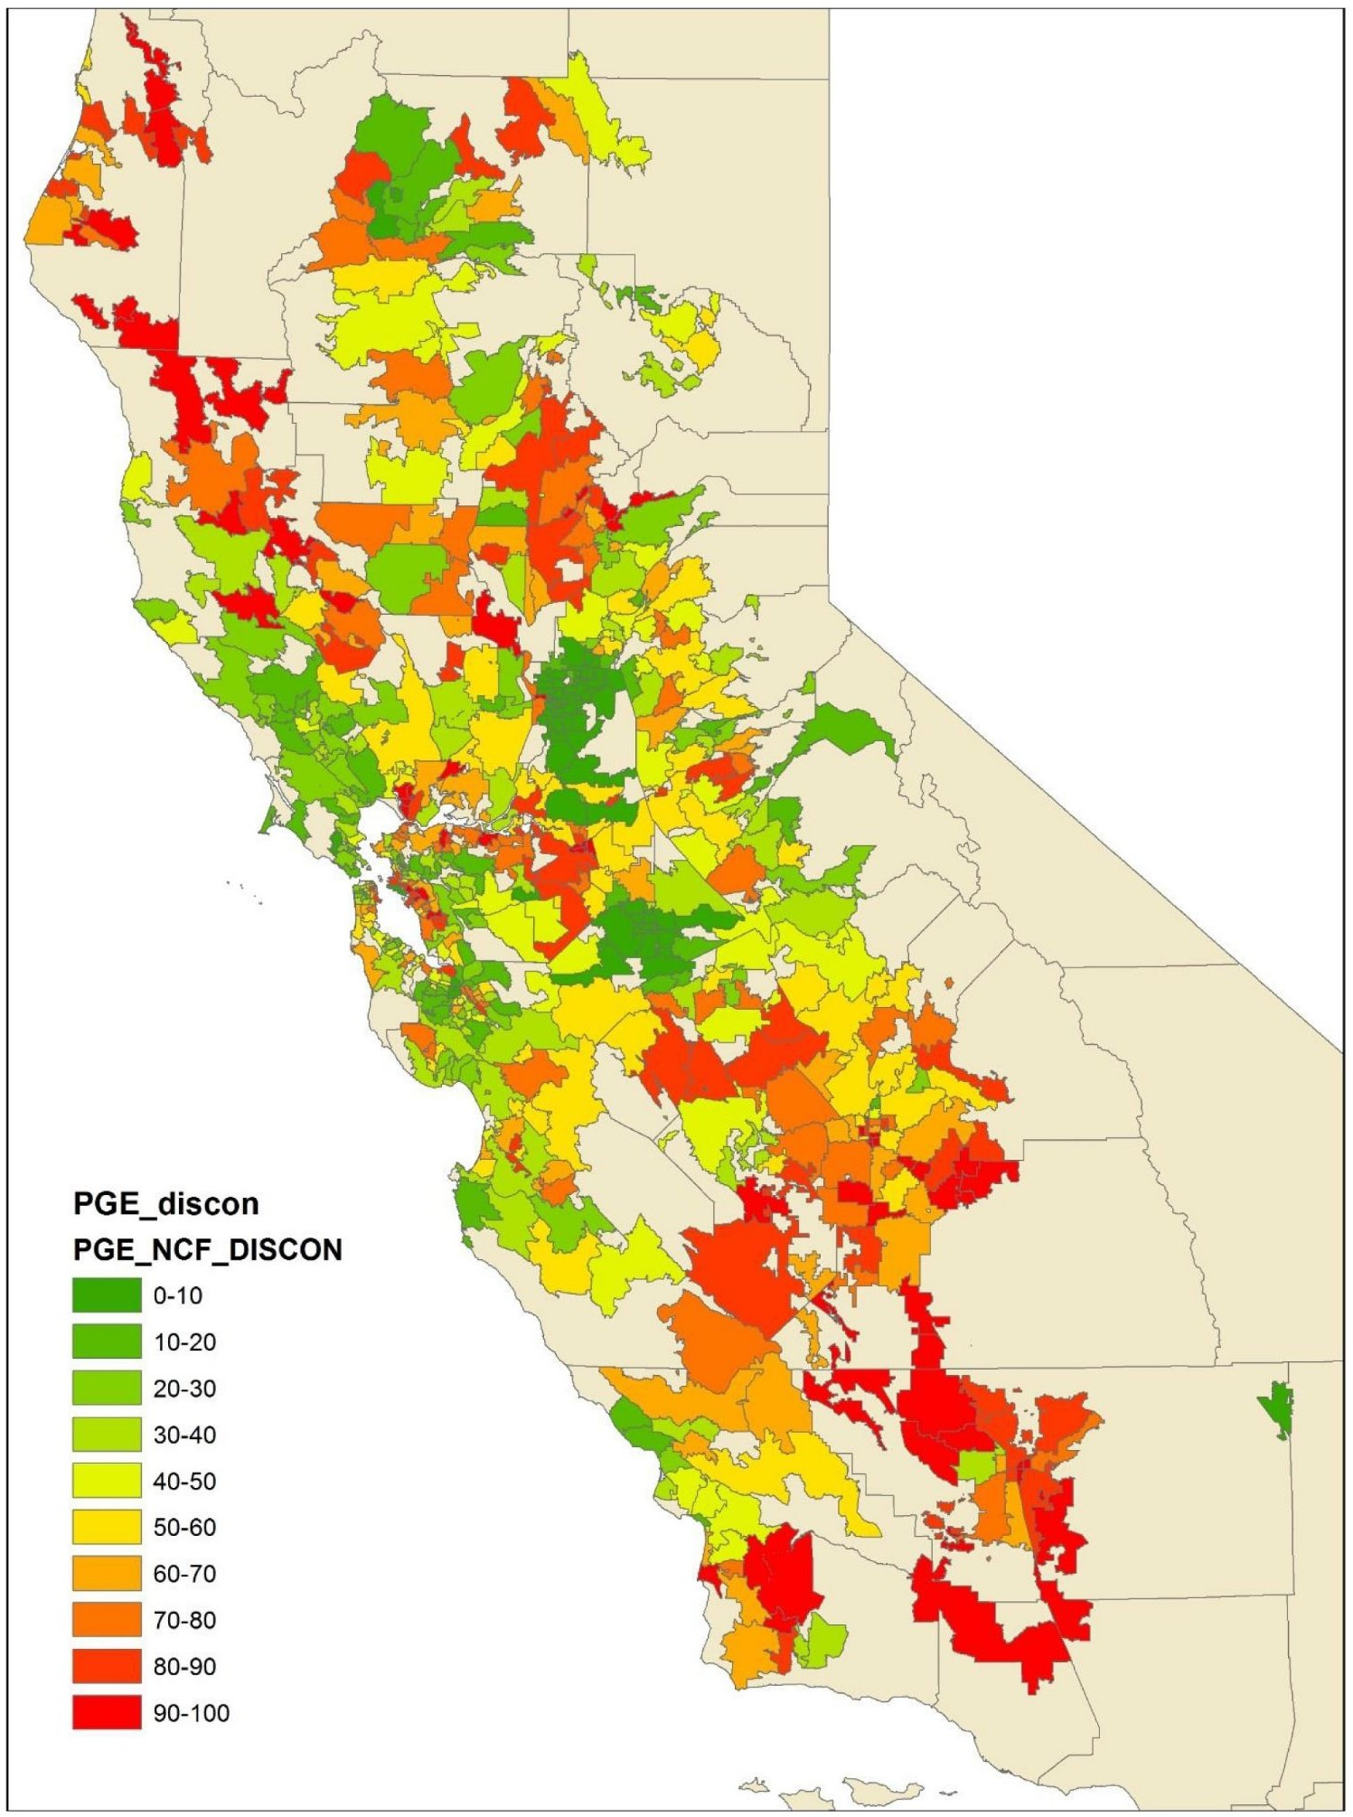

In addition to energy savings, energy eﬃciency can provide improved indoor comfort, increased property value, and reduced illness. The Barriers Study recommended greater coordination among state agencies to incorporate non-energy beneﬁts into energy eﬃciency program offerings. For example, a 2017 CPUC study on utility disconnections included maps showing non-CARE disconnections in 2016 by zip code for SCE, PG&E, SDG&E, and Southern California Gas Company (SoCalGas). [18] This ﬁgure shows the percentile of PG&E non-CARE disconnection rates. Many of the zip codes with the highest number of disconnections are in counties with high levels of heat-related illness in 2015, indicating an opportunity for targeted efforts to ensure disconnections are minimized during periods of extreme heat.
Source: CPUC

- White, Richard. December 28, 2017. A Review of Residential Customer Disconnection Inﬂuences and Trends. California Public Utilities Commission, Policy and Planning Division.
See http://www.cpuc.ca.gov.

Figure 22: System Average Interruption Duration Index for California Investor-Owned Electric Utilities Including Major Event Days (2007-2016)
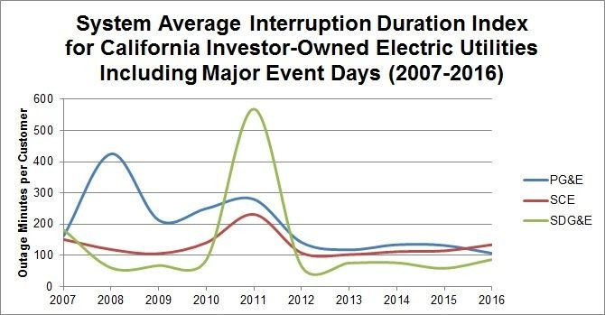
In 2008, PG&E service was affected by strong storms. In 2011, SCE and PG&E system outages were affected by storms, and SDG&E service was affected by the Paciﬁc Southwest electrical outage.
Electrical grid reliability and outages can have a signiﬁcant impact on the health and safety of customers, especially in regions affected by extreme heat and in need of cooling. More granular information is needed in updates to this report on the local reliability as it relates to low-income and

disadvantaged communities speciﬁcally. One impact of climate change is increased frequency and intensity of wildﬁres and severe weather.

Source: California Public Utilities Commission, Annual Electric Reliability Report, cpuc.ca.gov/2016_aers

Figure 23: Low-Income Areas Within Fire Threat
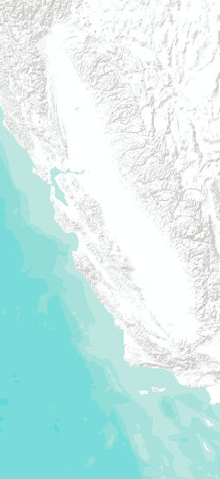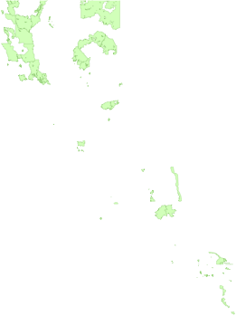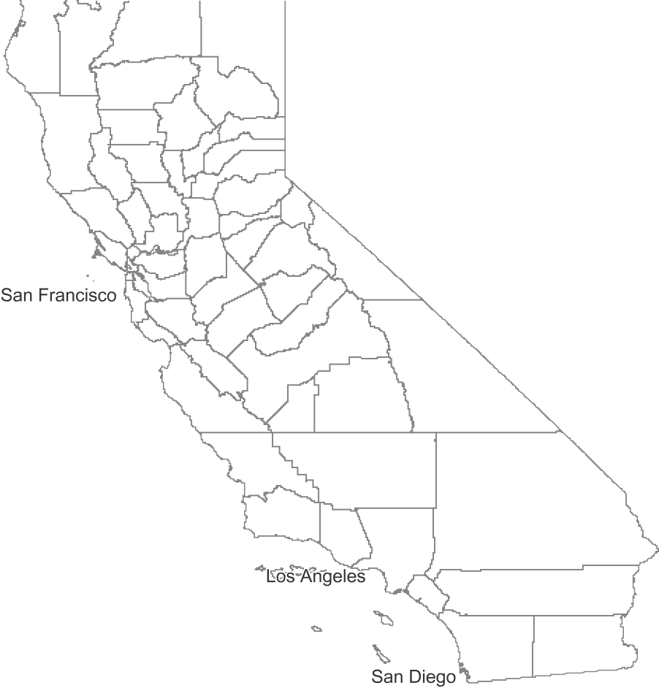
Sources: Esri, USGS, NOAA | US Census Bereau and E…
CCensus Tract Median Household Income/Statewide Median Household Income (Less TThan 60%) Within TTier 2 and 3 Fire TThreat Areas

Figure 23 shows the low-income areas of California that intersect Tier 2 or Tier 3 ﬁre-threat areas. Census tracts representing a total of 5.3 million people are in areas designated by the CPUC as Tier 2 or Tier 3 ﬁre-threat areas, or 13.7 percent of California’s population. About 6 percent of these census tracts are low income, representing a total of about 500,000 people. Population numbers were normalized by tract area within and outside ﬁre threat areas.

Source: CPUC Fire-Threat map; U.S. Census Bureau 2010 census tract boundaries; 2011-2015 American Community Survey (ACS) 5-year estimates

Figure 24: California Microgrid Development and Demonstration Projects (April 2018)
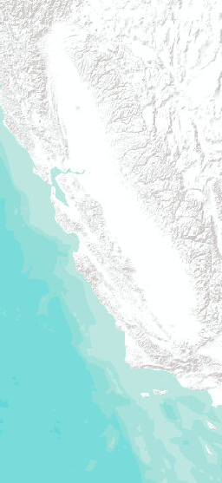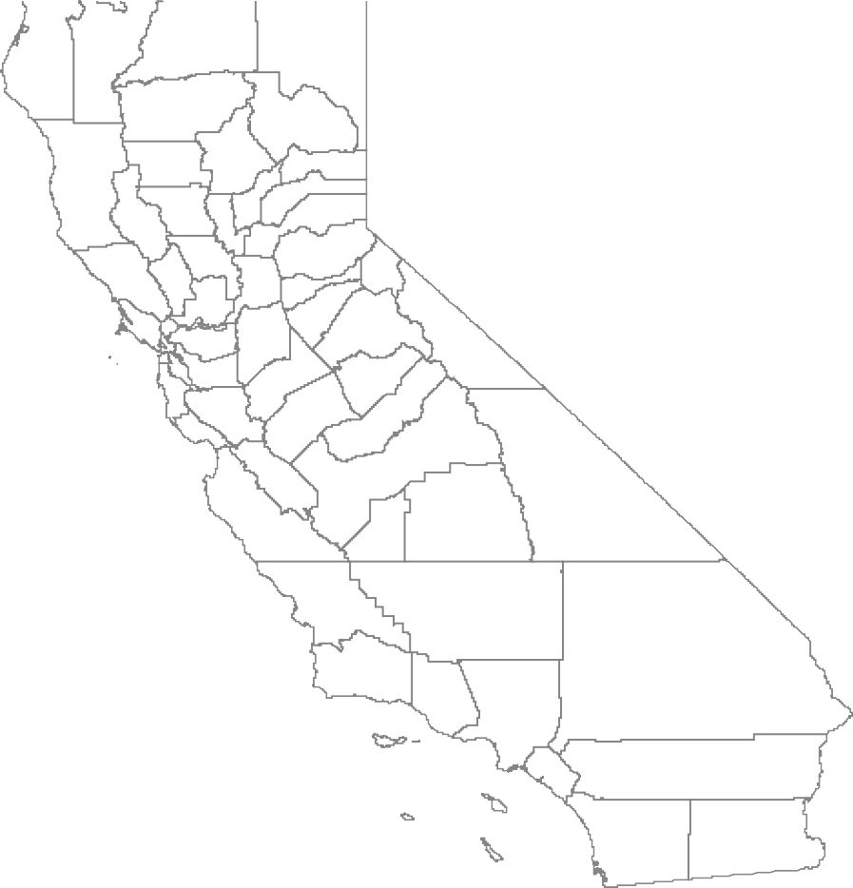
Sources: Esri, USGS, NOAA | US Census Bereau and E…

EEnergy Commission FFunded Microgrids - LLow-income and/or DDisadvantaged
CCommunity
EEnergy Commission FFunded Microgrid - OOther
WWorld Terrain Base World Terrain Base

Steps to strengthen the energy resilience of communities and supporting energy infrastructure, especially in low-income areas, are highlighted in the Safeguarding California Plan report, [19] as well as the 2017 Integrated Energy Policy Report (IEPR) [20] and other California climate adaptation reports. [21] In addition, the CPUC has set new ﬁre-safety standards, including de-energizing transmission and distribution lines under speciﬁed conditions to reduce the risk of ﬁre. The CPUC anticipates holding discussions of preferred options, potentially including energy storage or other energy infrastructure, to balance access to energy for water pumping, telecommunications, and other critical infrastructure with the need to reduce the risk of ﬁre.

This ﬁgure illustrates the locations of microgrids in California that have received funding from the

California Energy Commission to develop and demonstrate this innovative approach to energy resilience. Microgrids can be designed to maintain critical loads safely, even if the surrounding area is without electricity.

Source: California Energy Commission and CAL FIRE

- http://resources.ca.gov/wp-content/uploads/2018/01/CNRA-releases-2018-upate-to- Safeguarding-Report.pdf.

- http://www.energy.ca.gov/2017_energypolicy/.

- http://opr.ca.gov/clearinghouse/adaptation/. See also, http://www.opc.ca.gov/webmaster
/ftp/pdf/docs/rising-seas-in-california-an-update-on-sea-level-rise-science.pdf.

Figure 25: Microgrid Provided Resilience for Critical Facilities During the Blue Fire
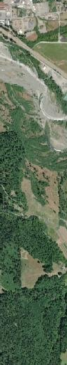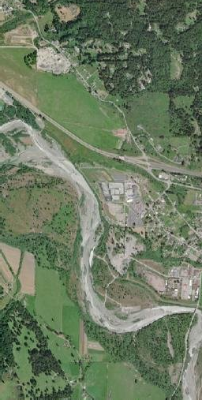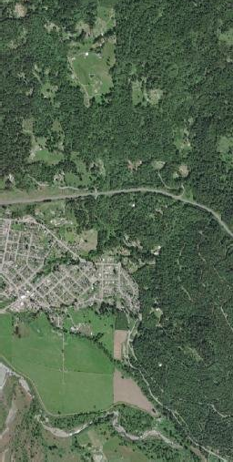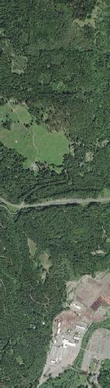
Maxar | BIA Paciﬁc Regional Oﬃce GIS staff. | The En…

BBlue Fire Location

EEnergy Commission FFunded Microgrid
HHospitals

CColleges and UUniversities
GGas Stations

PPrison_Boundaries

IIndian Rancheria LLocal_LLaw_Enforcement_LLocations

Figure 25 shows the location of a microgrid in a rural, forested area of Northern California that maintained power to critical facilities during a ﬁre-related outage. On October 8, 2017, a ﬁre started about a quarter-mile from the Blue Lake Microgrid. This caused the power to go out for about an hour and a half. Just under 1,900 customers were without power, according to PG&E. The microgrid detected the outage and islanded and kept the microgrid facilities, including a local emergency response center, from experiencing a blackout. No power was exported outside the microgrid. The

microgrid automatically reconnected to the grid when grid power was restored. This was all done automatically and transparently as part of the standard operation of the microgrid. The area is near a Tier 2 ﬁre threat area. The CPUC deﬁnes Tier 2 ﬁre threat areas as “areas where there is an elevated risk (including likelihood and potential impacts on people and property) from utility associated wildﬁres.” For more information, see http://www.cpuc.ca.gov/ﬁrethreatmaps/.

Source: Department of Homeland Security HiFLD, CAL FIRE, California Energy Commission

Figure 26: Opportunities to Increase Energy-Resilience of Critical Facilities
Sources: Esri, USGS, NOAA
Figure 26 highlights opportunities to increase resilience of energy infrastructure serving critical facilities, such as a low-income area of western Riverside County. Critical facilities shown on this map include microgrids, hospitals, gas stations, aircraft landing facilities, police stations, ﬁre stations, national shelter system facilities, colleges/universities, nonconﬁdential state-owned structures, prisons, and military bases. Western Riverside County includes areas subject to hot, dry Santa Ana winds in the fall. Under such conditions transmission and distribution lines may be de-energized for days at a time if necessary to reduce the risk of wildﬁre.

Source: Department of Homeland Security HiFLD, CAL FIRE, California Energy Commission

Figure 27: California Clean Energy Jobs by County (2015)
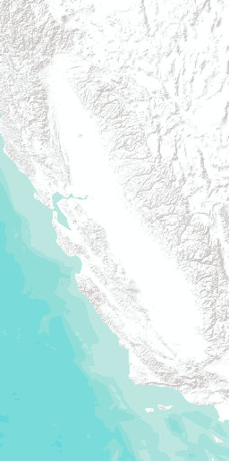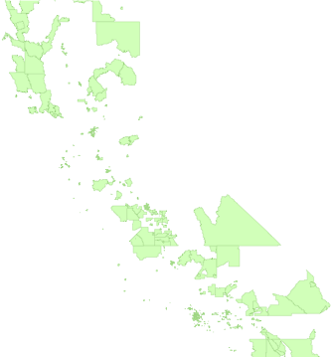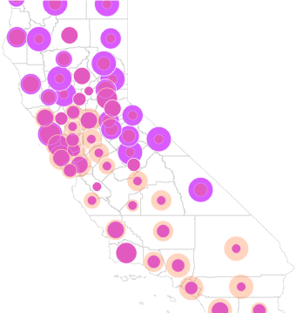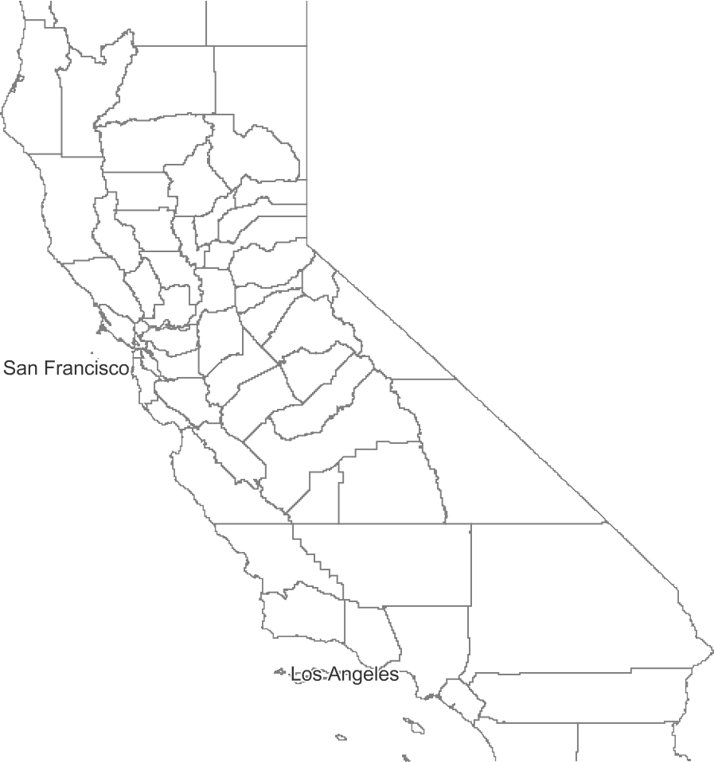
Sources: Esri, USGS, NOAA | US Census Bereau and E…

CClean Energy Jobs Per CCounty
Clean Energy Jobs 2016
> 10,767 – 114,292

> 3,353 – 10,767
> 1,624 – 3,353
> 697 – 1,624
20 – 697
PPercent Clean Energy JJobs by Population Per CCounty
Jobs_by_Population_Pct
> 2.32 – 5.2

> 1.85 – 2.32
> 1.38 – 1.85
> 0.91 – 1.38
0.62 – 0.91
CCensus Tract Median HHousehold IIncome/Statewide
MMedian Household IIncome (Less Than 60%)

Figure 27 shows statewide clean energy jobs in California by county for 2015. The average number of clean energy jobs per county in 2015 was about 8,750. Counties with a large number of clean energy jobs include Fresno and Tulare Counties. These two areas show that although there are many clean energy jobs available compared to surrounding counties, they have a low number of jobs compared to the size of the population in the area. This ﬁnding suggests a need for local hiring, job creating,

clean energy investment, and workforce development consistent with local priorities.

San Bernardino, Riverside, Sacramento, the San Francisco Bay Area, the Greater Los Angeles Area, and the San Joaquin Valley also have a large number of clean energy jobs. However, while the San Joaquin Valley scores well in terms of clean energy jobs, in 2015 it did not keep pace with other areas. As this is an area with many low-income and disadvantaged communities, this conclusion indicates an opportunity to invest in the local workforce through educational institutions and additional clean energy job opportunities.

Sources: Advanced Energy Economy Institute; U.S. Census Bureau. Semicircles are placed in the center of each county but represent data for the whole county

Figure 28: Percentage of California State Government Contract Dollars Awarded to Small Businesses and Microbusinesses: Annual Results (Fiscal Year 2009-2015)
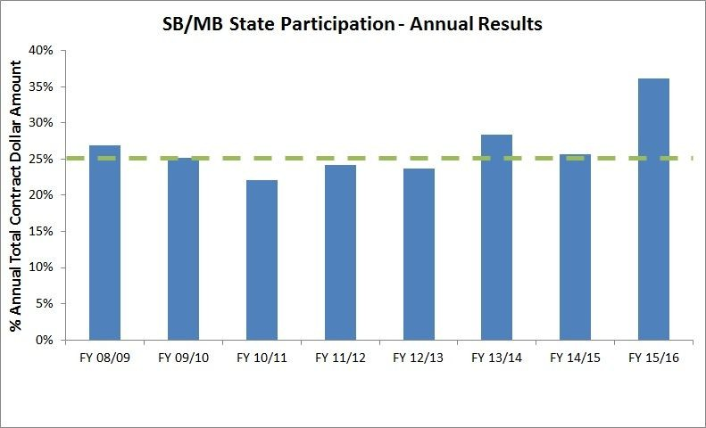
Small businesses in California can receive a certiﬁcation through the Department of General Services (DGS) to qualify for California’s Small Business Participation Program. This program has a goal that at least 25 percent of California state government contract dollars go to small businesses annually. As part of this program, small businesses are eligible for a 5 percent bid preference on applicable California state government solicitations. California state government has met the 25 percent minimum goal for small business participation for the past three ﬁscal years.

To help increase participation of small businesses in state government contracts, the
CaleProcure [24] website offers information and technical assistance with certiﬁcation, registration, and navigation of the online marketplace. In addition, the U.S. Small Business Administration, state government agencies, and local government agencies conduct numerous workshops each year to raise awareness and improve understanding of how to participate in government contracting procedures.

Source: Department of General Services

- https://caleprocure.ca.gov/pages/index.aspx

Figure 29: California Small and Microbusinesses in Low- income Areas
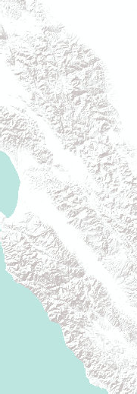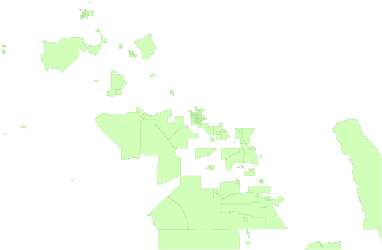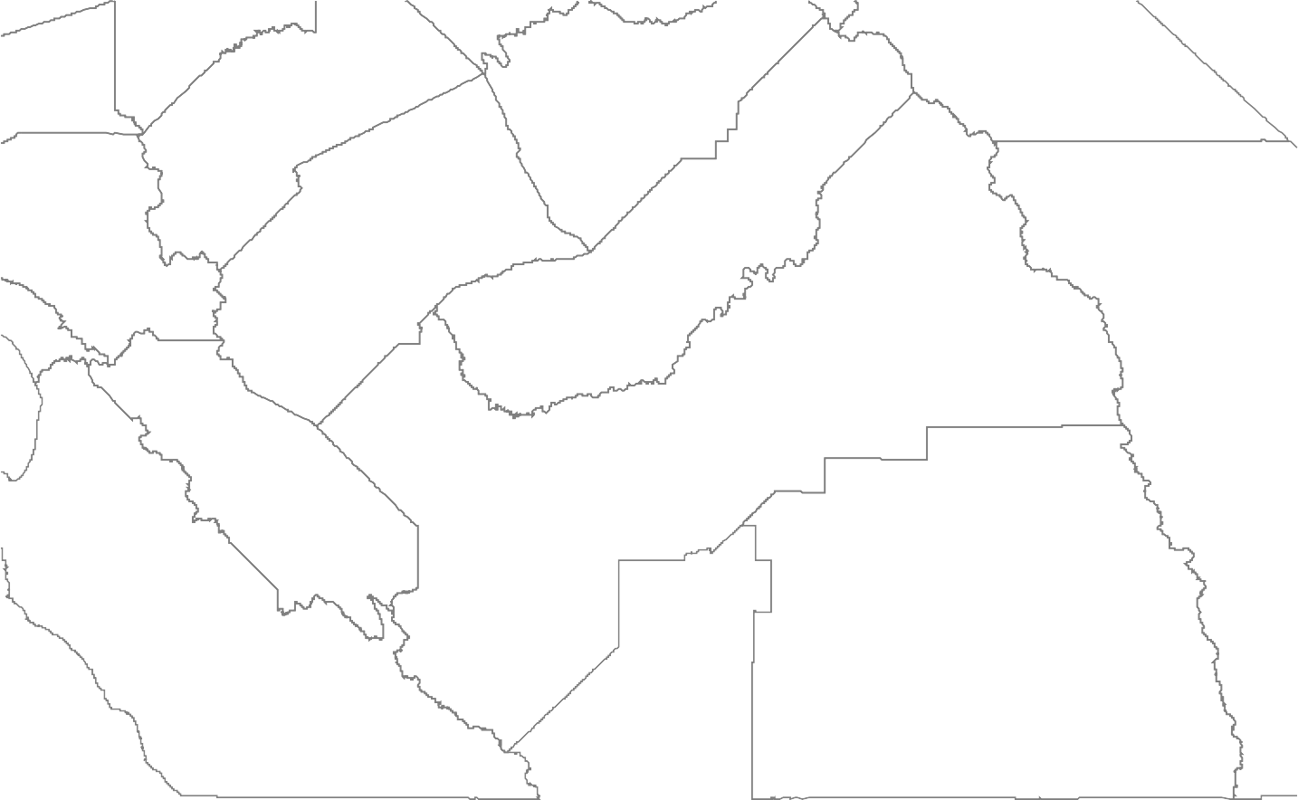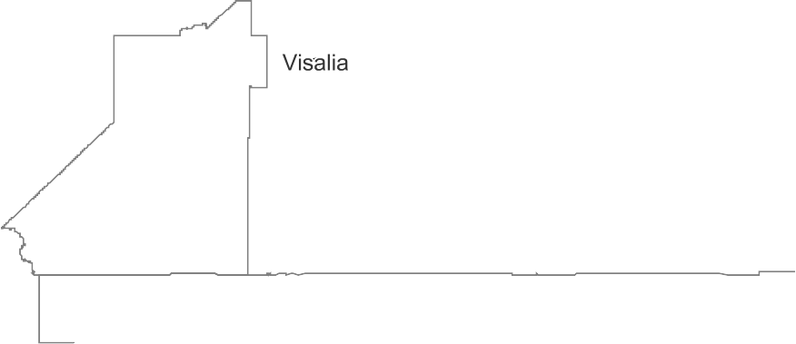
Sources: Esri, USGS, NOAA | US Census Bereau and E…

UUSDA Rural Service CCenter

SSmall Business ZIP Code CCenter Point within
CCensus Tract Median HHousehold IIncome/Statewide
MMedian Household IIncome (Less Than 60%) 3300 or Less Miles From
NNeaest USDA Rural SService Center
SSmall Business ZIP Code CCenter Point within
CCensus Tract Median HHousehold IIncome/Statewide
MMedian Household IIncome (Less Than 60%)
MMore Than 30 MMiles ffrom Nearest USDA
RRural Service Center
CCensus Tract Median HHousehold IIncome/Statewide
MMedian Household IIncome (Less Than 60%)

Figure 29 shows low-income zip codes containing clean energy small and microbusinesses, such as low-income areas of Fresno and surrounding areas. This map indicates locations that may beneﬁt from additional assistance through existing service centers (USDA rural development service centers are highlighted on this map) and locations where new pathways for assistance may be needed.

One of the recommendations of the Barriers Study called for further study to determine actions for increasing contracting opportunities for small businesses in low-income and disadvantaged communities. Results of that study will inform development of small business energy equity indicators.

For clean energy small businesses engaged in creating or developing innovative technologies, the Energy Commission’s Electric Program Investment Charge (EPIC) program offers competitive funding opportunities to help connect entrepreneurs with the resources needed to bring innovations to market. [25] Also, the U.S. Department of Energy offers competitive clean energy research funding for small businesses through the Small Business Innovation Research program and the Small Business Tech Transfer program. [26]

Source: U.S Department of Agriculture Service Center Locator; U.S. Census Bureau

- More information about EPIC funding opportunities available at http://www.energy.ca.gov
/contracts/epic.html.

- https://science.energy.gov/sbir/.

Figure 30: Energy Commission EPIC Technology Demonstration and Deployment Funding Through December 2017
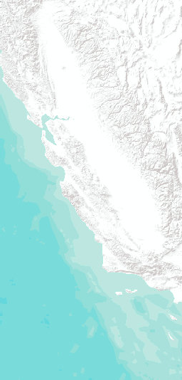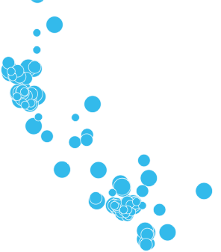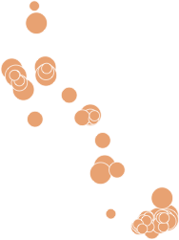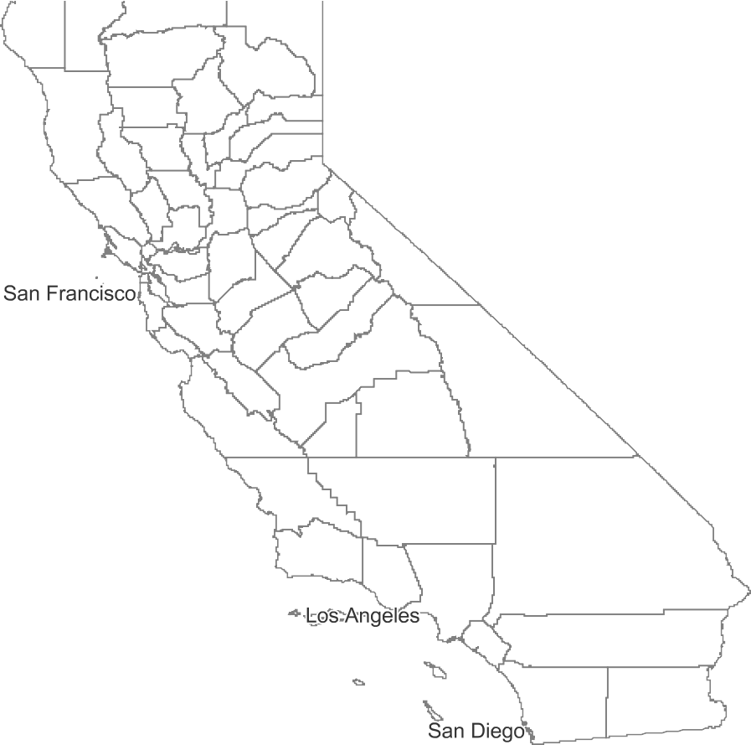
Sources: Esri, USGS, NOAA | BIA Paciﬁc Regional Oﬃc…

TTribal Land

AAllocated Funding to
SSites Per Census Tract
WWithin a Disadvantaged CCommunity
AAllocated Funding to
SSites Per Census Tract OOutside of a
DDisadvantaged CCommunity
Allocated Funding to Sites
CCensus Tract Median HHousehold IIncome/Statewide
MMedian Household IIncome (Less Than 60%)

Allocated Funding to Site
> 1,075,000 To
5,185,000
> 218,000 To
1,075,000
142,000 To 218,000
> 1,066,000 To
5,000,000
> 216,000 To
1,066,000
142,000 To 216,000

In October 2017, Assembly Bill 523 (Reyes, Chapter 551, Statutes of 2017) was signed into law. This law requires 25 percent of Energy Commission EPIC technology demonstration and deployment money to fund projects with sites located in, and beneﬁting, disadvantaged communities. In addition, 10 percent of these funds must be spent at sites located in, and beneﬁting, low-income communities, deﬁned as census tracts with median household incomes at or below 80 percent of the statewide median income or the applicable low-income threshold identiﬁed by the Department of Housing and Community Development.

This ﬁgure shows the amount of Energy Commission EPIC technology demonstration and deployment funding invested by census tract. The maps also show the location of disadvantaged communities, as well as low-income areas and tribal lands, to give an idea of the geographic and socioeconomic diversity of EPIC project awards and the progress toward maintaining the 25 percent goal and beyond.

As of December 31, 2017, $194 million was awarded for technology demonstration and deployment agreements. Of this amount, more than $61.7 million was allocated to project sites in disadvantaged communities. In 2018, the Energy Commission plans to continue expanding access to demonstration projects to meet the requirements of AB 523.

Source: Energy Commission; U.S. Census Bureau; Bureau of Indian Affairs Paciﬁc Regional Oﬃce 2017; CalEnviroScreen 3.0, 2017

Figure 31: Energy Commission EPIC Technology Demonstration and Deployment Funding Through December 2017, Los Angeles County
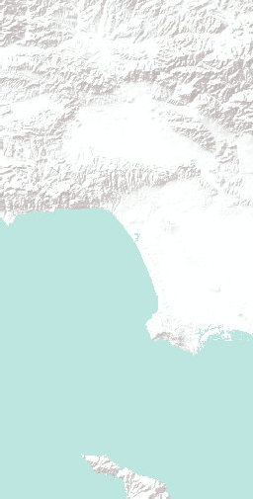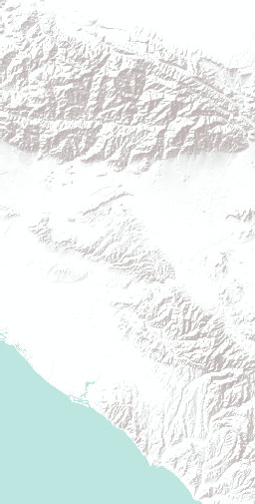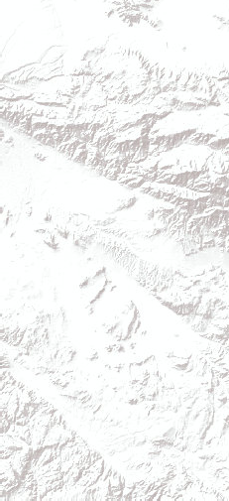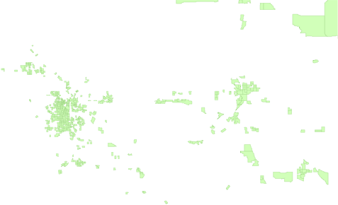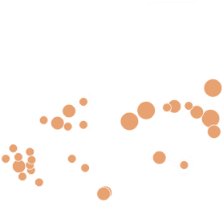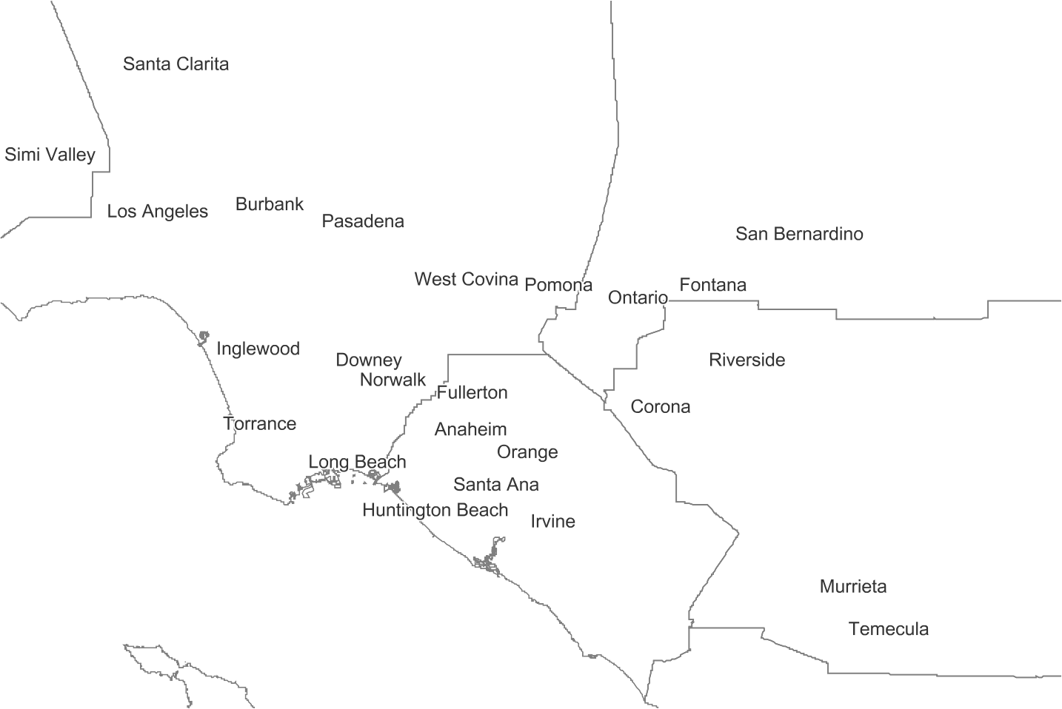
Sources: Esri, USGS, NOAA | BIA Paciﬁc Regional Oﬃc…

TTribal Land

AAllocated Funding to
SSites Per Census Tract
WWithin a Disadvantaged CCommunity
AAllocated Funding to
SSites Per Census Tract OOutside of a
DDisadvantaged CCommunity
Allocated Funding to Sites
CCensus Tract Median HHousehold IIncome/Statewide
MMedian Household IIncome (Less Than 60%)

Allocated Funding to Sites
> 1,075,000 To
5,185,000
> 218,000 To
1,075,000
142,000 To 218,000
> 1,066,000 To
5,000,000
> 216,000 To
1,066,000
142,000 To 216,000

Figure 31 shows the amount of Energy Commission EPIC technology demonstration and deployment funding invested by census tract, highlighting Los Angeles County and surrounding areas.

Source: California Energy Commission; U.S. Census Bureau; Bureau of Indian Affairs Paciﬁc Regional Oﬃce 2017; CalEnviroScreen 3.0, 2017

Figure 32: LADWP Consumer Rebate Program Fiscal Year 2015-2016
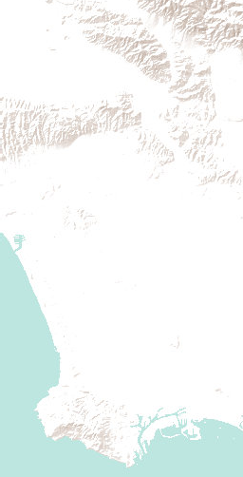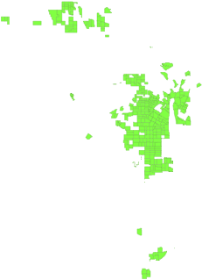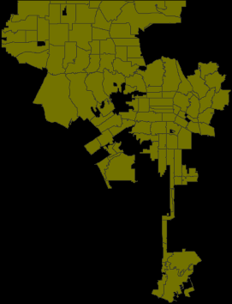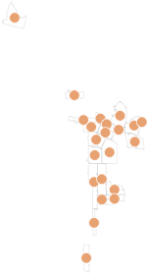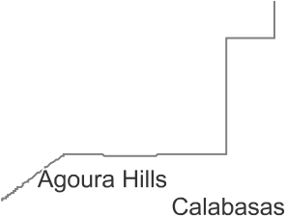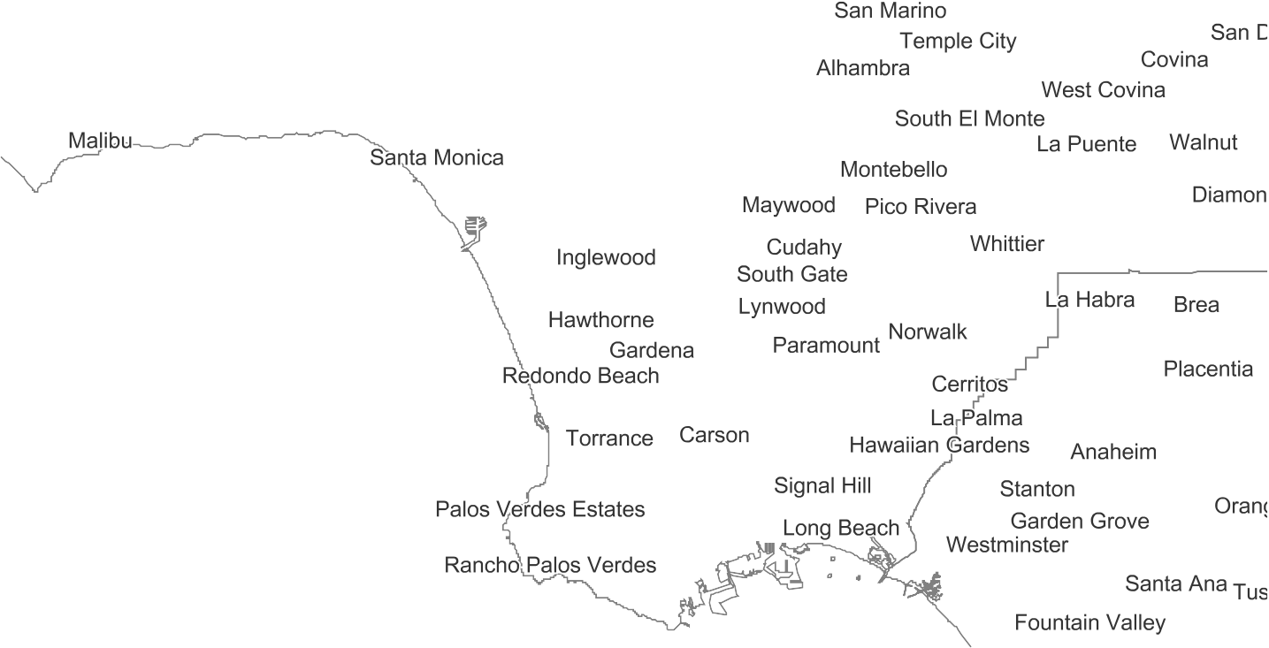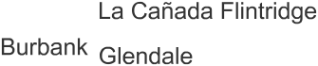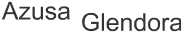
Sources: Esri, USGS, NOAA | US Census Bereau and E…

LLowest 20% of
CConsumer Rebate
PProgram PProjects PPer CCapita FY 2015-16 by
LLADWP Area ZIP Codes TThat Intersect Census
TTracts Where Median HHousehold IIncome/Statewide
MMedian Household IIncome (Less Than 60%) ((1,601 projects are not llocated)
Total Projects
Lowest 20% of Consumer Rebate Program Projects Per Capita FY 2015-16 by LADWP Area ZIP
Codes That Intersect Census Tracts Where
Median Household Income/Statewide Median Household Income (Less Than 60%) (1,601 projects are not located)
CConsumer Rebate
PProgram FY 2015-16

LLADWP Area Census
TTract Median Household IIncome/Statewide
MMedian Household IIncome (Less Than 60%)

Updates will include information on publicly owned electric utility energy equity indicators. LADWP is a leader in this area. For example, Figure 32 uses data from LADWP’s equity metrics data initiative to show the low-income areas with the lowest participation per capita (lowest 20 percent) in LADWP’s

residential energy eﬃciency rebate programs per zip code in 2015-2016. LADWP leverages data from its equity metrics data initiative to identify opportunities for investment and service improvements.
Additional information on LADWP’s equity metrics data initiative is available at www.ladwp.com/equitymetrics.

Source: Los Angeles Department of Water and Power Equity Metrics Data Initiative, U.S. Census Bureau

Next Steps and Additional References
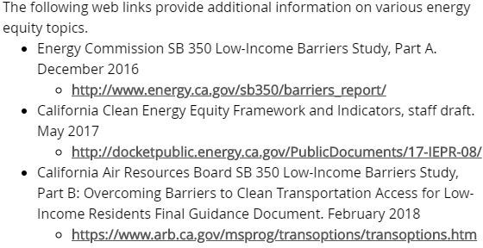

Work is underway to implement the recommendations described in the Barriers Study, facilitated by the Governor’s Oﬃce and representatives of key impacted agencies. As the recommendations are implemented, additional data may become available to support improvement of energy equity performance indicators and methods, as well as synergies with clean transportation access. Updates of this report will include these improvements.

