Industrial Systems Optimization Program (ISOP)

Implementation Plan
Pacific Gas & Electric Co.

December 2020
Version 2

Table of Contents

Program Budget and Savings 1
Implementation Plan Narrative 3
Supporting Documents 11

Program Budget and Savings

Program and/or Sub-Program Name
Industrial Systems Optimization Program (ISOP)

Program / Sub-Program ID number
PGE_Ind_003

Program / Sub-program Budget Table
Table 1 below shows the cumulative 3-year program budget.

Table 1. Program Budget
Administration | Marketing & Outreach | Direct Implementation |  |  | Total
 |  | Incentive | Non-Incentive | Performance Reserve
$1,151,867 | $764,656 | $6,114,685 | $4,887,596 | $2,398,128 | $15,316,931

Program / Sub-program Gross Impacts Table

Projected cumulative 3-year program savings impacts are shown in Table 2 below. Actual savings are subject to change.

Table 2. Program Gross Impacts
Electric Energy Savings  (kWh) | Electric Demand Savings  (kW) | Natural Gas Savings  (Therms)
30,500,000 | 4,700 | 3,000,000

Program / Sub-Program Cost Effectiveness (TRC)
Total Resource Benefit-Cost Ratio (TRCRatio): 1.31
Total Resource Benefit-Cost Ratio, minus program costs (TRCRatioNoAdmin): 3.10

Program / Sub-Program Cost Effectiveness (PAC)
Program Administrator Benefit-Cost Ratio (PAC): 1.32

Type of Program / Sub-Program Implementer
Third party-delivered

Market Sector(s)
Industrial

Specifically, ISOP serves the following North American Industry Classification System (NAICS) codes:
  - NAICS 31-33: Manufacturing and Food Processing, and similar manufacturing and food industry facilities.
  - NAICS 493110: General Warehousing and Storage, and associated food industry-related warehousing and distribution facilities.
  - NAICS 493120: Refrigerated Warehousing and Storage, and associated food industry-related warehousing and distribution facilities

Program / Sub-program Type
Resource

Market Channel(s) and Intervention Strategies
ISOP uses the following market channel(s) and intervention strategies:
  - Channel: Downstream
  - Intervention Strategies: Incentives, Financing, and Technical Assistance

Implementation Plan

Program Description
ISOP is an opt-in, single-point-of contact (SPOC) program delivery model for industrial, manufacturing and food processing customers designed to significantly improve customer awareness, opportunity discovery, participation, influence on decision making, energy savings, cost effectiveness, and customer satisfaction.

ISOP focuses on training, retro-commissioning, and capital projects with systems-level optimization via the following features:
  - Training Initiated Engagement (TIE): ISOP engages key facility operations personnel with high-quality energy efficiency training on systems and opportunities relevant to their plants, delivered by Cascade’s industrial manufacturing and food processing experts in an interactive format.
  - Energy Coach: ISOP assigns a long-term Energy Coach to each customer to simplify participation and establish a trusting relationship that supports new project identification, development, and implementation.
  - Multiple Tracks: ISOP offers customers who opt in two tracks to increase program accessibility:
    - A standard track offering more traditional a la carte energy efficiency services. The standard track includes regular Energy Coach touchpoints and technical support to identify and implement projects.
    - An enhanced track offering services designed around long-term energy management principles. The enhanced track includes energy management coaching, energy management and collaboration software, and ongoing Energy Coach support to drive projects.
  - Savings from Complex Systems and Processes: ISOP supports all relevant measure types but focuses on complex, interactive mechanical systems that yield interactive capital and behavioral, retro-commissioning, and operational (BRO) measures.
  - Incentives in Alignment with Program Objectives: ISOP offers a service and financial incentive structure designed to reduce market and customer barriers, scale with lifetime savings, and meet stated Pacific Gas & Electric (PG&E) objectives

ISOP objectives over the three-year program term include the following:
  - Generate cost-effective electricity and natural gas savings
  - Boost customer satisfaction, building customer energy-efficiency knowledge and commitment, reducing barriers to project implementation, and improving participation rates.
  - Improve Net-to-Gross (NTG) ratios by clearly documenting significant early project influence.
  - Improve cost-effectiveness by implementing more complex, comprehensive projects and sustaining savings of installed measures.
  - Create a strong project pipeline with engaged customers ready to act on opportunities.
  - Accelerate adoption of energy management principles and practices.
  - Support PG&E and the California Public Utilities Commission (CPUC) long-term energy-efficiency goals.

Program Delivery and Customer Services

Program Delivery
ISOP program delivery is accomplished by providing customers with valued training that builds trust and leads directly to projects. ISOP reaches customers through early and ongoing engagement with key influencers and decision-makers relevant to the industrial manufacturing and food processing segments.

Influencers include:
  - Industry associations
  - Vendors and contractors who serve the manufacturing and food processing sectors
  - Manufacturing and food processing sector peers
  - Facility and maintenance managers, and plant engineers

Decision-makers include:
  - For larger organizations with centralized administration, corporate executives within the operations ranks are typically decision-makers.
  - For organizations with local autonomy, a plant engineer or facility manager often makes the case for energy-efficiency projects to a general manager who consults with the Chief Financial Officer.

To engage customers and influence energy saving projects, ISOP offers segment-appropriate technical expertise and incorporates key energy efficiency strategies to identify potential projects, fully quantify savings and financial impacts for various alternatives, and help achieve customer buy-in. Customer eligibility is determined based on NAICS codes and other criteria as described in the ISOP Program Manual.

Services and Tools
Participating customers have access to some or all of the services listed in Table 3, depending on their level of commitment, facility characteristics, and program track.

Table 3. List of ISOP Customer Services
ISOP Service | Description
Energy Coach | Participants are assigned a single‐point‐of‐contact Energy Coach to facilitate the program process, provide energy coaching, and help each customer identify and advance energy‐saving projects. All Energy Coaches have strong interpersonal relationship and communication skills in addition to technical and industry-specific expertise, enabling them to build trusting, long-term relationships with customers.
Technical Training | ISOP offers Training Initiated Education early in a participant’s engagement. In-person or virtual TIE workshops are offered repeatedly and include invitees from multiple companies. Topics vary to be of interest to the market. Experts in industrial manufacturing and food processing systems and processes deliver TIE workshops, building trust with and helping activate customers.
On-Site Scoping Visit | ISOP can arrange for a technical expert to conduct an extensive scoping visit at interested high-potential sites to populate an opportunity register. During the scoping, the technical lead documents baseline and early program influence details.
Energy Management Coaching and Support | Participants pursuing the ISOP enhanced track receive energy coaching and energy management training. This coaching consists of a one-year site-level engagement during which the customer’s assigned Energy Coach and technical lead help implement the opportunity register of projects identified during scoping and subsequent treasure hunts.
SENSEI Energy Management and Collaboration Software | Active ISOP participants with high savings potential have access to SENSEI®—Cascade’s energy management and collaboration software—to build and implement a detailed opportunity register of BRO and custom projects, track ongoing normalized metered energy consumption (NMEC) performance, and provide regular energy-performance feedback. SENSEI® gathers energy data through Green Button Connect and production data through integration or upload and uses these and other factors to calculate and visualize energy savings over time.
Financial Incentives | ISOP offers multi-tier financial incentive structure designed to reduce market and customer barriers and scale with lifetime savings.
On-Bill Financing | Cash and non-cash incentives are complemented by on-bill financing – including On-Bill Financing (OBF) both with and without incentives – in alignment with PG&E’s Energy Efficiency Business Plan.

Program Design and Best Practices

Program Design
ISOP is designed to achieve deep, persistent, and long-lived savings, by leading with training, leveraging energy management coaching, and adopting energy management strategies that have proven effective in program delivery.

This program engages eligible energy users in manufacturing and food processing through a standard or enhanced track based on their preference and eligibility. Small- and medium-sized business customers across manufacturing and food processing segments are expected to participate via the standard track while large and/or highly engaged sites with significant energy savings opportunity and interest in initiating an ongoing program to capture deep savings are guided toward the enhanced track.

With a focus on complex mechanical systems such as refrigeration, compressed air, pumping, fans, blowers, boiler and steam systems, and the industrial processes they serve, ISOP supports all relevant measure types, including deemed and custom capital and BRO measures. While the program’s emphasis is on system, process, and controls optimization and associated upgrades, ISOP leverages all PG&E Energy Efficiency Platforms – deemed, custom, NMEC, and financing – to meet customer expectations and to quantify savings claims.

Thoughtfully structured, multi-tier incentives drive a wide variety of projects and deeper energy savings, in alignment with lifetime net energy savings. Additionally, ISOP helps participating customers scope and implement projects that capture known, relatively low-hanging forms of savings. OBF, both with and without incentives, is available as well.

Best Practices
ISOP is designed to overcome specific barriers to increased energy efficiency adoption within California’s industrial sector. For small and medium customers, in which projects are smaller and customer expertise is less specialized, existing vendor relationships and sales channels are key to cost-effective results. In addition to direct outreach, ISOP also leverages its existing network of vendors and trade allies to identify and develop projects that may benefit from an energy efficiency upgrade.

Mid-large industrial manufacturing and food processing customers value free, relevant technical assistance and often prefer getting value through incremental system optimization (BRO measures) before pursuing capital intensive energy efficiency projects. In response, ISOP targets this traditionally underserved segment (mid-large industrial manufacturing and food processing facilities without in-house, dedicated energy staff) and offers a long-term, highly competent single point of contact to simplify customer participation and identify, promote, and advance projects.

All but the largest manufacturing and food processing customers typically lack the resources to employ energy management staff, and thereby lack the knowledge and bandwidth to identify, quantify, and justify energy-efficiency measures. Even companies with energy-efficiency opportunities already identified are often short-staffed and unable to act on them. Manufacturing and food processing customers tend to maintain and repair older equipment for as long as possible, reducing the potential for energy-efficiency additions. ISOP offers deep, segment-appropriate technical expertise for new project identification and quality energy engineering services, energy studies, energy project management co-funding, and energy coaching to help customers of all sizes bridge the gap.

Larger manufacturing and food processing customers can struggle with layers of decision-makers with different motivations, and the internal capital allocation process can be highly competitive. Projects submitted for funding typically outstrip available budget by a factor of two- or three-to-one. Projects that increase production capacity or ensure ongoing compliance with regulation are typically selected over energy efficiency projects. For select customers, SENSEI® energy management and collaboration software makes energy information visible to staff and leaders within the organization to promote engagement around energy management. SENSEI provides access to actionable energy data, helps prioritize opportunities, ties actions to results and provides another means of documenting program influence.

ISOP takes a proactive approach to building relationships, fostering participation and influencing and supporting implementation. By deploying Energy Coaches experienced in the manufacturing and food processing industrial subsectors, ISOP builds strong relationships at the plant manager, maintenance manager and corporate energy manager levels. This simplified, single point of contact approach ensures a responsive and focused program interaction that helps build long-term customer relationships, increases project activity, and allows us to dig ever deeper into each site’s potential across multiple sub-systems and processes.

Seeking first to understand, building trust incrementally, becoming a trusted advisor, and consistently delivering on promises are best practices that enable a more effective program. For more information on barriers and strategies see the Program Theory of Change Diagram (Supporting Document 2).

Innovation
ISOP utilizes several innovations to technologies, marketing strategies, and program delivery to increase the uptake of cost-effective energy efficiency, improve program effectiveness, and increase customer participation (Table 4).

Table 4. Program Innovation Summary
Innovation | Innovation Type
 | Delivery Approach | Marketing Strategy | Technology
Long-term single point of contact to drive engagement and pipeline | ●
Energy management coaching to build awareness, facilitate long-term, ongoing engagement, build trust and influence and drive persistent savings | ●
Multiple tracks to increase program accessibility | ● | ●
Actionable energy data and influence documentation through SENSEI® | ● |  | ●
Creative, multi-tiered incentive options to drive deeper energy savings | ● | ●

Metrics
Table 5 summarizes the key performance indicators for assessing program performance.

Table 5. Key Performance Indicators
Category | Key Performance Indicator
Energy Savings | Annualized first-year net and gross energy savings (kW, kWh, Therms) for each calendar year, in addition to estimated net and gross lifecycle energy savings.
Cost Effectiveness | For gas and electric benefits: TRCRatio, TRCRatioNoAdmin, PAC, and Ratepayer Impact Measure (RIM Test)
Quality | Accuracy of savings estimates, deemed measure pass rate
Safety | Number of work-related injuries
Customer Outreach | Number of new customers contacted
Customer Engagement | Number of new and existing customers participating in TIE workshops or project scoping
Customer Satisfaction | Percent of positive customer surveys/ratings

To-Code Savings Design
To-code (and to-industry standard practice, or “to-ISP”) savings potential is widely prevalent in the industrial sector, particularly in facilities more than 20 years old where equipment is not past its useful life, but the specifications or applicability of codes have evolved. As a result, many industrial sites have grandfathered equipment and systems that continue to operate below code as long as they remain operable. Perversely, changes to any portion of these systems or equipment can trigger additional upgrades in order to come up to compliance with current code and standards. Hence it is common for customers in this situation to avoid bringing equipment to code as the costs outweigh benefits, and the incentive for bringing a system to code is not sufficient to accelerate turnover.

California Assembly Bill 802 and other policies have explicitly recognized and sought to capture this stranded potential, but the industrial sector continues to face unique challenges to cost-effective project scoping and implementation. To influence these potential projects, measures that capture to-code savings will be a key focus of ISOP and will be eligible for incentives and savings claims via NMEC, OBF without incentives, and custom methodologies:
- For sites using Site-Level NMEC and OBF (without incentive) methodologies to determine savings, to-code measures will be identified, listed in project-level reporting, and supported as applicable with documentation of existing equipment operability and program influence in accordance with PG&E and CPUC guidance and the ISOP Program-Level NMEC M&V Plan (Supporting Document 8).
- Similarly, where allowed by CPUC and PG&E policy guidance, ISOP may also implement to-code or to-ISP projects via the standard custom project review and approval process.

Pilots
Not applicable.

Workforce Education and Training
Not applicable.

Workforce Standards

HVAC Measures
Dedicated HVAC measures will be relatively limited, as ISOP focuses on industrial systems and process loads. However, for all projects and for each measure, installed, modified, or maintained in a nonresidential setting where the project is seeking an energy efficiency incentive of $3,000 or more, contractors must be licensed and certify that appropriate permits have been obtained.

Advanced Lighting Control Measures
Lighting and lighting control system installation measures are expected to be a very small portion of the measure types in the program. For all projects and for each measure installed in a non-residential setting where the project is seeking an energy efficiency incentive of $2,000 or more, workers and technicians involved in the project must certify completion of the California Advanced Lighting Controls Training Program.

Disadvantaged Worker Plan
ISOP is implemented by Cascade Energy as prime contractor; subcontractors may be recruited to assist with elements of program delivery. When working with subcontractors, Cascade will abide by PG&E’s Supply Chain Responsibility policy, including monthly reporting of expenditures to qualified Small Businesses Enterprises and Women, Minority, Disabled Veteran and Lesbian, Gay, Bisexual, and Transgender Business Enterprises.

Cascade recognizes that a diverse workforce and diverse supplier pool is a powerful tool for good business. While Cascade does not directly install, modify, repair, or maintain energy efficiency equipment, it is prepared to remain intentional and mindful in supporting strategies that are meant to provide Disadvantaged Workers improved access to career opportunities in the energy efficiency industry. Cascade has increased its efforts to proactively identify, build relationships with, and purchase goods and services from small and diverse businesses. Cascade’s activities include:
  - Analyzing company-wide spend-data comprehensively and in-detail to define and track Disadvantaged Business Enterprise (DBE) spend
  - Making a focused effort to increase the number of new DBE vendors
  - Delivering diversity, equity, and inclusion training specifically designed for Cascade leadership and human resources professionals, and employees at all levels in the organization
  - Developing a diverse applicant pool by reaching out to organizations that support, promote, and include women, people of color, veterans, and individuals with disabilities
  - Providing learning and development opportunities for employees to maximize their potential
  - Providing paid internship opportunities for diverse and/or disadvantaged high school students and college students

Additional Information
None.

Supporting Documents

Program Manuals and Program Rules
See the ISOP Program Manual for more information.

Program Theory and Program Logic Model
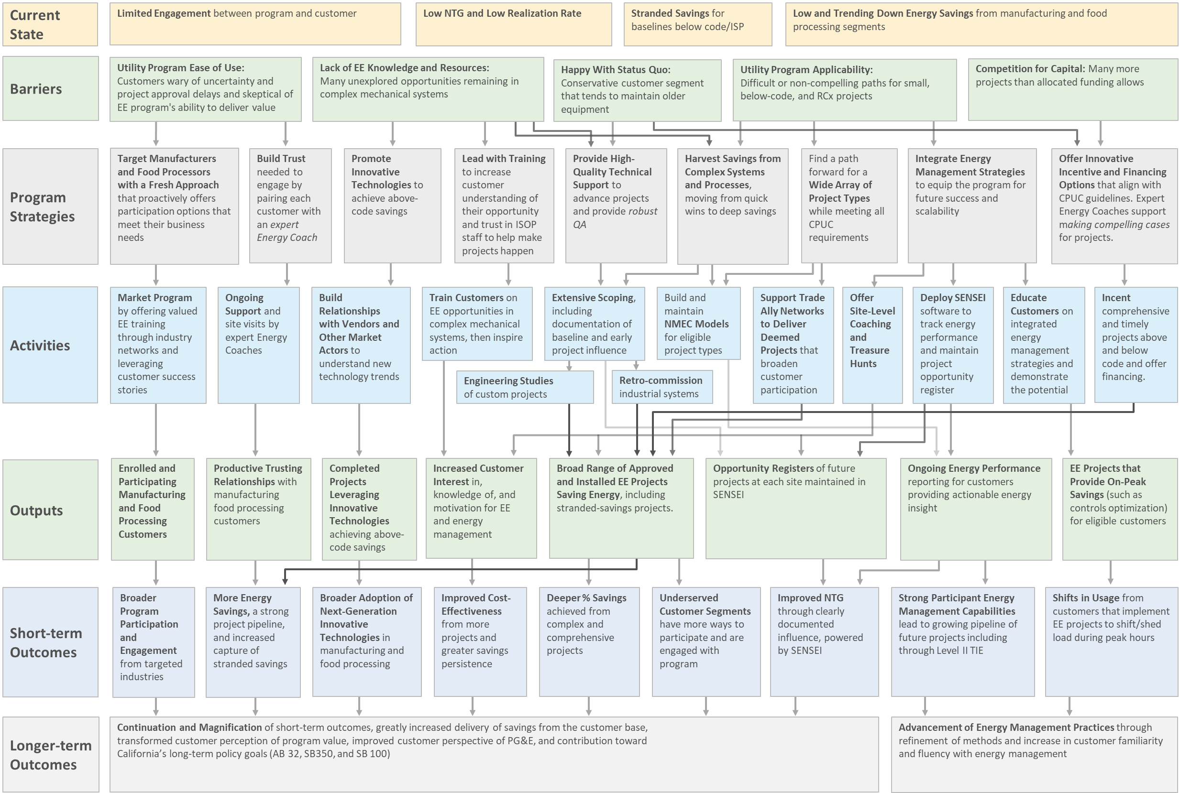

Process Flow Chart

Program Engagement

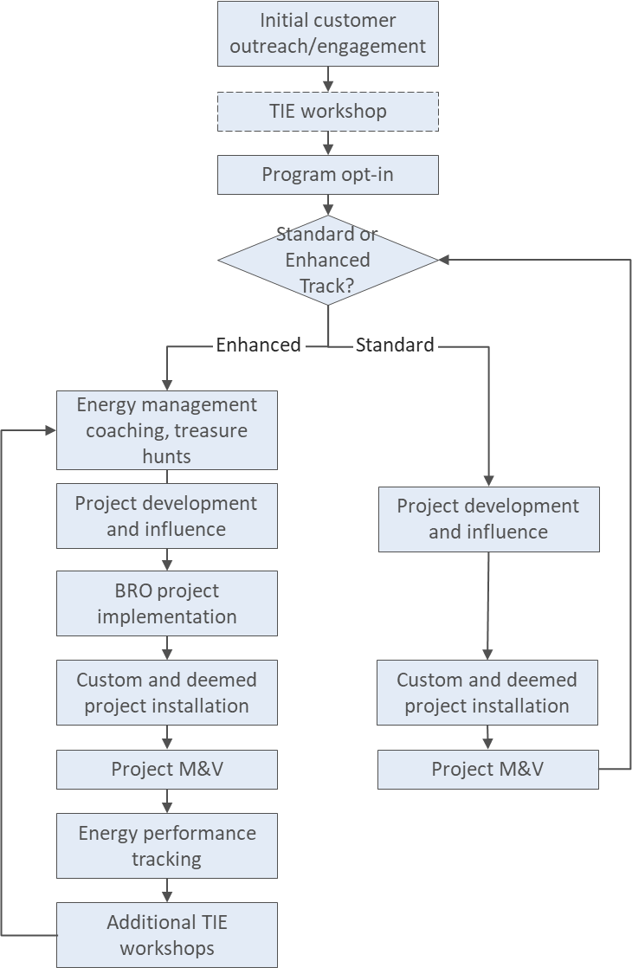

Project Implementation

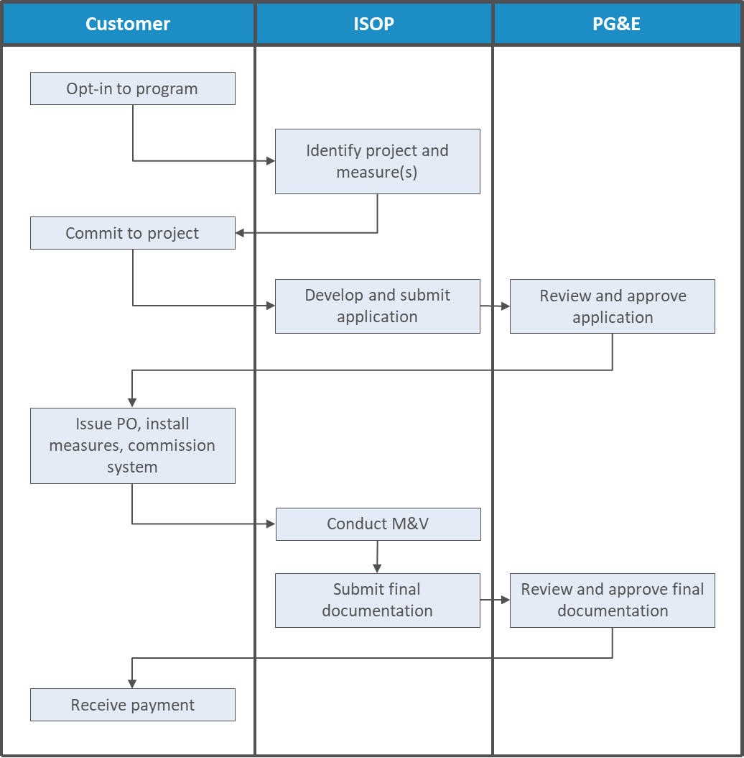

Incentive Tables, Workpapers, Software Tools
For Custom and NMEC projects, ISOP incentives are calculated as a function of electric and natural gas savings claims and align with CPUC guidance to align with net lifecycle savings, tailored to specific market barriers, and tied to performance to the extent practical.

Table 6. ISOP Base Incentive Levels
Incentive Tier | Project Type | Measurement Type | Measure Life (yrs) | Electric ($/kWh)* | Gas ($/therm)*
1 | BRO (Operational, RCx) | Custom | 2-3 | $0.06 | $0.75
2 | BRO (Operational, RCx) | NMEC | 3+ | $0.12 | $1.50
 | Add-On Equipment | Custom | 4-10
 | Accelerated Replacement | Custom | 4-10
3 | Normal Replacement/ Capacity Expansion | Custom | 11-20 | $0.20 | $2.50
* Base incentives for to-code custom projects are capped at 50% of those listed in Table 6.

Incentive adders may also be available for deep and persistent energy savings and strong program participation including, but not limited to the following:
  - Comprehensive projects with bundled measures
  - Prompt project completion
  - Adoption of emerging technologies
  - Enrollment of an Energy Program Manager

The total incentive with adders for a project is limited to 150% of the base incentive (Table 6). Rebates for deemed measures are aligned with PG&E rebate catalogs. For more information, see the ISOP Program Manual.

In addition to cash incentives, ISOP offers OBF, both with and without incentives. On-Bill Financing can drive energy-efficiency projects that do not meet a customer’s rate of return threshold with incentives or rebates alone, and the combination of OBF with incentives and rebates has the potential to accelerate projects with faster payback periods. OBF without incentives can encourage action on an array of measures where incentives are either not available, not compelling, or contingent upon a lengthy and uncertain review path that is disproportionate to the incentive dollars at stake.

Quantitative Program Targets
See Tables 1 and 2 above.

Diagram of Program
The following diagram summarizes how ISOP fits into PG&E’s customer programs portfolio and the broader statewide landscape, including connections with marketing and outreach, workforce training, emerging technologies, and Integrated Demand Side Management (IDSM) programs.

Figure 1. ISOP Program Diagram
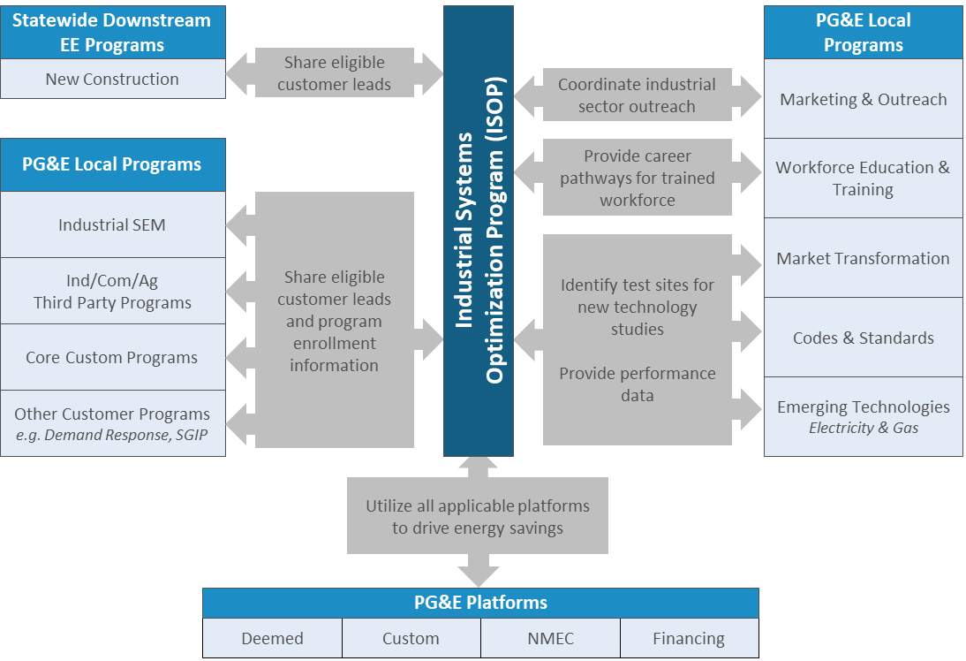

Evaluation, Measurement & Verification (EM&V)

Deemed Projects
ISOP supports all deemed measures for which the manufacturing and food processing customers served by the program are eligible. As new, applicable, and useful deemed measures become available, they will be incorporated into the program.

A random sample of completed deemed projects will be inspected and verified. Verification includes validating the equipment and installation, ensuring equipment is functioning as intended, documenting the installation with photos, and verifying that equipment specifications are consistent with the incentive application.

Custom Projects
ISOP embeds activities throughout the custom project lifecycle to support EM&V of attribution, baseline applicability, calculation methodologies and assumptions, and quality control. Pre-install and post-install activities will both be addressed by project-specific M&V plans.

Program engineers assess the applicability of requirements including Title 24 and documented Industry Standard Practices, as well as record copies of nameplates, dates of manufacture, and equipment age for all potential projects other than new construction. All project opportunities are screened for eligibility, viability, program influence, accuracy, measure application type (MAT), and baseline application before submittal to PG&E. All information on expected useful life (EUL), ISP and MAT will be compiled and included as part of the project documentation submittal to PG&E. Where required, new ISPs will be developed in line with PG&E guidance.

After implementation, program engineers will perform M&V to verify that the intended changes were made, and to measure and document the resulting energy and demand savings. The appropriate level of M&V rigor must be applied to each project based on expected quantity of savings, available data, and certainty (or uncertainty) of savings. Project-level M&V plans will adhere to International Performance Measurement and Verification Protocol (IPMVP), CPUC, and PG&E guidelines.

Normalized Metered Energy Consumption (NMEC)
CPUC NMEC Rulebook guidelines provide the basis for all NMEC savings claims. NMEC projects shall only be pursued within sectors, load types, or other factors authorized by the Rulebook and related PG&E and CPUC guidance.

See the ISOP Program-Level NMEC M&V Plan for additional information.

D.18-05-041, pp. 18-19 and 169-170 (Conclusion of Law 3)

