California Energy Efficiency Coordinating Committee-Hosted Meeting for
Composition, Diversity, Equity & Inclusion Working Group (CDEI WG)
Summary of 4th Meeting
March 15, 2022 9:00am-12:00pm
See Supporting Documents on Meeting Page
Facilitator: Katie Abrams, SESC

On March 15, 2022, the CAEECC hosted its fourth meeting for the Composition, Diversity, Equity & Inclusion Working Group (CDEI WG). The meeting was held via Zoom. 22 representatives attended from 16 WG Member organizations (including Leads, Alternates and Ex Officio). One member of the Public attended. A full list of meeting attendees is provided in Appendix A.

This meeting summary is a high-level overview of the meeting. It does not capture the discussion of concerns and alternative options for recommendations, as that is captured in the report. The report itself serves as the ultimate record going forward. Next Steps, at the end of this document, list all next steps discussed at the meeting.

Meeting materials, including the redline changes made during the meeting, are provided on the CAEECC website at: https://www.caeecc.org/4th-cdei-wg-mtg

Housekeeping & Next Steps/Process Discussion
Facilitator Katie Abrams provided general reminders, zoom etiquette, meeting norms, and an overview of the CAEECC Facilitation RFP. WG Members confirmed they’re on board with the meeting norms and groundrules. She then presented an overview of CAEECC’s process for seeking consensus, and noted that considering the aggressive timeline of this WG and the nature of the topics, the approach the WG may focus more on noting areas of concern/disagreement rather than developing a formal signup process for alternative options, if necessary.

WG Member Discussion (verbal and chat)
- Request that 2nd meeting norm on “Stories shared here stay here; what is learned here leaves here” ensure confidentiality of personal identifiable information

Report Recommendations Preview:
- 20 total high-level recommendations over 5 teams
  - Lara: pinning question on appendix and relation to CAEECC report
- 1 recommendation to create a future WG
Meeting Goals
- Mini teams present proposed recommendations
- seek consensus, delineate alternatives
- identify what CAEECC needs to approve to advance WG
Proposed Approach
- For each of the 3 categories, we will have dedicated time for presentation. 30-35 minutes for discussion and finalizing recommendations.
- one recc. at a time
- disagreement
- if no one raises concern, consensus is assumed
- for each non-consensus recommendation will raise hand to indicate preference
- polling for non-consensus next week
- Q&A
  - How often does CAEECC meet, what is their work in relation to how we are thinking about the recommendations? How does this group’s recommendations fit into CAEECC? These are a lot of rich recommendations. Traditionally, CAEECC meets quarterly for topics such as talking about new ideas, issues, need for future WGs, and reviewing the work plan. For this WG, we are asking CAEECC to approve a long-term WG – since this WG doesn’t have full autonomy.
- Key Questions for CAEECC’s approval
  - Fully fleshed out, ready for CAEEECC implementation
  - Fully flushed out requires CPUC approval
  - Partially fleshed out (needs more research/time)
  - Does sequence matter?
- Approach to April 12 (see slides)

Compensation
Fabi Lao (CSE) and Jim Dodenhoff (Silent Running) presented the status report they developed as volunteers leading the mini team on Compensation, and noted Nicole Cropper (CPUC) has served in a volunteer advisory. Here’s a high-level summary of their report out:
- Added an accountability section/paragraph
- 5 recommendations, 1st most important/impactful
- #1 Compensation is needed for certain CBOs and under resourced orgs.
  - Fixed fee-based
  - Sequencing is important and we thought about that, we feel like there’s some things that need to happen before this recommendation goes into effect
- #2 What are the activities you’re going to compensate for?
- #3 Where’s the money going to come from? Many illuminating conversations. Trying to be practical. Two options: one through staff via dedicated EE funding, then third-party funding (as a short-term funding option)
- #4 Let’s not reinvent the wheel. Know of other agencies grappling with similar issues. Use existing sources of information. Who should be part of CAEECC but aren’t or can’t be?
- #5 Acknowledge, support the idea that there’s more work to be done. Approve an on-going compensation WG to facilitate these conversations
- Appendix: record of research. Need to be mindful of new participants should not have a conflict of interest, but this needs to be taken into account. Sample budget. SOMAH model.

Summary of WG Member questions and feedback:
- Recommendation #1:
  - Is the Appendix meant to be approved by CAEECC (including amount) or background and consideration? For background. Table is a sample, not a recommendation. For purposes of consensus, we are only talking about the high-level recommendation.
  - Alice: Old comment is inadequate. CAEECC members eligible for and deserving of compensation is a critical barrier to remove. Propose we consider this be simplified. If we narrow it to limited CBOs in ESJ communities, we would further be siloing out other needing communities and stakeholders. The intent was to be inclusive. “Those that need resources to participate will be compensated”. Is there some way to split these recommendations into a few?
    - Elevate continuing WG up to #2 recommendation → Does this mean order is prioritized? Katie added a note that recs aren’t in a specific order
    - Minigroup shall be tasked with working out the details
    - Are you suggesting we combine recommendations into one? No, just don’t be as specific in one recommendation
    - Lara: second simplifying, so does Peter Franzese
  - Distinction between member organizations versus members in organizations. Too simplistic to say X organizations has Y resources and that they can support every member at an equitable level. If we want to bring in more diversity to the representatives themselves. We are starting from scratch, are we at the point where we can define members specifically? Compensating individuals directly gets very complicated very fast.
  - CONSENSUS
  - Note: WG member Alice Sung made the following suggestion in the chat, which the Facilitator was not aware of and did not see before testing for consensus. This alternative text is provided here in case CAEECC would like to consider it: “For Rec #1--what about saying: Compensation is critical to removing some strong barriers to CDEI, and must be included in some form such as fixed-fee remuneration, part time or FTE or other TBD."
- Recommendation #2:
  - Who to approve?
    - At least one WG member proposed decisionmaker should be TBD through followup WG and intersectional elements of Restructuring CAEECC Proposal
    - A mini team volunteer expressed he was not comfortable with making TBD tied to the Restructuring CAEECC recommendations
    - DELETED DECISION MAKER
  - Fixed fee silos people
  - Compensation isn’t always a solution to everything. People not at the table may not be aware of the table and the influence they could have at it. How do we think about outreach? Did acknowledge that this work needs to work with overall member retention and outreach and other mini teams
    - The Competencies Mini WG also felt the same - there were important actions that our group saw as important to encourage more CAEECC diversity, but it was not in our main area of focus. So we flagged the need for coordination with the other mini WG.
  - Can we determine who is ineligible versus eligible?
  - CONSENSUS
- Recommendation #3:
  - Discussion of using funds as a pilot now in which Program administrators put programs forward through advice letters. If ED sees it as outside authority, then it moves to a Resolution for Commission vote
    - What motivation would compel a PA to do so with any funds? Advocates would push for it
    - Some WG members did not support this approach, so it was not added to the recommendation
  - CPUC suggested striking "CPUC staff to"
    - Mini team leads did not support this and suggested additional discussion offline
  - Supported changing language to align with consensus changes made to recommendations 1-2 (re who the recommendation is targeting)

Katie summarized recommendations #1-2 are consensus; will circle back on recommendations #3-5 on Friday.

Competency Building
Mabell Garcia Paine (Viridis Consulting) and Dany Kahumoku (ICF) presented the draft recommendations they developed as volunteers leading the mini team on Competency Building, and noted Alison LaBonte (CPUC) has served in a volunteer advisory capacity.

Summary of WG Member questions and feedback:
- Recommendation #1
  - “Utilize reference educational materials” → changes made in document
  - Foundationally, CAEECC needs to demonstrate that CAEECC understands DEIJ, and that needs to happen first for us to require it for new members
    - Is that a "restructuring CAEECC" item?
  - What are we leaving in place that are or can be barriers for unfair benefits in privilege? Should CAEECC be providing EE information? Yes, because that removes a barrier. Should it be responsible for providing DEI/Racial Equity to those that need it? Yes because those that need it aren’t those in CBOs/DAC/new members. Maybe not on the nickel, but required for participation. Not part of this specific proposal
  - Don’t conflate someone working in a particular geographic area that they have the DEI/ESJ skills
  - CONSENSUS
- Recommendation #2
  - Proposed adding section of accountability in each recommendation; no one disagreed
  - Recommendation is about showing proof of DEIJ competency/commitment
    - how much should we ask folks to prove in the application process?
    - Showing registration for a future training could qualify as demonstration of competency….
    - Maybe a trial period for new members who don't meet current requirements?
    - Demonstrate in application and ongoing education
    - What does proof look like?
      - Proof varies by organization and over time
      - Perhaps we could test for DEI competency and knowledge
  - Personal commitment and organizational commitment
  - CONSENSUS
- Recommendation #3
  - CONSENSUS
- Recommendation #4
  - Added “framework” so “framework and lens” used throughout, as appropriate
  - Fabi: use framework vs lens
  - CONSENSUS
- Recommendation #5
  - To be discussed Friday 3/18

Katie summarized there is consensus on recommendations #1-4, and recommendation #5 will be discussed Friday. The WG also decided to replace DEI with JEDI (Justice, Equity, Diversity, and Inclusion) throughout report

Restructuring Caeecc
Lara Ettenson (NRDC) and Alice Sung (Greenbank Associates) presented the Restructuring CAEECC draft recommendations. Traditionally, CAEEECC has been focused on resolving conflicts. Proposing now a new approach, to be fleshed out through another working group. Some of the key elements of the proposal include: providing compensation for WG members (critical piece with sequencing implications), use what’s in the report to develop a new Prospectus that would be co-created with the WG, and that this is an opportunity for transformative change and a beginning growth model for the CPUC and the state at large. Lara summarized that the “ask” is for CAEECC to support the formation of the Working Group AND for the WG to finalize its own Prospectus. There were a couple questions which Lara suggested we address on Friday 3/18 when we review the proposal in detail.

Review Draft Final Report
Katie presented the non-recommendations sections of the draft final report, and reminded WG members that suggested edits were due Monday 3/14, and there will be another chance to review the updated final report after the 3/18 WG meeting.

Wrap-Up and Next Steps
Katie summarized next steps as follows:
- Re-read & be prepared to present concerns and/or proposed alternatives for Recruitment & Retention recommendations
- Re-read & be prepared to present concerns and/or proposed alternatives for Restructuring proposal
- Re-read & be prepared to present concerns and/or proposed alternatives for Compensation recommendations 3-5
- Re-read & be prepared to present concerns and/or proposed alternatives for Competency Building recommendation #4

Katie requested feedback on the meeting via Zoom poll (results below), and noted Members can also email her, Lara Ettenson, or Fabi Lao.

Poll Results
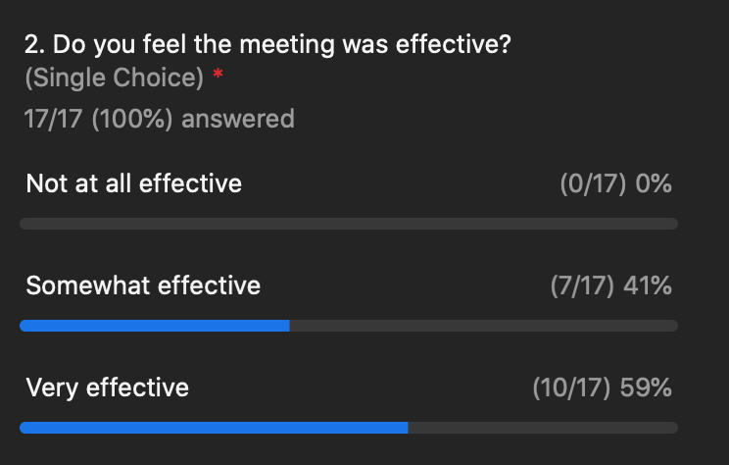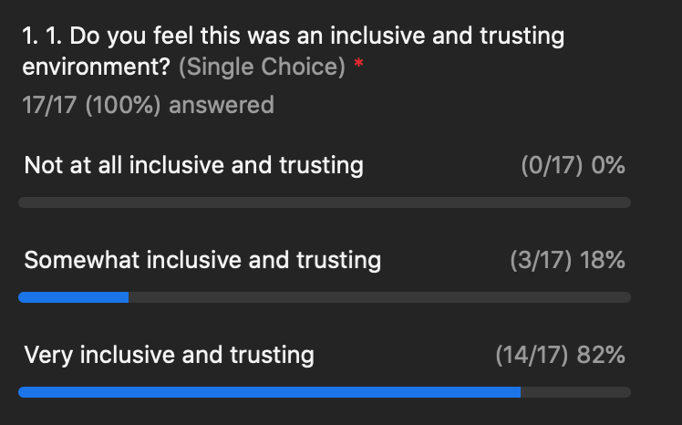

Appendix A: Attendance

Attendance for March 15, 2022 CDEI Working Group Meeting #4
Working Group Member Representatives & Alternates
Organization | First | Last
CEE (alternate) | Alex | Lantsberg
CSE | Fabi | Lao
Don Arambula Consulting (alternate) | Janelle | Villalba
Energy Efficiency Council | Allan | Rago
Energy Efficiency Council (alternate) | Ron | Garcia
Future Energy Enterprises (alternate) | Annette | Beitel
Greenbank Associates | Alice | Sung
ICF | Dany | Kahumoku
La Cooperativa Campesina de California | Robert | Castaneda
NRDC | Lara | Ettenson
SCE | Patty | Neri
SEI (alternate) | Stephanie | Doi
Silent Running LLC | James | Dodenhoff
SJVCEO | Kelsey | Jones
SoCalREN | Fernanda | Craig
The Energy Coalition | Genaro | Bugarin
Viridis Consulting, LLC | Mabell | Garcia Paine
Ex-Officio
CPUC | Nicole | Cropper
CPUC | Peter | Franzese
CPUC | Alison | LaBonte
CPUC | Yeshi | Lemma
CPUC | Nils | Strindberg
Public
Tierra Resource Consultants | Floyd | Keneipp

