Southern California Regional Energy Network

Implementation Plan

Public Agency Revolving Loan Fund

First Filing Date: mm/dd/yyyy

Table of Contents
Program Budget and Savings Information 3
Program Information 3
Program Implementer 3
Implementation Plan Narrative 5
Program Description 5
Program Delivery and Customer Services 5
Program Design and Best Practices 6
Evaluation, Measurement, and Verification (EM&V): 7
Program Performance Metrics 8
Quantitative Program Targets 9
Pilots 9
Program Logic Model 10
Process Flow Chart 10
Diagram of Program 12
Additional information 13
For Market Transformation Programs Only 13
Quantitative Baseline and Market Transformation Information 13
Market Transformation Strategy 13
Appendix: Supporting Information and Documents 14
Program Manuals and Program Rules 14
Incentive Tables, Workpapers, Software Tools 15

Program Budget and Savings Information

Program Information
Program Name | Public Agency Revolving Loan Fund
Program ID# | SoCalREN-SCR-FIN-C1

Program Implementer

Program Implementer | Yes
SOCALREN Only
SOCALREN – Statewide Lead
Other PA – Statewide Lead
Third Party | X
Other

- SOCALREN Business Plan Sector

SOCALREN Business Plan Sector | Yes
Residential
Commercial
Industrial
Agricultural
Public | X
Codes & Standards
Workforce Education & Training
Finance | X
Other

- Program Type
Program Type | Yes | No
Resource |  | X
Non-Resource | X

- Intervention Strategies
Primary Intervention Strategy | Yes | No
Upstream |  | X
Midstream |  | X
Downstream | X
Direct Install |  | X

- Projected Program Budget

Budget data on CEDARS?: | X | Yes |  | No | If No, then show below:

- Savings Impact
Budget data on CEDARS?: | X | Yes |  | No | If No, then show below:

- Program Effectiveness
Budget data on CEDARS?: | X | Yes |  | No | If No, then show below:

Implementation Plan Narrative

Program Description
Describe the program, its rationale, and objectives.

The Southern California Regional Energy Network (SoCalREN) Revolving Loan Fund (RLF) Program is delivered through and supports the SoCalREN’s Public Agency Energy Efficiency Project Delivery Program, the Distributed Energy Resources (DER) Disadvantaged Communities (DAC) Project Delivery program as well as the NMEC Program. The RLF Program is a financing cross-cutting program designed to support energy upgrades to buildings and facilities owned by participating public agencies via loans intended to accelerate the implementation of projects. These loans will provide short term construction period financing and serve either as bridge financing until other financing sources are available at the end of construction, or will be used for approved but not-yet-budgeted projects that would otherwise be delayed pending budget allocation.

The RLF Program Administration and its Marketing and Outreach is supported by rate-payer funds from the California Public Utilities Commission. The program is designed to be delivered as part of the SoCalREN Public Agency Program. An amount of $2.2 million in seed capital for the fund is used exclusively to issue loans to enrolled and participating agencies and is provided through the County of Los Angeles (LAC or County), the Program Administrator of the SoCalREN. The County of Los Angeles is utilizing American Reinvestment and Recovery Act (ARRA) funds already granted by the California Energy Commission (CEC) for the seed capital, and no utility rate-payer funds will be utilized for the loans.

The RLF Program is designed to meet the following objectives: (1) stimulate SoCalREN public agency enrollment, accelerate project development and increase public agency participation in energy efficiency programs; (2) assist public agencies in overcoming barriers related to lack of access to capital for energy projects; and (3) provide an innovative and low-cost solution for short-term energy project financing for public agencies.

Program Delivery and Customer Services
Describe how the energy efficiency (EE) program will deliver savings (upstream, downstream, direct install, etc.), how it will reach customers, and the services and it will provide.

Borrowing agencies (customers) are first enrolled with the SoCalREN under either of its Public Agency Project Delivery Program. They receive comprehensive energy efficiency project delivery services and in addition, are offered the RLF loan. The loans make possible energy efficiency projects that would not otherwise have been completed. The loans also accelerate project implementation by financing projects that are not expected to be budgeted by an agency in the immediate term. In each of these cases, the RLF Program delivers savings by availing all applicable Utility incentive programs (downstream, midstream, upstream, etc.) as determined by the type of project and the energy efficiency measures being implemented.
The program will reach customers by targeting borrowers included in the pool of public agencies located in SoCalREN’s service territory.
SoCalREN’s service territory includes ratepayers in SCE and/or SCG territory. This encompases all or portions of the counties of Los Angeles, Orange, San Bernardino, Riverside, Ventura, Mono, Santa Barbara, Inyo, Kern, Fresno and Tulare, with an emphasis on financing projects serving disadvantaged communities (DACs). The RLF Program is available to enrolled agencies of the SoCalREN Public Agency Program as applicable projects are identified and evaluated. Non-enrolled agencies are targeted in conjunction with the outreach and enrollment efforts of the SoCalREN Public Agency Program. The enhanced service offering is expected to stimulate enrollment and increase public agency participation in energy efficiency programs, one of the RLF Program’s core objectives.
The RLF Program is a streamlined and fully supported SoCalREN financing loan product.
The RLF Program has a streamlined administrative structure with loan application review and approval, fund management and debt service all housed within the SoCalREN. It is fully supported with marketing and outreach, project identification and development, financing options analysis as well as support for completion of loan applications all provided within the SoCalREN. By having the RLF Program as an integral part of the financial support services of the Public Agency Energy Efficiency Project Delivery Program, the RLF Program can benefit from a turnkey approach that offers oversight into every aspect of the project. Among the many benefits, this hands-on approach to customer service supports risk mitigation. Examples of risk management include ensuring that the Agency adheres to utility application requirements to successfully leverage incentives and On-Bill utility financing and ensuring that construction contracts deliver on the energy savings performance that is specified. The technical assistance and project management support provided by the SoCalREN can also alleviate perceived risks to a substantial degree.

Program Design and Best Practices
Describe how the program overcomes the market barriers in its market sector and/or end use. Describe why the program approach constitutes "best practices" or reflects "lessons learned." Provide references where available.

The RLF Program is designed to be delivered alongside the SoCalREN Public Agency Program not only because the customer base is the same, but also because leveraging the support of the Public Agency Program helps address a sector specific market gap, namely that energy efficiency project financing is often not pursued by public agencies because of the lack of internal resources to research and identify financing options, apply for the financing, and execute financing agreements. Described below are some of the best practices that will be applied to this program offering.

Addresses funding barriers specific to public agencies.

The RLF Program is designed to overcome a barrier in the existing framework of utility incentives plus On-Bill Financing (OBF) for energy efficiency projects. The barrier for many public agencies is the fact that both the incentives and OBF funds are only paid several months after project completion which can easily be more than a year from the initial project development and approval stages. The delays in being paid incentive and OBF funds by the utilities requires an agency to separately secure 100% of the funds needed for an energy efficiency project before construction can commence. Given the difficulty of securing capital improvement funds for normal public agency deferred maintenance projects, let alone the installation of new energy efficiency measures, it is not surprising that a 100% upfront capitalization requirement can be a significant hindrance to project implementation. The RLF Program overcomes this barrier by providing access to upfront funds that cover 100% of the project construction costs.

Evaluation criteria that tie RLF to broader Public Sector goals.
Evaluation of loan applications will emphasize three main criteria: 1) support for projects serving Disadvantaged Communities (DACs); 2) high level of confidence that the projects will result in the projected bill savings; and 3) confirmation of an appropriate and feasible strategy for loan repayment within two years to maximize RLF access across a larger pool of agencies. Loans will also be equitably allocated through a restriction on the total loan amount from any one agency to ensure that several agencies will be able to simultaneously access funding for their projects.

Evaluation, Measurement, and Verification (EM&V):
Describe any process evaluation or other evaluation efforts that the PA will undertake. Identify the evaluation needs that the PA must build into the program. These might include:
- Data collection strategies embedded in the design of the program or intervention to ensure ease of reporting and near term feedback, and/or q
- Internal performance analysis during deployment.

SoCalREN, in line with its new authority to manage its own EM&V process, is interested in conducting studies to better understand what financing structures are better suited for the public sector for the implementation of energy efficiency and related energy projects. Knowing what factors contributed to whether an RLF Program loan was used or not can help better understand long-term public agency needs and inform changes in future program design.
Furthermore, SoCalREN would benefit from EM&V studies that characterize agency type and their corresponding funding structures and unique financing needs, in relation to project types and sizes. Of particular interest is the role that utility incentives play within these project implementation strategies.
In order to prepare for effective program evaluation, the implementer will work closely with the Program Administrator for both the setup and design as well as the implementation of EM&V studies.
With regards to data collection during implementation, the existing CRM utilized by the Public Agency Program will be leveraged for data management and reporting. The data collected will include at a minimum:
- Customer name and contact information
- Total project costs and financing methods
- Total loan amount
- Influence of program services in implementation of project
- Data related to Program Performance Metrics (listed below)
- Number of participants
- Loan terms
- Coordination with partner programs
- Marketing, Education & Outreach efforts

Program Performance Metrics
Describe the program performance metrics. (metric, measurement method, frequency, etc)

As a new program, the table below shows key program performance tracking in the form of indicators rather than metrics. The table illustrates the corresponding method and frequency for each tactic or indicator as well.

Activity | Tactic | Indicators | Method | Frequency
Engage in Program Marketing and Outreach | Deliver RLF Program “loan informational overviews’ to potential borrowing agencies | Number of touch-points where RLF Program is presented | Implementer Reporting to Administrator | Annual
Perform Project Feasibility  Analysis for RLF  Loan | Deliver Project Proposals that present project economics with an RLF loan | Number of Project Proposals delivered | Implementer Reporting to Administrator | Annual
Prepare and submit  RLF Program Loan  Application | Evaluate an agency’s ability to take advantage of the RLF loan | Number of RLF Loan Applications | Implementer Reporting to Administrator | Annual
Provide the Offer to Finance for the RLF Loan | Provide eligible agencies an opportunity to use an RLF Loan | Number of Agency-approved loans | Implementer Reporting to Administrator | Annual
Agency completes project installation | Enable savings by funding projects with RLF Program loans | Number of RLF Program Loans Awarded, Dollar Amount Issued and Energy Savings attributed to the Project | Implementer Reporting to Administrator | Annual
Agency repays the loan within 2 years | Manage the RLF Program for repeated use of seed capital funds | Number of RLF Program Loans with full, on-time repayment | Implementer Reporting to Administrator | Annual

Quantitative Program Targets
Provide estimated quantitative information on the number of projects, companies, non-incentive customer services and/or incentives that the program aims to deliver and/or complete annually. Provide references where available.

The outcome of the program is primarily focused on issuing financing to public agencies. The metrics below are primary indicators of program success. New metrics will be developed in year two to refine the tracking of the program as it evolves.
[To be included in final draft that will be uploaded to EEstats and CEDARs]

Pilots
Please describe any pilot projects that are part of this program and explain what makes them innovative. The inclusion of this description should not replace the Ideation Process requirements currently agreed upon by the California Public Utilities Commission (CPUC or "Commission") staff and Investor Owned Utilities (IOUs). The Ideation Process is still undergoing refinements and will be further discussed as part of Phase III of this proceeding.

This program does not currently propose pilot activities.

Program Logic Model
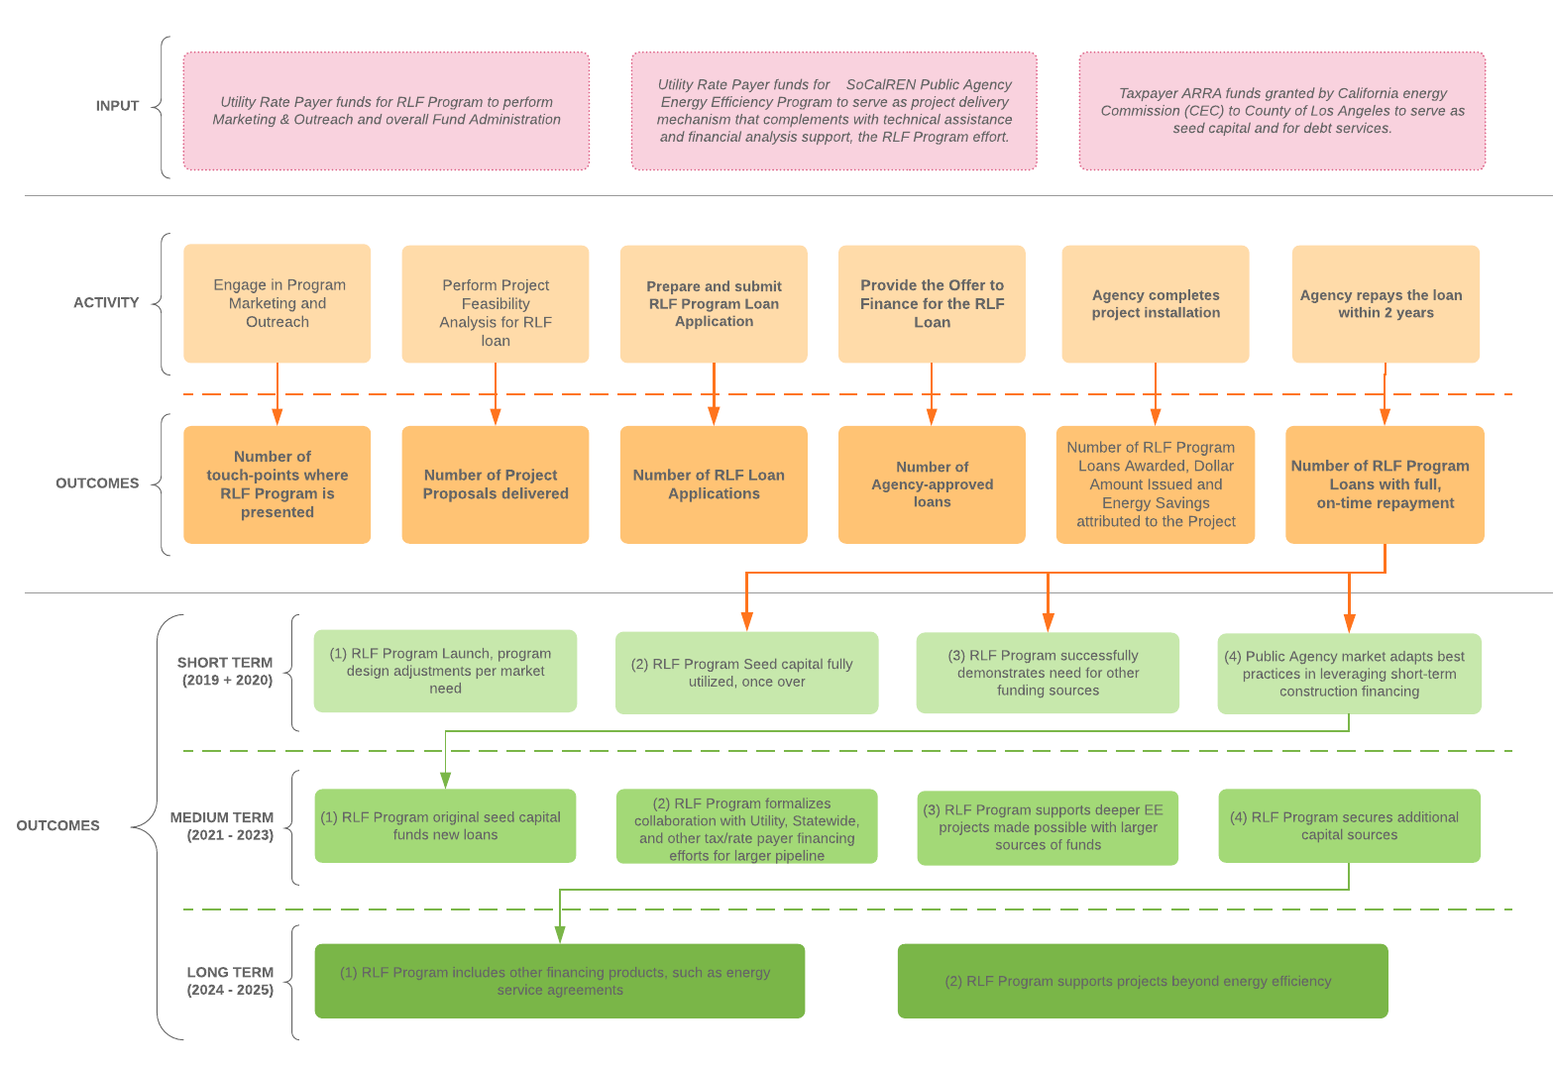

Process Flow Chart
Provide a sub-program process flow chart that describes the administrative and procedural components of the sub-program. For example, the flow chart might describe:
- A customer’s submittal of an application
- The screening of the application
- The approval and/or disapproval of an application
- Verification of purchase or installation
- The processing of incentive payments, and
- Any quality control activities.

[Initial draft of process flow. A more detailed flow chart describing on-going loan tracking and reporting to be included in final draft that will be uploaded to EEstats and CEDARs.]

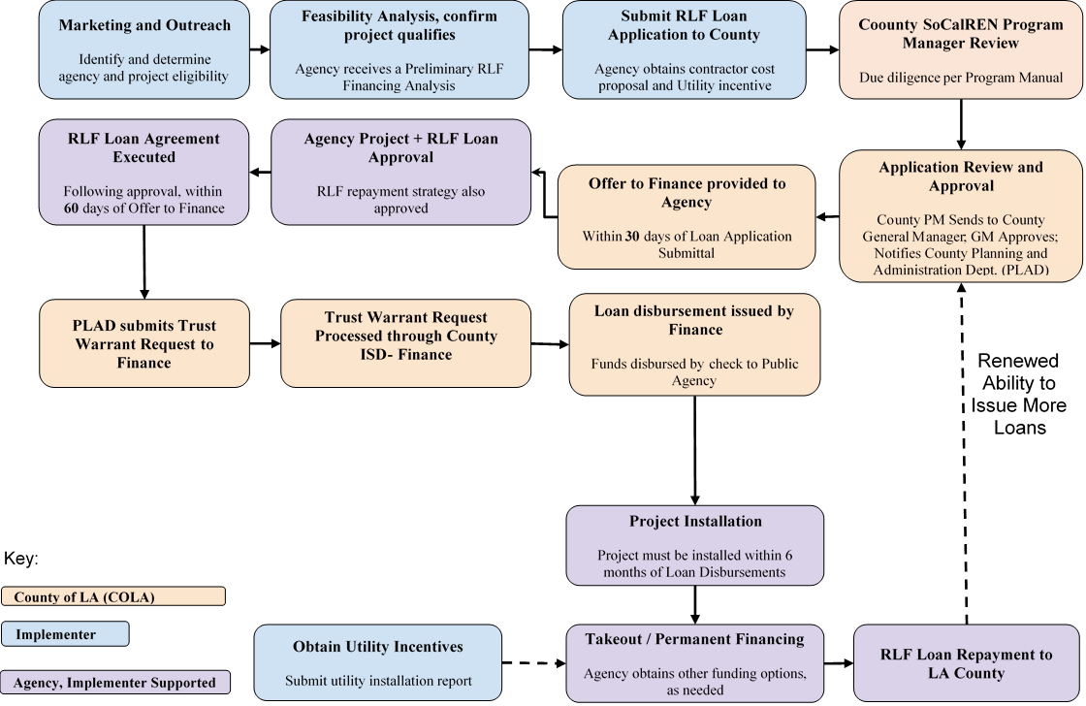

Diagram of Program
Please provide a one page diagram of the program including subprograms. This should visually illustrate the program/sub-program linkages to areas such as:
- Statewide and individual IOU marketing and outreach
- Workforce, Education and Training (WE&T) programs
- Emerging Technologies (ET) and Codes and Standards (C&S)
- Coordinated approaches across IOUs, and
- Integrated efforts across Demand Side Management (DSM) programs.

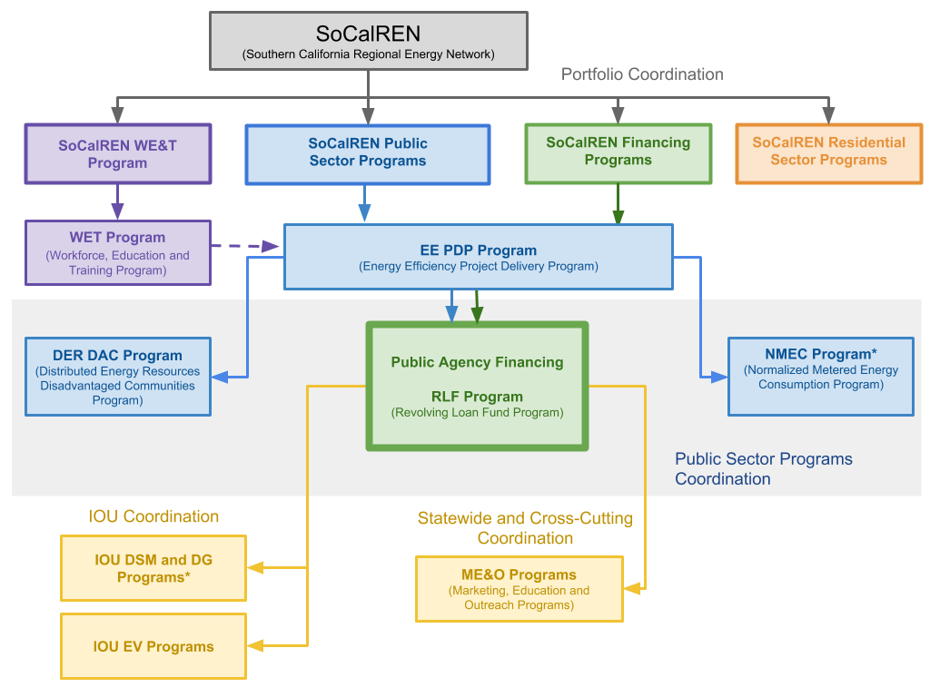
*Resource Program

Additional information
Include additional information as required by Commission decision or ruling. As applicable, indicate the decision or ruling, with page numbers.

N/A

For Market Transformation Programs Only

Quantitative Baseline and Market Transformation Information
Provide quantitative information describing the current EE program baseline information (and/or other relevant baseline information) for the market segment and major sub-segments, as available.

Not applicable to this program.

Market Transformation Strategy
Provide a market characterization and assessment of the relationships and/or dynamics among market actors, including identification of the key barriers and opportunities to advance DSM technologies and strategies. Describe the proposed intervention(s) and its/their intended results, and specify which barriers the intervention is intended to address.

Not applicable to this program.

Appendix: Supporting Information and Documents

Program Manuals and Program Rules
All programs must have manuals (brochures) for implementers and customers to clarify the eligibility requirements and rules of the program. At minimum, manuals should include:
[Program Manual to be included in final draft that will be uploaded to EEstats and CEDARs]
Table 1. Supportive Materials Index
# | Information  Required | Short Description | Location Name/URL link
1 | Eligible Measures or measure eligibility | A list of eligible measures, or measure eligibility requirements | RLF Projects will can pursue measures from SCE and SCG
2 | Customer Eligibility Requirements | Requirements for program participation (for example, annual energy use or peak kW demand) | Public Agencies Enrolled in SoCalREN Programs
3 | Contractor Eligibility Requirements | List of any contractor (and/or developer, manufacturer, retailer or other "participant") eligibility requirements. (For example: specific IOU-required trainings, specific contractor accreditations, and/or specific technician certifications.) | N/A
4 | Participating Contractors, Manufacturers, Retailers, Distributors | Information as to whether:  - Program or sub-program delivery channel is downstream, midstream, or upstream, and  - Program is an incentive and/or buy-down type program. | N/A
5 | Additional Services | Descriptions of any additional sub-program delivery, measure installation, marketing & outreach, training, and/or other services provided, if not yet described above. | N/A
6 | Audits | Information as to whether:  - Pre- and post-audits are required  - Funding or incentive levels have been set for audits, and  - The eligibility requirements for audit incentives. | N/A
7 | Sub-Program Quality Assurance Provisions | List of quality assurance and quality control requirements, including accreditations and/or certifications or other credentials of individuals or organizations performing this work. | Reference the Program Manual
8 | Other (not required) |  | N/A

Incentive Tables, Workpapers, Software Tools
Provide a summary table of measures and incentive levels, along with links to the associated workpapers.

# | Measure | Incentive Level
1 | n/a | n/a | n/a

# | Document Name | Short Description | URL link or location name
1 | n/a | n/a | n/a

IP Guidance from D.15-10-028: "Describe how the energy efficiency (EE) program will deliver savings (upstream, downstream, direct install, etc.), how it will reach customers, and the services and [sic] it will provide."
IP Guidance from D.15-10-028: "It is in the implementation plans that we want to see at least one metric for each program/strategy/sub-sector/intervention strategy; more than one where appropriate…. Implementation plans will contain metrics, as already discussed. PAs are free to start with a clean slate in developing metrics and associated reporting requirements, but for all programs will continue to provide monthly cost reports, and for resource programs will provide monthly savings data as well."
Codes & Standards program, Emerging Technologies program, Workforce Education & Training program, etc.

