BayREN Core Value and Proposed Value Metrics (Descriptive)
DRAFT as of 07/06/20 – posted to PDA for comment
This document is being put forward to facilitate a discussion around BayREN metrics – enabling CPUC staff and stakeholders to comment in advance of BayREN’s September Annual Budget Advice Letter (ABAL) filing. While not in the Ordering paragraphs, in the discussion section of D.19-12-021 and in informal discussions with CPUC staff, the CPUC requested that RENs “state their desired outcome from activities that fill gaps of other program administrators […] and propose savings goals and metrics associated with their unique value, as well as a methodology for measuring progress toward their metrics. (p. 30)” BayREN files an annual Joint Cooperation Memo (JCM) that demonstrates that BayREN’s activities do not overlap with other program administrators (PAs), and thus are filling gaps left by other PAs. This document complements the JCM to speak directly to the value that BayREN provides to the State, and measurement of that value.

The Bay Area Regional Energy Network (BayREN)
As a Regional Energy Network (REN), BayREN actively supports the State’s policy goals of reducing GHG emissions and increasing energy savings within the nine Bay Area counties.
“BayREN is a critical part of the solution for the State’s reliable and sustainable energy future that considers water, greenhouse gases, and resiliency. By uniting and coordinating multiple efforts at a regional level, and delivering these integrated solutions, BayREN [is working to] help the State meet … aggressive goals related to climate change.”
BayREN’s core strengths are the local network (i.e., BayREN’s connection to counties and communities) and the regional system of governance, which is based on a holacracy model, and is used to directly engage local government members.

BayREN’s Local Network and Connection to Local Governments
BayREN is organized around a representative agency from each of the nine Bay Area counties (the BayREN members), all of whom have a common purpose – providing a sustainable energy future and helping their communities become more resilient. The organization is led by the Association of Bay Area Governments, (ABAG, the program administrator), and the representative of ABAG works directly with the other BayREN members.
Figure 1. BayREN Members and Programs
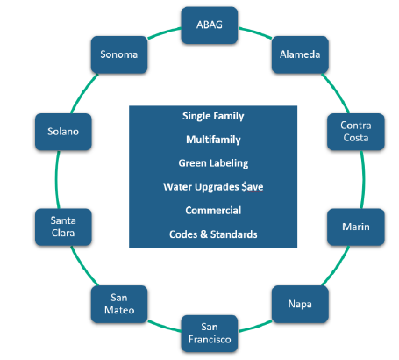
BayREN serves 101 cities/towns and 9 counties, for a total of 110 jurisdictions. Each of the nine members communicate to their local jurisdictions and local government agencies through existing interactions within a county. Through these existing channels, they can discuss and share information about BayREN programs. These connections allow for two-way communication, that is, the ability to share information between BayREN members (the counties) and the cities and towns that they represent. BayREN members can help local governments understand their offerings so these local governments can spread the word to their communities. BayREN members also are knowledgeable about local initiatives and local climate action and sustainability goals and the needs of the communities. In addition to sharing information, therefore, this network also enables BayREN to utilize the tools of the local governments. Local governments (both through the BayREN member representatives and through connections to the 110 local jurisdictions) offer unique relationships, communication channels, existing local programs and processes, and data that can be tapped into by the members. These are referred to as “local government levers.” That is, resources that can be readily utilized in BayREN programs because of the BayREN model. BayREN is actively seeking to better serve their 110 jurisdictions.

BayREN’s Regional Governance Structure
BayREN also has a unique governance structure built on holacracy. In 2016, BayREN chose to move to holacracy to enable clear roles and formal processes of communication and decision making. In holacracy, power is distributed throughout the organization, giving individuals and teams more freedom to self-manage, while staying aligned to the organization’s purpose. Unlike in a traditional structure, authority is spread across BayREN as an organization. As such, holacracy ensures that the members (i.e., local government representatives) are directly involved in administering BayREN’s energy efficiency programs and share in the program direction, the program design, and key program and organizational decision making.
Operationally, BayREN’s holacracy is made up of “circles” of people (also sometimes referred to as committees). BayREN as an organization has many different circles. These circles can form and disband as needed. BayREN has one large circle for the full set of member agencies (the Coordinating Circle) and one Program Circle (sub-circles of the Coordinating Circle) for each of the current programs (Single family, Multi-family, Commercial, Codes & Standards, Water Bill Savings, and Green Labeling). Each circle is open to staff from the member agencies, except for the Coordinating Circle, that has a one designated person (and an alternate).
This system of governance allows for clear decision making, representation of the interests of local communities and adaptation to local needs. It also allows for customization for both smaller and larger population areas (for example offering Codes & Standards forums, training, reach codes, or software depending on the city needs), while also facilitating coordination and information sharing between counties (and the local jurisdictions they represent).

BayREN’s Overarching Value Construct
BayREN makes the State’s policy objectives (i.e., reducing GHG emissions and increasing energy savings) practical at a local level by conducting activities within three overarching categories (also referred to as BayREN’s value pillars):
- BayREN builds human and organizational infrastructure within local jurisdictions so that Bay Area communities are better able to save energy and reduce greenhouse gas emissions
- BayREN is suited to serve in this capacity because of the member’s connections to local jurisdictions and their understanding of what is needed by local governments and their communities.
- BayREN obtains energy savings locally while also supporting local difficult to serve populations
- Local governments have a deep understanding of the needs of their communities. Based on the member’s (i.e., local government’s) assessment of the needs in their communities, they have identified populations that are in need of additional support and they are designing program activities to better target these populations.
- BayREN tests innovative solutions that have the potential to help local jurisdictions increase energy savings and reduce greenhouse gas emissions
- The innovative solutions tested by BayREN have bubbled up from discussions with local governments and thus represent local needs. These innovative solutions are wholly designed and implemented by the BayREN members, which are themselves local governments, to fill gaps that the members (local governments) feel exist.
BayREN’s Overarching Value Construct is shown in the figure below. BayREN’s Overarching Value Construct is anchored by state and local goals, as well as the direction of the nine Bay Area counties that it serves. At its foundation, BayREN’s Overarching Value Construct builds on the structure of the local governments/communities. The local governments have common goals as each other and the State (of GHG reductions and energy savings) but limited resources. At the top, state policy goals provide the North Star (i.e., the ultimate guide for all energy efficiency), including both GHG emission reductions and energy savings (shown in the roof). BayREN’s core activities are depicted by the three pillars.
Figure 2. BayREN’s Overarching Value Construct
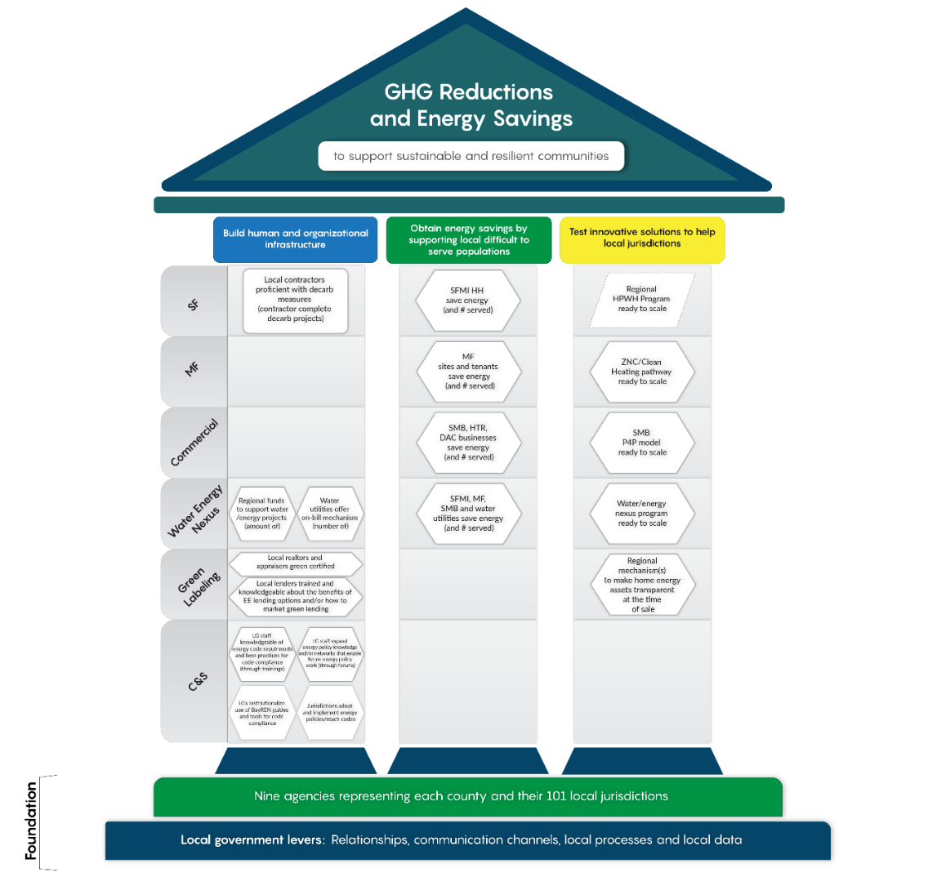
Key outcomes from BayREN’s six programs form the building blocks of these three value pillars. BayREN is proposing the measurement of these outcomes as BayREN’s “value metrics”
BayREN’s Overarching Value Construct includes three value pillars that succinctly describe BayREN’s efforts to help meet GHG reductions and energy savings (i.e. BayREN’s value to the State)
The remainder of this document describes the program outcomes that define the value pillars. Note that most of these are non-resource outcomes, but all of them support the overarching goal of GHG reductions and energy savings.
This document also describes how BayREN proposes to measure these outcomes. These measurements of the key program outcomes are referred to as BayREN’s value metrics. In this document, value metrics are measurements (within the three value pillars) that demonstrate BayREN’s impacts helping reduce GHG emissions and increase energy savings. These are focused measurements, intended to directly speak to the value that BayREN provides to the State.

Building BayREN’s Value Metrics
from Key Program Outcomes Supported By Program Theory
BayREN provides six programs:
- Single family program
- Multi-family program
- Commercial program
- Codes and Standards program
- Water-Energy Nexus program
- Green Labeling program
For Each Program
For each program, BayREN has utilized an intentional design process to lay out the program design, theory and outcomes in the program logic model (example shown below) and supporting documents. BayREN’s logic models use a color-coded system to call out the most important outcomes related to the three value pillars, with:
- Blue denoting a human/organizational infrastructure outcome (Value Pillar 1)
- Green denoting an energy savings outcome specifically from serving a local difficult to serve population (Value Pillar 2)
- Yellow denoting an innovative solution (Value Pillar 3)
Note that each program (and logic model) supports a unique set of outcomes. Not all programs are intended to support all pillars.
In addition, each logic models also describes:
- Local Government Levers – Local government levers are local relationships, communication channels, processes, data and community members that can be tapped into by BayREN members.
- Outputs to Track – This is a list to the right of the model that calls out all outputs that the programs will track in PY2021. This is an extensive list, that goes beyond value metrics. This more extensive list is used at a program level to ensure that the BayREN programs are on track.
Figure 3. Example Program Theory and Logic Model
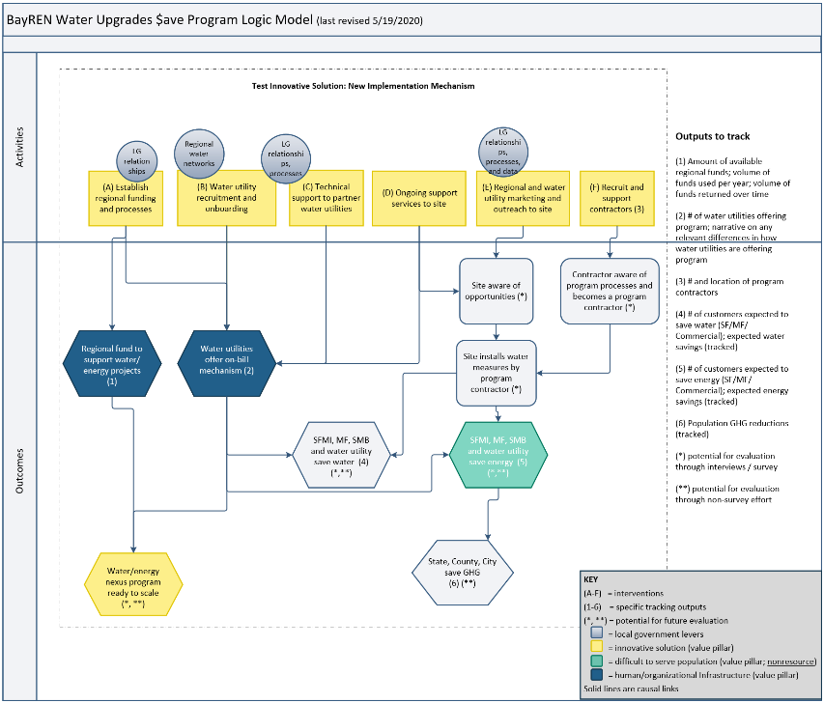
All six of the logic models are provided in Details Supporting BayREN Core Value and Proposed Value Metrics
We present the supporting details below, specifically, the logic models and metrics for BayREN’s portfolio of programs.
A. 2020 Draft Logic Models for BayREN Programs. The detailed description of how the programs lead to the outcomes above can be found in the respective program theory that is laid out in the PY2021 implementation plans (drafts available upon request).

Description of BayREN’s Core Outcomes
The most important outcomes across all six programs (shown in the shapes in the figure below) express BayREN’s core value at the organization level. These key outcomes from BayREN’s six programs form the building blocks of these three value pillars. BayREN is proposing the measurement of these outcomes as BayREN’s “value metrics.”
Figure 4. Overview of Building Blocks within BayREN’s Three Value Pillars
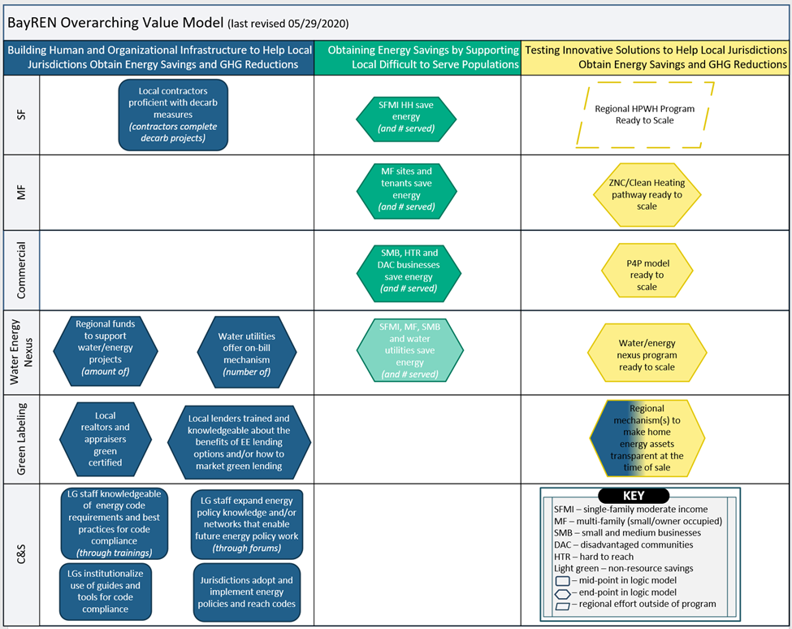
Measurement of these outcomes demonstrate the value that BayREN provides to the State. (Note that BayREN also tracks additional data on outputs for their programs, but for this document we focus on a core set of measurements that speak directly to the value provided to the State.)
Each of the three value pillars, and the building blocks that support the pillar, are described below.

Pillar 1: Building Human and Organizational Infrastructure
Four BayREN programs—Codes and Standards, Water Energy Nexus, Green Labeling, and Single Family Home+— include activities to help build human and organizational infrastructure within local jurisdictions in the Bay Area (as shown in blue Figure 4). Human and organizational infrastructure refers to staff, policies, or processes/systems within a local government or region that are built through the implementation of BayREN programs and services (and would be expected to continue even if a specific BayREN intervention no longer existed). BayREN is working to put this local infrastructure in place so that Bay Area communities are better able to save energy and reduce greenhouse gas emissions.
The Codes and Standards program forms the foundation of this pillar, working directly with local governments and their staff. This program contributes to the overall BayREN goal of GHG reductions and energy savings by expanding building department and other local staff’s knowledge of energy codes and policies. The support and investment in local government staff helps local governments make—and follow through on—energy codes and policies to help save energy and reduce GHG emissions. The Codes and Standards program also facilitates the institutionalization of code-related tools within the Bay Area communities and supports the development of state level energy policies and reach codes that work for local jurisdictions. BayREN’s relationships with local governments puts them in a unique position to work with local government building departments and energy policy staff. The outcomes describing the organizational and human infrastructure that is being built are:
- Jurisdictions adopt and implement energy policies and reach codes
- Local Governments (LGs) institutionalize the use of BayREN guides and tools for code compliance
- LG staff knowledgeable of energy code requirements and best practices for code compliance
- LG staff expand energy policy knowledge and/or networks that enable future energy policy work
These four outcomes (i.e., the four bullets above), and the specific measurement of each outcome, are described in Table 1 and Table 2.
The Water Energy Nexus program (known as Water Upgrades $ave) is also directly building infrastructure within local government agencies. The program establishes on-bill mechanisms within locally-run water utilities in the region. Specifically, the program partners with water utilities to establish a new on-water-bill mechanism that can support the installation of water and energy saving measures in homes and buildings throughout the Bay Area. The establishment of this new mechanism within the water utility facilitates energy savings from water customers, while funding these actions outside of the current CPUC energy efficiency budget. The outcomes that describe the organizational infrastructure that is being built are:
- Water utilities offer on-bill mechanisms
- Regional fund to support water/energy projects established
These outcomes, and the specific measurement of each outcome, are described in Table 1.
BayREN’s Green Labeling program is helping to build local capacity. Making significant and lasting reductions in energy use requires sustained, multifaceted interventions to motivate the public to invest in energy efficiency and other green home improvements. In support of the State’s urgent priority to improve the energy efficiency of buildings, BayREN’s Green Labeling program is training local real estate professionals so that they understand, market and evaluate energy efficiency and green homes at the time of sale. The program is developing mechanisms (e.g., the DOE’s Home Energy Score) that make home energy assets transparent at the time of sale. This infrastructure within local communities encourages energy efficient investments at a critical moment—the time of a home’s sale. Making these investments at this critical point in time will have a long-term effect on both the buildings and the larger community. The outcomes describing the organizational and human infrastructure that is being built are:
- Local realtors and appraisers green certified
- Local lenders trained and knowledgeable of EE financing options
- Regional mechanism(s) to make home energy assets transparent at the time of sale (e.g., green label(s) and/or public database(s)) established
These three outcomes, and the specific measurement of the outcomes, are described in Table 1 and Table 2.
A component of the Single Family Home+ program is helping to build capacity within local markets – specifically among local contractors. BayREN’s Home+ program facilitates local contractors gaining experience with decarbonization measures and projects so that they can become proficient with the installation of and marketing of decarbonization measures. Through training and projects (which provide practical application and familiarity with the measures), the BayREN program is building a community of local contractors that are comfortable with decarbonization measures (and the installation of those measures) to ready the region for the future. The outcomes describing infrastructure that is being built is:
- Local contractors proficient with decarb measures
This outcome, and the specific measurement of the outcome, is described in Table 2.

Pillar 2: Obtaining Energy Savings by Serving Local Difficult to Serve Populations
BayREN’s three resource programs, the Single Family Home+ program, the Multifamily program, and the Commercial program all focus on energy savings, while also targeting local difficult to serve populations (LDTS) that are not easily served by existing programs from the other program administrators. In addition to these three resource programs, BayREN’s Water Energy Nexus program (a non-resource program) also seeks to reach these and other local populations to obtain energy and water savings. This pillar is shown in green in Figure 4 and described below.
The Single Family Home+ program serves all single family customers, but with a focus on moderate income single-family households. Single family moderate income (SFMI), defined as households that make between $48,000 and $125,000, are considered LDTS by BayREN’s SF program. These households have been shown to be underserved in PG&E’s past Home Upgrade program and in a statewide review of residential programs.
The outcomes that describe the energy savings from the specific local difficult to serve population are:
- SFMI households served
- SFMI energy savings
Each of these outcomes (bullets), and the specific measurement of each outcome, is described in Table 3.
The Bay Area Multifamily Building Enhancement (BAMBE) program serves multifamily buildings and tenants that are not served by traditional programs such as those in small (<100 unit) or owner occupied multifamily (MF) buildings.
The following property types are considered LDTS for the MF program:
- Small (defined by <100 units)
- Has a resident ownership structure, such as a homeowner association or co-op
- Is a deed-restricted affordable property
- Is naturally occurring affordable, i.e., demonstrates low-income eligibility without a regulatory agreement (taken from LIWP).
  - Income documentation showing at least 66% of households are ≤ 80% AMI
  - Provision of document showing at least 66% households participate in public assistance programs or receive benefits primarily available to those with income levels ≤ 80% AMI
  - In housing serving lower income households, gross rents paid (rent charged plus the utility allowance) cannot exceed 30% of household income for the housing to be deemed affordable
  - Active Office of Migrant Services (OMS) Migrant Center
- Is located within a disadvantaged community (DAC)
  - Proxy for DAC, AB 1550 LI communities (based on address/zip code)
The outcomes that describe the energy savings from the specific local difficult to serve population are:
- MF sites served
- MF tenants served
- MF energy savings in units and common areas
Each of these outcomes (bullets), and the specific measurement of each outcome, is described in Table 3.
The Commercial program (i.e., the Small Medium Business Pay-for Performance, or P4P, program) reaches small and medium businesses (SMB) with some focus on hard-to-reach (HTR) and disadvantaged communities. All SMBs are considered LDTS by BayREN’s Commercial program. SMBs are defined as meeting one of three criteria: less than 50,000 sq. ft. in size; use less than 500,000 kWhs/year; or use less than 250,000 Therms/year. A commercial customer is considered HTR if the business is located in a DAC and meets one of the criteria below. Or, if the business is outside of a DAC, the customer is considered HTR by meeting all of the criteria below:
- Language – Primary language spoken is other than English
- Size – Less than ten employees and/or classified as “Very Small” (customers whose annual electric demand is less than 20 kW or whose annual gas consumption is less than 10,000 therms
- Leased or rented facilities – Investments in improvements to a facility rented or leased by a participating business customer
The outcomes that describe the energy savings from the specific local difficult to serve population are:
- SMB customers served (All, HTR, DAC)
- SMB energy savings (All, HTR, DAC)
Each of these outcomes (bullets), and the specific measurement of each outcome, is described in Table 3.
The Water Energy Nexus program (i.e., Water Upgrades $ave) is also available to serve these SMBs, small and/or owner-occupied MF and SFMI populations through a different channel (the water utility) with an alternative funding mechanism. The outcomes that describe the energy savings from the specific local difficult to serve population are:
- SFMI, MF, SMB customers served (non-resource program, but will track)
- SFMI, MF, SMB energy savings (non-resource program, but will track)
These outcomes are described in Table 3.

Pillar 3: Testing Innovative Solutions
In D.12-11-015, the Commission provided three criteria for evaluating proposed REN programs. One of the criteria is to “pilot activities where there is no current utility [or CCA] program offering, and where there is potential for scalability to a broader geographic region.” The Commission explained that the idea is to test program delivery that is different or unique, for potential to be scaled up to a statewide approach delivered either by RENs and/or by utilities in the future. All BayREN programs include activities to enhance innovation that are driven from local priorities and needs based on local government input; however, there are four initiatives that rise to the level of an innovative pilot where BayREN is testing an innovative solution with the goal of scaling the activities to the region or beyond. These include: developing a Multifamily ZNC/Clean Heating mechanism to support zero net carbon within multifamily buildings, testing a P4P model specifically aimed at SMBs, developing a water energy program that provides an alternative way to fund energy savings, and supporting green labeling mechanisms to make home energy assets transparent at the time of sale. (This pillar is shown in yellow in Figure 4 and described further below.)
BayREN’s current efforts that fall into this category include the following:
The Multifamily program’s ZNC/Clean Heating Pathway is working to create a zero net carbon pathway for multifamily buildings. The Clean Heating Pathway provides financial incentives to encourage multifamily property owners and/or managers to replace natural gas measures with electric measures (e.g., heat pump water heaters) because they are unlikely to do it on their own. This solution is needed in order to accelerate adoption, develop workforce and bring down the cost of gas-to-electric installations. The specific outcome that will be measured is:
- ZNC/Clean Heating Pathway ready to scale
The theory, timeline and path to this outcome is described in Table 4. (Note that we also describe the term “ready to scale” below and in call out box on the next page.)

The Commercial program’s SMB P4P model uses a performance-based model specifically to engage small and medium business customers. The P4P innovative solution provides SMB customers with the ability to obtain energy savings with lower upfront costs. SMB customers are offered a flexible solution that shields the customer (and ratepayers) from paying for expected savings that fail to materialize. A P4P design encourages maximizing savings from a wholistic set of measures. A solution like this is needed because SMB customers have thin financial margins and/or do not view energy efficiency as a direct business investment.
Ready to Scale
Metrics for this area, “testing innovative solutions,” are very different than those for a typical program, which may look at numbers reached and/or energy savings. The core metric is the endpoint, which we define as a point in time at which the effort is “ready to scale.”
Ready to scale is when you have a proven program model (i.e., endpoints in the tables below) that can demonstrate the ability to expand. We define this as having four general characteristics:
- Customer acceptance is high
- Acceptance is high among market actors/those who need to implement
- Needed systems are in place to be able the operate the program
- Operations are clearly defined for all of those involved

The specific outcome that will be measured is:
- SMB P4P program ready to scale
The theory, timeline and path to this outcome is described in Table 5.
The Water Energy Nexus program is developing a new mechanism to fund energy (and water) savings that is beyond the current CPUC offerings (and does not rely on CPUC/ ratepayers to fund the projects). New proactive state and local water goals (for 2023-2027) will create an opportunity for additional water/energy savings from customer-side water efficiency projects. Water utilities, constrained by the types of incentives they can put in place, will need new programs to reach these goals. As such, there is an opportunity for a regional solution that can reduce water use while also saving energy. Water utilities will participate because it helps their customers install water efficiency improvements with no up-front cost ― using a utility-approved on-bill charge that is significantly lower than the estimated savings ― so the customer begins saving right away.
The specific outcome that will be measured is:
- Water Energy Nexus program ready to scale
The theory, timeline and path to this outcome is described in Table 6.
The Green Labeling program’s Home Energy Score is a new mechanism(s) that makes a home’s energy assets transparent. When there is information about the ongoing energy cost of a home at the time of sale, it influences decisions and is valued. Homes with higher scores have a higher value (i.e., a value premium). Those homes that are more efficient are seen as more valued at the time of sale. If enough homes are scored and the scores are visible at the time of sale, the value of an efficient homes will be greater.
The specific outcome that will be measured is:
- Regional mechanism(s) to make energy assets transparent at the time of sale
The theory, timeline and path to this outcome is described in Table 7.
In addition to these four innovative solutions through the programs, BayREN is also supporting a Regional Heat Pump Water Heater (HPWH) Program Design Initiative. Using a BAAQMD Grant, BayREN (led by StopWaste and in partnership with the City of Palo Alto and Sonoma Clean Power) is working to establish a uniform program design that can be supported by local energy providers and demonstrate the Bay Area’s commitment to scaling up the HPWH market. This work includes designing a midstream incentive for HPWHs, engaging local energy providers (CCAs and Publicly Owned Utilities), engaging HPWH supply chain actors, supporting workforce education, and cross-promoting with other complementary programs. BayREN’s members, network, and connections are helping to facilitate this work. The endpoint for this effort is a Regional Heat Pump Water Heater program that would be ready to scale.
Metrics for this area, “testing innovative solutions,” are very different than those for a typical program, which may look at numbers reached and/or energy savings. The core metric is the endpoint, which we define as a point in time at which the effort is “ready to scale.”
Ready to scale is when you have a proven program model (i.e., endpoints in the tables below) that can demonstrate the ability to expand. We define this as having four general characteristics:
- Customer acceptance is high (i.e., program or activities are able to overcome barriers)
- Acceptance is high among market actors/those who need to implement (i.e., program or activities able to overcome barriers)
- Needed systems are in place to be able the operate the program (e.g., incentive or repayment systems, web-based platforms, etc.)
- Operations (e.g., how to navigate all program processes) are clearly defined for all of those involved
The specifics vary for each of the innovative solutions, but each includes a theory, timeline, and path for getting to the endpoint. In addition, BayREN plans to conduct a mid-pilot process evaluation for each, and through this mid-point evaluation BayREN will explore and report on the status of the “ready to scale” criteria listed above. More details on the specific method of measurement is included in the Pillar 3 Metrics: Testing Innovative Solutions section within the more detailed description below.

Details Supporting BayREN Core Value and Proposed Value Metrics
We present the supporting details below, specifically, the logic models and metrics for BayREN’s portfolio of programs.

A. 2020 Draft Logic Models for BayREN Programs
This section provides the draft logic models for each of BayREN’s six program efforts. BayREN also has individual program documents that include the program theory for each program (available upon request).
Note that each model calls out the local government levers, i.e., local relationships, communication channels, processes, data and community members that can be tapped into by BayREN members. These are shown in the circles.
Each logic model also includes a list of outputs that the programs intend to track (shown in the far right column), which extend beyond the value metrics in this document

A1: Single Family Program Logic Model
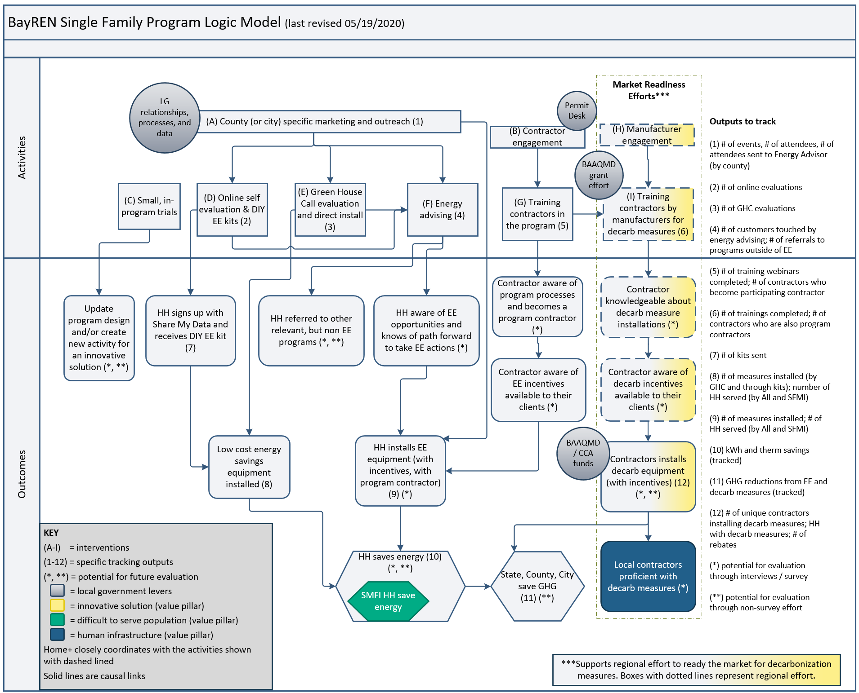

A2: Multifamily Program Logic Model
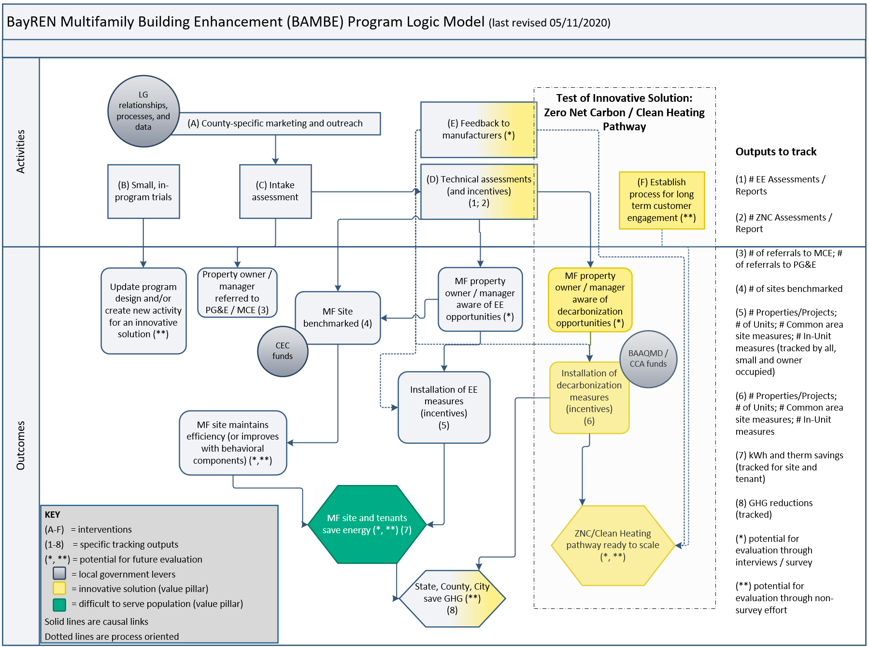

A3: Commercial Program Logic Model
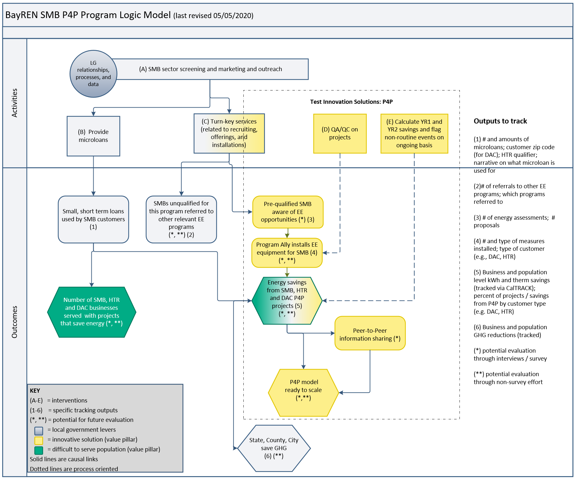

A4: Water Upgrades $ave Program Logic Model
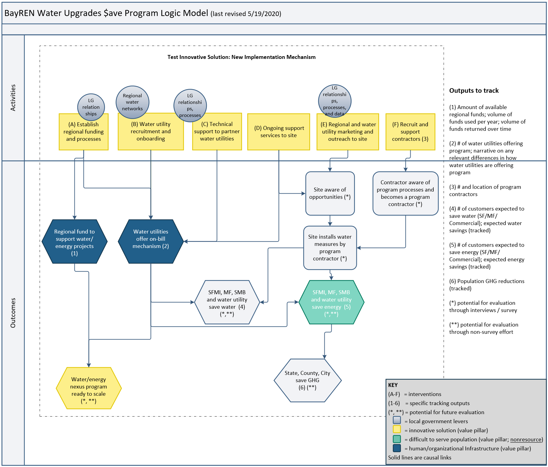

A5: Green Labeling Program Logic Model
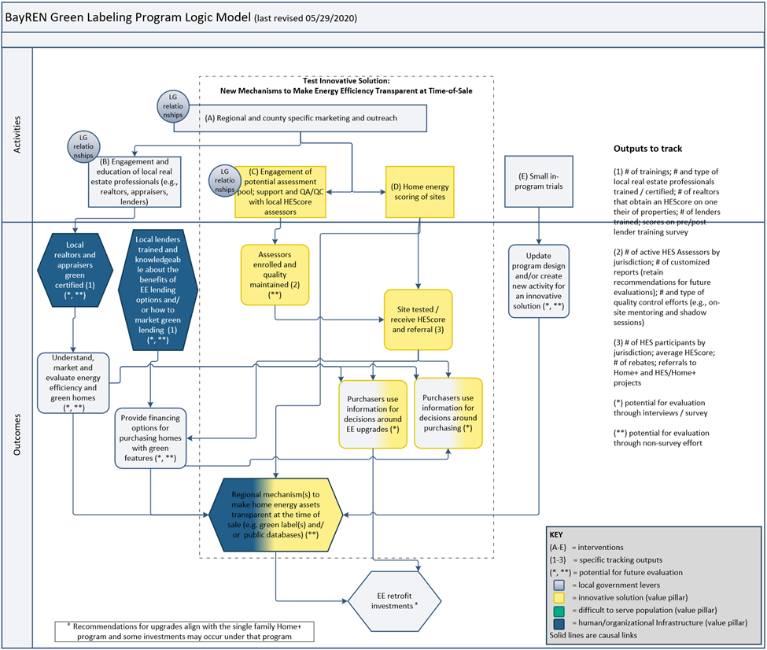

A6: Codes and Standards Program Logic Model
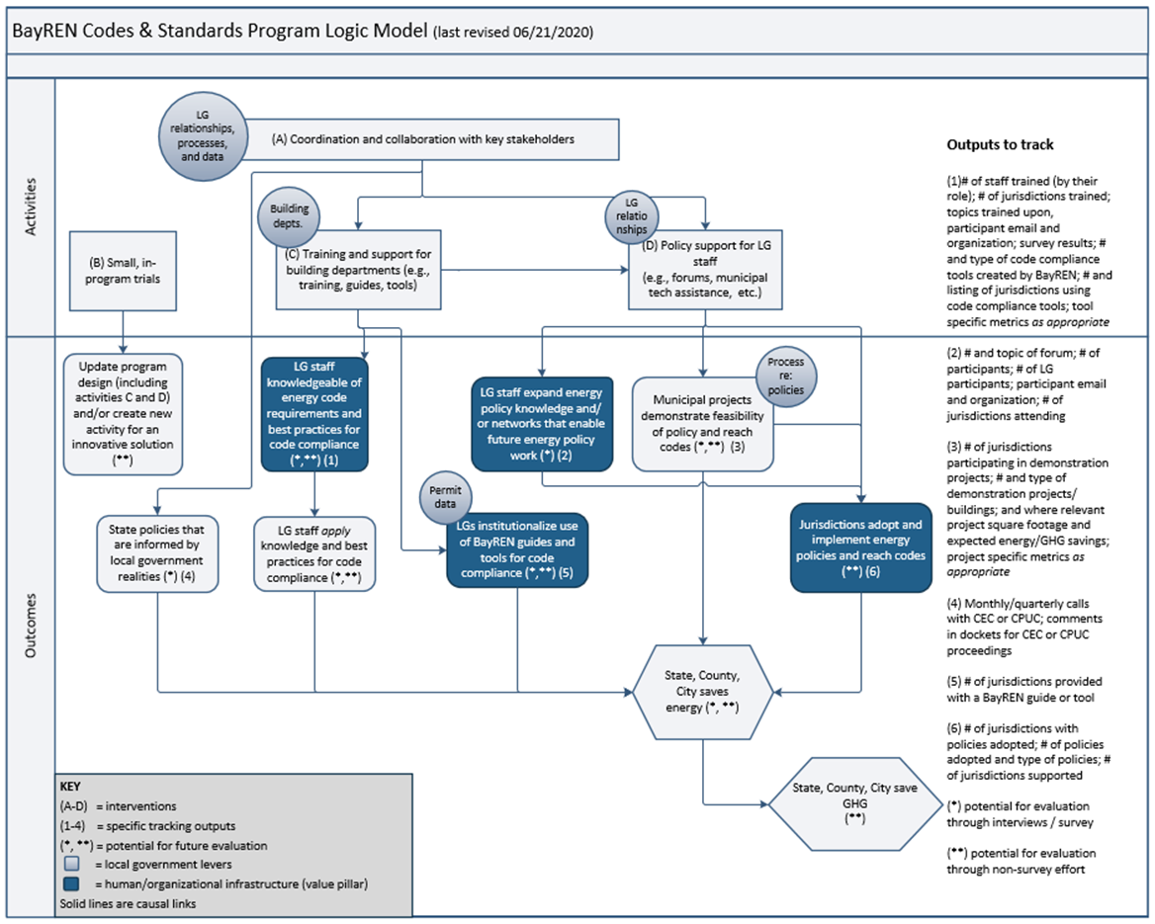

The colored shapes in each of these logic models represent the key outcomes from BayREN’s six programs. These outcomes form the building blocks of BayREN’s value pillars (as shown earlier in Figure 4). BayREN is proposing the measurement of these outcomes as BayREN’s value metrics. The next section provides the details for each metric.

B: Details of Value Metrics and/or Indicators by Value Pillar
This section presents BayREN’s proposed value metrics and indicators that support the overall goal of saving energy and reducing GHG emissions. Note that we are proposing indicators (that is, values without specific targets) for the first reporting year (2021). Whether or not BayREN would select targets for future years will be revisited after the first year of collecting data, that is, once a baseline is established.
Note that each row below directly relates to a colored shape in the logic model.
All of the tables below attempt to provide both quantitative counts (in the second to last column) along with the additional details of the information that BayREN will collect to provide context to the quantitative value.

Pillar 1 Metrics: Building Human and Organizational Infrastructure

Table 1. Draft Value Metrics and/or Indicators – Building Organizational Infrastructure (Dark Blue Shapes in Logic Models)
Program | Infrastructure Building Block(s) | Indicator  (will not change in the Annual Report) | Annual Accomplishments  Quantitative Value  (actual numbers in the Annual Report) | Details and Additional Information to Provide Context to the Quantitative Value
Organizational Infrastructure
Codes | Jurisdictions adopt and implement energy policies and reach codes | Number of jurisdictions that adopt and implement reach codes or energy policies | # Jurisdictions that adopt and implement reach codes or energy policies (with description) | BayREN will include a description of the type of reach codes and energy policies adopted to give context to the number.
Codes | Local Governments (LGs) institutionalize the use of BayREN guides and tools for code compliance | Number of jurisdictions that use BayREN guides and tools for code compliance | # Jurisdictions that use BayREN guides and tools | This would include jurisdictions using permit guides, CodeCycle and ePermit tools, and other tools and guides  Institutionalized indicates that it has become part of the normal process. Evaluation activities could follow up to determine this (via survey/observation), as desired. Annual proxy metric is “use.”
Water Energy Nexus | Water utilities offer on-bill mechanism | Number of water utilities offering programs with BayREN on-bill mechanism | # water utilities offering programs with BayREN on-bill mechanism | This would be a cumulative value  Note that customers are also in the outputs to track but this metric measures the building of the infrastructure across jurisdictions.
Water Energy Nexus | Regional fund to support water/energy projects | Amount of regional funds and description of long-term funding plan | $ Million in funding and milestones reached (see Innovative Solutions section) | This would include a description, as well  BayREN will also track allocated funds (see output tracked) but this metric was developed to measure the infrastructure.
Green Labeling | Regional mechanism(s) to make home energy assets transparent at the time of sale (e.g., green label(s) and/or public database(s)) | Description of tools (e.g., HEScore, MLS green fields, public databases for making scores transparent, etc.) and use of these tools | Milestones reached (see information under Innovative Solutions) | This will emerge and potentially change as the innovative solution develops, but the final endpoint will include organizational infrastructure such as databases or green fields that make energy assets at a site more transparent at the time of sale.
Notes: Start to track cumulative as of 2020 wherever possible.
Table 2. Draft Value Metrics and/or Indicators – Building Human Infrastructure (Dark Blue Shapes in Logic Models)
Program | Infrastructure Building Blocks | Indicator | Annual Accomplishments  (Quantitative Value) | Details and Additional Information to Provide Context to the Quantitative Value
Human Infrastructure
Codes | LG staff knowledgeable of energy code requirements and best practices for code compliance  (110 jurisdictions) | Number of jurisdictions with staff who note an increase in knowledge (including understanding of best practices for code compliance) | # Jurisdictions with staff who attend energy code training  # and % of local government staff attendees who increased knowledge of energy code requirements and best practices for code compliance* | This would be collected from counts of jurisdictions with training and surveys that are given at the end of each training. These post-training surveys are already administered at the end of each course. Note that they examine the increase in knowledge (comparing pre and post but the survey is administered once to reduce burden on the class/respondent). The questions asked align with the indicator here.*
Codes | LG staff expand energy policy knowledge and/or networks that enable future energy policy work | Number of jurisdictions with LG staff who indicate an increase in energy policy knowledge  Number of jurisdictions with LG staff who indicate forum expanded their energy efficiency networks (helping to build relationships that will enable future energy policy work) | # Jurisdictions with staff attending forum  # and % of respondents indicating increase in energy policy knowledge*  # and % of respondents indicating that they expanded their networks in a way that can enable future energy policy work* | The number of jurisdictions with staff and the percentage of all respondents indicating increased energy policy knowledge and/or expanded networks (collected from post-event survey) will be used as a proxy for the indicator. These post-training surveys are already administered. The questions asked align with the indicators here.*
Green Labeling | Local realtors and appraisers green certified | Number of realtors and appraisers certified (e.g., National Green Certified Real Estate Professionals) | # realtors and appraisers certified | Local realtors and appraisers take a test and receive a green certification or designation from a national organization
Green Labeling | Local lenders trained and knowledgeable of EE financing options | Number of local lenders trained who report an increase in knowledge about EE financing options | # local lenders trained  % reporting increase in knowledge* | This would be collected from counts of lenders attending training and surveys that are given at the end of each training.*
Single-Family | Local contractors proficient with decarb measures | Number of contractors who have performed 3+ projects of decarbonization measures | # Contractors with 3+ projects | Contractors will be reported by both individuals and companies.  3 is the minimum to be considered active in program. Report by type of measure installed
Notes: Start to track cumulative as of 2020. While we focus on building human infrastructure within specific groups described in the table above, these programs also build knowledge among private sector building professionals and others. Where possible, this will also be tracked or evaluated; however, this is outside of the Value Metrics listed here. *The surveys and survey questions are available but are not included here.

Pillar 2 Metrics: Obtaining Energy Savings in LDTS Populations
A significant part of the intention behind BayREN Business Plan’s is to create better access to energy efficiency programs for all ratepayers, particularly within those local population that have been difficult to serve with past programs (i.e., audiences that have various barriers to taking energy efficient actions). The value metrics and/or indicators below describe the local difficult to serve populations targeted by BayREN programs, the number served within the populations, as well as the net annual savings associated within those populations.
Table 3. Draft Value Metrics and/or Indicators – Obtaining Energy Savings by Supporting Local Difficult to Serve (LDTS) Populations (Green Shapes in the Logic Models)
Program | LDTS Building Blocks | Metric/Indicator  Unit | Annual Accomplishments  (Quantitative Value) | Details and Additional Information to Provide Context to the Quantitative Value
Single-Family | SFMI households served  (1,879,492 total SF households, or HH)  (725,000 SFMI HH) | SFMI households (HH) | # participating HH (e.g., 5,000 in PY20) | Report both All and # of LDTS (i.e., SFMI)  For annual, report exceeded / did not meet annual goal.
Single-Family | SFMI energy savings | Annual Net First Year Savings  kWh  kW  Therms | # kWh  # kW  # Therms | Report all savings and savings from LDTS (i.e., SFMI). Also present as percentage of savings goals.
Multifamily | MF sites served | Small and/or owner- occupied buildings* | # participating buildings | Report both All and # of LDTS (e.g., small and owner occupied).
Multifamily | MF tenants (units) served  (1,431,478 total MF units) | Small and/or owner- occupied tenant units* | # participating tenant units | Report both All and # of LDTS (e.g., small and owner occupied)  For annual, report exceeded / did not meet annual goal.
Multifamily | MF energy savings in MF units and common areas | Annual Net Savings  kWh  kW  Therms | # kWh  # kW  # Therms | Report all and savings from LDTS* (e.g., small and owner occupied). Also present as percentage of savings goals.
Commercial | SMB customers served (All, HTR and DAC)  (61,926 total SMB Customers)  (11,000 total DAC SMB Customers) | SMB customers | # participating customers | Report for All, HTR and DAC. Include microloans in count of customers served.  For annual, report exceeded / did not meet annual goal.
Commercial | SMB energy savings (All, HTR and DAC) | Annual Net Savings  kWh  kW  Therms | # kWh  # kW  # Therms | Report All, HTR, and DAC as a percentage of savings goals.
Water Energy Nexus | Will also track customers and savings in the categories above.
Notes: Details by county will be in a separate table. Start to track cumulative as of 2020 as this will show the overarching value over time when compared to the population. *The full description of LDTS is found under the introduction to the MF program and all would be included in the metric counts and savings.

Pillar 3 Metrics: Testing Innovative Solutions
BayREN is designing innovative solutions to explore new program delivery mechanisms and measures of the future, enabling PAs to achieve deeper savings and transform markets. The BayREN pilots are limited in scope and duration so that results are available in a specified time frame. The duration and description of each pilot is listed below.
Metrics for this area, “testing innovative solutions,” are very different than those for a typical program, which may look at numbers reached and/or energy savings. While there is no specific CPUC guidance on metrics for this REN directive, two existing CPUC documents provide some insights. Specifically, the Emerging Technologies Protocol and the more recent work on a Market Transformation Framework provide a starting point.
In 2006, California created the Emerging Technologies (ET) protocol because of the absence of specific energy/demand goals and the longer lead time required to introduce new solutions directly into the market. The protocol is flexible and while there is a minimum level of evaluation rigor, stakeholders are still informed about whether the effort is on track to achieve longer-term objectives. Portions of the protocol are helpful to consider when measuring BayREN efforts within this value pillar. Most relevant is “investigating the underlying concepts and developing models to advance understanding of some aspect of a program, project or phenomenon.” That is, laying out the theory of change and having a model of where change may occur is important in determining appropriate metrics for this BayREN value pillar. Note that each of the innovative solutions below is supported by a program theory and logic model, found in the program documents and also described briefly below.
More recently (2019), California adopted a stage gate approach for the development and deployment of efforts that seek to transform a market. Within the Adopted Market Transformation (MT) Framework (D.19-12-021), stage gates “describe critical decision-making points and expected activities at each stage” and define a process that is “designed to reduce and manage the risk inherent in undertaking market transformation initiatives.” The MT framework describes the development phase (a phase that includes a pilot effort that moves through two stage gates) as including “identification of a market adoption baseline, creation of a logic model, and establishment of progress metrics” as well as defining success criteria for the pilot effort. These stages are measured by milestones. Similarly, for each of the four pilots, BayREN has developed milestones to measure progress towards the pilot’s goal or end point. Tables 4-7 below describe these four pilot efforts.
The BayREN Multifamily program is developing a ZNC/Clean heating pathway that will be able to be scaled to the full BayREN region or beyond. The specific plan and timeframe to move a successful pilot program to a larger scalable effort is described below.
Table 4. Draft Milestones for the Innovative Solution – ZNC/Clean Heating Pathway Innovative Solution (Endpoint/Yellow Shape in Logic Model)
Description and theory
Description of the solution and why it is believed that this solution is needed | The Clean Heating Pathway provides financial incentives to encourage multifamily property owners and/or managers to replace natural gas measures with electric measures (e.g., heat pump water heaters) because they are unlikely to do it on their own since the GHG reductions accrue to the state and not to the property owner. This solution is needed in order to accelerate adoption, develop workforce and bring down the cost of gas-to-electric installations.
Theory of what will occur over time based on the pilot intervention | As the market adjusts to reflect the health, resiliency, and grid benefits of electrification, existing projects will show that that installation of decarbonization measures provide benefits in multifamily buildings (and costs are in line with other measures), and property owners will become willing to install decarbonization measures.
BY YEAR | Milestone(s) | Accomplishments
Pre-Program (2019) | BAAQMD funding (for DAC pilot) to get a head start on the challenges of implementing a BayREN program |  | Was reported in 2019 Annual Report*
First year (2020) | Build on lessons learned from 2019 to roll out a decarbonization pathway that offers supplemental incentives for decarb heating technologies |  | Will be reported in  2020 Annual Report
Expected 2021 accomplishment(s) | Program expands to offer multiple decarb measures in a broader population (e.g., 1,250 units with pathway measures installed cumulative)  Program aligns with local and state agencies and utilities offer electrification & controls incentives to promote clean, resilient housing (e.g., Program incorporates demand controls measures on heat pump technology where incentives are available)  Mid-pilot evaluation effort to assess implementation and share lessons learned |  | Will be reported in  2021 Annual Report
Expected 2022 accomplishment(s) | Clean Heating Pathway project units exceed Traditional Pathway project units  Traditional incentives begin to be phased out for general MF population for gas-to-gas upgrades with feasible electric options  Integration of demand control measure requirements/Controls required on heat pump water heater and HVAC equipment where cost effective  Electrification Incentive adders re-evaluated and reset as needed |  | Will be reported in  2022 Annual Report
Endpoint
Endpoint (roughly 3 years out) | ZNC/ Clean Heating Pathway ready to scale
*2019 Annual Report described - Launched a BAAQMD pilot in DAC communities. From the more than 520 properties that have participated in BAMBE and the stakeholder relationships developed over 6 years, the program has gained valuable insight into how to evolve and intensify the role that the multifamily market plays in helping California meet its energy efficiency and decarbonization goals. See Annual Report for additional details.

The BayREN Commercial program is developing a SMB P4P model that will be able to be scaled to the full BayREN region or beyond. The specific plan and timeframe to move a successful pilot program to a larger scalable effort is described below.
Table 5. Draft Milestones for the Innovative Solution - SMB P4P Model (Endpoint/Yellow Shape in Logic Model)
Description and theory
Description of the solution and why it is believed that this solution is needed | The P4P innovative solution provides small and medium business customers (SMBs) with the ability to obtain energy savings for a lower upfront cost. It gives SMB customers a flexible solution that shields the customer (and ratepayers) from paying for expected savings that fail to materialize. A P4P design encourages maximizing savings from a wholistic set of measures.  A solution like this is needed because SMB customers have thin financial margins and/or do not view energy efficiency as an investment in their business. Local governments are able to come up with innovative solutions to meet local needs.
Theory of what will occur over time based on the pilot intervention | Sharing information on lessons learned from P4P program implementation in the SMB segment will improve BayREN’s P4P program and enable new programs to be launched outside of BayREN. Note that BayREN’s efforts should be one of a number of pilots to determine best practices.  SMB customers will become comfortable with obtaining energy savings from a P4P program design, which will lead to SMB customers being served more easily each year.
BY YEAR | Milestone(s) | Accomplishments
First year (2019) | Solicitations for program implementer and allies  Execution of agreements with BayREN member and other counties and development of county-specific marketing strategies  Creation of program systems and tools (e.g., calculators and platforms) |  | Was reported in 2019 Annual Report*
Expected 2020 accomplishment(s) | Launch the program  Install measures for initial projects  Establish peer-to-peer information sharing system |  | Will be reported in  2020 Annual Report
Expected 2021 accomplishment(s) | Expand number of projects while adjusting P4P model to make measurement and verification more accurate and reliable (to help program scale)  Share information though peer-to-peer information sharing system |  | Will be reported in  2022 Annual Report
Expected 2022-2023 accomplishment(s) | Expand number of projects while adjusting P4P model to make measurement and verification more accurate and reliable (to help program scale)  Improve data flow mechanism(s) to allow BayREN P4P model to be more reliable, secure and consistent (to help program scale)  Mid-pilot evaluation effort to assess implementation  Share information though peer-to-peer information sharing system |  | Will be reported in  2022 and 2023 Annual Reports
Endpoint
End point (roughly 5 years out) | SMB P4P program model ready to scale
*2019 Annual Report described - Successfully completed two (2) Request for Proposals Solicitations: one for Implementer and the other for Program Ally. Executed agreement between SF Environment and Mission Asset Fund for the Microloan subprogram. Engaged the nine BayREN counties to develop the Program’s marketing strategy and finalized the marketing collateral. Established and initialized programmatic systems, such as database set up, meter-measurement and verification, and incentive calculation systems for a smooth launch in 2020. Started the process to request smart meter data from PG&E and CCAs to automate the targeting and pre-qualification process. Reviewed and vetted the program’s energy savings calculator tools. Updated the Implementation Plan and Program Manual. See Annual Report for additional details.

The BayREN Water Energy Nexus program is developing an on-water-bill mechanism to support water and energy saving actions. This is a new implementation mechanism that does not rely on energy or water ratepayer dollars to obtain both energy and water savings. The program will be able to be used regionally (and possibly beyond) to meet new state water goals for 2022-2025. The specific plan and timeframe to move a successful pilot program to a larger scalable effort is described below.
Table 6. Draft Milestones for the Testing of Innovative Solution – Water Energy Nexus Program (Endpoint/Yellow Shape in Logic Model)
Description and theory
Description of the solution and why it is believed that this solution is needed | BayREN’s Water Energy Nexus program will create a regional project financing service and a new mechanism (on-water-bill) for obtaining water-related energy savings that does not rely on energy-ratepayer dollars.  New proactive state and local water goals (for 2023-2027) will create an opportunity for additional water/energy savings from customer-side water efficiency projects. Water utilities will need new programs to reach these goals yet can be constrained in terms of incentives they can put in place. As such, there is an opportunity for a regional solution that can reduce water use while saving energy.  Water utilities will participate because it helps their customers install water efficiency improvements with no up-front cost ― using a utility-approved on-bill charge that is significantly lower than the estimated savings ― so the customer begins saving right away.
Theory of what will occur over time based on the pilot intervention | Water utilities will support water savings (that also save energy) using an on-water-bill financing mechanism that does not rely on CPUC- or water utility‒funded customer rebates because utilities want to help their customers and be ready for stricter state goals.
Starting year/date/status | Began in 2012 with 1 pilot and expanding to 3 pilots by 2016  Regional effort started ramping up in 2019  Status: 2020 Regional design phase
BY YEAR | Milestone(s) | Accomplishments
Pre-2019 | Pilot in communities (three pilot efforts) |  |  | See process evaluation of pilots for details
First year (2019) for regional effort | Lay the foundation for regional program  Funding mechanism set |  |  | Was reported in 2019 Annual Report*
Expected 2020 accomplishment(s) | Endpoint #1:  Program design and processes established (e.g., ABAG legal “approves to form” the Master Agreement packet. Program hires and trains Program Operator. Program completes branding/marketing plan for customer and utility enrollment. Program Operator contracts and trains Program Contractors. Program begins CRM platform operation. Program aligns services with Partner Utility state water conservation targets.)  Two (2) water utilities offer on-bill programs to their customers. |  |  | Will be reported in  2020 Annual Report
 | Endpoint #2:  Program provides initial project- and measure-level data reporting to initiate discussions with CPUC and stakeholders regarding savings protocols for this program |  |  | Will be reported in  2020 Annual Report
Expected 2021-2022 accomplishment(s) | Endpoint #1:  Program design and processes expanded based on second year accomplishments and Partner Utility state water conservation targets. Program expanded to offer services to small/medium commercial customers.  Eight (8) water utilities offer on-bill programs to their customers (i.e., program enrolls six (6) additional Partner Utilities and begins customer service delivery.)  Program develops long-term scalable funding plan with ABAG and secures additional ABAG funding, as needed |  |  | Will be reported in  2021-2022 Annual Reports
 | Endpoint #2:  Establish feedback loop with CPUC-designated lead(s) to gather input and feedback on project- and measure-level benefits and costs not currently eligible for CPUC resource claims. |  |  | Will be reported in  2021-2022 Annual Reports
Expected 2023-2024 accomplishment(s) | General: Mid-point evaluation effort to assess implementation and share lessons learned
 | Endpoint #1:  Sixteen (16) water utilities offer on-bill programs to their customers (i.e., eight (8) additional Partner Utilities begin customer service delivery.)  Program secures additional ABAG funding, as needed.  Program analyzes self-supporting capacity tied to project volume. |  | Will be reported in  2023-2024 Annual Reports
 | Endpoint #2:  Updated reporting by Water Energy Nexus program per CPUC input and feedback (e.g., Adjust program reporting protocols in accordance with CPUC input and feedback.) |  | Will be reported in  2023-2024 Annual Reports

Expected 2025 accomplishment(s) | Endpoint #1:  Twenty (20) water utilities offer on-bill programs to their customers  Program secures additional ABAG funding, as needed. Program analyzes self-supporting capacity tied to project volume. |  | Will be reported in  2025 Annual Report
 | Endpoint #2:  Water Energy Nexus Program reports energy and water program metrics data based on agreed-upon protocols |  | Will be reported in  2025 Annual Report
Endpoint (s)
Endpoint #1 |  | Water Energy Nexus Program used regionally (and possibly beyond) to meet State water goals
Endpoint #2 |  | Water Energy Nexus Program able to report energy and water program metrics data using agreed-upon protocols
*2019 Annual Report described - Secured an initial $1 million fund for project financing in partnership with the Association of Bay Area Governments (ABAG) and Metropolitan Transportation Commission. Obtained ABAG Executive Board approval to execute Water Upgrades $ave Master Agreements with Partner Municipal Water Utilities. Drafted and engaged stakeholder review of the Master Agreement and nine Exhibits outlining the contractual roles/responsibilities for all Program partners in preparation for “approval to form” by the ABAG/BayREN legal team.
Ensured all Program documents are compliant with Senate Bill 564 — Water Bill Savings Act (2017) and applicable state codes. Initiated Customer Relationship Management platform to design activities to provide automated and consistent flow of program information between Program Partners. Initiated a branding and market strategy process for customer and utility enrollment. Engaged existing Pilot Utility partners (Windsor, Hayward and EBMUD) and City of Sebastopol on preliminary interest in joining as Partner Utilities for Water Upgrades $ave. See Annual Report for additional details.
The BayREN Green Labeling program is developing regional mechanisms to make energy assets transparent at the time of sale. The specific plan and timeframe to move a successful pilot program to a larger scalable effort is described below.
Table 7. Draft Milestones for the Testing of Innovative Solution - Regional Mechanism(s) to Make Energy Assets Transparent at Time of Sale
Description and theory
Description of the solution and why it is believed that this solution is needed | The program supports mechanisms such as a home energy assessment that is both a score and a label and the infrastructure to get the information to customers. Homes are labeled to make energy assets transparent and valued at the time of sale because purchasers and real estate professionals do not value energy efficient investments. This infrastructure within local communities encourages energy efficient investments at a critical moment—the time of a home’s sale.
Theory of what will occur over time based on the pilot intervention | When there is information about energy assets of homes at the time of sale, it influences decisions and is valued. Realtors and buyers view homes with higher scores (i.e., are more efficient) as having a higher value. Homes with lower scores also provide value, in that the buyer has more knowledge about potential upgrades and utilities bills going into the sale versus a home with no label.  If homes are scored and the scores are visible at the time of sale, (i.e., the process is institutionalized and becomes a normal process), the value of an efficient homes will be higher and buyers will be more informed, as they are with pest and home inspections.
BY YEAR | Milestone(s) |  | Accomplishments
First year (2019) for regional effort | Explore integrated and aligned green labeling and other opportunities (e.g., creation of a public registry of all scored homes and explore the connection to the MLS) to increase awareness and information transparency, and to support and increase savings in the single family programs.  Increase participation in $200 rebate program for Scores outside of City of Berkeley.  Increase the number of Assessors recruited into program.  Expand real estate professional knowledge of energy efficiency and BayREN programs. |  |  | Was reported in 2019 Annual Report*
Expected 2020 accomplishment(s) | Increase transparency by obtaining more post-improvement scores by providing a kicker incentive for re-scores.  Establish home inspector delivery channel by working with home inspectors and realtors to enroll more inspectors in the program and increase scores at the time of sale.  Expand access and availability of real estate education through virtual trainings. |  |  | Will be reported in  2020 Annual Report
Expected 2021-2022 accomplishment(s) | Mid-pilot evaluation effort to assess implementation and share lessons learned  Explore ways to step down incentives, such as by incorporating into assessor business model or identifying other funding sources.  Diversify assessor types so that scores can happen at various intervention points (i.e. time of sale, before a major renovation, or when a homeowner would like more energy information on their home).  Increase the number of publicly available scores and reports.  Expand trainings for appraisers and lenders, so that EE is valued differently in the real estate process |  |  | Will be reported in  2021 and 2022 Annual Reports
Endpoint
End point (roughly four years) |  | Regional mechanism(s) to make energy assets transparent at the time of sale (are institutionalized and ultimately change the valuation of homes)
*2019 Annual Report described - Home Energy Score: Explored use of HEScore to help make energy use of a home transparent at time of sale. 2,449 Scores were performed across all 9 counties (258 of which were BESO Scores); Provided 2,082 rebates, totaling $416,950 in incentives. Successfully enrolled 19 Assessors, with 51 active Assessors in 2019. Green Real Estate Trainings: Provided five different types of training, as well as mentoring, to reach nearly all parties to a real estate transaction, including realtors, appraisers, and lenders: Provided four National Association of Realtors (NAR) Green Designation Trainings to 85 professionals. Led two Certified Green Real Estate Professional (CGREP) courses and certified 9 professionals. Provided one Certified Green Lender Professional (CGLP) Trainings to 3 professionals. Provided two Accredited Green Appraiser (AGA) Trainings to 40 professionals. See Annual Report for more details.

In addition, the BayREN single family program is also contributing to the creation of an electrification pathway that attempts to ready the market for a full-scale regional decarbonization program. On behalf of BayREN, StopWaste (as the Alameda County BayREN member) obtained a Bay Area Air Quality Management District (BAAQMD) grant to administer a project designed to increase the use of heat pump water heaters in the region. This grant includes coordination of manufacturer training for installation of decarbonization measures and working to align incentives across the region. As such, under this outside grant, BayREN is working to create an emerging energy solution, specifically a regional program model to promote decarbonization in homes and transforms the market. This effort will result in a regional heat pump water heater program that is ready to scale. No milestones are provided since this effort is being funded through an outside source with its own metrics and deliverables.

Additional BayREN Value (Not Tracked)
Along with the value metrics above, BayREN is considering –but not currently planning to track – co-benefits.
BayREN’s programs offer co-benefits or additional benefits that accrue to the local communities from the energy efficiency activities. This can take a variety of forms. Energy efficiency programs can have substantial economic development and quality-of-life impacts on communities including creating jobs, increasing property values, enhancing the comfort and health of residents, and generating discretionary income.
BayREN programs provide the following co-benefits:
- Water resource benefits (the reduction in a customer’s water costs associated with reduced water consumption)
- Productivity benefits (the reduction in a customer’s cost to maintain equipment due to installation of energy efficient equipment)
- Health benefits (the reduction in a customer’s sick days or medical costs due to installation of energy efficient equipment)
- Asset value benefits (the improvement in the value of an asset such as a home due to performance and functionality improvements in the dwelling equipment)
- Comfort benefits (the reduction in noise or thermal swings due to installation of energy efficiency measures)
These co-benefits (with the exception of the water resource benefits) require additional research to obtain values. While BayREN will report on water savings, BayREN is not currently planning to report on the other above-described benefits. External parties are being funded to study co-benefits for local government partnerships and the State (by the CEC). Once methods are established, BayREN may also seek to track and report on co-benefits.

This is BayREN’s stated mission from their Business Plan.
The CPUC uses the term capacity building, which is similar to “building human and organizational infrastructure.” BayREN uses this alternative term since we have been unable to identify a specific CPUC definition for capacity building, and therefore are unable to identify whether or not these activities align. Note that the utilities have conducted some capacity building activities in prior years under their local government partnerships, but these activities are currently limited (and are constrained by IOU directives).
The term “underserved” is similar in nature to the phrase “local difficult to serve populations” used in this document. The CPUC is considering defining the term “underserved,” and the ultimate definition may or may not align with the populations that are difficult to serve in BayREN’s region. As such, BayREN uses an alternative term, local difficult to serve, to specifically define Bay Area populations that have been defined as underserved by the Bay Area local government members.
The Codes and Standards program also provides resources to the broader private sector building community.
This is a new term that BayREN is using to point to populations in need of services.
Fuel substitution measures are unlikely since the benefit of GHG reductions accrues to the state or local government, not directly to the building, so there is no incentive for a building owner or operator to take these actions without outside encouragement.
California Energy Efficiency Evaluation Protocols: Technical, Methodological, and Reporting Requirements for Evaluation Professionals. April 2006
The MT framework includes seven stages and three phases. Phase 1 (concept development) has two stages, Phase 2 (program development) has two stages, and Phase 3 (market deployment) has three stages. The framework includes multiple deliverables for each stage. For example, stage 3 (strategy development) includes market characterization studies, pilot testing plans that include evaluation plans and success criteria. We do not include information on all phases and stages as they are not as relevant for BayREN consideration.
The program facilitates upgrades using customer investment (through payment of their on-bill charge) rather than using CPUC funds used to pay a rebate.
The Business Plan refers to increases in property values, which is represented by this non-energy benefit. Other possible non-energy benefits mentioned in the Business Plan include business retention and neighborhood enhancement, but we have not seen any studies monetizing the value of these benefits.

